|  |
| --- |
| **Learning Set 1: How are the traits of the two varieties of monkeyflowers similar or different?** |

|  |  |  |  |
| --- | --- | --- | --- |
| **Driving Question**  **for the unit:**  What causes the similarities and differences between organisms?  **Sub-driving question**  **for learning set 1:**  How are the traits of the two varieties of monkeyflowers similar or different?     |  | | --- | |  | | **Materials**  ***Supplies:***   * Big post-it * microscopes * magnifying glasses * slides of minimulus plant parts   ***Background information:***   * [***Pre-Unit Set up***](https://hioh.education/sites/default/files/curriculum-files/unit-1/Monkeyflower-LS1-Materials/Pre-unit-Setup.docx)   + [Links to videos for setting up plants](https://hioh.education/plant-set-up-videos)   + Planting Timeline   + Pictures of the plants   + Maps of monkeyflower locations   + Mutations map * [Parent Letter](https://hioh.education/sites/default/files/curriculum-files/unit-1/Monkeyflower-LS1-Materials/Dear-Parent-Monkeyflower-letter-20220307.docx) * [Dr. David Lowry in NYTimes](https://hioh.education/sites/default/files/curriculum-files/unit-1/Monkeyflower-LS1-Materials/Dr-David-Lowry-Seeds-From-142-Year-Old-Science-Experiment-Have-Sprouted.pdf) * [Listen to Dr. Lowry talking about some of his work on NPR](https://www.npr.org/transcripts/989333092) * [Instructions Quiet Observation,](https://hioh.education/sites/default/files/curriculum-files/unit-1/Monkeyflower-LS1-Materials/Outdoor-Observations-adapted.docx) (optional)   ***Handouts:***   * [Outdoor observation Data form](https://hioh.education/sites/default/files/curriculum-files/unit-1/Monkeyflower-LS1-Materials/Outdoor-Observation-Data-form.docx) * [(Sample) Data collecting sheet for Monkeyflowers](https://hioh.education/sites/default/files/curriculum-files/unit-1/Monkeyflower-LS1-Materials/Sample-Data-Collecting-Sheet.docx) * [Monkeyflower Observation Chart Worksheet](https://hioh.education/sites/default/files/curriculum-files/unit-1/Monkeyflower-LS1-Materials/Lesson-3-Monkeyflower-Observation-Chart-worksheet.docx) * [Driving Question Flowchart](https://hioh.education/sites/default/files/curriculum-files/unit-1/Monkeyflower-LS1-Materials/Driving-Question-Flowchart.pptx)   ***Videos:***   * [David Lowry, Plant biologist](https://hioh.education/sites/default/files/curriculum-files/unit-1/Monkeyflower-LS1-Materials/David-Lowry-Interview-audio-improved-022022.mov) Dr. David Lowry, Plant Biologist. Michigan State University (2019, April) * [How to plant monkeyflower seeds](https://youtu.be/iqOD5sXOH80)   ***Comic module:***   * **Module 1 PDF -** [**https://hioh.education/comic-module-1**](https://hioh.education/comic-module-1) | **Suggested lesson time**  **7 days** |

|  |
| --- |
| **Building Coherence** |

This unit guides students through a journey to figure out what causes the similarities and differences between two varieties of monkeyflower. Genes are regions in the DNA that contain the instructions that code for forming species’ traits. The traits that positively affect survival are more likely to be reproduced and survive. Throughout the unit, students will investigate several sub-driving questions to support them to gradually answer the bigdriving question, “What causes the similarities and differences between organisms?” which encompasses these scientific ideas. **See the** [**Storyline**](https://hioh.education/sites/default/files/curriculum-files/unit-1/HS-Monkeyflowers-Storyline_teacher-version.docx)

Guided by the sub-driving question, the journey unfolds as students figure out:

* In **LS1** - The different parts of the monkeyflowers and the similarities and differences in traits of organisms to answer the sub-driving question, *“How are the traits of the two varieties of monkeyflowers similar or different?”*
* In **LS2** - The structure and function of the DNA, the relationship between DNA and proteins, and the mechanisms of genetic variation to answer the sub-driving question, *“What causes the differences between monkeyflower traits?”*
* In **LS3** - The effect of environmental conditions changes in the growth and survival of organisms to answer the sub-driving question, *“How does changing the environmental conditions affect the survival of different monkeyflowers?”*
* In **LS4** - The process of natural selection to answer the sub-driving question, *“How do the similarities and differences between monkeyflowers develop over time?”*

|  |
| --- |
| **Framing the Learning Set** |

**Purpose**

This learning set introduces the mystery story of the monkeyflower to the students through an immersive graphic novel and a plant experiment with monkeyflowers. The graphic novel and plant experiment are based on the scientific work of Dr. David Lowry, and his research about speciation of monkeyflowers at Michigan State University <https://davidbryantlowry.wordpress.com/people/>. In this learning set, the students will conduct a field observation and try to answer a question that will help them recognize the similarities and differences between organisms and later understand the concepts of variation in traits and natural selection: What are the similarities and differences in traits between the two varieties of monkeyflowers?

**Learning Set Learning Goals (For instructional use)**

* The students generate various questions about the two different varieties of monkeyflower.
* The students conduct an outdoor observation to compare and contrast traits in different organisms.
* The students develop and use models to explain the hierarchical structural organization of monkey flowers (an organism).
* The students use models to explain how the subsystems work together to maintain the overall function of monkeyflower (living organisms).

|  |
| --- |
| **Overview of the Learning Set** |

|  |  |
| --- | --- |
| **Instructional sequence overview** | **Instruction days** |
| ***Lesson 1 - Introducing the phenomenon: The Mystery of the Monkeyflowers***  Students are introduced to the two different monkeyflower plants and make observations and ask questions about the differences between the plants. Students are also introduced to Module 1 of the comic book. They create a driving question (DQ) flowchart to organize their questions. | 2 |
| ***Lesson 2 - Becoming science researchers: Conducting an outdoor investigation***  The students read Module 1 of the story about the bee scientists, Maia and William and the mystery plant. The students conduct an outdoor observation on characteristics of organisms in the schoolyard to trigger a discussion about the differences and similarities between traits of organisms. Then they set up the investigation by planting the seeds, outlining the investigation, and conducting initial observations. | 2 |
| ***Lesson 3 - How do the parts of the monkeyflower work together to keep the monkeyflower plant alive?***  Each group of students studies the different parts of two varieties of monkeyflowers. Each group observes (both at macro and micro level) each part and examines their structure, roles, and importance. They build a model by combining all the information from each group. Then they discuss how each of the parts works together to sustain the plant as a whole. | 2 |
|
|
| ***Lesson 4 Wrapping up - What are the similarities and differences in traits between the two varieties of monkeyflowers?***  The students go back and revisit the DQ flowchart. Based on what they figured out in previous lessons, they examine the similarities and differences in traits between the two varieties of monkeyflowers. | 1 |

|  |
| --- |
| **Connection to NGSS** |

|  |  |  |
| --- | --- | --- |
| **Target Performance Expectations**  [**HS-LS1-1**](https://www.nextgenscience.org/pe/hs-ls1-1-molecules-organisms-structures-and-processes) Construct an explanation based on evidence for how the structure of DNA determines the structure of proteins which carry out the essential functions of life through systems of specialized cells.  [**HS-LS1-2**](https://www.nextgenscience.org/pe/hs-ls1-2-molecules-organisms-structures-and-processes)Develop and use a model to illustrate the hierarchical organization of interacting systems that provide specific functions within multicellular organisms. | | |
| **Learning Performances**  Students carry out an investigation to identify and explain how different traits of an individual affect its growth (and survival). | | |
| **Disciplinary core idea** | **Science and engineering practices** | **Crosscutting concepts** |
| **LS1.A: Structure and Function**  - Systems of specialized cells within organisms help them perform the essential functions of life.  - Multicellular organisms have a hierarchical structural organization, in which any one system is made up of numerous parts and is itself a component of the next level. | **Plan and carry out investigation**   * Plan an investigation or test a design individually and collaboratively to produce data to serve as the basis for evidence as part of building and revising models, supporting explanations for phenomena, or testing solutions to problems | **Pattern**   * Empirical evidence is needed to identify patterns. |
| **How these elements are integrated and embedded in this learning set**  In this learning set, students will explain the similarities and differences in traits between the two varieties of monkeyflowers. The learning set begins with a story of the mystery plant. Students will construct a DQ flowchart by adding questions. Then, they will conduct outdoor observations to identify the differences and similarities between traits of organisms. The students will also observe and develop models about the different parts of two varieties of monkeyflowers. | | |

|  |
| --- |
| **Connection to Students’ Lives** |

***Link to out-of-school activity and everyday life***

* Encourage students to observe the natural world around them. They can generate questions from what they observe and conduct experiments and analyze data to answer their questions that are related to their surroundings and even their own lives.

***Link to career-awareness***

* This learning set introduces what field research scientists do: scientists ask questions about the natural world and try to answer their questions based on evidence. Let students know that what they will do in this learning set is very similar to what field research scientists do: they will plan and carry out investigations, collect and analyze data, and draw evidence-based conclusions.

|  |
| --- |
| **Instructional sequence** |

|  |
| --- |
| ***Lesson 1 – Introducing The Mystery of the Monkeyflower plant*** |

|  |  |
| --- | --- |
| **Learning Goal** | The students generate various questions about the two different varieties of monkeyflower. |
| **Connection to NGSS** | DCI: LS1.B: Growth and Development of Organisms |
| Practice: Asking question |
| CCC: Patterns |

1. **Plant a few seeds of Plant A and B about 6 weeks before you start the unit so that you have plants for Lesson 1 introducing the plants and DQF.** 
   * [Pre-unit set up](https://hioh.education/sites/default/files/curriculum-files/unit-1/Monkeyflower-LS1-Materials/Pre-unit-Setup.docx)
   * [Watch Video planting the seeds and setting up the shelving and lights.](https://www.youtube.com/watch?v=4nTn9fWAwuU&t=144s)
   * [Watch Video on how to plant the seeds](https://www.youtube.com/watch?v=iqOD5sXOH80)
   * [Watch Video of thinning the plants once they begin to grow](https://www.youtube.com/watch?v=ZO5dK0HbuBI)
   * Refer to the timeline for planting the seeds in the Pre-unit setup
2. **Send the Parent Letter home**: Encourage students to share the parent letter with family to inform them of what student will be learning over the next few weeks. In the past, some students and parents have wanted to know more about the origins of the monkeyflower name and more about the comic they will be using in the unit.
3. **Introduce two different varieties of monkeyflowers**: Present students with the two plants (Plant A and Plant B). **DO NOT** let them know which is Coastal or Inland. Let them know that they are varieties of the plant called monkeyflower. If you have mature plants, let students look at the live plants and discuss. If you do not have live mature plants to show students, show them the picture below to begin the discussion and brainstorming.
4. **Brainstorming questions**: Students make observations and generate some ideas but then those ideas need to be generated into questions. These questions should be put up on the board or big paper to keep for future use.

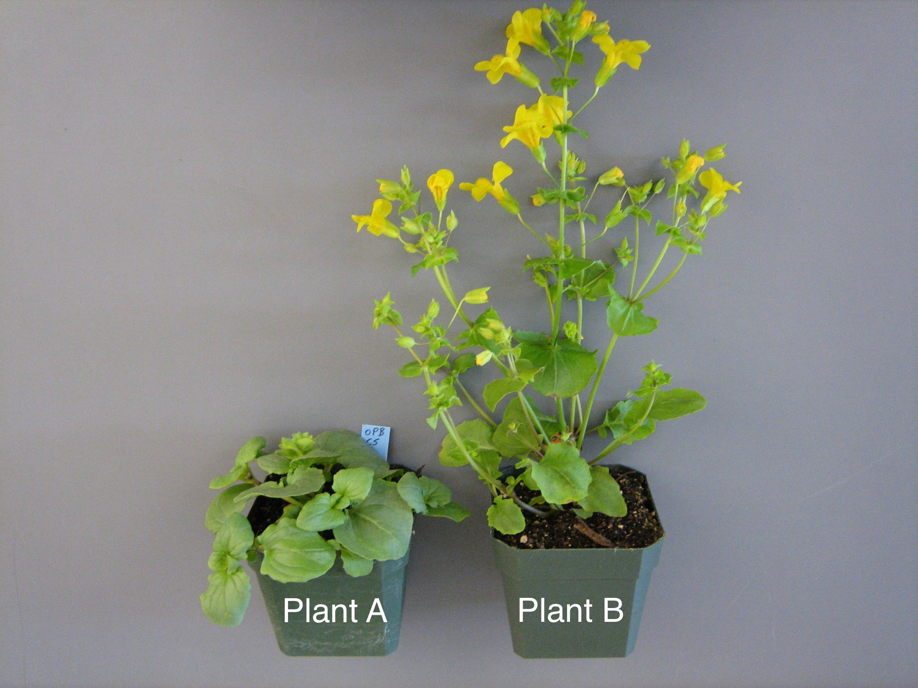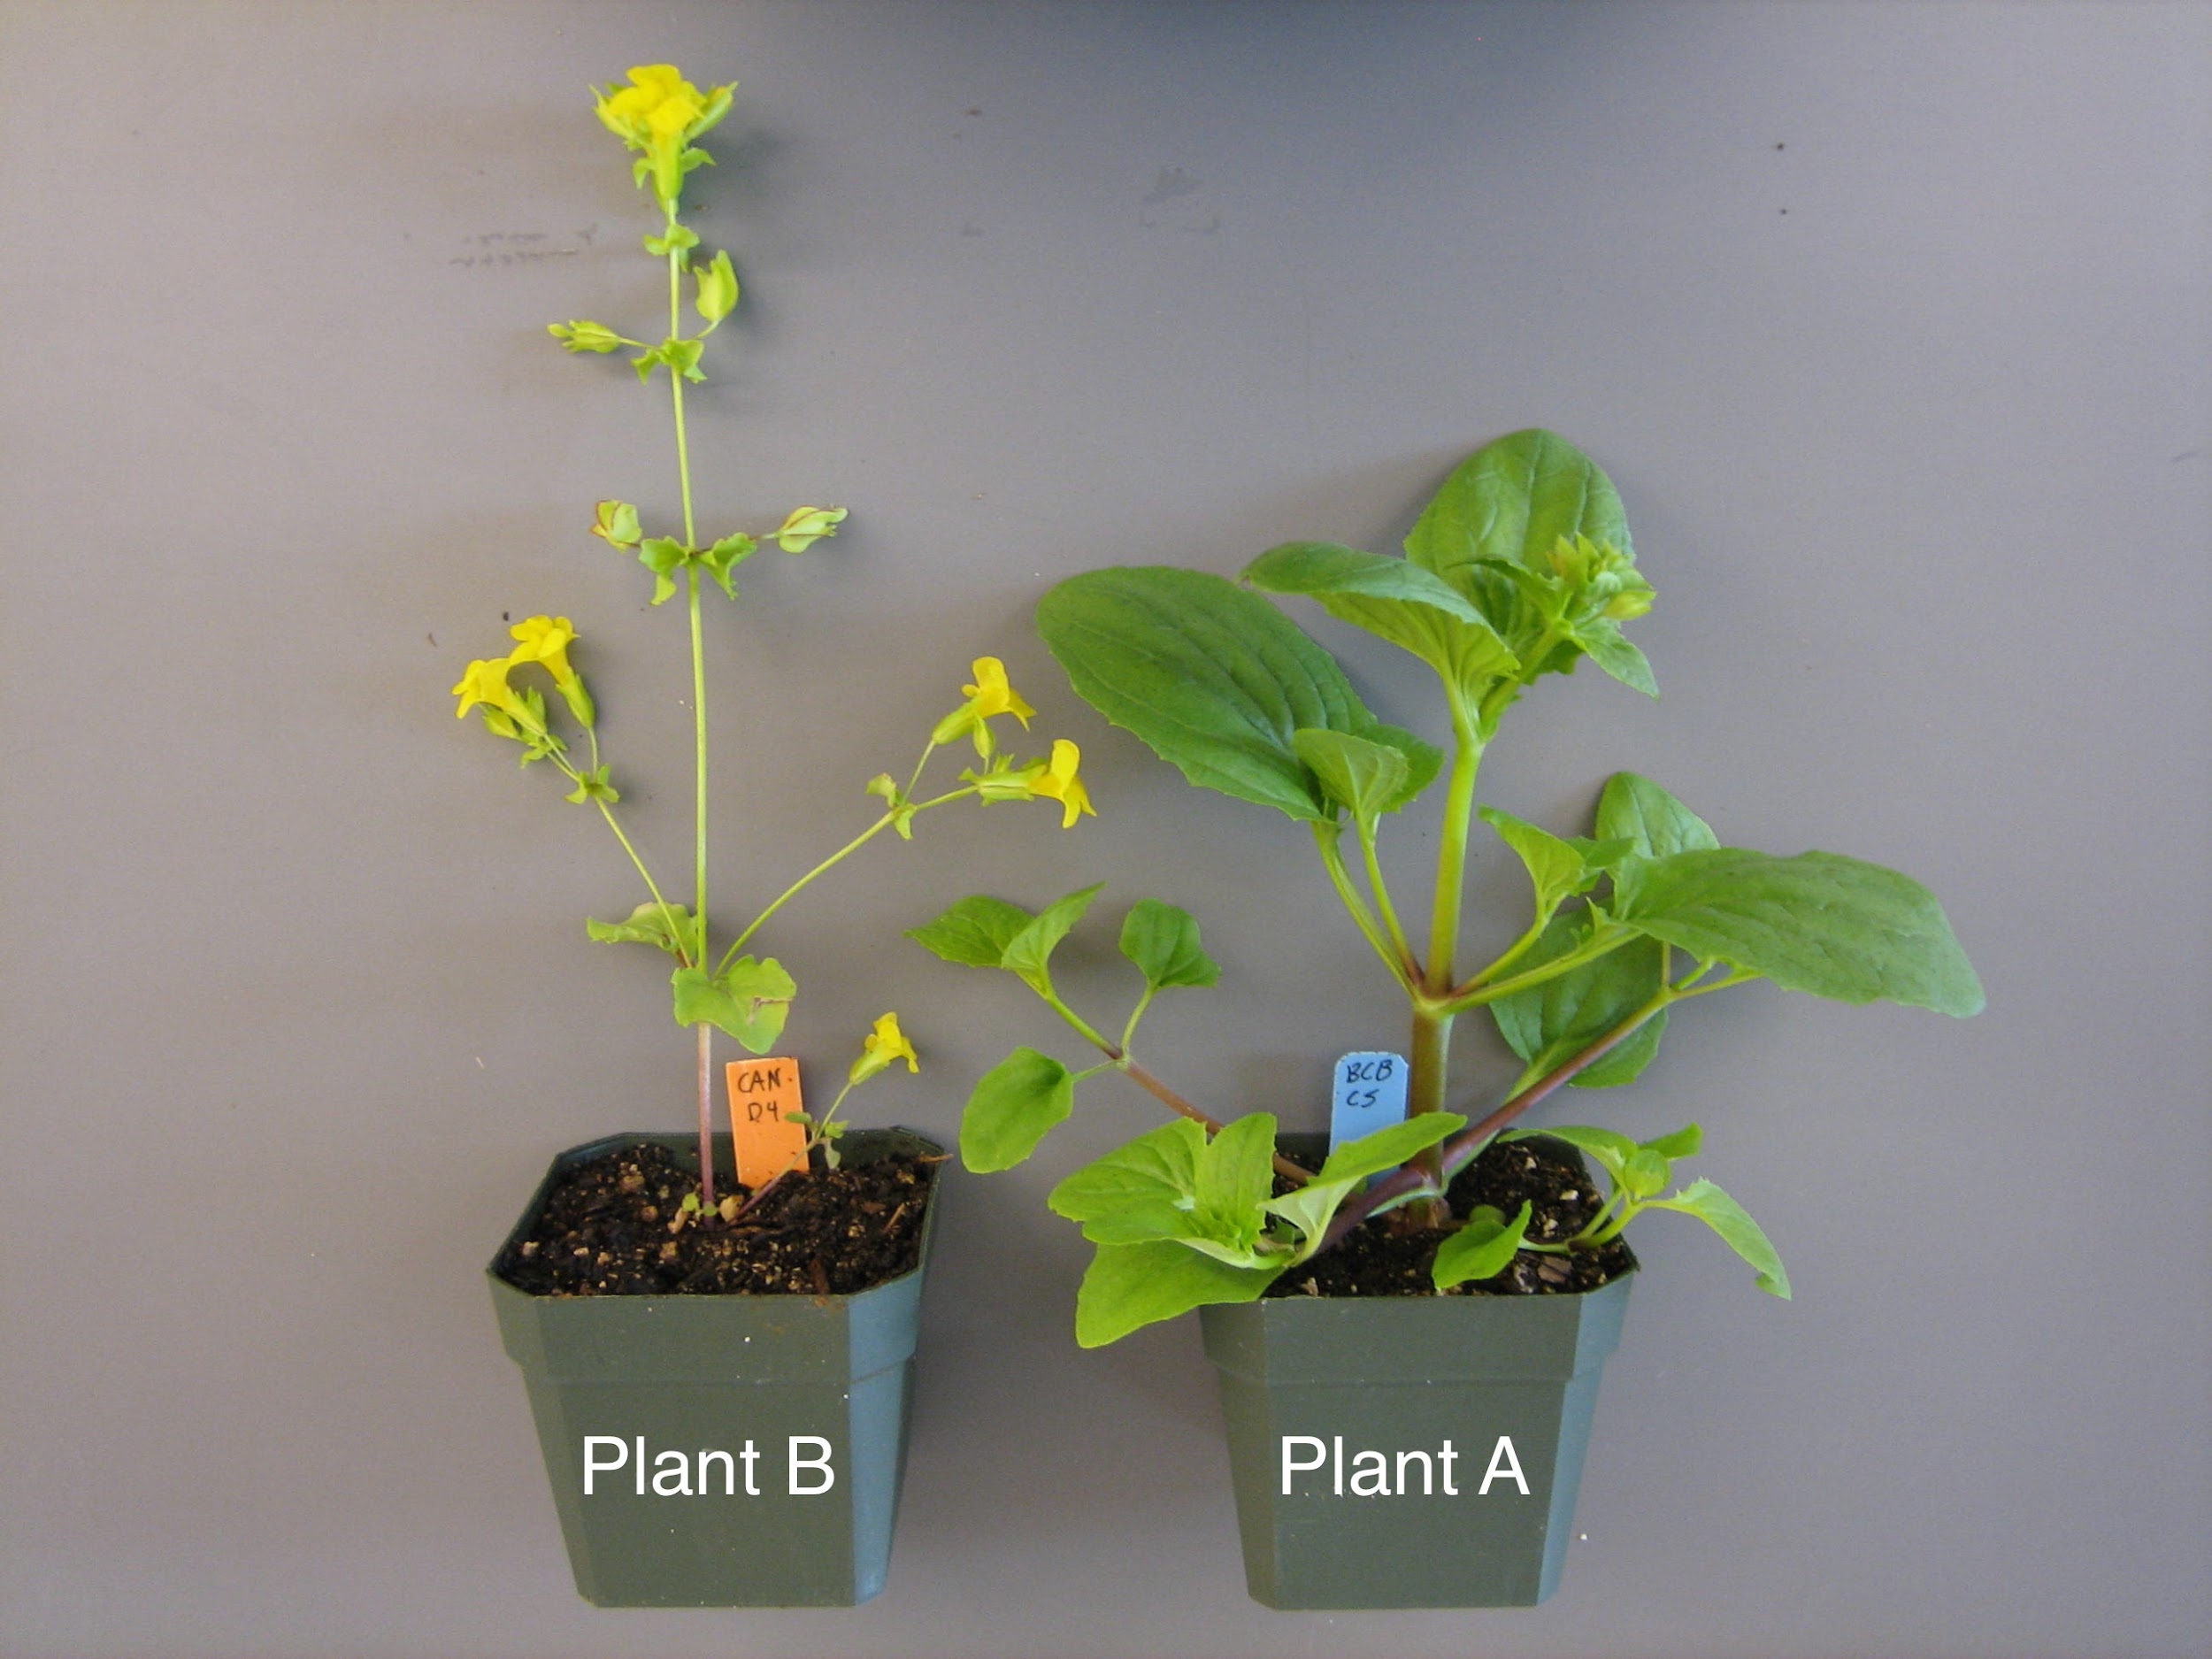

|  |
| --- |
| **Note for teachers:**  The following are examples of possible ideas and questions. At this point, students are not expected to come up with any explanations or answers, the goal is to get students to verbalize or share their observations and then formulate questions from their observations and wonderings. During this discussion, help students change statements or observations to questions.   * What do you notice? * Do they look like the same plants or not? Why or why not? * How are they different? * Why do they think they are different? (use “tell me more/say more” talk moves to respond to students’ observations) * One observation could be “One is bigger than the other”. Then the student's question would be “Why is one bigger than the other?” * One observation could be “They are different because they live in different places”. Then the student's question could be “Do they live in the same place?” * One observation might be “They have different genetics” Then, the student's question could be “Are they genetically similar or different?” |

* + If students do not come up with questions about where the plants live, support them to think about the environment. For example,
    - Where might the plants live?
    - Do you think they might live in different areas?
    - What might be the different conditions in their environment and how might that affect their survival? Show students the pictures of where the monkeyflowers grow. (Students should still not know which is Coastal or Inland, they only know Plant A and Plant B).

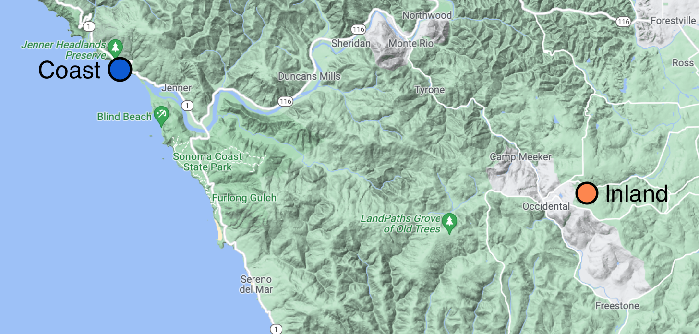

* + Ask students - What is the difference between these regions? Why do you think so?
    - Students should be able to identify that the plants grow in two different regions- Coastal and Inland.
    - What do you think that means if they are growing in different regions?
      * What questions does this bring up for us?

|  |  |
| --- | --- |
| creativity.png | **Scaffolding students using *Brainstorming***   1. **What is brainstorming -** Explain what brainstorming is, and emphasize the importance of learning strategies for effective learning. 2. **Explain what *Brainstorming* is and how it can be used** - Brainstorming is a strategy for generating ideas. It includes generating a list of spontaneous ideas which are associated with a specific topic. For effective brainstorming: (a) focus on quantity; (b) withhold criticism; (c) welcome unusual and wild ideas; and (d) combine and improve ideas. 3. **Scaffold *Brainstorming*** - Together with the entire class, use the *brainstorming* strategy to generate as many questions related to the phenomenon. |

1. **Discuss possible questions with the students that they will investigate throughout the unit.** Keep track of the ideas on a large board, you can use sticky notes for each of the student generated questions. (Instruct students to write ONE question per sticky note.) Based on students’ questions and observations, help students group the questions according to themes. The suggested themes that students will likely come up with are below in the first column. Once the questions are grouped, help students come up with one BIG question that covers those grouped questions.

|  |
| --- |
| **Note for teachers:** Suggested BIG questions can be found below in the second column (wording may vary). Students do not have to come up with all of the categories; the DQ flowchart will be revisited at the end of each learning set and likely the category will be raised at that time, before proceeding to the next learning set. For example, if students do not come up with the second question about *what causes the similarities and differences*, students may ask about that at the end of Learning Set 1 when they have figured out some of the physical similarities and differences between the plants. Also, if students do not come up with questions about how the monkeyflowers changed over time, the category will come up at the end of Learning Set 3, the characters of the comic book bring up the idea at the end of the comic module 4. Teachers may also use talk moves to help lead the conversation to those sub-driving questions if desired. For example, if students are really noticing the physical differences between the plants, perhaps asking the students questions about how those differences might come about may lead to ideas about genes and genetics. From there, teachers could lead students to ask questions about genes which leads to the sub-driving question about what exactly causes those similarities and differences. |

|  |  |
| --- | --- |
| Observation/ideas/questions students generated | Suggested BIG Themes and Questions to investigate in the unit |
| Why do they look different?  Why is one bigger than the other?  The flowers look the same in both plants. | *How are the traits of the two varieties of monkeyflowers similar or different?”* |
| Do the plants have the same genetics?  What is different about the plant's genetics? | *What causes the similarities and differences between monkeyflowers’ traits?* |
| Can both plants live in regions A and B?  What happens if we try to put them in the same region?  Is the weather or climate the same in both regions? | *How does changing the environmental conditions affect the survival of different monkeyflowers?* |
| If the plants are the same, but they live in different regions, did the plants have to change to live in that region? did the changes happen quickly, or, slowly? | *How do the similarities and differences between monkeyflowers develop over time?* |

1. **Introducing Driving Question Flowchart:**
2. **Print the DQF slides**: One slide per page and add one by one as the class constructs the DQF. Print arrows to place between questions. (<https://hioh.education/sites/default/files/curriculum-files/unit-1/DQF-slides.pptx>) It will look something like the following in the end.

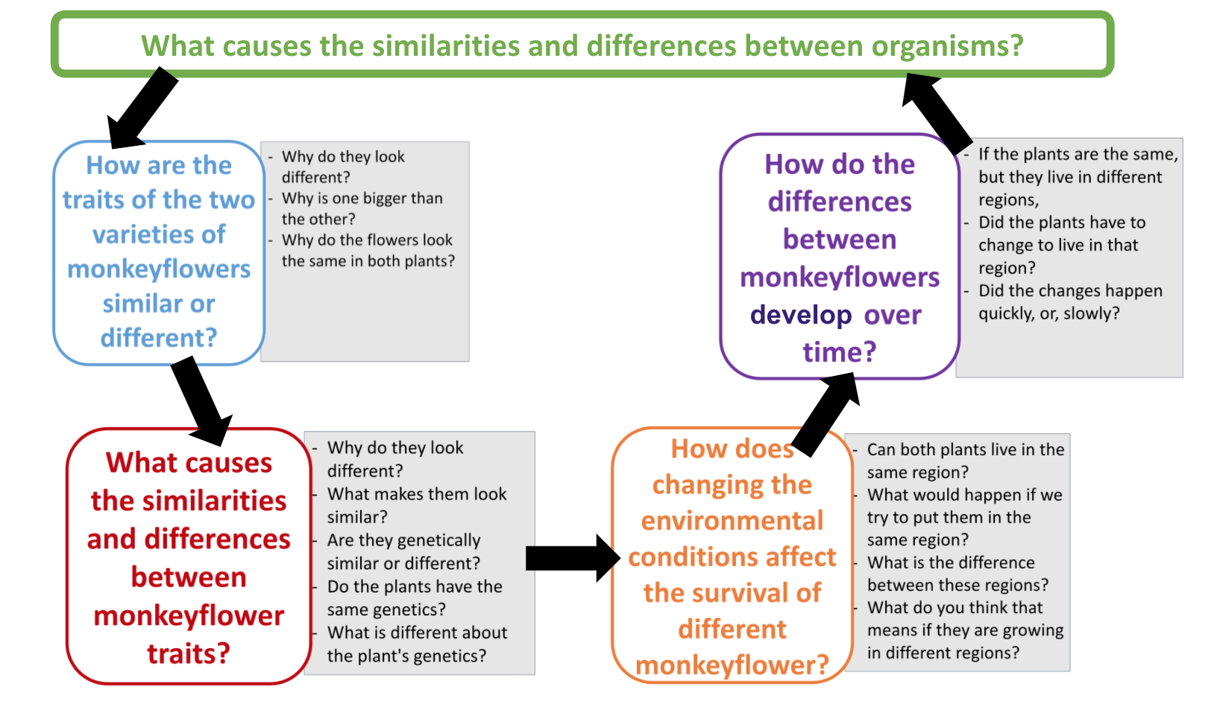

1. **Introducing the unit driving question:** Students have brought up a number of observations that have led them to ask thoughtful questions. Tell them that they will investigate these questions throughout this unit.
   1. To help us investigate all our questions, we will organize them into a Driving Question Flowchart**.**
   2. Introduce students to the Driving Question of the Monkeyflower Unit: ***What causes the similarities and differences between organisms?***
   3. See the example above for how your classes DQ Flowchart might look. Work with students to come up with your classes' own flowchart with questions.
      * The themes/BIG Questions students came up with go in the colored square
      * Next, in the area on the right, place the specific questions generated by students that fit with the theme of the BIG question.

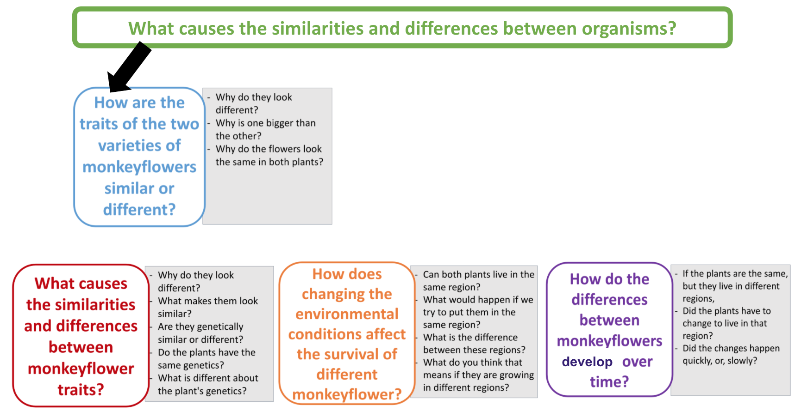

|  |  |
| --- | --- |
| creativity.png | **Scaffolding students using *learning strategies***   1. **What are learning strategies:** Explain what learning strategies are, and emphasize the importance of learning strategies for effective learning. These are ways that students use to learn or accomplish something and become independent learners. 2. **Explain what *a Driving Question Flowchart******(DQF)*** ***is and how it can be used:*** A Driving Question Flowchart (DQF) is a visual reference used to develop students’ understanding of the overarching driving question. It is a dynamic tool, which will organize learning and change over time as the students progress through the lessons.   **Note to teacher:** The DQF can also be a virtual reference instead of a physical presence in the classroom. Several applications, for example Jamboard, Padlet, and EdPuzzle, can be used to serve this same purpose for online and face-to-face learning. |

|  |
| --- |
| ***Lesson 2 – Conducting an outdoor investigation - How do traits differ between organisms?*** |

|  |  |
| --- | --- |
| **Learning Goal** | The students conduct an outdoor observation to compare and contrast traits in different organisms. |
| **Connection to NGSS** | DCI: LS1.B: Growth and Development of Organisms |
| Practice: Plan and carryout investigation |
| CCC: Patterns |

1. **Introduce the comic, the Mystery of the Monkeyflower**: Students are introduced to Maia and William who are bee scientists. Have students read [**Module 1**](https://hioh.education/comic-module-1) (titled: A Tale of Two Flowers) **UP TO PAGE 6-7** (Maia taking a picture). Depending on your students, you could use a variety of ways to have students engage with the comic. For example, having the students act out the comic, read as a group, the teacher could read the comic to the students, etc. Then, discuss prior knowledge by using the following questions.
   * What do you know about field research?
   * What do you think the field science researchers do?
   * Why do you think some scientists go out in the field for their research?
2. **Conducting an outdoor investigation**
   1. Relate the field research to students’ experience – Ask the students if they have had any similar experiences in the field (such as at their backyard, park, school site, or etc.)
   2. Explain that they will conduct an outdoor investigation about organisms in the school yard to experience aspects of field research in biology. In teams of 4, they will [collect data](https://hioh.education/sites/default/files/curriculum-files/unit-1/Monkeyflower-LS1-Materials/Outdoor-Observation-Data-form.docx) using the Outdoor Observation Data form to compare and contrast traits in different organisms and discuss the differences and similarities which have evolved, and the relationship between these traits and the environment in which the organisms live. In teams, the students will explore an environment in the school yard. They will choose two different organisms, take a picture if possible, and draw them in their natural habitat. The students will propose ideas as to why these organisms live where they do and add these hypotheses to their drawing.

|  |  |
| --- | --- |
| creativity.png  **Learning and teaching strategies** | **To reduce “**[**novelty space**](https://hioh.education/sites/default/files/curriculum-files/unit-1/Monkeyflower-LS1-Materials/MoFl-LS1-Novelty-Space.pptx)**” before going out in the field, refer to the MoFl Novelty Space PPT. Prepare students by discussing what to expect during the outdoor investigation, for example:**   1. **Cognitive -**     * Activate prior knowledge - what previous experiences have they had going outside during class? What do they expect it will be like today? What is an organism? We are identifying 2 plant organisms today. What is biotic vs. abiotic? So, plants we identify can also be dead.    * Review the worksheet and fill in the information on the first page that students can complete in the classroom.    * Instruct students to take pictures of their samples - one from far and one close up. Use a ruler to establish size or to estimate the size of larger objects by having a team member hold it up. 2. **Geographical -** Draw a map on the board to give students an idea of where they will be going and for them to use on their forms to locate where they identified their sample organisms. 3. **Psychological -**     * Affective learning - teams should stay together and work together. Don’t damage or collect live things. Dead leaves and such can be brought back.    * Physical comfort - are students prepared to go outside or do they need to stop at lockers for a coat or more appropriate shoes? |

1. **When going outside may be a challenge**: When you are not able to take students outside, you can bring the outdoors inside. You and your students can make observations out the window – different windows – from their classroom, from the cafeteria, from the library. If possible, take pictures or drawings from these different places. Most students will have a phone to take pictures with. Or:
   * Students can take pictures, collect plant material coming to school.
   * Volunteer emissary(s) (student(s) prepared, able, and willing) can go out for the class or teams of students and bring in plant materials for further investigation.
   * Students who are not prepared for field work can stand inside and look out the window or outside near the school or on the sidewalk, while other team members collect plant materials that may be on more difficult terrain. Students who are unable to go outside can be assigned other roles such as completing the data sheet, taking environmental measures such as temperature, etc.
   * If there is more time, there is a good window space, the weather is good, and/or students are prepared and engaged in the activity, then additional activities and observations can be added.
   * For example, a [5-minute observation and journaling exercise](https://hioh.education/sites/default/files/curriculum-files/unit-1/Monkeyflower-LS1-Materials/Outdoor-Observations-adapted.docx) (refer to the Outdoor Observation adapted document).
2. **Sharing -** The students will share their work with others in a gallery walk. Each team reports their findings to their peers through a ‘gallery walk’.
   1. Each team will present their results by posting their data collection forms
   2. Teams will circle around the class and provide comments to other groups using sticky-notes. Prompts to be used:
      1. What is something new I learned
      2. Something similar to my results
      3. Something different from my results
   3. Each team will finalize their posters, making edits if any new insights are gained by the comments.
3. **Discussion** 
   * Conduct a class discussion about the different traits of the organisms they have found, eliciting potential ideas about the relationship between the organisms’ traits and their environment. Examples of prompts:
     + What different traits did students observe in plants? In animals?
     + How do the structures of different traits help organisms function successfully in their habitats
     + *What do you think causes differences between organisms?*
4. **Revisit Module 1 :** This time students read the whole [Module 1](https://hioh.education/comic-module-1) of the Mystery of the Monkeyflower, titled: A Tale of Two Flowers. Students are introduced to Maia and William who are bee scientists. While conducting research, they notice a strange phenomenon in the field.
   * Have students think about the relationship between the story and their own outdoor observations.
     + How do the experiences of these scientists, William and Maia from the comic book, compare to your experience doing research outdoors?
   * Now, having read the comic book and going outside, let’s discuss:
     + What do you know about field research?
       - What new ideas have you learned about field research?
     + What do you think the field science researchers do?
       - Is this something that might be interesting to you? Why or why not?
     + Based on what you read in the comic, why do you think some scientists go out in the field for their research?
     + What else would you like to know about field research?
     + What do you think might be causing the differences between the two Monkeyflower plants?

|  |  |
| --- | --- |
| **The science behind the narrative** | **Module 1 – The bee scientists and the mystery plant**  Maia and William notice the two distinct yet similar varieties of monkeyflowers in the field. Maia is curious as to the reasons for the different traits between the two flowers.  The students will design and carry out an investigation to answer the following questions: What causes the similarities and differences between the two kinds of plants? |

1. **Introduce a Plant Biologist, David Lowry -** Introduce students to David Lowry through the video.
   * Drawing from prior knowledge: Have a discussion to encourage students to think about *why science researchers use plants for research and what field researches do.*
   * What do you know about plants?
   * What is your experience with growing plants?
   * What do you know about how plants grow?
   * Why do scientists use plants for their research?

* Watch a video of a plant biologist***David Lowry*,** whose research we will follow through this unit.
  + - [Watch an interview with David Lowry](https://hioh.education/sites/default/files/curriculum-files/unit-1/Monkeyflower-LS1-Materials/David-Lowry-Interview-audio-improved-022022.mov)
    - [Read about Dr. Lowry’s work on World’s Longest Running Experiment in the NYT](https://hioh.education/sites/default/files/curriculum-files/unit-1/Monkeyflower-LS1-Materials/Dr-David-Lowry-Seeds-From-142-Year-Old-Science-Experiment-Have-Sprouted.pdf).
    - [Listen to Dr. Lowry talking about some of his work on NPR](https://www.npr.org/transcripts/989333092)

1. **Setting up the Michigan State Plant Lab** 
   * **Introducing the context** - Your classroom is the creative group that William had heard about. Your teacher received packets of seeds in the mail, and it is your job now to answer the question that Maia and William discussed. Let’s start there: based on the observations made by the two scientists, what testable question (or questions) can you come up with? Let’s design an experiment that can provide data which might support an answer to that question.
   * **Revisit their research questions found in the DQ Flowchart** that has questions that look similar to these.
     + *How are the traits of the two varieties of monkeyflowers similar or different?”*
     + *What causes the similarities and differences between monkeyflowers’ traits?*
     + *“How does changing the environmental conditions affect the survival of different monkeyflowers?”*
     + *How do the similarities and differences between monkeyflowers happen over time?*
   * **Setting up the groups**
     + Making groups
       - Each student group should consist of 2-3 students
     + Together with your class, you will plant the seeds that Maia and William sent you.
       - The shelves and lighting (including timers and extension cords if needed) should be set up in an open space in your classroom.
       - You can decide if the trays with pots will be set up prior or if you will have students do that as well. Each tray holds 17 pots.
       - You and your class should plant enough seeds/pots so that each group of 2-3 students has two pots of seeds of Plant A and Plant B.
       - Use these videos and word document to help get you started, plant seeds and weeding the plants
       - [Review the Pre-Unit Setup document](https://hioh.education/sites/default/files/curriculum-files/unit-1/Monkeyflower-LS1-Materials/Pre-unit-Setup.docx)
       - [Review the planting videos](https://hioh.education/plant-set-up-videos)
     + Assign the pots/plants
       - Each student group should have 2 of each Plant A and Plant B that they will observe throughout the unit.
       - Be sure students **observe and take measurements of the same set of plants throughout the unit enactment**, this will be important to their data collection.
         1. Some suggestions for making sure plants don’t get mixed up with other groups’ plants

Tape 1 Plant A and 1 Plant B together and label that set of plants for one group. Do the same for each groups’ plants.

Have students place tape on their plants and mark the tape with the names of the people in the group or they can come up with their own group name.

1. **Setting up the investigation** 
   * Have a class discussion
     + How do we set up our investigation?
     + Students generate ideas about:
       - what data to collect,
       - how to collect data,
       - how long to collect data,
       - how to organize the data
     + For this part of the investigation, students are focusing on collecting data on growth of the plants and describing what the plants look like.
     + [Sample Data Collecting Sheet](https://hioh.education/sites/default/files/curriculum-files/unit-1/Monkeyflower-LS1-Materials/Sample-Data-Collecting-Sheet.docx) for students to record their data. You and your students may come up with more data to be collected about the plants.
   * Once students have created their data collection sheets, they should begin collecting and recording their observation data.
     + Observations and collecting data should be done about twice a week.
     + Be sure to make time during those data collecting times in class for students to collect and record their data and observations.

|  |
| --- |
| **Note to Teacher**: Data collection **should begin promptly around 4 weeks after seeds have been planted.** Students will note there are no flowers yet, those will appear around weeks 5 and 6. The important thing is for students to practice collecting data which they will analyze later in the unit. |

|  |
| --- |
| ***Lesson 3 - How do the parts of the monkey flower work together to keep the monkey flower plant alive?*** |

|  |  |
| --- | --- |
| **Learning Goal** | The students develop and use models to explain the hierarchical structural organization of an organism (monkey flowers).  Students use models to explain how the subsystems work together to maintain the overall function of living organisms (monkey flower) |
| **Connection to NGSS** | DCI: LS1.A Structure and Function |
| Practice: Developing and using models |
| CCC: Systems and system model |

1. **Introduction to plant morphology** – Jigsaw activity
   1. Discussion:
      * What are the parts of the plants?
      * Can you name them and think about what their role is in supporting the plant’s survival?
      * What do you think is the role, function and importance of each part of the plant?
      * Do both Plant A and Plant B have these same plant parts?
   2. Perhaps pull one of the extra small growing plants out of one of the pots to let them look at and identify and discuss the parts of the plant. Explain that they will be investigating the different parts of the plant and then coming together to create models of the plant parts and the whole plant and figuring out how those parts work together.
   3. Create 6 home groups (3 home groups for plant A and 3 home groups for Plant B), the students will learn about plant morphology by studying the different parts of plants. Each home group will receive 3 plant parts.
   4. Within each home group, have pairs of students investigate each part of the plant:
      * roots and stems
      * leaves
      * flowers
   5. In their pairs, students will explore their plant part of the monkeyflower. This means, studying the various parts both on the observable (macro) and non-observable (micro) levels. Students use the [Monkeyflower Observation Chart worksheet](https://hioh.education/sites/default/files/curriculum-files/unit-1/Monkeyflower-LS1-Materials/Lesson-3-Monkeyflower-Observation-Chart-worksheet.docx) to organize their observation and thinking using diagrams/models and **blow-ups**(enlarged parts of a model) for non-observable features.
   6. Let students work through column 1, observable features, and predict some non-observable features using blow-ups for column 2.
   7. Introduce the slides for students to observe the specialized structures, at the micro level for the plant part (stem/root, leaf, and flower), as they describe the characteristics. This is intended for students to explain and deepen their understanding of non-observable structures of plant parts.
   8. Students will use available resources to figure out the function/role/importance of their plant part (and fill in column 3 in their chart). Students will become experts in their plant part
      * Stem and root - key structures/roles/importance
      * Flower- key structures/roles/importance
        1. [Show the picture of a cross-section of a flower petal](https://hioh.education/sites/default/files/curriculum-files/unit-1/Monkeyflower-LS1-Materials/Monkeyflower-Slides/Cross-section-Flower-Petal-Monkeyflower.png)
        2. [Show the picture Chilean Monkeyflower flowers](https://hioh.education/sites/default/files/curriculum-files/unit-1/Monkeyflower-LS1-Materials/Monkeyflower-Slides/Chilean-Monkeyflower-flowers.png) to be able to discuss about the different flower colors of the monkeyflower
        3. [Show the picture of the seed development](https://hioh.education/sites/default/files/curriculum-files/unit-1/Monkeyflower-LS1-Materials/Monkeyflower-Slides/Seed-Development-Monkeyflower.png) in the monkeyflower
      * Leaves- key structures/roles/importance
        1. [Show the picture of leaf morphology](https://hioh.education/sites/default/files/curriculum-files/unit-1/Monkeyflower-LS1-Materials/Monkeyflower-Slides/Leaf%20Morphology-of-Mimulus-lewisii-A-E-and-M-tilingii-F-I-glandular-trichomes-visualized.png) of monkeyflower
        2. [Show the picture of the long-stalk trichomes](https://hioh.education/sites/default/files/curriculum-files/unit-1/Monkeyflower-LS1-Materials/Monkeyflower-Slides/Long-stalk-multicelled-glandular-trichomes-found-on-leaf-surfaces-of-both-Mimulus-637.png) found on leaves of monkeyflower
        3. [Show pictures of the histochemical secretions](https://hioh.education/sites/default/files/curriculum-files/unit-1/Monkeyflower-LS1-Materials/Monkeyflower-Slides/Histochemical-characterization-of-secretions-of-Mimulus-lewisii-A-H-and-M-tilingii-I.png) part of monkeyflower leaf
   9. Expert pairs from each of the plant parts return to their home group. Each pair shares their findings about their plant part.
   10. Provide each home group with a poster paper. In their home groups, students should discuss their findings and work to build a consensus model on the poster paper for their whole plant (students use the observation/modeling chart).

|  |
| --- |
| **Note to teacher:** How to evaluate sources for reliability and bias  Ask students, “How can you tell if this is accurate and reliable data? Just because I gave this data to you, is that enough evidence? What if you want more information about your topic? How would you go about finding reliable information?”  Elicit responses from students about reliable information sources.  Make a list on the board and discuss if they are reliable sources and why.  Show students a [video](https://www.youtube.com/watch?v=q1k8rcYUmbQ) about how to find and use reliable and biased sources. |

1. **Discussion: Presenting models**
   1. Each home group will present their whole plant model to the whole class and discuss the roles of the parts in keeping the monkeyflower plant functioning well. The goal is to create a coherent classroom model that shows how the various parts work together to sustain the whole plant, as well as discussing the differences between Plants A and B.
   2. The following questions could be used to guide the presentation and discussion paying attention to the differences between plant A and plant B:
      * What physical structures are present?
      * What is the role/importance of those structures?
      * Using blow-ups, what are the non-observable structures you found? Make sure they are shown/added in the model
      * In what ways are the non-observable structures important to the plant part?
      * Explain how your part works to sustain the monkeyflower plant? In your explanation, incorporate the function of the structures you identified above.
      * From the presentation, what differences do we notice between the plants?

|  |  |
| --- | --- |
| Suggestion for teachers | To avoid groups repeating the same answers for questions 1-6 above, have each home group for each plant pick 2 questions from above to answer. Also encourage all of the groups to support one another and fill in/add to answers where necessary. |

* 1. Conclude by having all the students write a poem, song, paragraph, draw, and/or simulate a brief explanation on how the three parts work together to form a functioning system.

|  |  |
| --- | --- |
| creativity.png  **Learning and teaching strategies** | **Scaffolding students using *learning strategies***   1. **What are learning strategies -** Remind what learning strategies are and emphasize the importance of learning strategies for effective learning (see teacher’s guide). 2. **Explain blow-ups and how they can be used to show unobservable features and processes.** *Blow-ups are enlarged parts of a model to show microscopic things in a phenomenon. They help students show and communicate what is happening at a level that they cannot visualize.* 3. **Explain what *Brainstorming* is and how it can be used** - Brainstorming is a strategy for generating ideas. It includes generating a list of spontaneous ideas which are associated with a specific topic. For effective brainstorming: (a) focus on quantity; (b) withhold criticism; (c) welcome unusual and wild ideas; and (d) combine and improve ideas. 4. **Scaffold using observation and modeling chart** - Together with the entire class, use the *observation modeling chart* to show students how to use it to record and model their ideas.   ***\* This is not an exhaustive list*** |

|  |
| --- |
| ***Lesson 4 – Wrapping up - revisiting the Driving Question Flowchart*** |

|  |  |
| --- | --- |
| **Learning Goal** | The student will revisit the DQ Flowchart to discuss what questions have been addressed thus far and/or adding more questions to the DQ Flowchart |
| **Connection to NGSS** | DCI: LS4.C: Adaptation |
| Practice: Asking questions |
| CCC: Cause and Effect |

1. **Returning to the Flowchart:**  Students have now set up their Michigan Plant Lab.
2. **Remind students** that they are beginning to answer the unit driving question: What **causes the differences between organisms?** with their first BIG question (insert your classes’ question here).
3. **Review the questions they had under their first BIG question. Were any of the questions answered? Do they have new questions?** Bring them back together in their groups for **a whole class discussion.**
4. **To close**- reiterate the purpose of the DQ Flowchart. Throughout the unit we will be revisiting and adding to the DQ Flowchart where you will see that many of their questions are being addressed.
5. **Moving forward**- the teacher and students look at their BIG Questions and discuss which question they should explore next. Teachers should guide students to the next question that explores What causes the similarities and differences?
6. Our next BIG Question is: ______________________________________

|  |  |
| --- | --- |
| creativity.png | **Scaffolding students using *learning strategies***   1. **What are learning strategies -** Explain what learning strategies are, and emphasize the importance of learning strategies for effective learning. 2. **Explain what *Brainstorming* is and how it can be used** - Brainstorming is a strategy for generating ideas. It includes generating a list of spontaneous ideas which are associated with a specific topic. For effective brainstorming: (a) focus on quantity; (b) withhold criticism; (c) welcome unusual and wild ideas; and (d) combine and improve ideas. 3. **Scaffold *Brainstorming*** - Together with the entire class, use the *brainstorming* strategy to generate as many hypotheses as possible regarding the question. |

**Lesson 2 Quiet Observations**

**Outdoor Observations**

This exercise is adapted from: Kara Haas, Teaching Science Outdoors-Urban Partnerships, teachingscienceoutdoors.org.

Sometimes we call this the ‘5-Minute Quiet Observation’!

* The quiet observation is a teaching tool that we can use whenever we go outside.
* The 5 minutes are always quiet, solo and we model different observation techniques (listening, watching, listing, sketching, mapping, drawing, taking pictures, etc.).
* Observation is a tool for experiencing “place” and learning through experiencing the place. Below are instructions for several observation sessions.
* Adaptations for weather: quiet observations can be accomplished in inclement weather by having students observe through a window. Consider if there is a view from your classroom or another public space such as cafeteria or hallway. Students could also observe an inner courtyard. These experiences can be supplemented by asking students to conduct an outdoor observation at home.
* Other adaptations to ‘quiet observation’ instructions include: change your perspective (stand, sit, lie down), pretend to be really big or really little (pretend to be a bird or a bear); try to see the world through someone or something else’s eye.
* Debrief - after each quiet observation, take a few minutes for students to share what they noticed. What questions or “I wonder” statements did they write down? Students can post their questions, pictures and drawings in the classroom or using technology or PPT slides. Create a word cloud (for example using slido.com) - ask students to add words to answer a question, such as, “what did I see (or hear, smell) during the quiet observation?” “How did the quiet observation make me feel?”. Responses may read like a poem.

Materials: paper, pencil. (Optional) Journal, grid paper, colored pencils/markers, phone for taking pictures.

Example series of quiet observations (see other suggestions above):

Session 1_ 5-minute observation, 5-minute journaling

1. Stand in your habitat and take 5 minutes to observe your surroundings. Take a moment to study the land around your feet, then bring your eyes to the horizon, then lift them to the sky.
   1. What do you notice? What do you wonder?
   2. Write down your observations in a journal. Please note the date and the hour.
   3. Words, drawings, etc.

Session 2_ 5-minute observation, 5-minute journaling

1. Stand or sit in your habitat and take 5 minutes to observe your surroundings. Focus on what you can hear. If you feel comfortable, close your eyes and listen.
   1. What do you notice? What do you wonder?
   2. Write down your observations in a journal. Please note the date and the hour.
   3. Words, drawings, etc.

Session 3_ 5-minute observation, 5-minute journaling

1. Step into your habitat, take a moment to find an object to study closely (it could be a plant, animal, something unnatural). Take 5 minutes to observe your object closely.
   1. What do you notice? What do you wonder?
   2. Write down your observations in a journal. Please note the date and the hour
   3. Make a sketch of your object if you like.

Session 4_ 5-minute observation, 5-minute journaling

1. Step into your habitat and take 5 minutes to observe your surroundings. Focus on what you can feel (on your skin, with your hands). Either sit in one location and feel for objects within reach or take a walk and touch things along the way.
   1. What do you notice? What do you wonder?
   2. Write down your observations in a journal. Please note the date and the hour
   3. Words, drawings, etc.

Lesson 2 Observation Form

***How do traits differ between organisms?***

***Data Collection Form***

|  |  |  |
| --- | --- | --- |
| ***Student team names:*** | | |
| ***Teacher’s Name:***  ***Class Hour:*** | | ***Date:*** |
| ***Weather***   * ***Temperature:*** | ***Circle one:***   * ***Sunny/Partly Cloudy/Overcast*** * ***Calm/Windy*** | |

***Location of your data collection***

* ***Draw a map***
* ***Mark the location(s) of where you found your samples with an X***
* ***Label them S1 and S2***

|  |
| --- |
| ***Student team names:***  ***Organism 1:*** |
| ***Description of habitat where sample was identified:***  ***(if possible, take a picture)*** |
| ***Describe organism:*** |
| ***Drawing:*** |
| ***Why do you think this organism lives in this habitat? What traits do you think help it survive in this environment?*** |
| ***Student team names:***  ***Organism 2:*** |
| ***Description of habitat where sample was identified:***  ***(if possible, take a picture)*** |
| ***Describe organism:*** |
| ***Drawing:*** |
| ***Why do you think this organism lives in this habitat? What traits do you think help it survive in this environment?*** |

Sample Data Collection Sheet

**Data collecting sheet Team name: ____________________________ Student name: _______________________________**

|  |  |  |  |  |  |  |  |  |
| --- | --- | --- | --- | --- | --- | --- | --- | --- |
| ***Variables*** | **Height (cm)** | | **Leaves** | | **Flowers** | | **Notes (describe the plants- color, texture, noticings, etc)** | |
| ***Type of flower*** | **Plant A** | **Plant B** | **Plant A** | **Plant B** | **Plant A** | **Plant B** | **Plant A** | **Plant B** |
| **Date:** |  |  | **Size (cm)** |  | **Size (cm)** |  |  |  |
| **Number** |  | **Number** |  |
| **Date:** |  |  | **Size (cm)** |  | **Size (cm)** |  |  |  |
| **Number** |  | **Number** |  |
| **Date:** |  |  | **Size (cm)** |  | **Size (cm)** |  |  |  |
| **Number** |  | **Number** |  |
| **Date:** |  |  | **Size (cm)** |  | **Size (cm)** |  |  |  |
| **Number** |  | **Number** |  |
| **Date:** |  |  | **Size** |  | **Size** |  |  |  |
| **Number** |  | **Number** |  |

Lesson 3- Plant Morphology

**Lesson 3 - Monkeyflower Observation chart**

|  |  |  |
| --- | --- | --- |
| **Plant: A or B (circle one) Plant part: ______________________** | | |
| **Observable features/level**  **(Write and draw what you see).** | **Non-observable features/level**  **(Write and draw what you see and think).** | **Describe the part’s function/role/importance** |
| What you think (preliminary thoughts): |  |  |
| What you figured out from the slides and researching (use available resources): |  |  |
| How does the plant part you have studied above help the monkeyflower to function? | | |
| What will happen to the monkeyflower if the part you studied does not function correctly? | | |

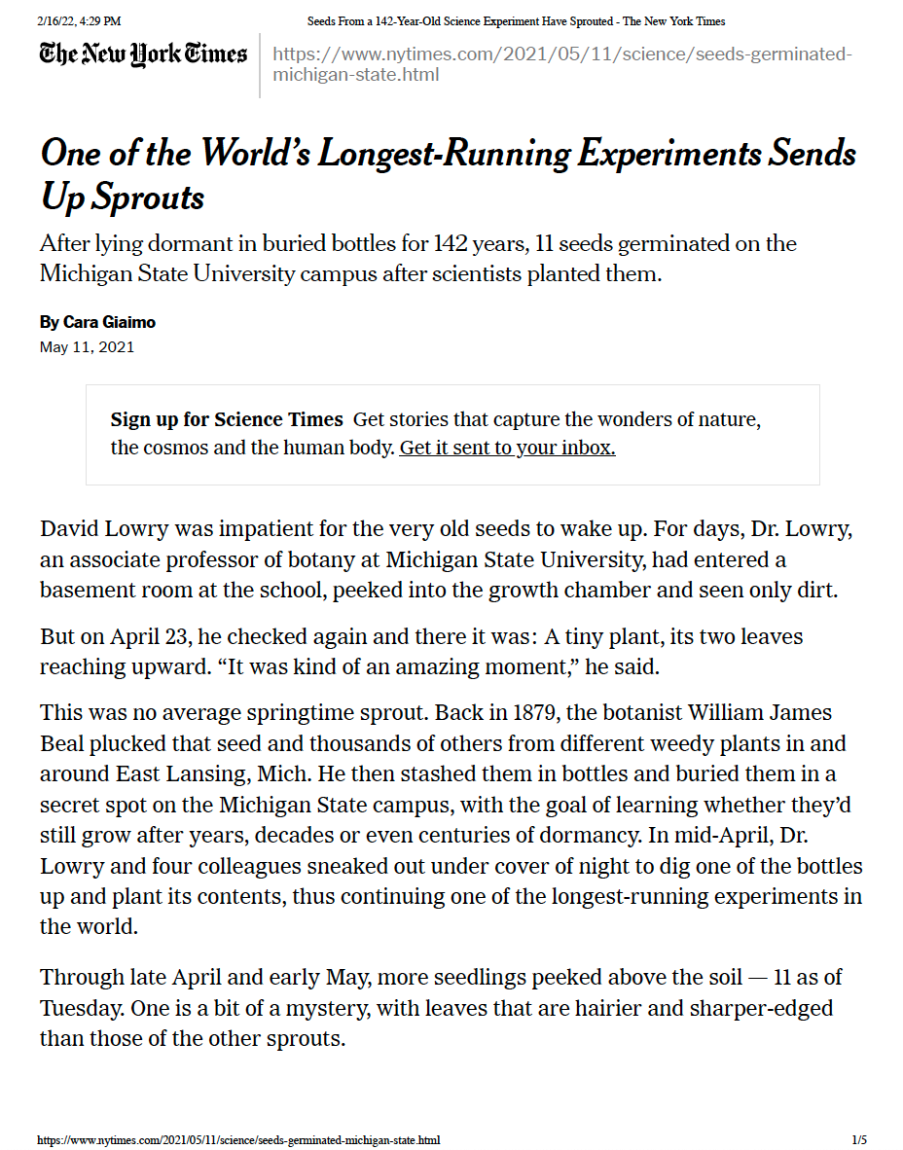

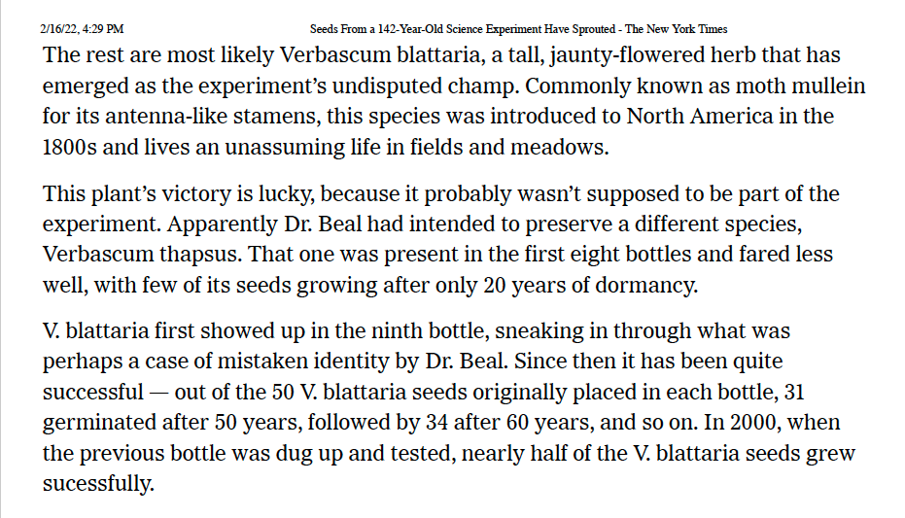

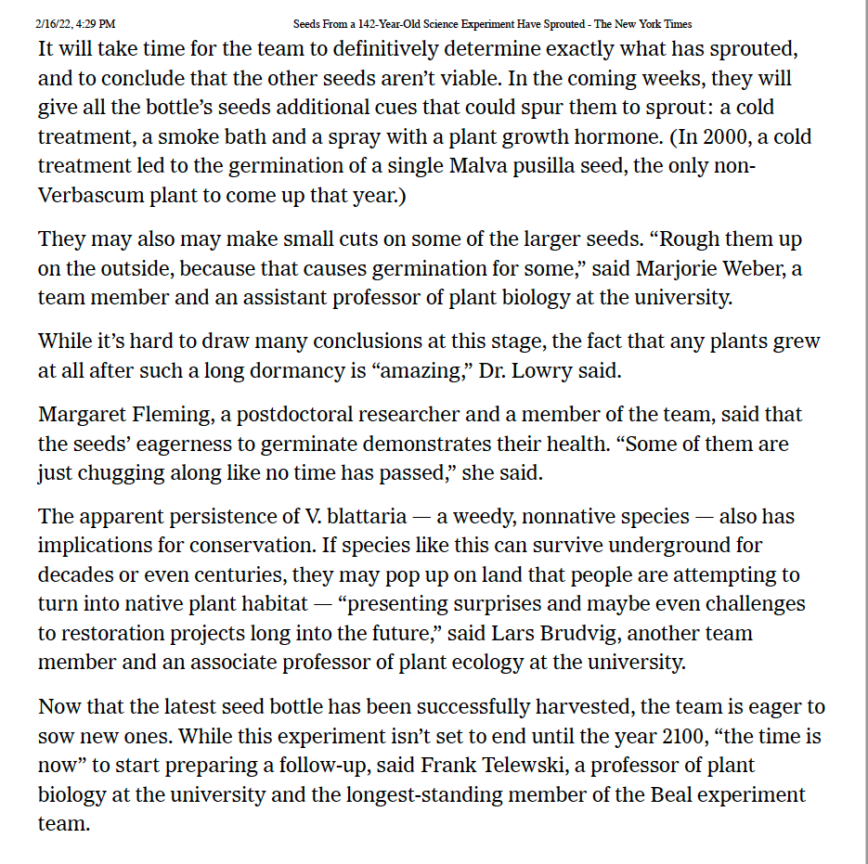

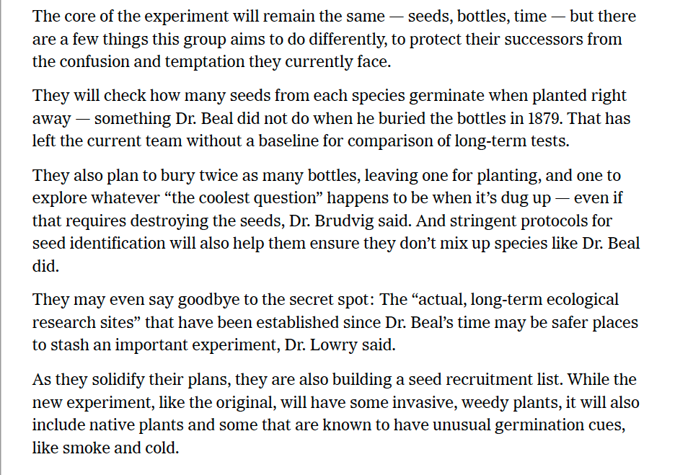

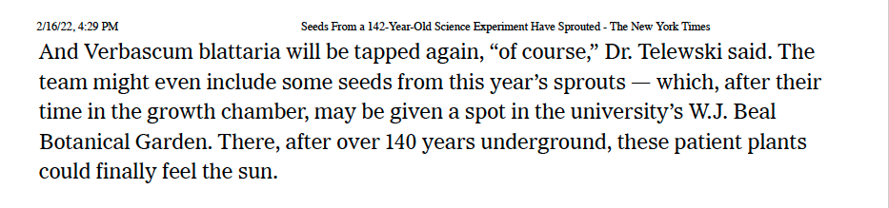

**Sample** Driving Question Flowchart

