Learning Set 2: What causes the similarities and differences between monkeyflower traits?

Driving Question  for the unit:  What causes similarities and differences between organisms?  Driving Question  for learning set 2 :  What causes the similarities and differences between monkeyflower traits? | Materials  Supplies:  - Strawberry extraction protocol worksheet and materials list  - Pipe cleaners  - Pony beads  Handouts:  - How do the plants reproduce?  - Mendelian Worksheet  - Meiosis Worksheet  - How do monkeyflowers inherit their traits from their parents?  - What does DNA look like?  - Real monkeyflower DNA sequence  - How are proteins made from DNA?  - How does DNA affect monkeyflower traits?  - How can changes in the structure of DNA affect an organisms traits?  Links to videos:  - What is a mutation?  - What is a gene?  - Discovering DNA  - How to make a DNA molecule?  Comic modules:  - Module 2 PDF - https://hioh.education/comic-module-2  - Module 3 PDF - https://hioh.education/comic-module-3  PPT:  - Monkeyflower Mendelian traits  - Suggested grouping of Monkeyflower DNA strands | Suggested lesson time  18 days

Building Coherence

This unit guides students through a journey to figure out what causes the similarities and differences between two varieties of monkeyflower. Genes are regions in the DNA that contain the instructions that code for forming species’ traits. The traits that positively affect survival are more likely to be passed on to offspring. Throughout the unit, students will investigate several sub-driving questions to support them to gradually answer the big unit driving question, “What causes the similarities and differences between organisms?” which encompasses these scientific ideas. See the Storyline

Guided by the sub-driving question, the journey unfolds as students figure out:
- In LS1 - The different parts of the monkeyflowers and the similarities and differences in traits of organisms to answer the sub-driving question, “How are the traits of the two varieties of monkeyflowers similar or different?”
- In LS2 - The structure and function of the DNA, the relationship between DNA and proteins, and the mechanisms of genetic variation to answer the sub-driving question, “What causes the differences between monkeyflower traits?”
- In LS3 - The effect of environmental conditions, changes in the growth and survival of organisms to answer the sub-driving question, “How does changing the environmental conditions affect the survival of different monkeyflowers?”
- In LS4 - The process of natural selection to answer the sub-driving question, “How do the similarities and differences between monkeyflowers develop over time?”

Framing the Learning Set

Purpose
In this learning set, the students will figure out the process of sexual reproduction of plants and the structure and function of DNA. Through the pipe cleaner and bead hands-on simulation, students will figure out how the traits are passed from parents to offsprings. Then, they will engage in various activities to support their understanding of the relationships between DNA, proteins and traits.

Learning Set Learning Goals (For instructional use)
- The students ask questions about what causes the differences between two monkeyflowers.
- The students simulate the process of meiosis and explain how it can result in genetic variation.
- The students use models that support their figuring out the structure of DNA.
- The students use a computer simulation to figure out how DNA can be used to make proteins and what happens when mutations (unexpected changes in DNA) happen.
- The students explain how different traits of organisms are associated with genes that code for proteins.

Overview of the Learning Set

Instructional sequence overview | Instruction days
Lesson 1 - Mystery story  The students read comic module #2 and go back to the DQ flowchart to make hypotheses for the sub-driving question (SDQ). | 1
Lesson 2 - How are traits passed from parent to offspring?  The students review their prior knowledge about genes and inheritance. Then, students use pipe cleaners and beads to simulate and figure out meiosis, and Medelian inheritance with the story of scientists who worked on genetics. | 3
Lesson 3 - How do monkeyflowers inherit their traits from parents?  The lesson introduces the variation of color of monkeyflowers. The students continue to use the pipe cleaner and beads activity to simulate from Monkeyflower parents to offspring to figure out meiosis with crossing over and genetic variation caused by recombination and independent assortment. | 2
Lesson 4 - What is DNA and what does is look like?  The students begin reading Module 3 of the mystery story and extract DNA from strawberries. The students use physical models and visual representations to identify the important structural characteristics relevant to DNA and make claims based on evidence for the structure of the DNA. | 3
Lesson 5 - How does DNA affect monkeyflower traits?  The students use the computer simulation(s) to figure out transcription and translation. Then they go back to their physical models and figure out transcription and translation sequences of their monkeyflower DNA sequence. | 3
Lesson 6 - How can changes in the structure of DNA affect an organism's traits?  The students use the computer simulation(s) to figure out mutations. | 2
Lesson 7 - Mystery story - How are Plant A and Plant B genetically similar and different?  All student groups bring their pieces of a sequence of monkeyflower DNA together to compare plants A and B. They generate an explanation from the evidence about the genetic similarities and differences between Plants A and Plant B. | 3
Lesson 8 - Wrapping-up - revisiting the Driving Question Flowchart  The students revisit the DQ flowchart and reflect upon their learning. | 1

Connection to NGSS

Target Performance Expectations
HS-LS1-1 Construct an explanation based on evidence for how the structure of DNA determines the structure of proteins which carry out the essential functions of life through systems of specialized cells.

HS-LS3-1 Ask questions to clarify relationships about the role of DNA and chromosomes in coding the instructions for characteristic traits passed from parents to offspring.

HS-LS3-2 Make and defend a claim based on evidence that inheritable genetic variations may result from: (1) new genetic combinations through meiosis, (2) viable errors occurring during replication, and/or (3) mutations caused by environmental factors.

HS-LS3-3 Apply concepts of statistics and probability to explain the variation and distribution of expressed traits in a population.
Learning Performances
- Students develop and use models to explain how genetic variation can occur.
- Students develop and use models to explain how genetic information carried in DNA affects the structure and function of an organism’s traits.
- Students construct an explanation of how processes (such as mutation and meiosis) result in variation of traits.
Disciplinary core idea | Science and engineering practices | Crosscutting concepts
LS1.A: Structure and Function  - All cells contain genetic information in the form of DNA molecules. Genes are regions in the DNA that contain the instructions that code for the formation of proteins, which carry out most of the work of cells.  LS3.B: Variation of Traits  In sexual reproduction, chromosomes can sometimes swap sections during the process of meiosis (cell division) thereby creating new genetic combinations and thus more genetic variation. | Developing and using models  - Develop, revise, and/or use a model based on evidence to illustrate and/or predict the relationships between systems or between components of a system.  - Develop and/or use multiple types of models to provide mechanistic accounts and/or predict phenomena, and move flexibly between model types based on merits and limitations  Constructing a scientific explanation  - Construct and revise an explanation based on valid and reliable evidence obtained from a variety of sources (including students’ own investigations, models, theories, simulations, peer review) and the assumption that theories and laws that describe the natural world operate today as they did in the past and will continue to do so in the future. | System and system models  - Models (e.g., physical, mathematical, computer models) can be used to simulate systems and interactions—including energy, matter, and information flows within and between systems at different scales.  Structure and function  - The functions and properties of natural and designed objects and systems can be inferred from their overall structure, the way their components are shaped and used, and the molecular substructures of its various materials.
How these elements are integrated and embedded in this learning set: In this learning set, students will use text and visual displays to collect evidence that supports their understanding of the structure and function of the DNA, proteins, and mutations to explain how different traits of organisms are associated with genes by connecting their findings from the experiments and simulations.

Connection to Students’ Lives

Link to out-of-school activity and everyday life
- Encourage students to observe the natural world around them. They can generate questions from what they observe and conduct experiments and analyze data to answer their questions that are related to their surroundings and even their own lives.

Link to career-awareness
- This learning set introduces what field research scientists do: scientists ask questions about the natural world and try to answer their questions based on evidence. Let students know that what they will do in this learning set is very similar to what field research scientists do: they will plan and carry out investigations, collect and analyze data, and draw evidence-based conclusions.

Instructional sequence

Lesson 1 - What causes the differences between monkeyflower traits?

Learning Goal | The students ask questions about what causes the difference between two monkeyflowers.
Connection to NGSS | DCI: LS3.B: Variation of Traits
 | Practice: Asking questions
 | CCC: Cause and effect

1. Introduce Module 2 of the plant mystery story
- To introduce the students to this next learning set, remind them of where they left off in the previous learning set.
  - Introduction to Maia and William.
  - Introduction to field research.
  - Introduction to the monkeyflower and its morphology.
  - Beginning research on the similarities and differences between two varieties of monkeyflower.
- Students read comic module #2.

  The science behind the narrative | Module 2 – On the flip side of the same species  Maia and William identified the pattern that the different traits correlated with two distinct types of environments. Module 2 ends up with the question: What causes the differences between organisms? The students will be engaged in various activities to answer the question.

2. Identify the next Sub-Driving Question.

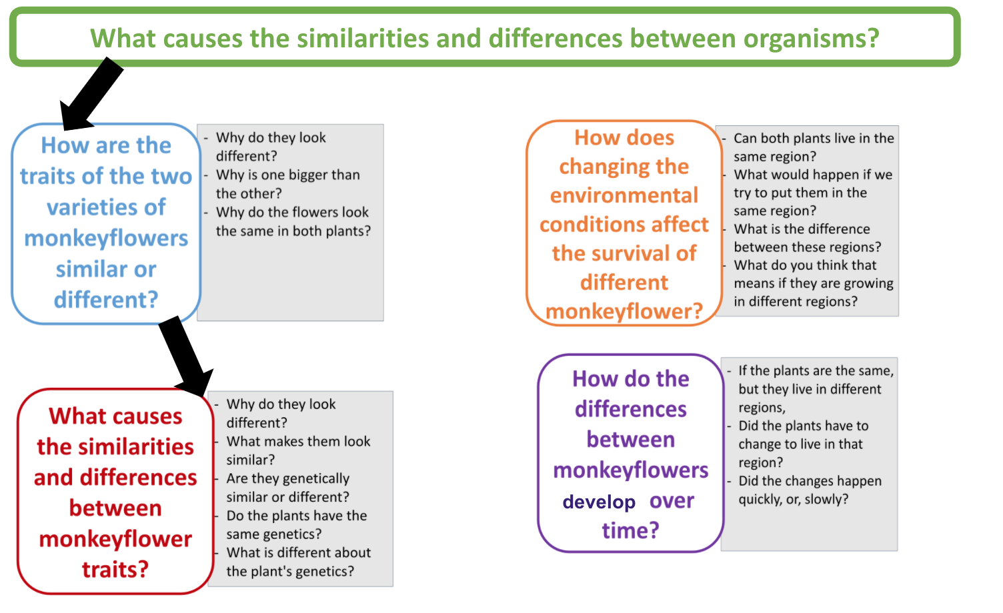

- Reiterate the purpose of the DQ Flowchart: Throughout the unit we will be revisiting and adding to the DQ Flowchart to keep track of the questions that students generated and the questions that can be answered at the end of each learning set as they figure out more.
- Revisit the DQ flowchart to look for questions from the list that the class generated that are similar to questions that Maia and William raised at the end of the comic.
- To help students figure out what causes the differences between organisms, students will specifically study the question: What causes the differences between monkeyflower traits?
- Move a set of questions under the question “What causes the differences between monkeyflower traits?” as the next step in the flowchart.

Lesson 2 - How are traits passed from parent to offspring?

Learning Goal | The students use models to explain the process of sexual reproduction in plants at micro and cellular level.
Connection to NGSS | DCI: LS3.B: Variation of Traits
 | Practice: Develop and use models
 | CCC: System and system model

1. Review prior knowledge
- Have a whole class discussion about what students know about genes using the following prompts.
  - What do you know about genes?
  - What do you know about chromosomes?
  - How do genes affect our traits?
  - How are genes that code for traits passed from parents to offspring?
- At this point, students are expected to know the following.
  - Cells build proteins using information contained in genes. Genes are found on chromosomes and each chromosome can contain hundreds, even thousands, of genes. Unique combinations of genes in each individual’s genetic code are responsible for everything in our body.

Genes on chromosomes

affects

Protein made

affects

Traits

  - Our focus in this unit is around the Monkeyflower plant. Specifically, how do you think plants reproduce and pass genetic information to offspring?

2. How do the plants reproduce? Review and engage students through a discussion around the diagram to figure out what is happening at the macro-level of flower:
- Refer back to the flower parts in the previous learning set:
  - Petals
  - Sepals
  - Stamen (male reproductive part consists of anther and filament)
    - The anther is a sac-like structure that produces and stores pollen.
    - The filament supports the anther.
  - The pistil (female reproductive part consists of stigma, style, and ovary)
    - Stigma is the topmost part of a flower.
    - The style is the long tube which connects the stigma to the ovary.
    - The ovary contains a lot of ovules. It is the part of the plant where the seed formation takes place.
- Using the worksheet, engage students in a discussion to figure out what is happening in the diagram at the macro-level of a flower. Students work in small groups to figure out what is happening and then come together to figure it out as a class.
  - The pollen reaches the stigma. Pollination is the process of transferring pollen grains from the anther, male part of a flower, to the stigma, female part of a flower. In order to form a zygote, male gametes in pollen grains have to fuse with the egg in the ovule. The pollen moves down the style and reaches the ovary of the plant and fertilizes the egg. Then, the zygote is formed (seed).
- Now we know what is happening at the macro level of the flower, but what do you think is going on at the cellular level to make reproduction happen?

3. What happens at the cellular level?
- Remind students what they have learned about the inheritance of genes.
  - How are genes transmitted from each generation?
  - What do you know about how genes are transmitted from your mom and dad?
  - At this point students are expected to know the following
    - Chromosomes come in matching sets of two (or pairs), one from each parent.
    - Genes come in pairs, too. Offsprings get ½ of genes from mom and ½ from dad.
    - One copy of a gene is called an allele and each gene has two alleles, one comes from each of your parents.
- Ask students the following questions to encourage students to start thinking about meiosis.
  - What is happening at the cellular level so that living things get ½ of their genes from each parent?
  - What does that actually mean to get ½ of your genes from each parent?
  - How can sex cells with half the original amount of genetic information be produced?
- In pairs, use pipe cleaners and beads to simulate the meiosis process. Here is the link to the meiosis worksheet. Use part 1 of the worksheet.
  - Step 1
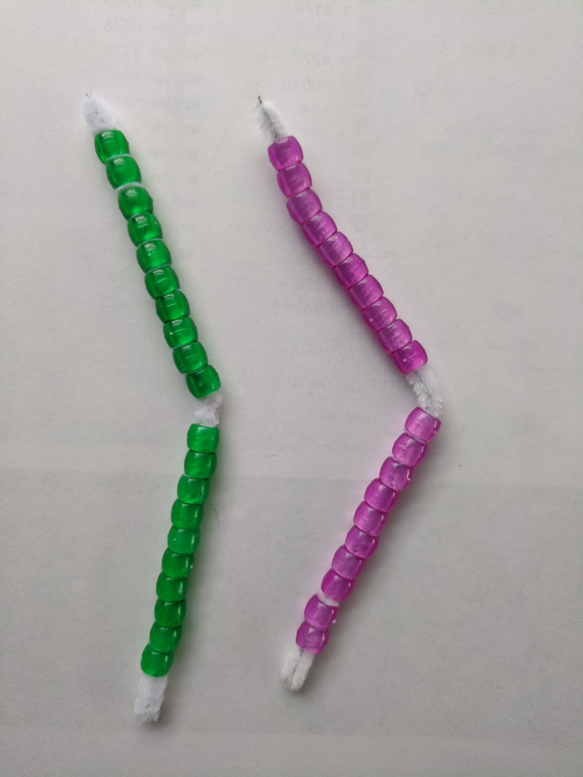

  - Step 2
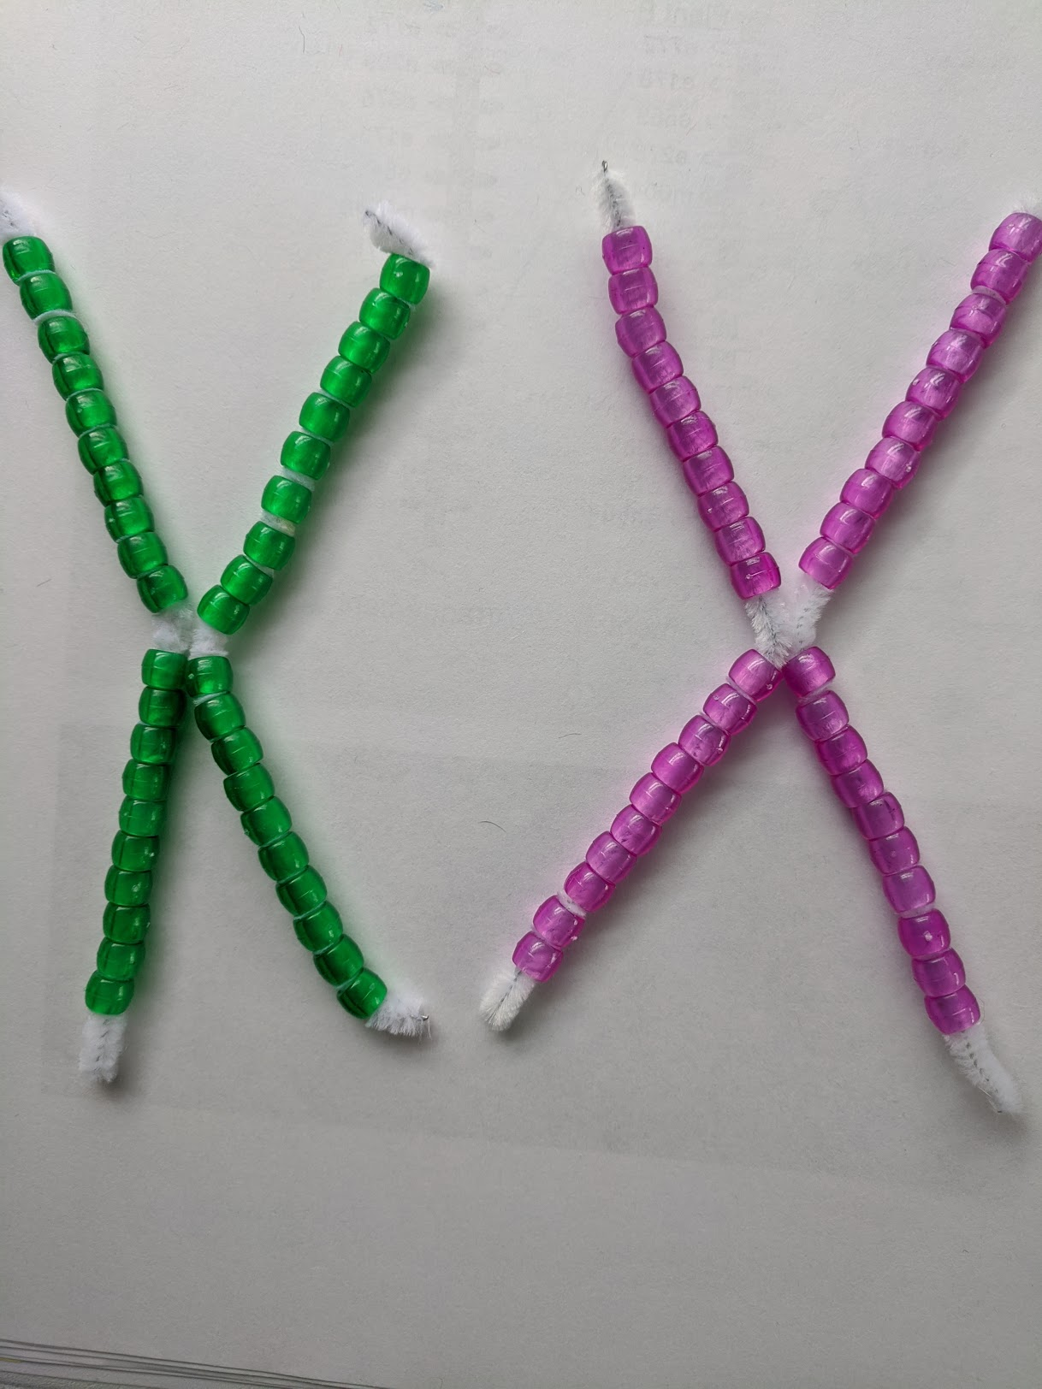
  - Step 3
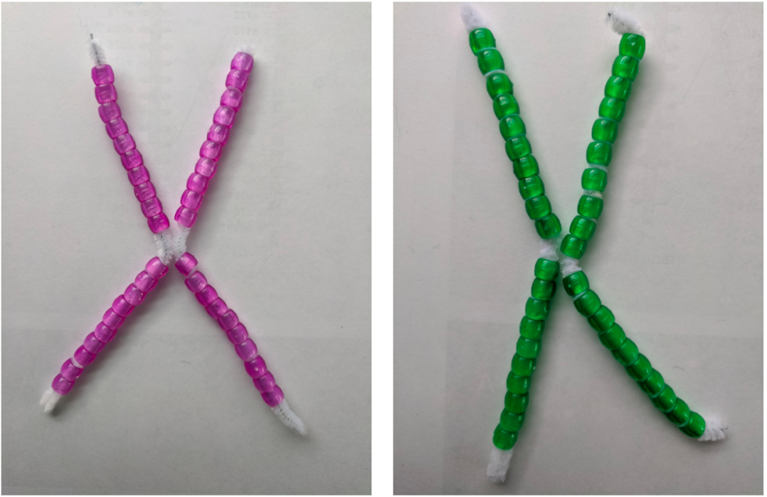
  - Step 4
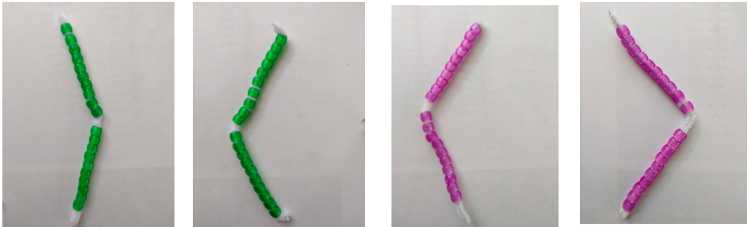

- Discussion:
  - What do beads represent? (the genes)
  - What about their colors? (the paternal and maternal origin of those beads)
  - The process starts with 1 cell, how many cells does meiosis end up with? (4 cells)
  - What does each of these cells actually contain at the end of the process? How are they different from the original cell that we started with? (½ of the genetic material)
- Extension:
  - This Meiosis activity represents meiosis with just one homologous pair of chromosomes.
  - For more practice, students could simulate meiosis with more than one homologous pair of chromosomes. In this case, students would need to use two different colors of pipe cleaners where each set of pipe cleaners would represent the different homologous chromosome pairs.
  - You would begin with something like this and then go through the meiosis process without crossing over:
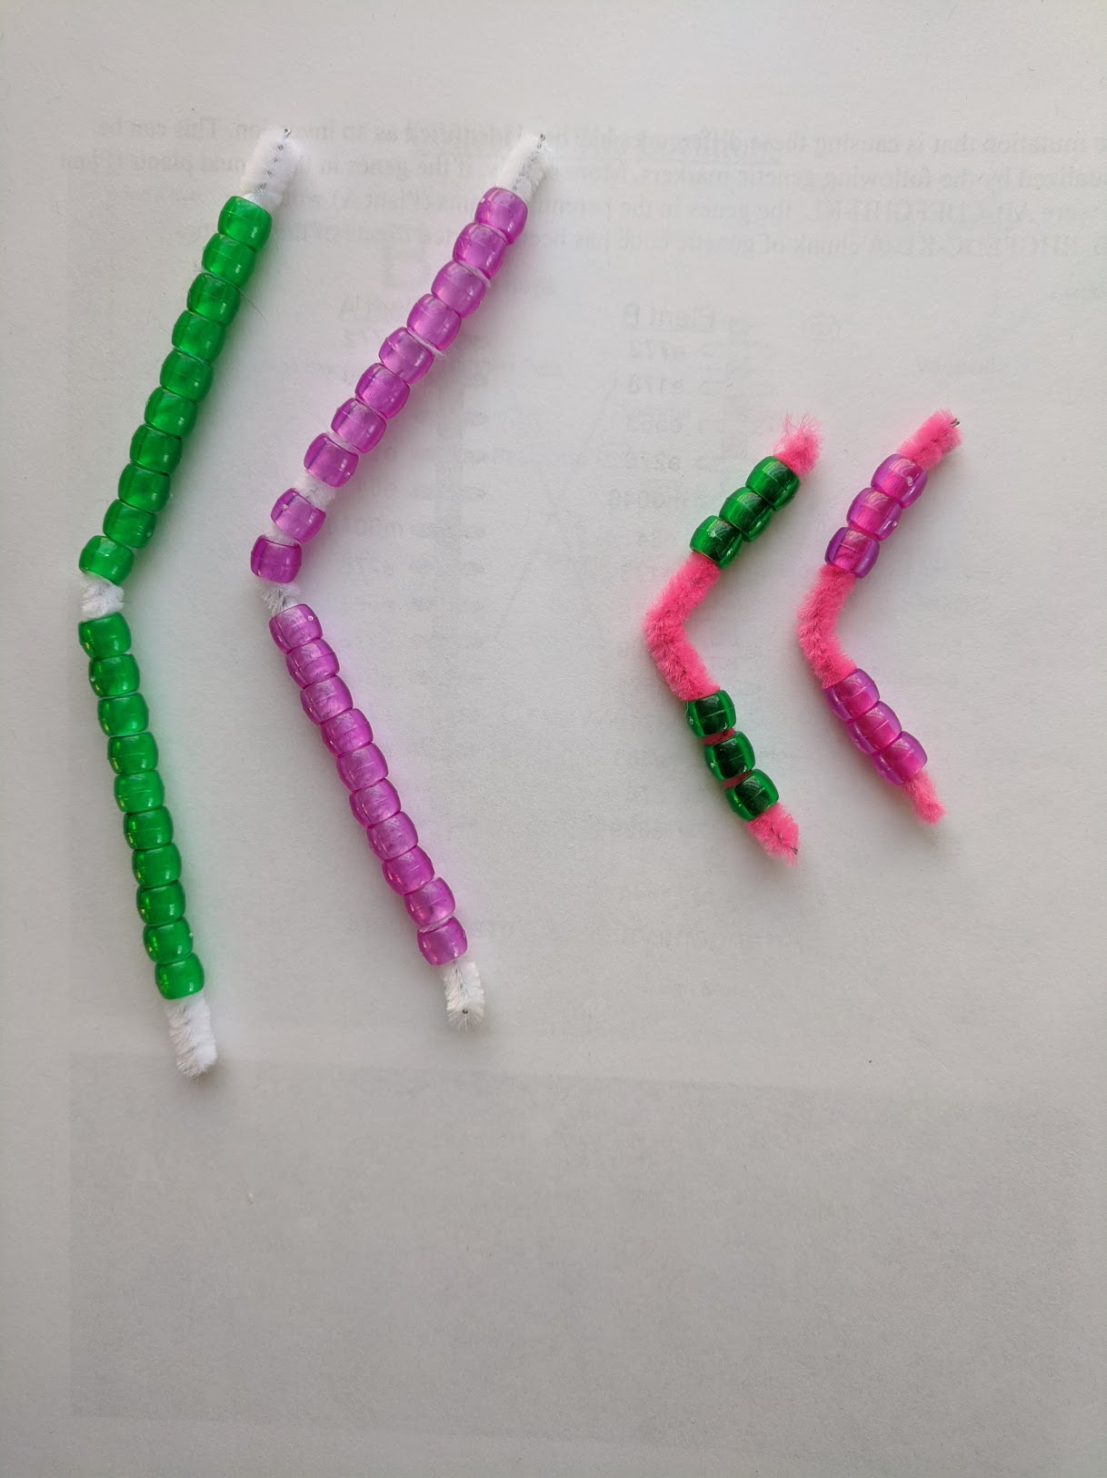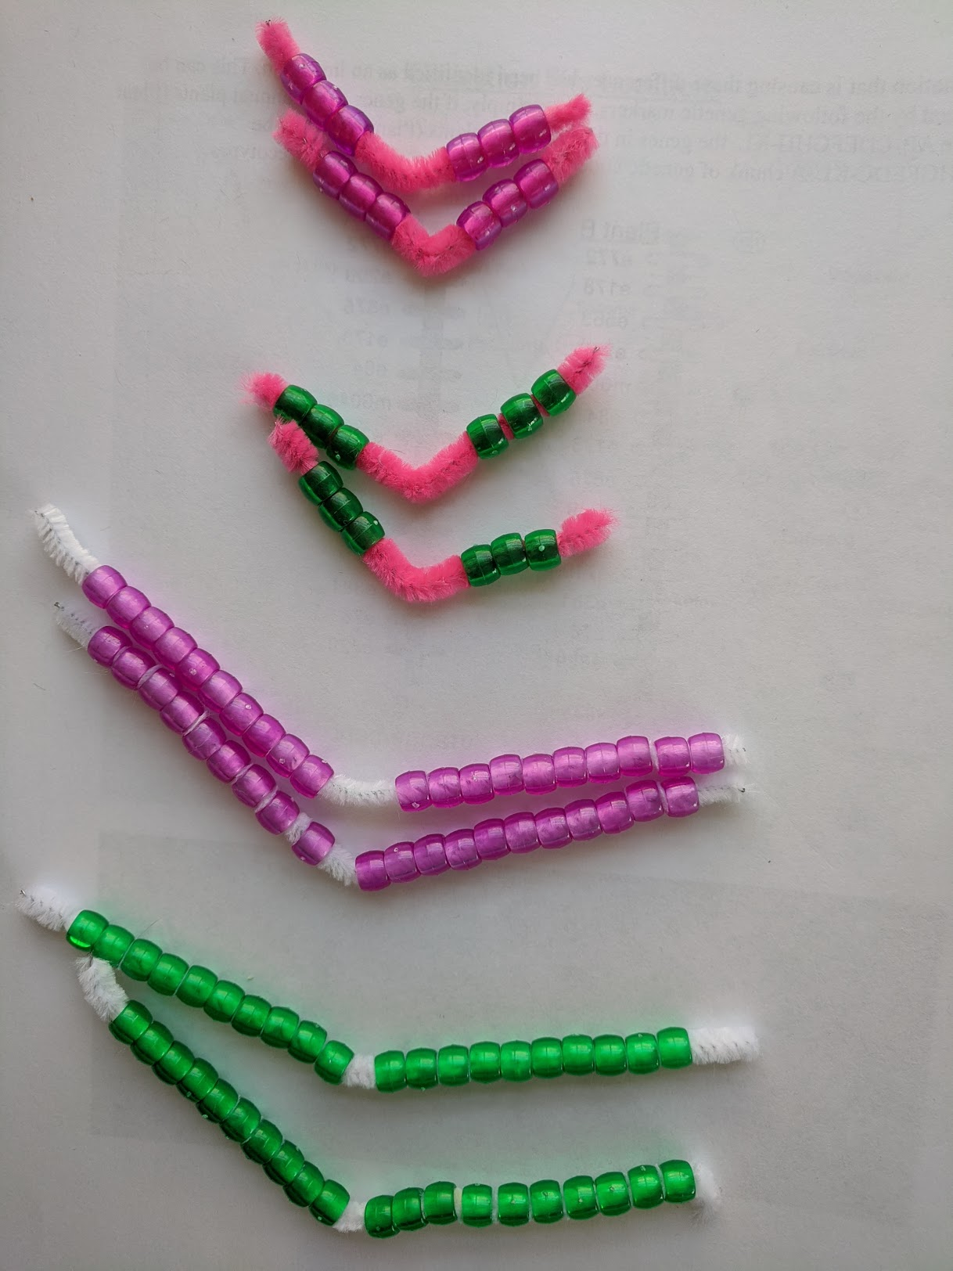
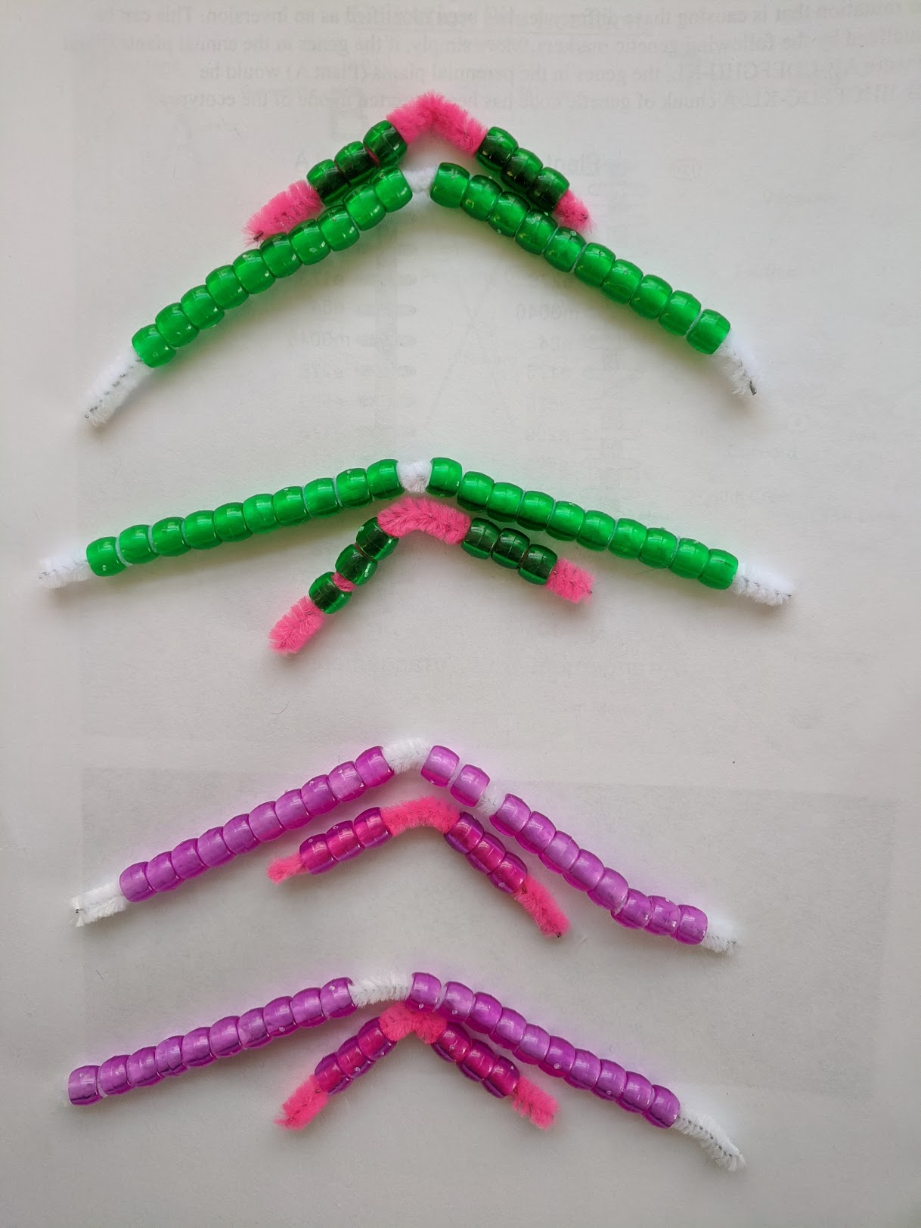(4 haploid cells would form)

4. Mendel’s story: Use the worksheet with some guiding questions for discussion embedded to introduce Mendel and his experiment.
- As students begin using the Punnett Squares, it will be good to discuss the terms “dominant” and “recessive” with them.
  - The terms “dominant” and “recessive” do not indicate superiority or inferiority. These are terms used in science to differentiate the alleles of the gene. When the dominant allele is present, in this case for flower color, it means the allele for the color purple determines the flower color.
  - Also, there are other genes and types of traits where both alleles may be expressed. Dominant/recessive is not the rule.
  - There are also other factors, such as environment that affect the expression of one allele over another.

5. Monkeyflower 3:1 Example: This is what the 3:1 ratio looks like using an example from the monkeyflower.
- Use the PPT to show the students how one monkeyflower trait also follows the 3:1 ratio.
- Link to the PPT : Monkeyflower Mendelian traits

Lesson 3 - How do monkeyflowers inherit their traits from parents?

Learning Goal | The students use models to explain the process of sexual reproduction in plants at micro and cellular level.
Connection to NGSS | DCI: LS3.B: Variation of Traits
 | Practice: Develop and use models
 | CCC: System and system model

In this lesson, students will continue figuring out the process of meiosis - this time with crossing over occurring in the monkeyflower plants. Students work in pairs or groups of 3.

1. Introduce the case of monkeyflower (Variation of color of flowers).
- Have a whole class discussion:
- Take a look at this picture, what do you notice about the flowers?
- Are there different varieties shown here?
- Thinking back to our last lesson when we talked about simple Mendelian genetics, do these varieties of monkeyflowers seem to follow the 3:1 rule?
  - Why or why not? Explain
  - Can you use what you figured out in the previous lesson to explain what is going on with the inheritance of flower color in this picture?’
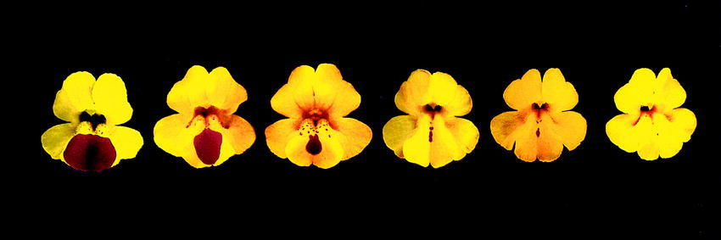
- Guide students to figure out that the 3:1 ratio does not work here, something more complicated is occurring and we need to figure out what is happening.

2. Do pipe cleaner and beads activity to simulate from Monkeyflower parents to offspring using Part 2 of the meiosis worksheet.
- Let’s look again at what we’ve learned about meiosis from the previous lesson.
- This time, go back to Step 1 of the meiosis activity and follow the same steps as in the first meiosis process only this time in Step 3, switch 1 or 2 or 3 beads on each chromatid (single chromosome strand). Remember, the number of alleles you swap must be the same on each chromatid, otherwise one chromatid would be incomplete and the corresponding chromatid would have too many.
  - Step 1

  - Step 2

  - Step 3a
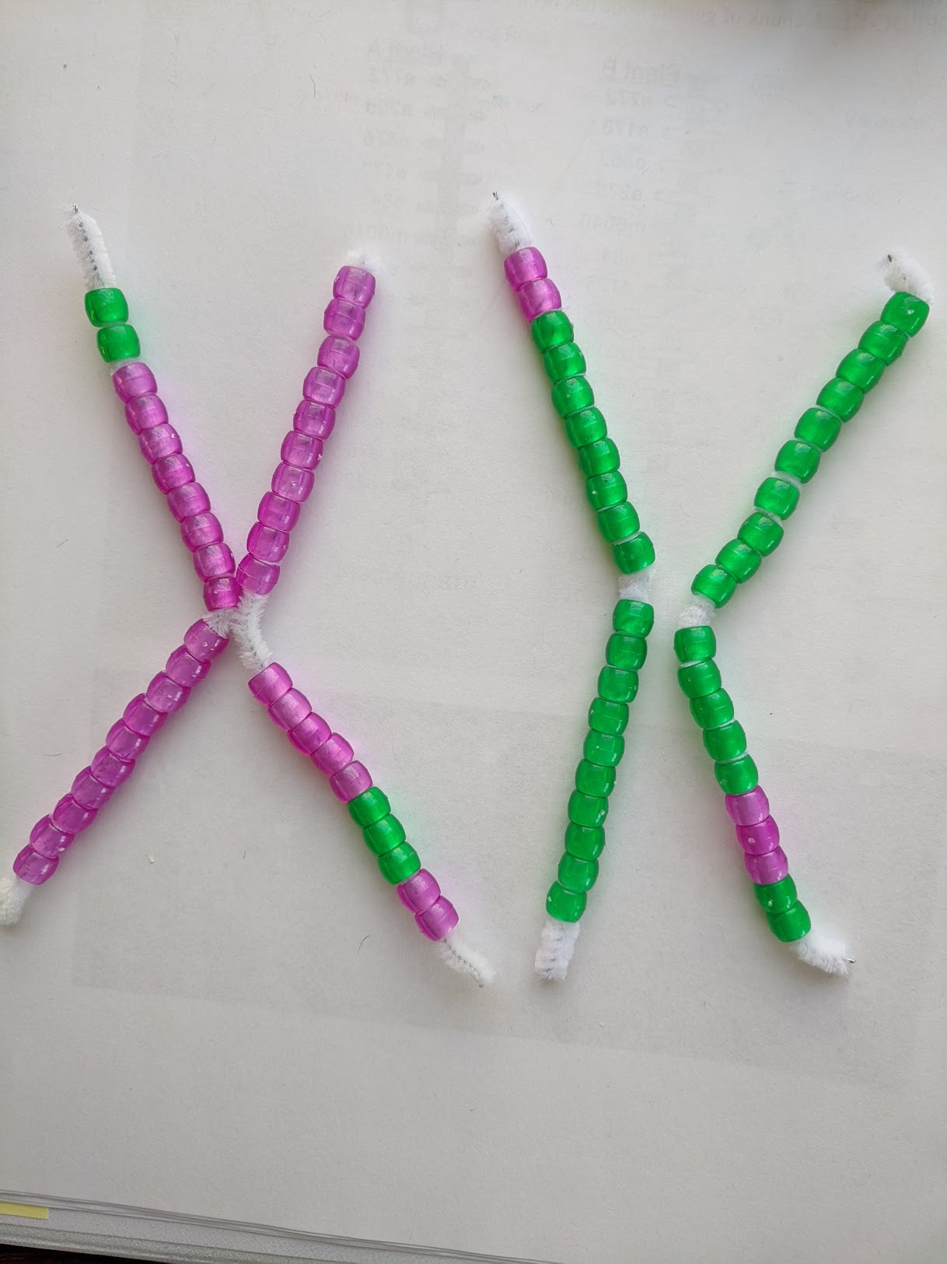

  - Step 3b
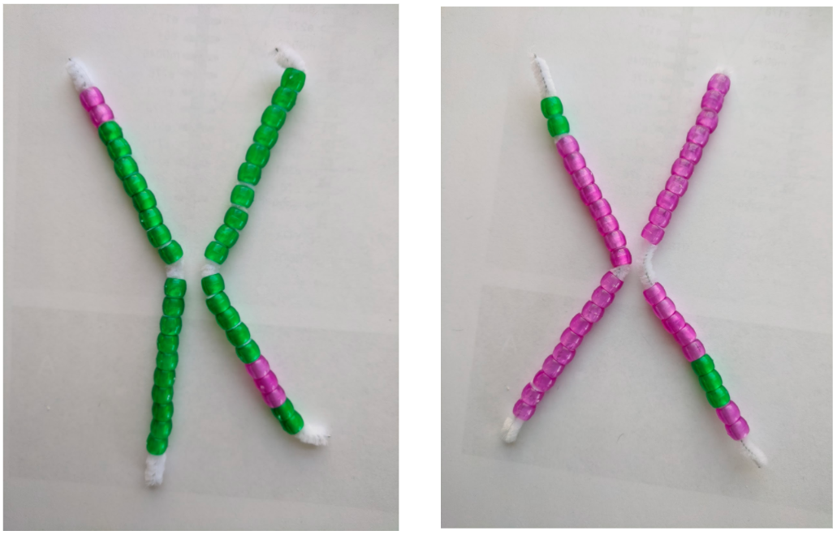

  - Step 4
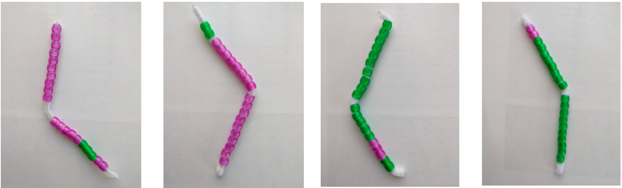

- Complete the process of meiosis like you did in the last lesson. Do your chromosomes look the same as they did in the last lesson? (no crossing over).
  - Chromosomes and chromatids now have different colors. What has happened?
  - The genetic materials have been swapped between chromosomes to create new combinations.
    - In genetics, when this happens, we call it crossing over.
    - The random separation of the chromatids from one set of chromosomes is also called independent assortment.
  - Genetic variation can be caused by recombination and independent assortment
  - How do you think crossing over and independent assortment affects what the organism looks like?
    - Will have some individuals that look different from their “siblings.”
  - What about at the population level? Why do you think it would be a good idea to have these differences in traits in a population?
    - Variation is good in a population.
- Extension:
  - This Meiosis activity represents meiosis with just one homologous pair of chromosomes.
  - For more practice, students could simulate meiosis with more than one homologous pair of chromosomes. In this case, students would need to use two different colors of pipe cleaners where each set of pipe cleaners would represent the different homologous chromosome pairs.
  - You would begin with something like this and then go through the meiosis process with crossing over:
  - 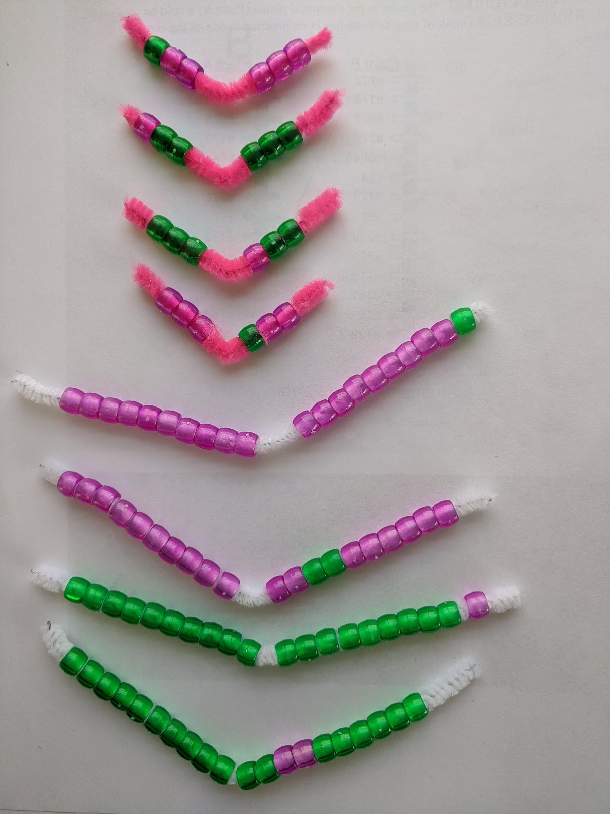
  - 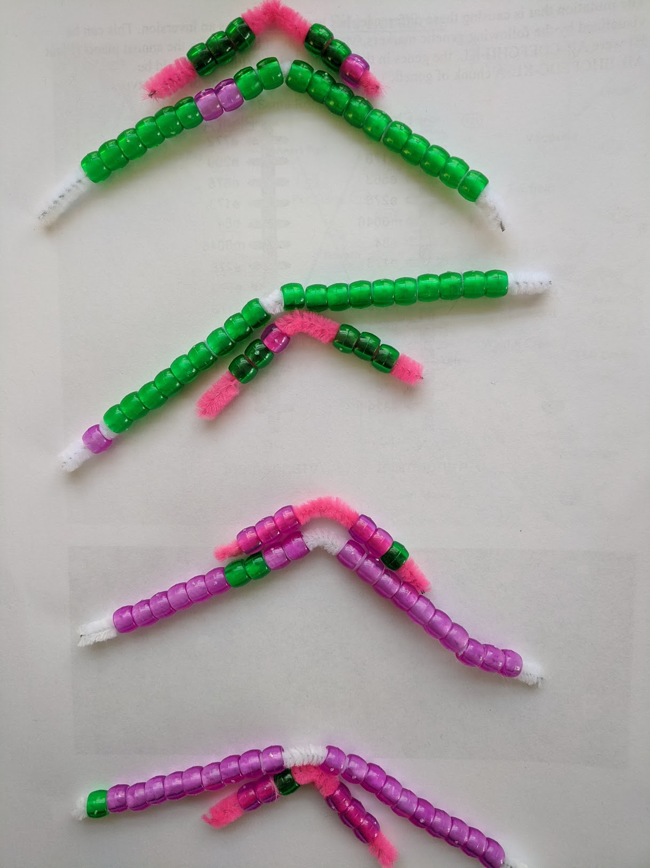(4 haploid cells would form)

5. Punnett square that includes two linked genes
- Let’s see how this kind of cross affects the probability of offspring genotype and phenotype of an organism.
- Part 1 Use the worksheet with some guiding questions for discussion

6. Part 2 Students use the worksheet to write a scientific explanation to answer the question: How do monkeyflowers inherit traits from their parents?

Lesson 4 - What is DNA and what does it look like?

Learning Goal | The students use visual representations to explain their figuring out the structure and function of DNA.
Connection to NGSS | DCI: LS1.A: Structure and Function
 | Practice: Develop and use models
 | CCC: Structure and function

1. Mystery Story Module 3: Students begin reading the next part of the mystery story. Module 3 (p.2-3 of the comic- page 1 of the PDF is blank)

The science behind the narrative | Module 3 – Let’s proceed inside the seed  - Maia brings up the concept of genes. This reading will trigger the conversation about genes and traits, and will help expose students’ prior knowledge about genetics.  - The goal of this part of the story is to spark students’ curiosity around DNA and genes, lead them to conduct the following lessons in the learning set and develop an understanding of the relationship between genes and traits.

2. What is DNA?
- DNA isolation protocol - Students extract DNA from strawberries. Follow the instructions of the strawberry DNA extraction protocol worksheet with the class, to isolate DNA from strawberries.
- Figuring out the structure of DNA
  - Link to the simulation
  - Link to the worksheet
- Summarizing the structure of DNA
  - Read Module 3 (p.4-8)
  - Use a video about DNA structure: What is a gene? https://www.youtube.com/watch?v=5MQdXjRPHmQ
- The real story of the DNA discovery
  - The contribution of Rosalind Franklin - James Watson, Francis Crick and Rosalind Franklin https://www.youtube.com/watch?v=BIP0lYrdirI
  - Have a discussion about the contribution of Rosalind Franklin
    - What did Franklin discover through her research? How did it contribute to discovering DNA?
    - How do you think we could recognize the significance of Franklin’s discovery today? Is this important? Why or why not?
    - Have you ever had an idea that was used by someone else in which you did not receive credit? How did it make you feel? What might you say if faced with that situation again?

For further reading:
Rosalind Franklin see https://www.pbs.org/wgbh/evolution/library/06/3/l_063_01.html
DNA Structure see https://www.khanacademy.org/science/biology/dna-as-the-genetic-material/dna-discovery-and-structure/a/discovery-of-the-structure-of-dna

3. What does DNA look like? : Build physical model of a piece of the monkeyflower DNA
- Each group gets different sequences of real monkeyflower DNA- some groups will get sequences of Plant A and some groups will receive sequences for Plant B
→ Link to Plant A and B sequences for each group
  - 10 groups with 5 having different Plant A sequences and 5 having different Plant B sequences
  - The sequence of 36 nucleotides (the first piece will include start codon and the final piece will include stop codon)
  - This will become more relevant once they go to Lesson 7 when they have to compare and see there are differences and similarities in the DNA of the two plants that results in different physical traits.
- Prepare 6 different color pipe cleaners 4 for nucleotides and 2 for backbone. Per group:
  - 2 pipe cleaners of each color/nucleotide cut into 6 pieces per pipe cleaner A-Blue (12 little pieces), T-Yellow (12 little pieces), C-Red (12 little pieces), G-Green (12 little pieces)
  - 10 White and 10 Black pipe cleaners for the backbone
  - Link to the instruction video https://www.youtube.com/watch?v=Knc_CSrZkcU
  - DNA strands for each group will be very long, be sure you have plenty of white and black pipe cleaners.
  - Another variation is to simply have students put their assigned DNA sequence using beads (that correspond to the nucleotide colors listed above) on the backbone pipe cleaners. This may make transcription and translation part easier for students to complete. The drawback is that students will not be able to visualize the double helix structure.

Note for teachers | This is the real DNA sequence from David Lowery’s lab in Michigan State University that the students will be using. Here, Link to Plant A and B sequences for each group the three nucleotides that work as a start codon were added intentionally in the beginning of the sequence,as well as the three nucleotides that work as a stop codon were added at the end.  >L1_GA20ox2_cds_inland  AATAATACTAATAATCTTGTCTTCGACACATCCCACATCGAAAAGCAGCCAAATCTGCCGACGCAGTTCCTATGGCCGCACGAGGATTTAGCCTCCGCCGCCGAAGAAGAACTCAAACAGCCGCCGGTAGACCTGACCGGATTCTTCGCCGGCGATTCGGAAGCAACCCTTTCGGCGGCG  >S1_GA20ox2_cds_coastal  AATGAAATTAATAATCTTGTCTTCGACACATCCCACATCGAAAAACAGCCAAATCTGCCGACGCAGTTCCTATGGCCGGACGAGGATTTAGCCTCCGCCGCCAAAGAAGAACTCAAACAGCCGCCGGTGGACCTGAACGGATTCTTCGCCGGCGATCGGGAAGCAACCCTTTCGGCGGCG

4. Whole class discussion: Together with the class, discuss the students’ answers
- What do you know about DNA?
- Where do you think DNA is located?
- Where are the genes located?
- What is the role of DNA in living organisms?
- What is the role of genes in your body?
- What is the structure of the DNA?
- What are the “building blocks” of DNA?
- What are the pairs?
- How do genes help make proteins? → This question can help make a transition to the next lesson about transcription and translation.

Teacher Version of Final Monkeyflower DNA→amino acid student investigation (DO NOT Print for students)
Students will progressively create the different pieces of their DNA→ amino acid sequence throughout Lesson 4, Lesson 5, Lesson 6 and Lesson 7
At the end, students will put together their amino acid sequences (5 for Plant A and 5 for Plant B) and compare Plant A and Plant B as a class to identify the differences. See PPT for suggested grouping of Monkeyflower DNA strands.

Have students color-code their DNA strands on their handouts- suggested as follows: A-Blue, T-Yellow, C-Red, G-Green. For RNA we suggest using a different shade of blue to represent the Uracil (U).

Plant A DNA Template is in yellow
Group 1 | TAC TTA TTA TGA TTA TTA GAA CAG AAG CTG TGT AGG GTG complimentary DNA strand  ATG AAT AAT ACT AAT AAT CTT GTC TTC GAC ACA TCC CAC  AUG AAU AAU ACU AAU AAU CUU GUC UUC GAC ACA UCC CAC (mRNA)  Met-Asn-Asn-Thr-Asn-Asn-Leu-Val-Phe-Asp-Thr-Ser-His amino acid seq  START
Group 2 | TAG CTT TTC GTC GGT TTA GAC GGC TGC GTC AAG GAT complimentary DNA strand  ATC GAA AAG CAG CCA AAT CTG CCG ACG CAG TTC CTA  AUC GAA AAG CAG CCA AAU CUG CCG ACG CAG UUC CUA (mRNA)  Ile-Glu-Lys-Gln-Pro-Asn-Leu-Pro-Thr-Gln-Phe-Leu amino acid seq
Group 3 | ACC GGC GTG CTC CTA AAT CGG AGG CGG CGG CTT CTT complimentary DNA strand  TGG CCG CAC GAG GAT TTA GCC TCC GCC GCC GAA GAA  UGG CCG CAC GAG GAU UUA GCC UCC GCC GCC GAA GAA (mRNA)  Trp-Pro-His-Glu-Asp-Leu-Ala-Ser-Ala-Ala-Glu-Glu amino acid seq
Group 4 | CTT GAG TTT GTC GGC GGC CAT CTG GAC TGG CCT AAG complimentary DNA strand  GAA CTC AAA CAG CCG CCG GTA GAC CTG ACC GGA TTC  GAA CUC AAA CAG CCG CCG GUA GAC CUG ACC GGA UUC (mRNA)  Glu-Leu-Lys-Gln-Pro-Pro-Val-Asp-Leu-Thr-Gly-Phe amino acid seq
Group 5 | AAG CGG CCG CTA AGC CTT CGT TGG GAA AGC CGC CGC ACT complimentary DNA strand  TTC GCC GGC GAT TCG GAA GCA ACC CTT TCG GCG GCG TGA  UUC GCC GGC GAU UCG GAA GCA ACC CUU UCG GCG GCG UGA (mRNA)  Phe-Ala-Gly-Asp-Ser-Glu-Ala-Thr-Leu-Ser-Ala-Ala-STOP amino acid seq

Plant B DNA Template
Group 1 | TAC TTA CTT TAA TTA TTA GAA CAG AAG CTG TGA AGG GTG complimentary DNA strand  ATG AAT GAA ATT AAT AAT CTT GTC TTC GAC ACA TCC CAC  AUG AAU GAA AUU AAU AAU CUU GUC UUC GAC ACA UCC CAC mRNA  Met-Asn-Glu-Ile-Asn-Asn-Leu-Val-Phe-Asp-Thr-Ser amino acid sequence
Group 2 | TAG CTT TTT GTC GGT TTA GAC GGC TGC GTC AAG GAT complimentary DNA strand  ATC GAA AAA CAG CCA AAT CTG CCG ACG CAG TTC CTA  AUC GAA AAA CAG CCA AAU CUG CCG ACG CAG UUC CUA mRNA  Ilc-Glu-Lys-Gln-Pro-Asn-Leu-Pro-Thr-Gln-Phe-Leu- amino acid sequence
Group 3 | ACC GGC CTG CTC CTA AAT CGG AGG CGG CGG TTT CTT complimentary DNA strand  TGG CCG GAC GAG GAT TTA GCC TCC GCC GCC AAA GAA  UGG CCG GAC GAG GAU UUA GCC UCC GCC GCC AAA GAA mRNA  Trp-Pro-Asp-Glu-Asp-Leu-Ala-Ser-Ala-Ala-Lys-Glu amino acid sequence
Group 4 | CTT GAG TTT GTC GGC GGC CAC CTG GAC TTG CCT AAG complimentary DNA strand  GAA CTC AAA CAG CCG CCG GTG GAC CTG AAC GGA TTC  GAA CUC AAA CAG CCG CCG GUG GAC CUG AAC GGA UUC mRNA  Glu-Leu-Lys-Gln-Pro-Pro-Val-Asp-Leu-Asn-Gly-Phe amino acid sequence
Group 5 | AAG CGG CCG CTA GCC CTT CGT TGG GAA AGC CGC CGC ATT complimentary DNA strand  TTC GCC GGC GAT CGG GAA GCA ACC CTT TCG GCG GCG TAA  UUC GCC GGC GAU CGG GAA GCA ACC CUU UCG GCG GCG UAA mRNA  Phe-Ala-Gly-Asp-Arg-Glu-Ala-Thr-Leu-Ser-Ala-Ala-Stop amino acid seq

Lesson 5 - How does DNA affect monkeyflower traits?

Learning Goal | The students use computer simulation to figure out how DNA can be used to make proteins.
Connection to NGSS | DCI: LS1.A: Structure and Function
 | Practice: Developing and using models
 | CCC: Structure and functions

1. Finishing Module 3: Continue and finish reading Module 3

2. Discussion: Give students time to share their thoughts about how the proteins are made from DNA based on what they figure out about DNA.
For review and to transition to the processes of Transcription and Translation,
- Where is DNA located?
- How is the genetic information embedded in DNA?
- Where should the proteins be located to function? Inside or outside the nucleus? Why do you think so?
→ How do you think the genetic information in the DNA structure is accessed in order to build proteins? How do you think the information in DNA travels out to where the proteins are made?

3. DNA to protein videos and simulations
- Briefly introduce the two central processes that make protein from DNA.
  - Transcription and translation short video
- In pairs, students work on the worksheet as they explore the following simulation to figure out transcription and translation.
  - Simulation 1 - Transcription
  - Simulation 2 - Translation

4. Applying to monkeyflower
- Each group works on the worksheet. Use their sequence of DNA of monkeyflower to simulate monkeyflower’s transcription and translation.
- Share the results with the whole class and have a discussion about the similarities and differences between plant A and plant B and discuss what it means to the monkeyflowers.

Lesson 6 – How can changes in the structure of DNA affect an organism's traits?

Learning Goal | The students use computer simulation to figure out how DNA can be used to make proteins.
Connection to NGSS | DCI: LS1.A: Structure and Function
 | Practice: Developing and using models
 | CCC: Structure and functions

- Whole class discussion:
- Who has heard of the word mutation? Most of you have probably heard the word mutation, but what does it mean? Give students time in pairs to talk over what it means. Write a class definition on the board.
- How do you think mutations happen? Give students time in pairs to talk over what they think happens. Write their ideas on the board.
- Do you think mutations are good or bad? Why? Give students time in pairs to talk. Write responses on the board.

- Have students watch the video: What is a mutation?
  - We’ve figured out the process from DNA to proteins in the last few lessons. But what happens when something in the process doesn’t go as planned?
  - https://learn.genetics.utah.edu/content/basics/mutation/
  - After watching the video, have a class discussion.
    - What is a gene mutation?
    - Why are gene mutations important to populations of living things?
    - What did you find surprising or interesting from the video

- Different kinds of mutations
  - Mutation worksheet
    - Substitution (including silent) : link to substitution simulation
    - Insertion
    - Deletion (Frameshift)

- Applying to monkeyflower : Each group works on the worksheet. Use their sequence of DNA of monkeyflower to simulate monkeyflower’s mutation. Share their results with the whole class.

Lesson 7: Mystery story - How are Plant A and Plant B genetically similar and different?

Learning Goal | The students will explain how different traits of organisms are associated with genes that code protein.
Connection to NGSS | DCI: LS1.A: Structure and Function
 | Practice: Developing and using models
 | CCC: Structure and functions

1. Have a class discussion to find out the differences.
- Have each group go back to the data recorded on the Monkeyflower worksheet.
- All groups bring their pieces of sequence together to compare plant A and B.
  - The groups with Plant A sequences combine their sequences to make one long strand of Plant A sequence.
  - The groups with Plant B sequences combine their sequences to make one long strand of Plant B sequence.
- Guide the students to generate an explanation from the evidence about the genetic similarities and differences between Plant A and Plant B.
  - Do you see evidence that certain marked genes could be associated with the differences that you see between Plant A and Plant B?
  - If so, which markers?
  - What does that imply about the cause of the differences between the plants?

Lesson 8 – Wrapping up - Revisiting the Driving Question Flowchart

Learning Goal | The student will revisit the DQ Flowchart to discuss what questions have been addressed thus far and/or adding more questions to the DQ Flowchart
Connection to NGSS | DCI: LS1.B: Growth and Development of Organisms
 | Practice: Asking questions
 | CCC: Cause and Effect

- Revisiting the Driving Question Flowchart: With the class, revisit the Driving Question Flowchart. Prompt the students to reflect upon their learning using the following prompts:
- Which questions and hypotheses on the DQ Flowchart have we addressed, and which remain open?
  - Students should attach their answers/artifacts of investigation onto the DQ Flowchart next to the questions they relate to.
- After completing the lessons in the learning set, do you have any additional questions?
  - Any new questions should be added to the board near the SDQ they relate to.
- Transition question for the next learning set
  - What else (other than genes) can cause the similarities and differences between monkeyflower traits?
  - What happens if environmental conditions change?
  - How does the change of environment affect different monkeyflowers?

Lesson 2 - How do the plants reproduce?

The picture below explains how plants reproduce. Answer the following question on each step.
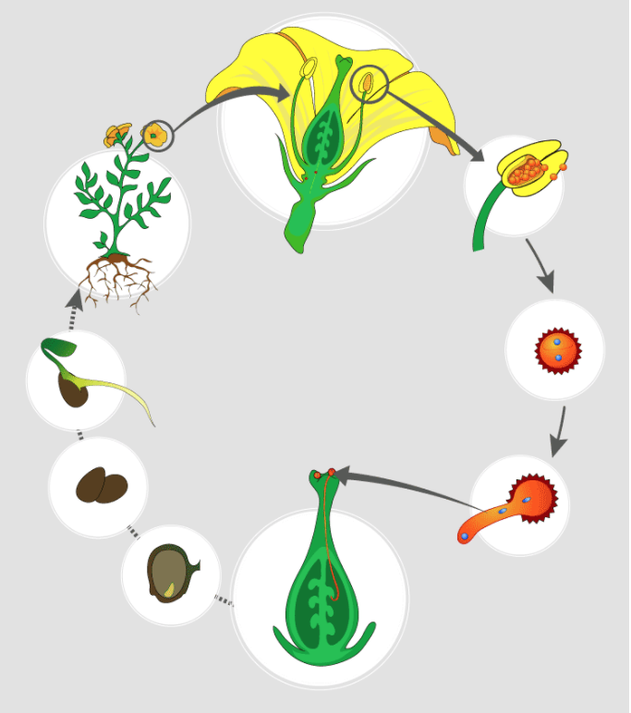
image from https://byjus.com/biology/sexual-reproduction-plants/
Step 1: What part is being identified?

Step 2-3: What is it?

Step 4-5: What is happening here?

Step 5: These steps show fertilization. What is happening here?

Step 6: What is it? What has been made as a result of fertilization?

Step 7-9: What is happening here?

Lesson 2 Meiosis
Lesson 2 & 3 - Meiosis Name:__________________________

Purpose: The purpose of this activity is to help you understand the process of meiosis both with and without crossing over by modeling the process using pipe cleaners and beads.

Materials: 2 different color sets of pony beads (40 of each color), and 2 pipe cleaners (one color)cut in ½ with scissors.

Part 1. Meiosis without crossing over

Step 1. Start from one pipe cleaner with green beads (20 beads) and the other pipe cleaner, with purple beads (20 beads). These make one homologous pair of chromosomes. (A homologous pair of chromosomes consists of one chromosome from each parent that share the same size and shape and the same genes in the same locations.)
Represent your pipe cleaners with a drawing of this step.
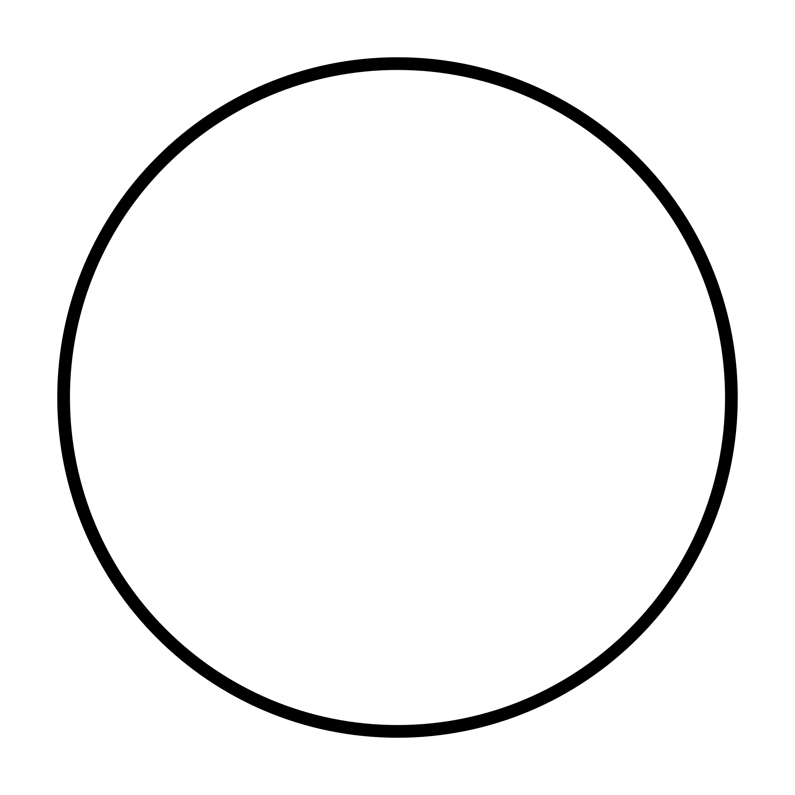

Step 2. Each strand in the pair makes a copy. Make a copy of pipe cleaner with green beads and a copy of pipe cleaner with purple beads. Connect each new pair in the middle to make X shape. Now, you will have a homologous pair of replicated chromosomes, one X shape of green and one X shape of purple.
Represent your pipe cleaners with a drawing of this step.

Step 3. The X pairs separate and form two new cells. One cell with the X shaped green chromosome and the other cell with the X shaped purple chromosome.
Represent your pipe cleaners with a drawing of this step.

Step 4. The homologous chromosome pairs (X shaped green and X shaped purple) separate. This creates the sex cells of the organism.

Question 1 . What do beads represent?

Question 2. What about their colors? What do the colors represent?

Question 3. The process starts with one cell. How many cells does meiosis end up with?

Question 4. What does each of these cells at the end actually contain? How are they different from the original cell that we started with?

Question 5. Why do you think the process of meiosis is important for organisms? What would happen if each of the sex cells did NOT contain half of the genetic material?

Lesson 2 - The story of Mendel
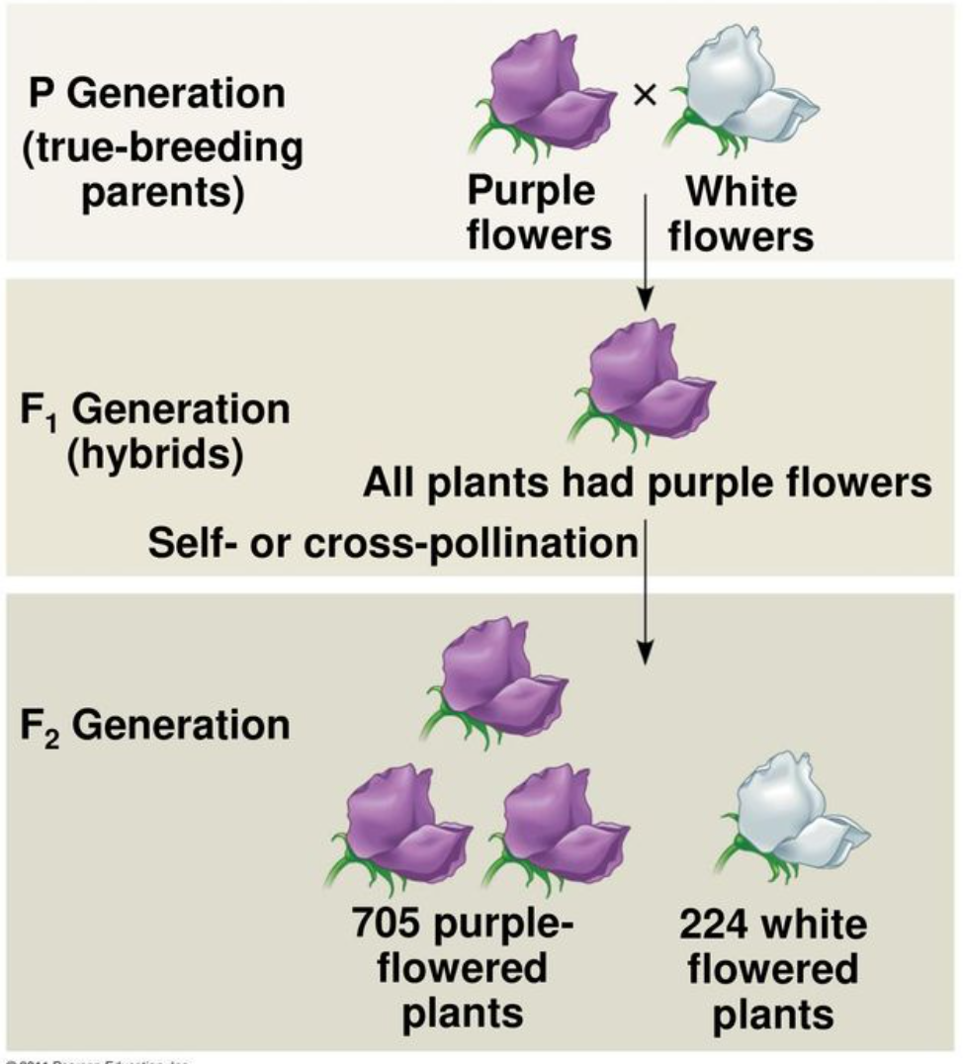
Gregor Mendel was born and grew up on his family’s farm. He worked as a gardener and studied beekeeping in his childhood. Later, he decided to be a monk and was allowed to conduct experiments about the inheritance of traits in plants in the monastery’s garden.

He chose to conduct his studies with the edible pea. He looked at seven different traits in peas, including flower color. He cross-pollinated purple and white flower parent pea plants (P). All of the plants in the 1st generation (F1) had purple flowers.

Question 1 : What do you think has happened to the characteristics of white flowers in F1?

He self-pollinated the 1st generation. He was surprised by the results. Some of the 2nd generation plants (F2) had white flowers.

Question 2: How do you think the characteristics of white flowers reappear in F2?

Question 3: Mendel realized that some of the characteristics showed up much more often. Which characteristic do you think showed up more often-purple or white flowers? Explain why using what you know about Mendel’s experiment (see figures above).
To figure out the process of inheritance of traits/characteristics, scientists came up with a method to predict how the next generation would look. Let’s use a table called a Punnett square to explain this process of inheritance.

Keep in mind:
- Scientists use letters to represent the alleles of a gene.
  - A capital letter is used to represent the “dominant” allele (P).
  - A lowercase letter is used to represent the “recessive” allele (p).
  - The terms “dominant” and “recessive” do not indicate superiority or inferiority.
  - When the “dominant” allele is present, it means that is the allele that will be expressed, for example the flower color above, purple flower color is expressed.
- Dominant/recessive is not the rule. There are other genes and types of traits where both alleles may be expressed.
- There are also other factors, such as the environment that affect the expression of the alleles.
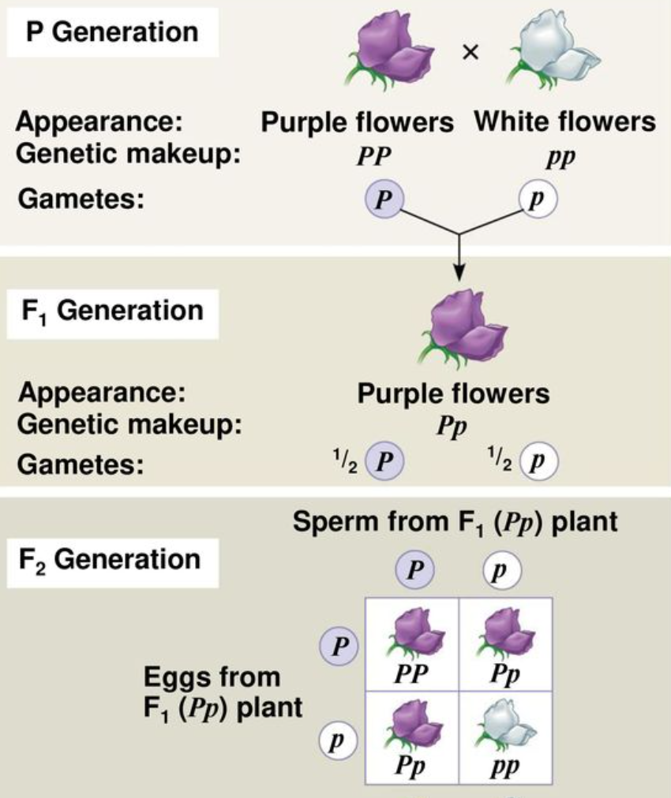
In the box on the right, the colors of the flowers (for example, purple and white) represent the outcome of those gene alleles.

In the case of the flowers on the right, the gene for flower color has two alleles, P and p. When a flower pollinates, the resulting zygote receives ½ of the genes from the male (pollen) and ½ from the female (pistil).

Question 4: Can you predict what percentage of offspring will have purple flowers? What percentage will have white flowers?

Percent of purple plants:

Percent of white plants:

Lesson 3 Meiosis Part 2
Part 2 - Meiosis with crossing over
Do all organisms look exactly the same? Why or why not? How do organisms look similar but different at the same time? Let’s explore these questions. Use the pipe cleaners and beads from Part 1 of the Meiosis Without Crossing Over Worksheet.

Step 1. Start from one pipe cleaner with green beads and another pipe cleaner with purple beads. These make one homologous pair of chromosomes. (A homologous pair of chromosomes consists of one chromatid from each parent that share the same size and shape and the same genes in the same locations.)
Represent your pipe cleaners with a drawing of this step.

Step 2. Each strand in the pair makes a copy. Make a copy of pipe cleaner with green beads and a copy of pipe cleaner with purple beads. Connect each new pair in the middle to make X shape. Now, you will have a homologous pair of replicated chromosomes, one X shape of green and one X shape of purple.
Represent your pipe cleaners with a drawing of this step.

Step 3a. Switch 3 of the green beads with three of the purple beads. This switch of beads needs to be at the same location between the two chromatids. Represent your pipe cleaners with a drawing of this step.

Step 3b. The new X-shaped chromosome pair (with mixed color) separate and form two new cells.
Represent your pipe cleaners with a drawing of this step.

Step 4. The homologous chromosome pairs (X shaped) separate, this creates the sex cells of the organism.
Represent your pipe cleaners with a drawing of this step.
Question 1. What did you do differently in this process of meiosis that was different from the first model in Part 1?

Question 2. What does it represent in the process of meiosis?
Question 3. How do the cells at the end of this model differ from the cells at the end of the model in Part 1?
Question 4. In the real world, how would this exchange of “beads” affect the organism?
Question 5. Explain how organisms can look similar but different at the same time using your models.

Lesson 3 How do monkeyflowers inherit their traits from parents?

Part 1- Punnett Square with 2 linked genes

Remember from the last lesson: In the case of the pea flowers, the gene for flower color has two alleles, P and p. When a flower pollinates, the resulting zygote receives ½ of the genes from the male (pollen) and ½ from the female (pistil).

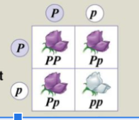

What if we knew that the shape of the pea (round (R)or wrinkled (r)) were independent alleles (the genes are located on different chromosomes). If that is the case, the offspring of a heterozygous organism has an equal chance of inheriting the dominant or recessive allele.

For example, if you again look at Mendel’s peas and cross two heterozygous parents for flower color and pea shape, how would we go about making that cross to figure out the genotype and phenotype of the offspring?

How do we use the Punnett Square method to cross two plants that are heterozygous for both alleles?

What is the genotype of the parents?
Parent Plant 1 ________________________ X Parent Plant 2 _______________________

What is the phenotype of the parents?
Parent Plant 1 ________________________ X Parent Plant 2 _______________________

To find the expected outcomes for crossing two heterozygotes for two independent traits, you can make a sixteen box Punnett square. Each parent has four different combinations that can be passed on that will be positioned along the top and side of the square.

Fill in the Genotype of the parents to figure out the genotype of the offspring
Parents→
↓Genotypes

How many offspring would have purple flowers with round seeds?

How many offspring would have purple flowers and wrinkled seeds?

How many offspring would have white flowers with round seeds?

How many offspring would have white flowers with wrinkled seeds?

OR
You can also skip the larger Punnett square and use math to find the combined probability of each allele. Create a Punnett Square for each allele and then multiply the chance of each trait occurring to get the probability that both traits appear together in the offspring.

The first Punnett Square with the alleles for flower color would look like:

Probability of Purple flower (P__) = ______________________

Probability of White flower (pp)= _______________________

The second Punnett Square with the alleles for seed shape would look like:

Probability of Round seeds (R__) = ______________________

Probability of Smooth seeds (rr)= ______________________

Next: To figure out the probability of the two alleles, you need multiply the probability of each possible combination between the two Punnett Squares:

Purple flower/Round seed= ____X____=

Purple flower/Wrinkled seed= ____X____=

White flower/Round seed= ____X____=

White flower/Wrinkled seed= ____X____=

Finally, the overall ratio would be: ____: ____: ____: ____

Part 2- Students write a scientific explanation to answer the question: How do monkeyflowers inherit traits from their parents?

Using what you already know about genetics and inheritance, along with what you have learned so far in this Learning Set, write a scientific explanation that answers the question: How do monkeyflowers inherit traits from their parents?

Claim
Evidence
Reasoning

Lesson 4 Strawberry DNA Extraction
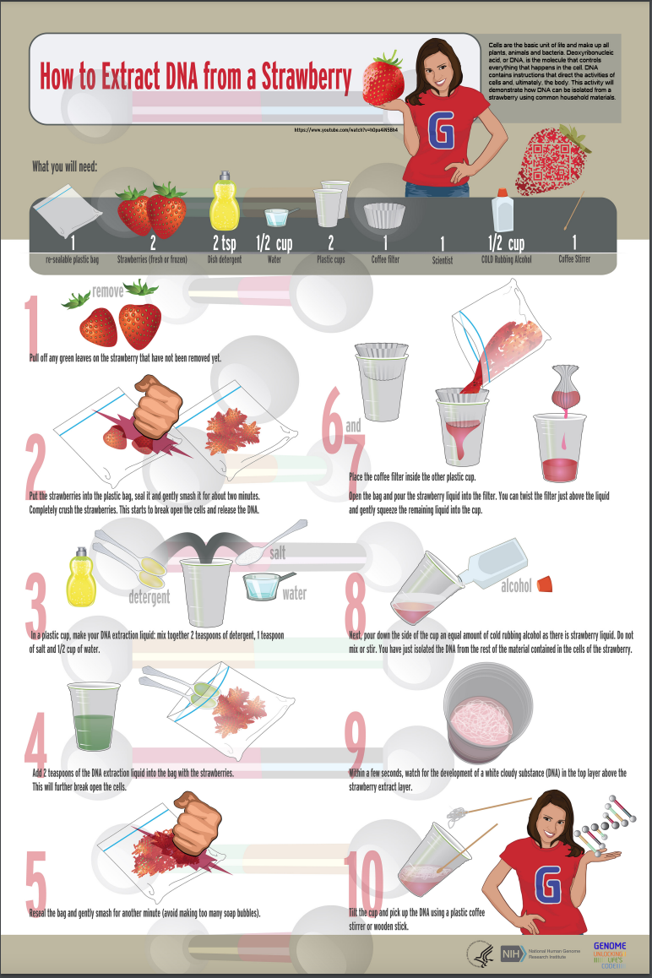

Lesson 4 - What does DNA look like?
https://lab.concord.org/embeddable.html#interactives/itsi/protein-structure/jsmol-dna.json

Part 1 : Start with “Show DNA as ladder” / “Show strand 1” / “Color by chain” as shown below. To explore the strand more closely, click and drag on the strand to move it around and zoom in or out to make the figure smaller or bigger.
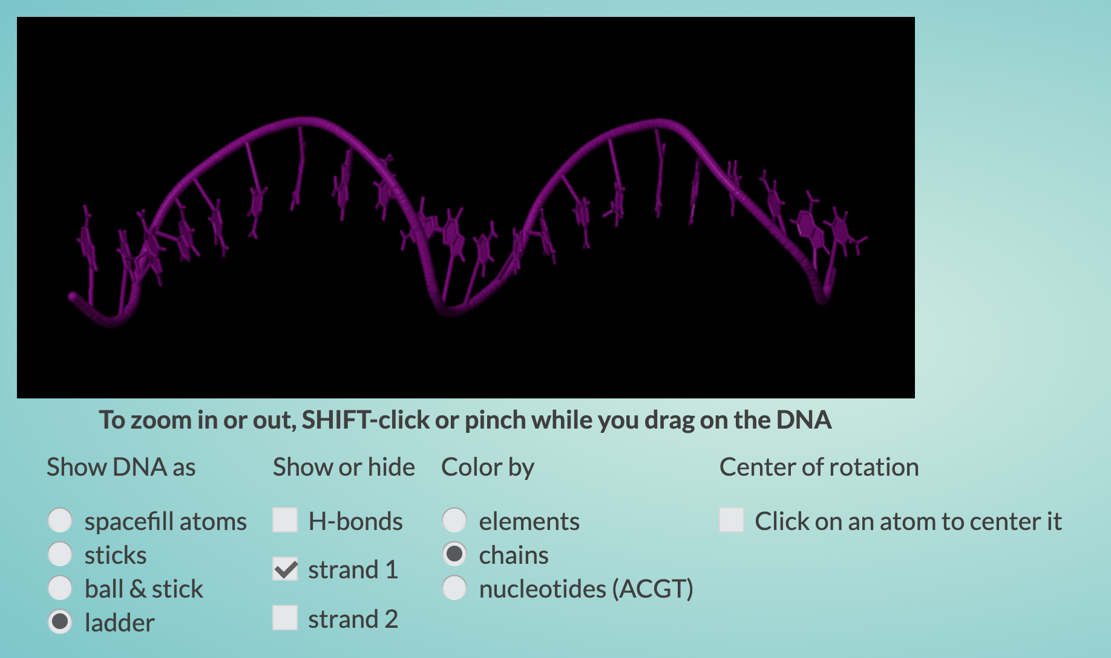

- Add the second strand by clicking on strand 2 to see what happens.
- Which do you think would be more stable, one or two strands? Explain why. Think about a real life ladder, is it more or less stable with one side and just half rungs?

Part 2. Start with “Show DNA as ladder” / “Show strand 1” / “Color by nucleotides” as shown below. To explore the strand more closely, click and drag on the strand to move it around and zoom in or out to make the figure smaller or bigger.
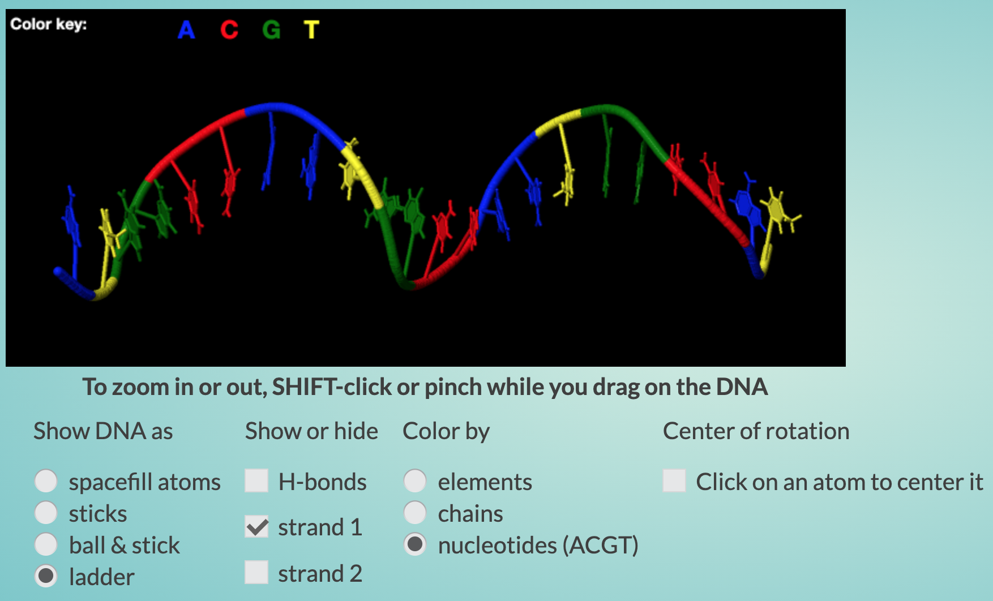

- What do you notice?

- Add the second strand by clicking on strand 2 to see what happens.
- What do you notice about the pairing of two strands? What colors seem to go together?

- The colors represent nucleotides. In DNA, there are 4 nucleotides that make up all living organisms’ DNA. Each letter represents one nucleotide. Their names are:

A= Adenine T= Thymine C= Cytosine G= Guanine

A DNA nucleotide from one strand pairs with a specific nucleotide on the other strand. These nucleotides attract, or bond, in a certain way. From your model, use the color key in the top left corner to figure out which nucleotides attract one another?

Lesson 4 - Real monkeyflower DNA sequence

Each group will work on a different portion of one segment of monkeyflower DNA. Each group will have a portion of either Plant A or Plant B. Once you have been assigned a segment of DNA from either Plant A or Plant B, you need to work with your group to build a physical model of a piece of the monkeyflower DNA. Keep this sequence handy, you will revisit these sequences in Lesson 7.
To learn how to do this:
- This is one strand of the double stranded DNA helix; your group will use your assigned piece to create the matching strand.
- Prepare 6 different color pipe cleaners 4 for nucleotides and 2 for backbone
  - A-Blue, T-Yellow, C-Red, G-Green
  - Link to the instruction video https://www.youtube.com/watch?v=Knc_CSrZkcU

Plant A DNA Template
Group 1 | ATGAATAATACTAATAATCTTGTCTTCGACACATCCCAC
Group 2 | ATCGAAAAGCAGCCAAATCTGCCGACGCAGTTCCTA
Group 3 | TGGCCGCACGAGGATTTAGCCTCCGCCGCCGAAGAA
Group 4 | GAACTCAAACAGCCGCCGGTAGACCTGACCGGATTC
Group 5 | TTCGCCGGCGATTCGGAAGCAACCCTTTCGGCGGCGTGA

Plant B DNA Template
Group 1 | ATGAATGAAATTAATAATCTTGTCTTCGACACATCCCAC
Group 2 | ATCGAAAAACAGCCAAATCTGCCGACGCAGTTCCTA
Group 3 | TGGCCGGACGAGGATTTAGCCTCCGCCGCCAAAGAA
Group 4 | GAACTCAAACAGCCGCCGGTGGACCTGAACGGATTC
Group 5 | TTCGCCGGCGATCGGGAAGCAACCCTTTCGGCGGCGTAA

Lesson 5 - How are proteins made from DNA?
https://lab.concord.org/embeddable.html#interactives/sam/DNA-to-proteins/2-modeling-transcription.json

Part 1. DNA to mRNA: Transcription

DNA is found in the nucleus, but the proteins, made from the information in DNA, are built outside the nucleus. How does the information in DNA travel out to where the proteins are made? It is carried by an RNA copy of the DNA gene. This "messenger" RNA (mRNA) is made in a process called transcription.

In the simulation, you can see DNA. When DNA is copied into RNA, one strand serves as a template for the mRNA copy to be made. In the model, the bottom strand is always the template strand. Here is the link to the simulation : https://lab.concord.org/embeddable.html#interactives/sam/DNA-to-proteins/2-modeling-transcription.json
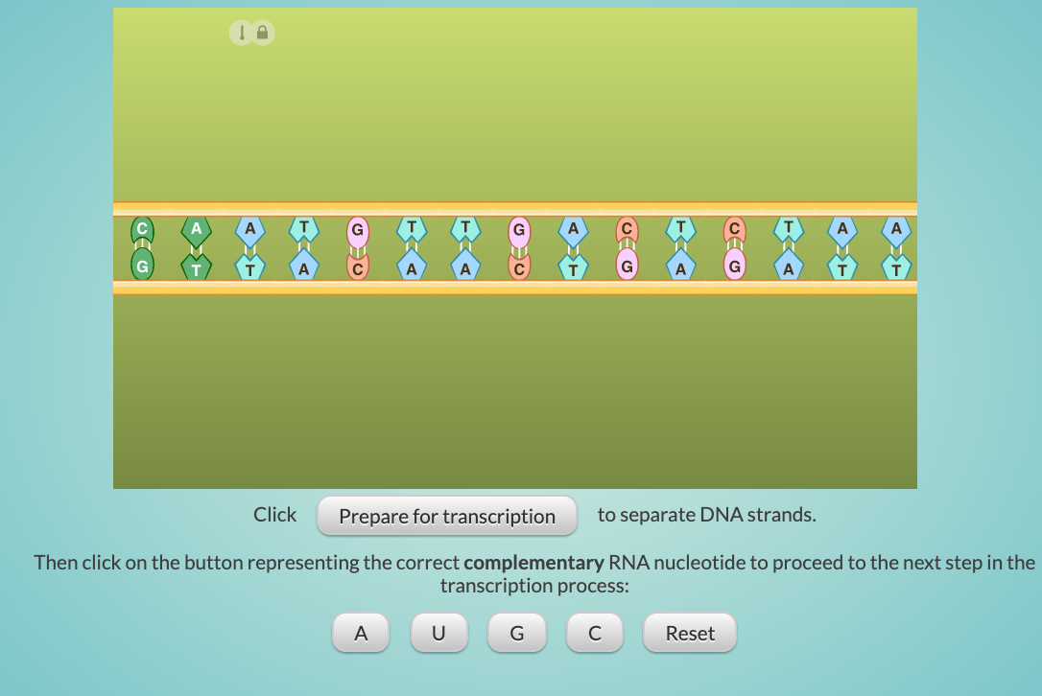

1. Click "Prepare for transcription" to begin. Describe what is happening when you click the “Prepare for transcription” button.

2. Click on the button representing the correct matching RNA nucleotide using what you know about DNA nucleotide pairing.

Identify the pattern of RNA nucleotide pairing with each DNA nucleotide that you figured out from the simulation. What is different about the way mRNA pairs compared to the nucleotide pairing in DNA? Describe.

In transcribing RNA, you should have noticed that the Thymine nucleotide (T) was replaced with a “U” or Uracil as the matching nucleotide to adenine (A).

Part 2. mRNA to protein: Translation
https://lab.concord.org/embeddable.html#interactives/sam/DNA-to-proteins/3-modeling-translation.json

At this point in the transcription process, the work of DNA is done and the ladder closes up. The work inside the nucleus is finished and the rest of the process needs to move outside of the nucleus.
The linked chain of amino acids is the basic structure of a protein. This process of building a protein is called translation. Here is the link to the simulation of translation: https://lab.concord.org/embeddable.html#interactives/sam/DNA-to-proteins/3-modeling-translation-2.json
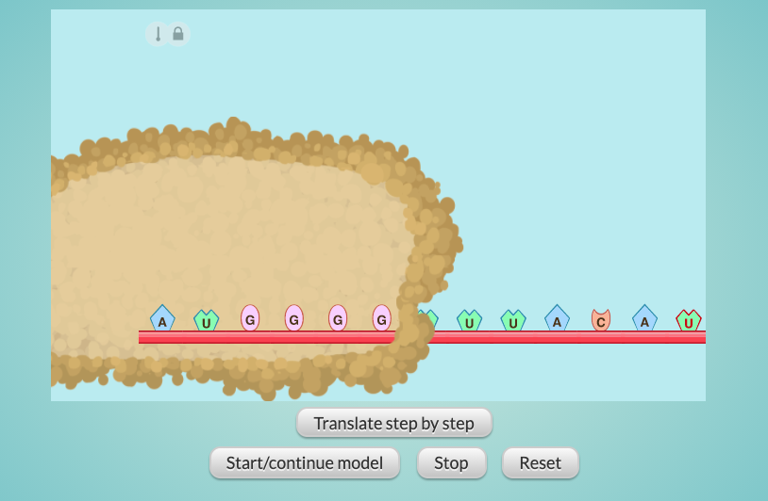

Let’s explore each step as the RNA is translated. Click the "Translate step by step" button once.

1. After clicking the button once, what did you notice was happening? What do you see besides the RNA strand? Describe it.

2. Continue clicking the step-by-step translation button. What is happening?

When the mRNA leaves the nucleus, it docks with a large molecular machine called a ribosome. The ribosome detects the sequence of nucleotides of the mRNA, and uses that information, along with a special type of RNA called transfer RNA (tRNA), to link together a sequence of amino acids. The job of transfer RNA (tRNA) is to carry amino acids to the ribosome. A group of three nucleotides codes for one amino acid.

3. Notice the last three mRNA nucleotides seemed to be left alone. What do you think is the function of the final three nucleotides (in red) in the mRNA of this model?

These groups of three mRNA nucleotides are called codons. There is one tRNA for each amino acid codon. Nucleotides at the base of each tRNA molecule pair up with codons on the mRNA to bring the correct amino acid to the protein sequence.

The following model explains how DNA affects traits of organisms.

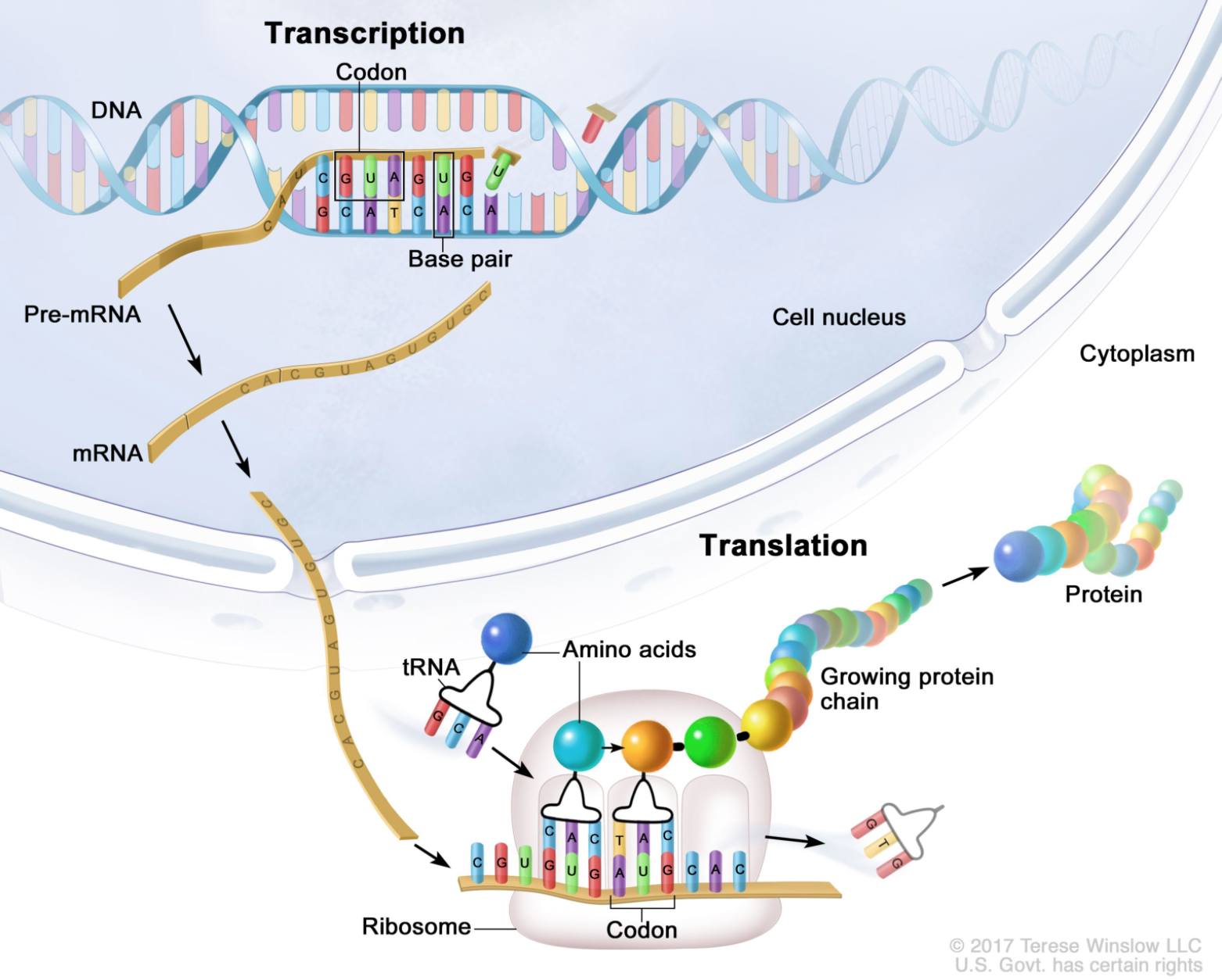
https://nci-media.cancer.gov/pdq/media/images/761782.jpg
Lesson 6 - How can changes in the structure of DNA affect an organism's traits?

Part 1- What happens when an amino acid changes to another?
Here is the link to the simulation we will use for this lesson: https://lab.concord.org/embeddable.html#interactives/sam/DNA-to-proteins/4-mutations.json
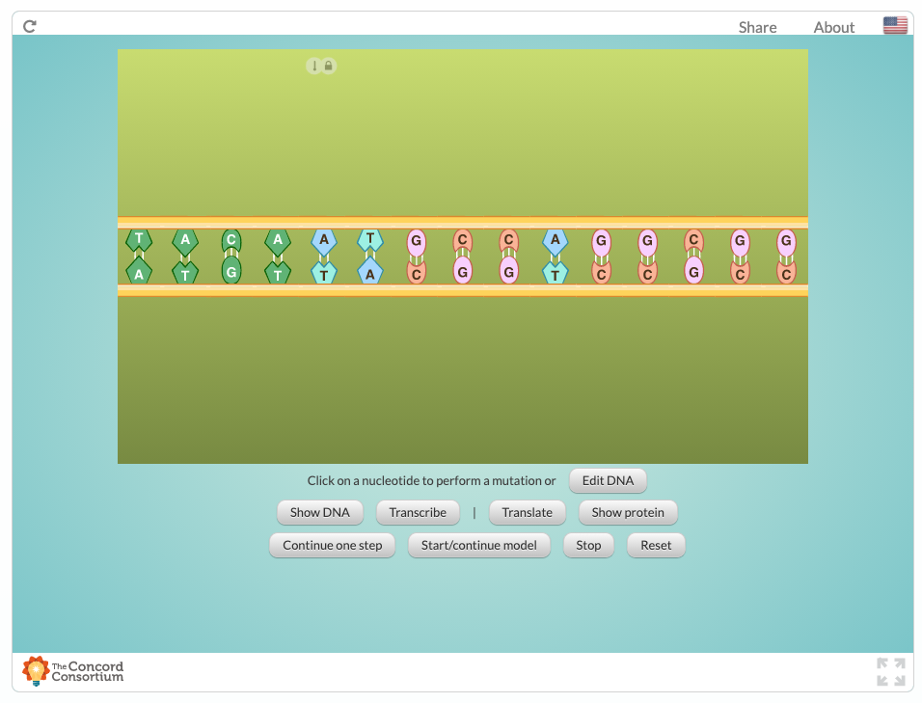
In this exercise, you will make a mutation that REPLACE ONE DNA nucleotide for another. The figure below shows the protein made from the original DNA sequence.
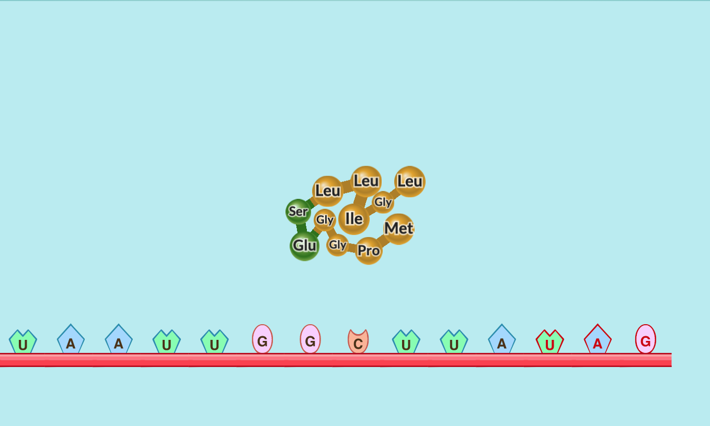

Challenge 1- Make changes to the second codon DNA sequence (CCA→ CAA) see what difference this makes to the amino acid (Pro→ Gln)

Challenge 2- Again, make changes to the second codon DNA sequence (CCA→ CCC) see what difference this makes to the amino acid (no change in AA)

1. What happens when you change the second codon DNA sequence from CCA to CAA?

2. What happens when you change the second codon DNA sequence from CCA to CCC?

3. Do you think mutations always result in a change in the protein? Explain why using the result from challenge 1 and 2 as evidence.

4. Look at the amino acid box below and explain why these changes in nucleotides could, but do not always, cause a change in the amino acid.

A silent mutation is a change from one codon to another that codes for the exact same amino acid. It has no effect on the amino acid sequence of the resulting protein.
For example: UUA could mutate to UUG but the three-letter codon still codes for the amino acid leucine

Amino Acid Box (mRNA codons)
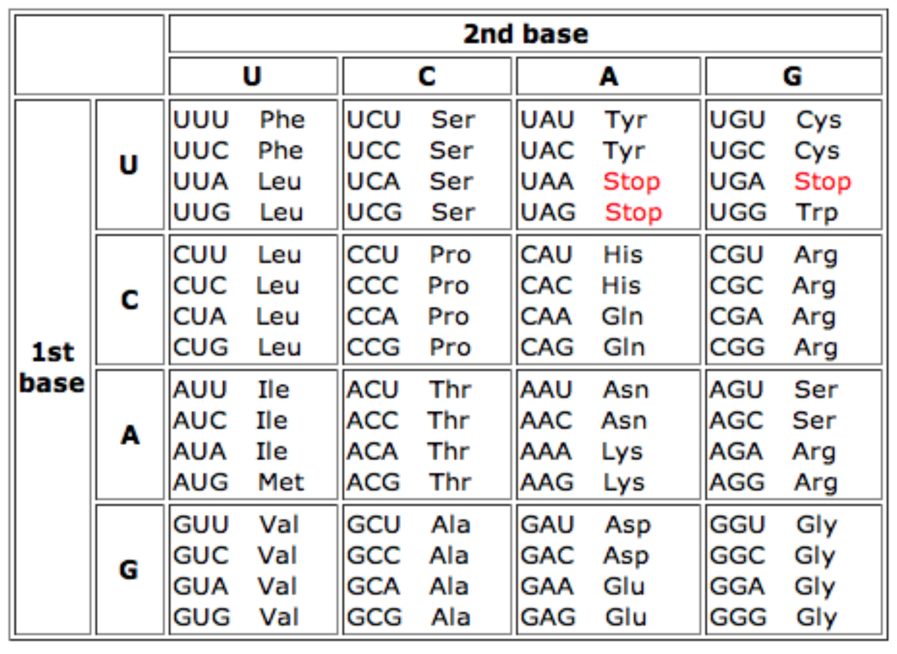

Part 2- Insertions and Deletions
Some nucleotide changes result from insertions and deletions.
What do you think an insertion refers to? How do you think it will affect protein building and/or its function?

What do you think a deletion refers to? How do you think it will affect protein building and/or its function?

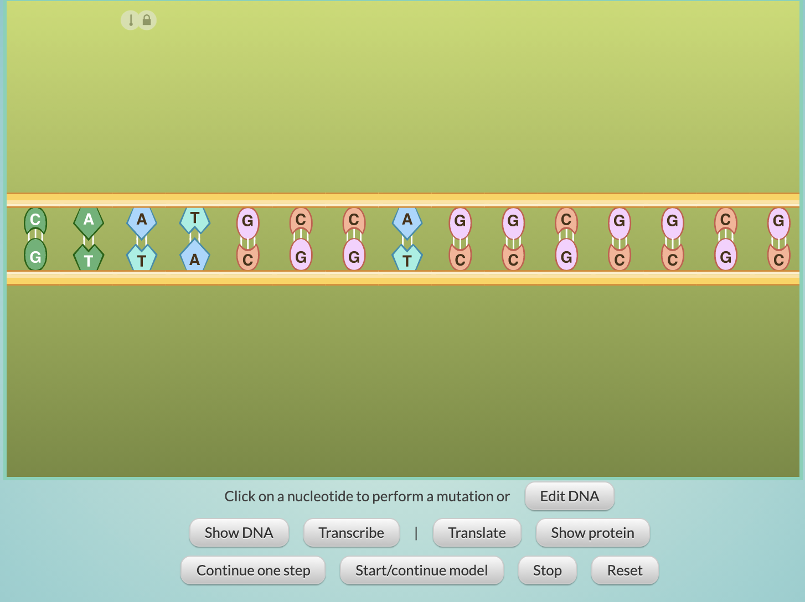

https://lab.concord.org/embeddable.html#interactives/sam/DNA-to-proteins/4-mutations.json

Challenge 1: Use the simulation again, this time click on the edit DNA button and make an insertion somewhere in the first half of the DNA sequence. Synthesize the mutated protein and locate the difference(s) compared to the unmutated protein. What are the differences?

Challenge 2: Use the simulation again, this time click on the edit DNA button and make a deletion somewhere in the first half of the DNA sequence. Synthesize the mutated protein and locate the difference(s) compared to the unmutated protein. What are the differences?

Challenge 3: Which kind of mutation (substitution, deletion or insertion) do you think causes the most change in a protein? Why?

Part 3 - Overview

Errors in the DNA replication process can cause mutations. Changes or damage to DNA can also be caused by radiation or certain chemicals. Although the term “mutation” may seem like a bad thing, mutations can actually be important to living things. Mutations can create variation among individuals that result in differences in traits that can impact survival and reproduction. These variations are most likely caused by mutations during the replication process. However, some errors in the DNA replication process have no effect at all.

What are the different types of mutations?
When one nucleotide is replaced with another, it is called a substitution mutation.
For example, changing ATCG to ATAG.
When a nucleotide is added into the sequence, it is called an insertion mutation.
For example, changing ATCG to ATGCG.
When a nucleotide is lost from the DNA sequence, it is called a deletion mutation.
For example, changing ATCG to ACG.
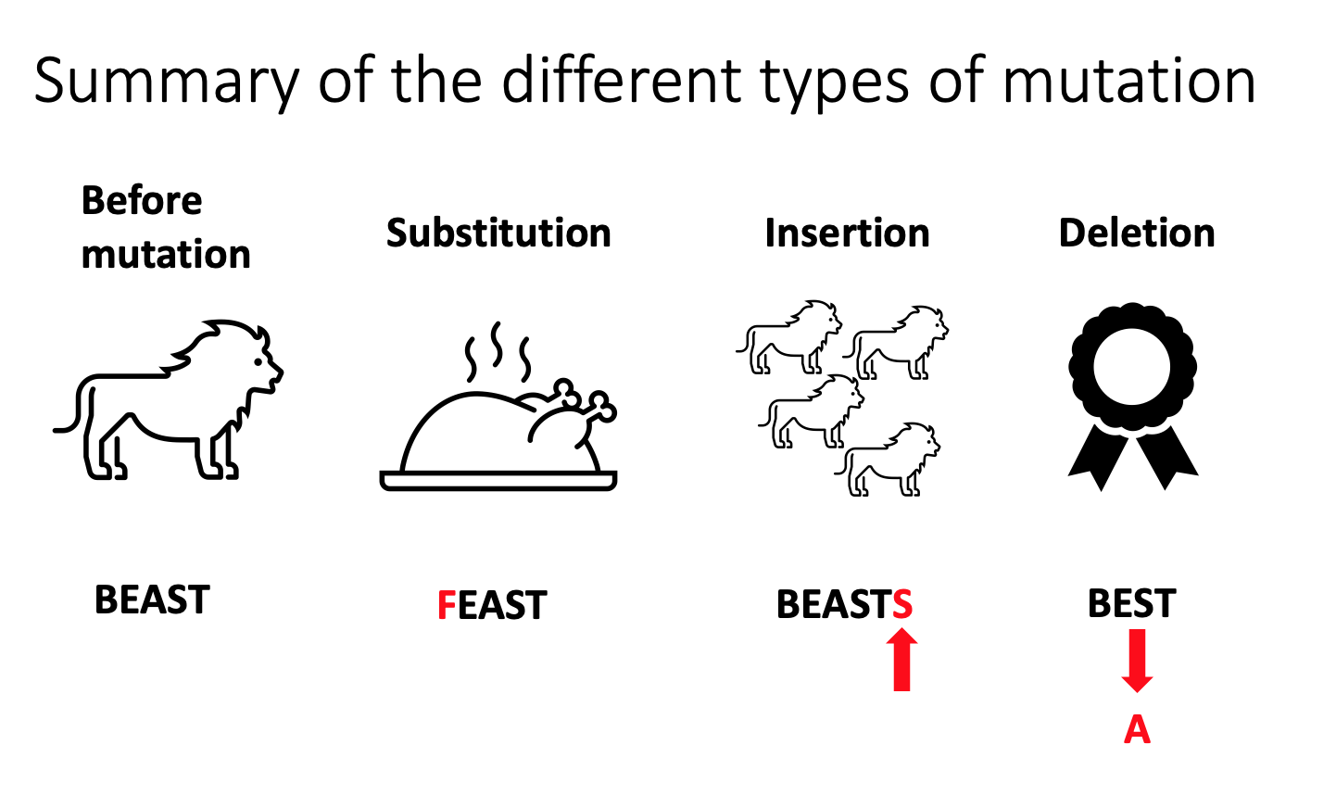
*Note for teacher: Please be sure to emphasize that the summary of mutations is a representation of the different kinds of mutations using an actual word to demonstrate. The mutations will not follow this literal change from beast→feast→beasts→ best when the mutations occur.

Extend your thinking - For an extra challenge, try this:

An insertion or deletion of a single nucleotide causes a much bigger change in the protein than a substitution, because of the frame-shift effect.

Frame-shift
The reading frame of a gene is the organization of the DNA into three-letter codons. A frame-shift occurs when an insertion or deletion shifts nucleotides over, while the reading frame stays in place.
For example, as you can see in the diagram, the sequence following an insertion stays the same, but the codons change. The result is that the codons after the inserted nucleotide code for different amino acids.
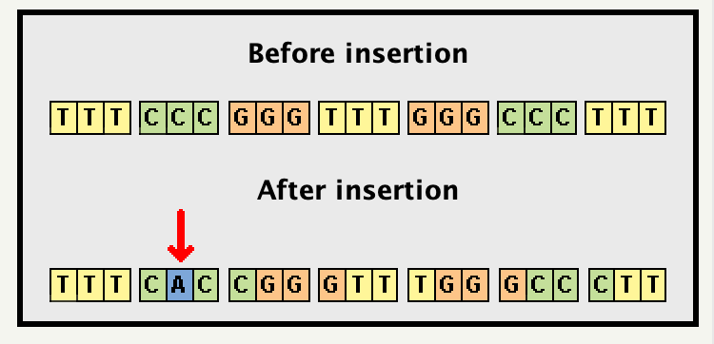

Challenge: Make a combination of insertions and/or deletions that do NOT cause a frame-shift.

Reset the model.

Make a combination of insertions and/or deletions, such that no frame-shift occurs.
Hint: You can compensate for an insertion by making a deletion at another spot in the same codon. Try it out - then see if you can find other ways to avoid a frame shift when insertions or deletions occur.

What did you change in the DNA so that no frame-shift occurred?

Lesson 5 / 6 / 7 - How does DNA affect monkeyflower traits?

Let’s go back to your DNA sequences that you created in Lesson 4. Write your monkeyflower DNA sequence (36 nucleotides)

Your monkeyflower DNA is now being transcribed to mRNA. Write your mRNA nucleotide sequence matching with the DNA.

mRNA travels out the nucleus and is detected by the ribosome. Write your nucleotide sequence of tRNAs. Leave spaces between each tRNA for each amino acid codon.

Use the table below to write a sequence of amino acids that will be part of the monkeyflower proteins.

