|  |
| --- |
| **Learning Set 3: How does changing the environmental conditions affect the survival of different monkeyflowers?** |

|  |  |  |
| --- | --- | --- |
| **Driving Question**  **for the unit:**  What causes the similarities and differences between organisms?  **Sub-Driving Question**  **for learning set 3:**  How does changing the environmental conditions affect the survival of different monkeyflowers? | **Materials**  ***Supplies:***   * Spray bottles * Salt [note: 2 tbsp. (or 1/8 cup) of salt in 1 liter of water in a spray bottle] * Water * Either a tablespoon or a 1/8 measuring cup * Multiple individuals of Plant A * Multiple individuals of Plant B * Computers   ***Handouts:***   * ***Sample*** Data collecting sheet for Monkeyflowers per team   ***Comic module:***   * Module 4 PDF   ***PPT:***   * [Planning an investigation](https://docs.google.com/presentation/d/1T_k8wKauBHSWhXobZ8tfFulXStGeR7-G4c_sUpvKkn8/edit#slide=id.p30) | **Suggested learning set time**  **9 days** |

|  |
| --- |
| **Framing the Learning Set** |

**Purpose**

In this learning set, the students will continue their experiments with the monkeyflowers to examine how adaptive traits can become non-adaptive traits if the environmental conditions change. The students will plan and carry out an investigation to examine what happens to the coastal and inland monkeyflowers when their environmental conditions change.

**Learning Goals**

* The students will plan and carry out an investigation to examine what happens to the coastal and inland monkeyflowers when their environmental conditions change.
* The students will analyze and interpret data to explain what happens to the coastal and inland monkeyflowers when their environmental conditions change.
* The students will construct a scientific explanation of how the changes in the environment affect monkeyflowers with different traits.

|  |
| --- |
| **Building Coherence** |

This unit guides students through a journey to figure out what causes the similarities and differences between two varieties of monkeyflower. Genes are regions in the DNA that contain the instructions that code for forming species’ traits. The traits that positively affect survival are more likely to be reproduced and survive. Throughout the unit, students will investigate several sub-driving questions to support them to gradually answer the bigdriving question, “What causes the similarities and differences between organisms?” which encompasses these scientific ideas. **See the Monkeyflower Storyline**

Guided by the sub-driving question, the journey unfolds as students figure out:

* In **LS1** - The different parts of the monkeyflowers and the similarities and differences in traits of organisms to answer the sub-driving question, *“How are the traits of the two varieties of monkeyflowers similar or different?”*
* In **LS2** - The structure and function of the DNA, the relationship between DNA and proteins, and the mechanisms of genetic variation to answer the sub-driving question, *“What causes the differences between monkeyflower traits?”*
* In **LS3** - The effect of environmental conditions changes in the growth and survival of organisms to answer the sub-driving question, *“How does changing the environmental conditions affect the survival of different monkeyflowers?”*
* In **LS4** - The process of natural selection to answer the sub-driving question, *“How do the similarities and differences between monkeyflowers develop over time?”*

|  |
| --- |
| **Overview of the Learning Set** |

|  |  |
| --- | --- |
| **Instructional sequence overview** | **Instruction days** |
| ***Lesson 1 - What happens if environmental conditions change?***  The students will read **Module 4 pages 1-3** of the story. Triggered by the story, they will then plan and carry out the salt resistance experiment. Once their experiments ends, they will analyze the data from their experiment. | 3-4 |
| ***Lesson 2 - What does other data tell us?***  The students combine their classroom data to compare and analyze. | 2 |
| ***Lesson 3 - Communicating findings to Maia and William***  Writing a scientific explanation - As researchers, the students write a report to Maia and Williams communicating the findings from the salt experiment to them. They will finish reading Module 4 of the mystery story. | 2 |
| ***Lesson 4 - Wrapping-up - revisiting the Driving Question Flowchart***  The students will revisit the DQflowchart and reflect upon their learning. | 1` |

|  |
| --- |
| **Connection to NGSS** |

|  |  |  |
| --- | --- | --- |
| **Target Performance Expectations**  [**MS-LS4-4.**](https://www.nextgenscience.org/pe/ms-ls4-4-biological-evolution-unity-and-diversity)Construct an explanation based on evidence that describes how genetic variation of traits in a population increases some individuals’ probability of surviving and reproducing in a specific environment.  [**MS-LS4-6.**](https://www.nextgenscience.org/pe/ms-ls4-6-biological-evolution-unity-and-diversity) Use mathematical representations to support explanations of how natural selection may lead to increases and decreases of specific traits in populations over time. | | |
| **Learning Performances**  Students analyze and interpret data to explain how environment affects the growth and survival of organisms | | |
| **Disciplinary core idea** | **Science and engineering practices** | **Crosscutting concepts** |
| **LS4.C: Adaptation**Changes in the physical environment, whether naturally occurring or human induced, have thus contributed to the expansion of some species, the emergence of new distinct species as populations diverge under different conditions, and the decline–and sometimes the extinction-of some species. | **Constructing explanations**   * Construct an explanation that includes qualitative or quantitative relationships between variables that describe phenomena. | **Cause and effect**   * Cause and effect relationships may be used to predict phenomena in natural systems. |
| **How these elements are integrated and embedded in this learning set**  In this learning set, students will plan and carry out an experiment to identify what happens to different varieties of monkeyflowers if the environment changes to construct a scientific explanation on how a certain environment can influence the organisms with different traits. | | |

|  |
| --- |
| **Connection to Students’ Lives** |

***Link to out-of-school activity and everyday life***

* Encourage students to observe the natural world around them. They can generate questions from what they observe and conduct experiments and analyze data to answer their questions that are related to their surroundings and even their own lives.

***Link to career-awareness***

* This learning set introduces what field research scientists do: scientists ask questions about the natural world and try to answer their questions based on evidence. Let students know that what they will do in this learning set is very similar to what field research scientists do: they will plan and carry out investigations, collect and analyze data, and draw evidence-based conclusions.

|  |
| --- |
| **Instructional sequence** |

|  |
| --- |
| ***Lesson 1 – What happens if the environmental conditions change?*** |

|  |  |
| --- | --- |
| **Learning Goal** | The students will plan and carry out an investigation to examine what happens to the coastal and inland monkeyflowers when their environmental conditions change. |
| **Connection to NGSS** | DCI: LS4.C: Adaptation |
| Practice: Planning and Carrying out a Scientific Investigation |
| CCC: Pattern |

1. **Introduce Module 4 of the plant mystery story:** Continue reading with the students **Module 4** **pages 1-3 (Stop at the point William writes a letter)** - **DO NOT READ BEYOND THESE PAGES!**

|  |  |
| --- | --- |
| **Science behind the narrative** | **Module 4 – A seed here. A seed there. Something different in the air.**  The goal of this part of the story is to lead the students to think about how the environment is playing a ***selective*** role in causing the observed differences to come about, or how ***environmental and genetic*** factors together affect these two plant populations differently. |

|  |  |
| --- | --- |
| **Scientific background** | **Gene - environment interactions** (or **G×E**) is when two different [genotypes](https://en.wikipedia.org/wiki/Genotypes) respond to environmental variation in different ways. A [norm of reaction](https://en.wikipedia.org/wiki/Norm_of_reaction) is a graph that shows the relationship between [genes](https://en.wikipedia.org/wiki/Genes) and [environmental factors](https://en.wikipedia.org/wiki/Environmental_factors) when phenotypic differences are continuous. They can help illustrate GxE interactions. When the norm of reaction is not parallel, as shown in the figure here, there is a gene by environment interaction. This indicates that each genotype responds to environmental variation in a different way. Environmental variation can be physical, chemical, biological, behavior patterns or life events. (Wikipedia)  Genes constantly interact with the environment, and this occurs at multiple levels, from individual gene expression to the survival of organisms with particular traits and to the survival of species, all of which are affected by changes in environmental conditions. |

1. **Returning to Driving Question Flowchart**
   1. Remind students that they have already discussed some questions in the DQ flowchart to answer the unit question, *What causes the similarities and differences between organisms?*
   2. Based on the comic, guide students to the next question, *How does changing the environmental conditions affect the survival of different monkeyflowers?* 
      * What factors might be excluding Plant B from growing on the Coast?
      * What are the differences between the two habitats?
      * How do we model the different environments in the lab?
      * How are organisms with different genotypes affected by the environment in different ways?
   3. Use the *Brainstorming* strategy to add more questions around the LS3 Sub-Driving Question if they can. Reiterate the purpose of the DQ Flowchart.

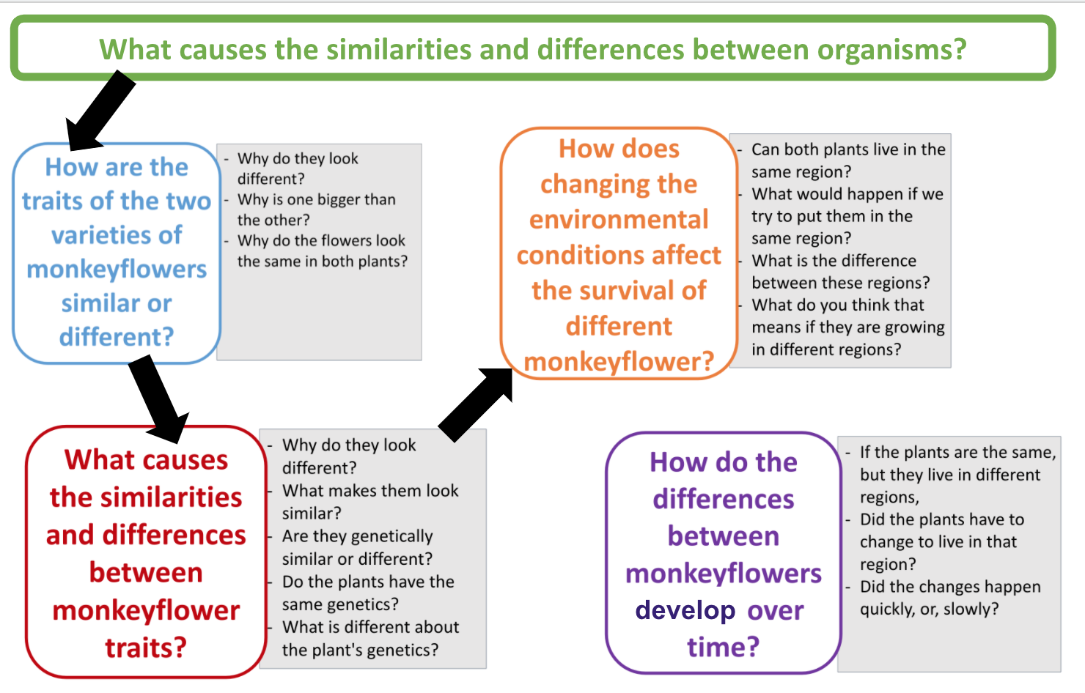

|  |  |
| --- | --- |
| creativity.png | **Scaffolding students using *learning strategies***   1. **What are learning strategies -** Explain what learning strategies are, and emphasize the importance of learning strategies for effective learning. 2. **Explain what *Brainstorming* is and how it can be used** - Brainstorming is a strategy for generating ideas. It includes generating a list of spontaneous ideas which are associated with a specific topic. For effective brainstorming: (a) focus on quantity; (b) withhold criticism; (c) welcome unusual and wild ideas; and (d) combine and improve ideas. 3. **Scaffold *Brainstorming*** - Together with the entire class, use the *brainstorming* strategy to generate as many hypotheses as possible regarding the question. |

**3. Planning the experiment**

* + Discuss with the students the two environments (coastal and inland) and the differences they identified between them:
  + 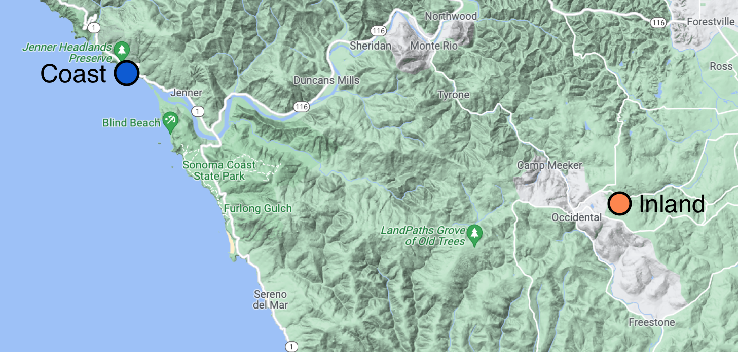
    - What environmental factors might be present on the coast that would not be present at the inland site? Remind the students the differences they observed between the two environments.
    - Of the environmental factors that you have identified, which can be simulated in your classroom, and how would you go about simulating those factors?
  + Then, guide the students to develop the “Salt experiment” that tests the response of the inland plants to a stressful factor only present on the coast - salt water spray from the ocean.
  + Discuss the Investigation Preparation PPT with inquiry questions and independent and dependent variables and parts of an investigation that students will need.

**4. Carrying out the experiment** - In teams, have the students replicate a coastal environment and look at the consequences on plant’s A & B growth = genes and environment interactions. Follow the instructions below:

* + Ask students - How might we determine which plant grows in Region A and Region B? Why?
  + Guide students to figure out that a big difference between Region A and Region B is that one is by ocean water, the other is not.
    - How do coastal environments differ from inland environments? What is one of the differences?
    - Maybe a student(s) will come up with treating the plants with seawater to see if they both survive or react differently.

* If students are unable to come up with the answer (seawater) perhaps ask students: Is there a difference in the water they are exposed to? How is the water different?

* + If we know ocean water is one of the big differences, how could we investigate or research to determine which of these plants lives by the ocean?
  + How could we expose them to seawater in our class?
    - * To treat the plants with seawater, what do we need to know? (salinity of seawater)
      * An important question would be, how do we make seawater?
        + Students might investigate the salinity of seawater and figure out how to make seawater as a treatment.
  + Could we expose each plant to seawater to see if they both survive?
  + What do you think will happen if we expose both to seawater?
  + In writing up the way in which students will carry out their experiments, students research should include the following components:
    - **The Research Question**
      * For example: How does treating Plants A and B with “seawater” affect their growth?
    - **Methodology**
      * Including materials used
        + Seawater
        + Treatment Plants A and B
        + Control Plants A and B
      * How to make seawater - salinity of water
        + Students should research this online and then figure out how to make it in the lab. For example:

To replicate seawater at home, weigh 35 grams of salt and add it to a beaker. Add tap water until the total mass of the solution inside the beaker is 1,000 grams, stirring until the salt is completely dissolved (remember to take the weight of the beaker itself into account). Rock salt, sea salt, kosher salt and table salt can all be used to make seawater at home. To make hypersaline water water, which is saltier than seawater, increase the amount of salt to 50 grams. Oceans with high temperatures and confined circulation, such as the Red Sea, have high rates of surface evaporation and little freshwater inflow from rivers and, as a result, have higher salinity. Taken from: <https://sciencing.com/make-sea-water-home-6368912.html>

* + - * How much to treat the plants with seawater
        + Two sprays with the spray bottle each day
      * How often to treat the plants with seawater
        + Plants will be treated once a day
    - **Data Collection**
      * Students will need to decide, like they did in Learning Set 1, what kind of data they will collect, for how long and create a data sheet. Use the sample data sheet that students might create.

**Note:** After a day or two, students will be able to clearly identify which plant is from Region A and Region B (Region B plants should die fairly quickly).

|  |
| --- |
| This is a sample experiment outline for the teacher. Students should come up with their own materials and plan the experiment.  **Note:**  Support students who might be struggling with this to come up with the materials and/or plan the investigation to ensure equitable participation.  **Salt Tolerance Experiment**  Materials   * Salt * Water * Spray Bottle * Either a tablespoon or a 1/8 measuring cup * Multiple individuals of Plant A * Multiple individuals of Plant B   Methods   * Each team already has 2 plants called A and 2 plants called B. For Plant A - label one plant “**Salt Treatment**” and the other “**Control**”. Repeat for Plant B (If each group does not have multiple plants of either type A or B, pair with another group).   + Note: if you are performing this at the same time as the drought tolerance experiment and are low on plants, you can use the same plants as a control for both experiments * Dissolve 2 tbsp. (or 1/8 cup) of salt in 1 liter of water in the spray bottle. This will give you a solution concentration similar to that of sea water. * Daily, spray the solution directly onto the plants in the “Salt Treatment” category. **Take care to do this away from the plants in the “Control” category!** * Data collection - Have the students use their Data Collection Sheets every few days until the plants die. They will draw a graph according to their data.   **Extend your thinking - For an extra challenge**  Have the students research and replicate the inland environment and look at the consequences on plant’s A & B growth = genes and environment interactions.  Students should use the same process of writing up their lab investigation that they completed with the salt experiment. They are changing the environment to replicate the inland this time. |

|  |
| --- |
| ***Lesson 2 – What does the data tell us?*** |

|  |  |
| --- | --- |
| **Learning Goal** | The students will analyze and interpret data to explain what happens to the coastal and inland monkeyflowers when their environmental conditions change. |
| **Connection to NGSS** | DCI: LS4.C: Adaptation |
| Practice: Analyzing and interpreting data |
| CCC: Pattern |

1. **Class discussion**- With the entire class, discuss their observation sheets.
   * What did they notice was happening to each of the plants?
     + Coastal and inland control
     + Coastal and inland salt treatment
   * Did all the plants survive?
     + Which survived?
     + Which did not survive?
     + Why do they think so?
   * How long did it take for the plants to die (if any of them died)?
     + What did they notice about what those plants looked like as they progressively died?
       - Did they die over a few days, one day?
2. **Data Analysis / results:** Have groups talk through how they might represent their findings with a graph.
   * What are the variables to be graphed? Why?
   * What goes on the X and Y axis? Why?
   * What kind of graph is it? Bar graph, line graph, other? Why did you choose that graph?
   * Graph the results. Be sure the graph has a title, key, axis are identified
3. **Conclusion (at group level)- What do the results mean? -** Have students talk through and then write what their results mean.
   * What was the answer to their Research Question?
   * What do the results say about changing the environment of the plants?
4. **Whole Class Findings - Aggregate the class data**
   * Now that students have interpreted their findings at the group level, it will be important for students to look at the whole class data and explain the trends.
   * Have groups share their results with each other.
   * Are there patterns in the findings? What are they?
     + What might the aggregated patterns say about how the different plant populations might be affected in the real world- outside of their lab investigation?
   * Are there groups that have results that are different from the rest? Outliers?
     + Why do you think that might have happened?
       - Human error?
     + What would you need to do to verify these results?
       - Discussion on why scientists need to do experiments over many times, to ensure they continually get the same results.
       - Discussion on why it’s important to share results with colleagues.
     + If they were to do this experiment again, what things would they want to do differently? Why?

|  |
| --- |
| ***Lesson 3 – Communicating findings to Maia and William*** |

|  |  |
| --- | --- |
| **Learning Goal** | The students will construct a scientific explanation of how the changes of environment affect monkeyflowers with different traits. |
| **Connection to NGSS** | DCI: LS4.C: Adaptation |
| Practice: Constructing Explanations |
| CCC: Cause and Effect |

**1. Constructing a scientific explanation** - With the entire class, share and discuss the results and conclusions of the Salt Experiment by developing **scientific explanations** which include **Claim, Evidence, and Reasoning (CER).** Use the following prompts to encourage the students to share their results and conclusions and to explain the effect of environmental factors on monkeyflower traits by writing them on the board as a reference:

|  |  |
| --- | --- |
| **Prompts** | **Responses could reference:** |
| What **claim** can you make about William’s question: ***What would happen if the plants from the inland tried to grow along the coast?*** | Inland plants cannot grow along the coast.  The inland plants will die if you try to grow them along the coast. |
| What **pattern** can you find from the data?  Are there patterns in the way each set of plant populations (coastal and inland) were growing in the salt environment? | All the inland plants die when sprayed with salt.  The coastal plants can survive when sprayed with salt. |
| What **evidence** do you have that supports your claim? | From their salt experiment, actual data (numbers-plants that survived, plants that died, measurements, observations) |
| What is your **reasoning**: how does your experiment relate to what you have learned about the effects of the environment and genetics on organisms? Think about:  Why did some of the monkeyflower plants survive exposure to salt water while others did not.  How did ***environmental and genetic*** factors together affect these two plant populations differently? | **Mechanistic explanation:**  Gene and environment  Gene/environment interactions  Mutation  Natural selection |

**2. Writing a report to Maia and Williams -** Based on the class discussion, in each group, students will write a report to Maia and Williams explaining the whole class findings of their Salt Experiment. The report should include a brief explanation:

* The research question
* The methodology
* The results and conclusion: Tell students to make sure to address the prompts for CER above.

|  |  |
| --- | --- |
| creativity.png  **Learning and teaching strategies** | **Scaffolding students using *learning strategies***   1. **What are learning strategies -** Explain what learning strategies are, and emphasize the importance of learning strategies for effective learning. 2. **Explain what** a ***scientific explanation* is and how it can be used** - Scientists try to explain how and why a natural phenomenon occurs. Scientific explanations consist of claims, evidence, and reasoning (CER). The claim is a testable statement that expresses the answer or conclusion to a question or problem. Evidence is scientific data that supports the claim. The reasoning describes how or why the evidence can be used to support the claim using scientific ideas and principles. 3. **Model *CER*** - Guide students to draw a conclusion about Williams’ question based on the data that they collected from the investigation. 4. **Instructional tips** - Ask the students to explain 1) their conclusions, 2) their evidence (data that they collected from the simulation), and 3) what scientific principle connects the evidence and claim. Then, share them with the whole class. |

3. **Sharing and discussing** - Students share and critique their reports with each other. There are several several options for sharing:

* As a Gallery Walk. As they read the reports, ask the students to examine the similarities and differences between their claims and those of their peers. If done as a gallery walk - students can provide feedback to others using sticky notes.
* As a large group discussion students read or act the reports out.
* In a “Writing group” - two groups of students share or read their reports to each other and provide feedback through peer review.

4. **Finishing reading Module 4 of the plant mystery story –** Continue and finish reading Module 4.

|  |  |
| --- | --- |
| **Scientific background** | **Teacher Note**  The students should recognize that there are many differences between the two varieties of plants. Since the plants were grown under the same environmental conditions, the students should be able to conclude that the differences that they observe between the plants are due to genetic differences.  Based on the observation of the plants and the conclusion that the differences between them are due to genetics, the students can have a discussion on what might cause those differences. The reason for the genetic differences between the plants is due to mutations in genes. Plant A carries one set of genes with mutations in them that are different from the mutations in Plant B. Scientists are currently working to try to figure out what genes and mutations cause the differences between Plants A and B. The current hypothesis is that mutations in genes involved in a growth hormone (Gibberellin) are responsible for the difference in how Plant A and B look. |

|  |
| --- |
| ***Lesson 4 – Wrapping up - revisiting the Driving Question Flowchart*** |

|  |  |
| --- | --- |
| **Learning Goal** | The student will revisit the DQ Flowchart to discuss what questions have been addressed thus far and/or adding more questions to the DQ Flowchart |
| **Connection to NGSS** | DCI: LS4.C: Adaptation |
| Practice: Asking questions |
| CCC: Cause and Effect |

**Revisiting the Driving Question Flowchart**

With the class, revisit the ENTIRE ***Driving Question Flowchart***. Prompt the students to reflect upon their learning throughout the unit using the following prompts:

* Which questions on the Flowchart have we addressed, and which remain open?
  + How would we now answer each of the flowchart questions?
  + After completing the lessons in the learning set, do you have any additional questions?
* Spend some time discussing each question, reflecting on what activities you all did to help you investigate that question.
* Spend some time discussing the question: What do we know now about gene-environment interactions?
* We studied monkeyflowers to answer the questions in the flowchart, do the ideas we covered in this unit transfer to other organisms, besides monkeyflowers? For example, what about humans? Do these ideas help us explain what causes differences in humans? How similar and different are humans? This is the subject of the next unit.

**Salt Tolerance Experiment - Sample Data Collection Sheet**

|  |  |  |  |  |
| --- | --- | --- | --- | --- |
| Date | Observation record for Coastal Plant | | Observation record for Inland Plant | |
| Control | Salt treatment | Control | Salt treatment |
|  |  |  |  |  |
|  |  |  |  |  |
|  |  |  |  |  |
|  |  |  |  |  |
|  |  |  |  |  |
|  |  |  |  |  |
|  |  |  |  |  |
|  |  |  |  |  |
|  |  |  |  |  |
|  |  |  |  |  |
|  |  |  |  |  |
|  |  |  |  |  |
|  |  |  |  |  |
|  |  |  |  |  |
|  |  |  |  |  |
|  |  |  |  |  |
|  |  |  |  |  |
|  |  |  |  |  |
|  |  |  |  |  |
|  |  |  |  |  |