Learning Set 4: How do the differences between monkeyflowers develop over time?

Driving Question  for the unit:  What causes the similarities and differences between organisms?  Driving Question  for learning set 4:  How do the differences between monkeyflowers develop over time? | Materials  Supplies:  - Big post-it  Background information:  Handouts:  - Driving Question Flowchart PPT (LS1)  - Lesson 2 Fish cards  - Lesson 2 Fish sampling  - Lesson 2 Link to Teacher Guide  - Lesson 3 Part 1 Stickleback worksheet (fillable PDF)  - Lesson 3 Part 1 Stickleback Crosses cards  - Lesson 3 Part 1 Teacher Version  - Lesson 3 Part 2 Candidate Gene student worksheet  - Lesson 3 Part 2 Gene Cards  - Lesson 3 Part 2 Eda Reading  - Lesson 4 Reproductive Advantage Cards  - Lesson 4 Reproductive Advantage Argument Organizer (student handout)  - Lesson 5 Natural Selection Checklist  - Lesson 5 Natural Selection Argument  - Lesson 5 Evaluating Arguments Checklist  - Lesson 6 Adaptation through Natural Selection Argument Monkeyflower  - Lesson 6 Evaluating Arguments Checklist  Simulations:  Links to videos:  - Meet the Threespine Stickleback Fish  - What is Evolution?  - What is natural selection?  - Adaptation  Links  - Monkeyflowers as a model system | Suggested lesson time  13 days

Framing the Learning Set

Purpose
In this learning set, the students will focus on the sub-driving question, “How do the differences between monkeyflowers develop over time?” and learn how traits evolved over time through natural selection. The students use the context of stickleback fish in Loberg Lake to figure out the principles of natural selection. Then, they will apply the concept of natural selection and adaptation to the changes of monkeyflowers. Finally, the students will construct an argument and scientific explanation to demonstrate their understanding.

Learning Goals
- The students ask questions about how traits in a population change over time.
- The students analyze and interpret data to identify that individuals in a population typically vary in their traits.
- The students analyze and interpret data to figure out that heritable traits pass between generations by way of genes from parent to offspring.
- The students make an argument that organisms with an advantageous heritable trait tend to survive and reproduce more than organisms lacking this trait.
- The students make an argument that natural selection can cause adaptive traits to become more or less common in a population over time.
- The students construct a scientific explanation to explain that adaptation through natural selection can cause some organisms to become better suited to their environment; this process occurs over time and many generations.

Building Coherence

This unit guides students through a journey to figure out what causes the similarities and differences between two types of monkeyflower. Genes are regions in the DNA that contain the instructions that code for forming species’ traits. The organisms with traits that positively affect survival are more likely to survive and reproduce. Throughout the unit, students will investigate several sub-driving questions to support them answering the big driving question: “What causes the similarities and differences between organisms?” which encompasses these scientific ideas. See the Storyline

Guided by the sub-driving question, the journey unfolds as students figure out:
- In LS1 - The different parts of the monkeyflowers and the similarities and differences in traits of organisms to answer the sub-driving question, “How are the traits of the two types of monkeyflowers similar or different?”
- In LS2 - The structure and function of the DNA, the relationship between DNA and proteins, and the mechanisms of genetic variation to answer the sub-driving question, “What causes the differences between monkeyflower traits?”
- In LS3 - The effect of environmental conditions changes in the growth and survival of organisms to answer the sub-driving question, “How does changing the environmental conditions affect the survival of different monkeyflowers?”
- In LS4 - The process of natural selection to answer the sub-driving question, “How do the similarities and differences between monkeyflowers develop over time?”

Overview of the Learning Set

Instructional sequence overview | Instruction days
Lesson 1 - How do the differences between monkeyflowers happen over time?  In this lesson, students are introduced to a new organism that might have changed like the monkeyflowers. This will help them figure out how the monkeyflowers might have changed over time. | 1
Lesson 2 – Is the lateral plate trait variable among individuals in the population?  The students collect a random sample of stickleback fish from Loberg Lake and arrange them by lateral plate number on a labeled bar graph. They repeat the process for three sampling periods. | 2
Lesson 3 – Is the lateral plate trait heritable?  The students analyze a scatter plot showing data from different stickleback crosses. The plot shows a positive correlation between lateral plate number in parents and offspring. Then, working in pairs, they sort cards representing stickleback genotypes to find the gene that correlates with lateral plate phenotype. | 3
Lesson 4 – Is there a reproductive advantage to having a low number of lateral plates in Loberg Lake?  The students gain more practice with the components of an argument. First, they match “evidence cards” to reasoning, then they identify claims about who has the reproductive advantage in Loberg Lake. Students then choose which of the arguments are plausible. | 2
Lesson 5 – Is natural selection causing the lateral plate number in the population of sticklebacks to change over time?  The students make an argument that the stickleback fish case is an example of natural selection and natural selection can cause trait variation to become more or less common in a population over time. | 2
Lesson 6 – Is natural selection causing the difference between two types of monkeyflower over time?  The students figure out and explain how the three principles of natural selection connect to the monkeyflower. | 2
Lesson 7 - Wrapping-up - revisiting the Driving Question Flowchart models  The students will revisit the DQ flowchart and reflect upon their learning. | 1

Connection to NGSS

Target Performance Expectations
HS-LS4-2. Construct an explanation based on evidence that the process of evolution primarily results from four factors: (1) the potential for a species to increase in number, (2) the heritable genetic variation of individuals in a species due to mutation and sexual reproduction, (3) competition for limited resources, and (4) the proliferation of those organisms that are better able to survive and reproduce in the environment.
HS-LS4-3. Apply concepts of statistics and probability to support explanations that organisms with an advantageous heritable trait tend to increase in proportion to organisms lacking this trait.
HS-LS4-4. Construct an explanation based on evidence for how natural selection leads to adaptation of populations.
HS-LS4-5. Evaluate the evidence supporting claims that changes in environmental
conditions may result in: (1) increases in the number of individuals of some species, (2) the emergence of new species over time, and (3) the extinction of other species.
Learning performances
Students construct an explanation of how the process of natural selection can result in organisms that are more well adapted to their environment.
Disciplinary core idea | Science and engineering practices | Crosscutting concepts
LS4.B: Natural Selection  Natural selection occurs only if there is both (1) variation in the genetic information between organisms in a population and (2) variation in the expression of that genetic information—that is, trait variation—that leads to differences in performance among individuals.  The traits that positively affect survival are more likely to be reproduced, and thus are more common in the population. | Constructing scientific explanation  - Construct their own explanations of phenomena using their knowledge of accepted scientific theory and linking it to models and evidence.  - Use primary or secondary scientific evidence and models to support or refute an explanatory account of a phenomenon.  - Offer causal explanations appropriate to their level of scientific knowledge. | Cause and effect  - Empirical evidence is required to make claims about specific causes and effects.
How these elements are integrated and embedded in this learning set
In this learning set, students will collect and analyze a random sample of stickleback fish from Loberg Lake to figure out three principles of natural selection and make an argument that natural selection can cause trait variation to become more or less common in a population over time. Then, they apply what they figured out to explain how natural selection affects monkeyflowers.

Connection to Students’ Lives

Link to out-of-school activity and everyday life
- Encourage students to observe the natural world around them. They can generate questions from what they observe and conduct experiments and analyze data to answer their questions that are related to their surroundings and even their own lives.

Link to career-awareness
- This learning set introduces what scientists do: scientists ask questions about the natural world and try to answer their questions based on evidence. Let students know that what they will do in this learning set is very similar to what scientists do: they will plan and carry out investigations, collect and analyze data, and draw evidence-based conclusions.

Instructional sequence for Learning Set

Lesson 1 – How do the differences between monkeyflowers happen over time?

Learning Goal | The students ask questions about how the monkeyflower changes over time.
Connection to NGSS | DCI: LS4B: Natural Selection
 | Practice: Ask question
 | CCC: Pattern

- Introducing the sub-driving question for this learning set
  - Remind students about the previous learning set
    - We have read the comic and learned about the monkeyflower plant and how scientists do field research to learn about how organisms reproduce and grow in different environments.
    - We ended the comic with William asking about how the monkeyflower plants evolve over time.
  - Link it to the driving question flowchart
    - Bring the last sub-driving question about natural selection (How do the differences between monkeyflowers develop over time?)

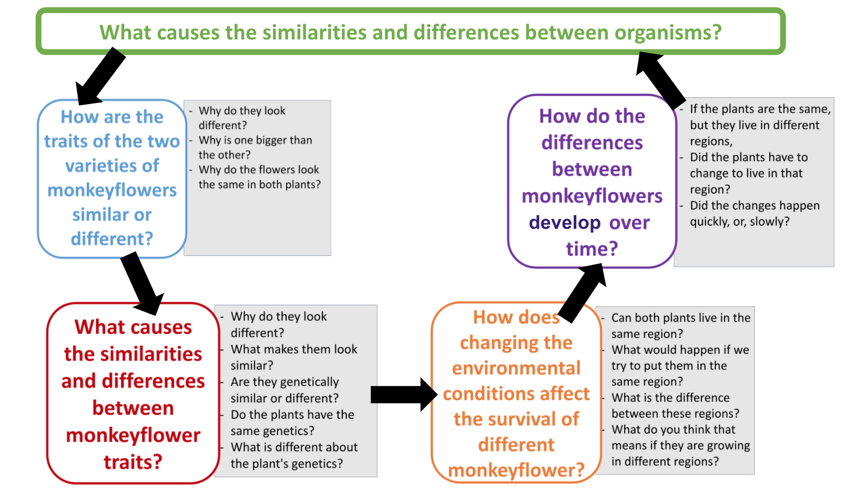
- Introducing the new context
  - Introduce the stickleback fish
    - We have come up with our sub-driving question about how organisms within a population evolve over time.
    - To help us figure out how the monkeyflower populations might have changed over time, we are going to take a look at another organism whose population might have changed over time like our monkeyflowers.
    - The fish is called the stickleback fish
      - Watch a short video about the stickleback: https://learn.genetics.utah.edu/content/evolution/meet
  - Outline this learning set
    - In this learning set, we will figure out how the stickleback have changed over time by using a simulation to collect and analyze data similar to what field research scientists collected at Loberg Lake.
    - Let’s see if what we figure out about the stickleback fish helps us answer our sub-driving question: How do the differences between monkeyflowers develop over time?
    - Can we make a connection between the stickleback fish and the monkeyflowers?

Lesson 2 – Is the lateral plate trait variable among individuals in the population?

Learning Goal | The students analyze and interpret data to identify that individuals in a population typically vary in their traits.
Connection to NGSS | DCI: LS4B: Natural Selection
 | Practices: Analyze and interpret data
 | CCC: Pattern

1. Introduce the lesson
- Do you think that the trait varies among individual fish in the population? Do you think the lateral plate trait may change over time in a population of stickleback fish?
- As researchers, you will collect a random sample of paper stickleback fish from Loberg Lake and plot them by lateral plate number on a bar graph.

2. Stickleback Sampling
- Distribute the fish card and student handouts. Have students take 20 fish cards from each sample year (1990, 1996, and 2002).
  - Lesson 2 fish cards:
Note : There are 100 cards for each sample year. Make enough copies for each student or group to select 20 cards per sample year. Cut the cards out and shuffle them well. Keep each sample year separate. Tips: To make it easier to tell the sample years apart, print the cards in color or onto different colors of paper. Paperclip shuffled cards together in groups of 20 for easier distribution.
  - Lesson 2 fish sampling worksheet
- For the 1990 sample only, tell students to arrange their fish by lateral plate number and plot them on their graphs.
- When students are finished, project or hand out the aggregate graph for 1990 and discuss:
  - Lesson 2 Teacher Guide PDF
  - Raise your hand if your graph looks different from your neighbor’s. Why might the graphs look different?
  - Raise your hand if your graph looks different from the aggregate.
  - Sample size:
    - The fish in one small sample may not be representative of the whole population. A larger sample size is more representative of the population.
  - Using the aggregate graph, review graph interpretation:
    - What is the range in plate number?
    - What is the most frequent number of plates on fish in this sample?
- For the 1996 sample, tell students to arrange their fish by lateral plate number and plot them on their graphs.
- When students are finished, project or hand out the aggregate graph for 1996. Remind students that 6 years have passed, and sticklebacks live for roughly 2 years. Discuss:
  - How are the 1990 and 1996 graphs different?
  - Describe lateral plate trait in the population for 1996.
  - Are these the same fish from the previous sample, or different fish? (Answer: They are different fish.)
  - Where did the fish with fewer lateral plates come from? (Answer: They are the great-grandchildren of the 1990 population.)
- Repeat the process for the 2002 sample. Emphasize that each sample represents the descendants of the previous sample—not the same fish. Project the three aggregate graphs and discuss the differences between the samples:
  - What are the trends/patterns for the lateral plate number trait in Loberg Lake sticklebacks over the generations? (Answer: Over time, the number of lateral plates in the population decreased. Or, the number of low-plated individuals increased, while the number of high-plated individuals decreased, shifting the number of lateral plates in the population as a whole.)
- Discuss:
  - Did the changes in the lake stickleback populations’ lateral plate happen in one generation? Or, did it take time to see this change? What do our data tell us?
Emphasize the importance of time in these studies as related to the stickleback populations’ changing lateral plate trait. It is a HUGE misconception that students often hold that a single organism can change its traits. These changes happen over time and many generations(remember, each generation lives for approximately 2 years) as these activities with the stickleback population have shown.
For comparison, they could think of parents, children, grandparents. Humans have a longer time span in generations (approximately 25 years). They could also think the monkeyflower plants that could have about 3 generations in one year).
You could remind students that the generations are labeled P1→F1→F2 etc. They saw this notation in the Mendelian genetics piece in LS2.

Lesson 3 – Is the lateral plate trait heritable?

Learning Goal | The students analyze and interpret data to figure out the heritable traits pass by way of genes from parent to offspring.
Connection to NGSS | DCI: LS4B: Natural Selection
 | Practice: Analyzing and interpreting data
 | CCC: Pattern

- Introduce the lesson
  - In the last lesson we looked at trends/patterns for the lateral plate number trait in Loberg Lake sticklebacks over the generations.
  - What did we figure out?
    - We figured out, over time, the number of lateral plates in the population decreased. Or, the number of low-plated individuals increased, while the number of high-plated individuals decreased, shifting the number of lateral plates in the population as a whole.
  - In this lesson, as researchers, you will analyze a scatterplot showing data from different stickleback crosses.

- Stickleback Crosses Part 1 - This activity looks at the macro level idea of genetic heritability.
  - Provide each student with a worksheet- Lesson 3 Part 1 worksheet
  - Provide each student or pairs of students with one card. Lesson 3 Part 1 stickleback crosses cards
  - Teacher demo of the student worksheet- Lesson 3 Part 1 Teacher Version
  - Discussion
    - Remember, in Learning Set 2, what did we figure out about the link between genes, traits, parents, and offspring?
      - Heritable traits pass by way of genes from parents to offspring.
    - In this activity what were we comparing?
      - Lateral plates between parents and offspring
    - What did we figure out about heritability from this comparison?
      - Heritability can be determined by comparing traits in parents and offspring. If a trait is heritable, offspring tend to resemble parents.
      - This could provide the opportunity to also talk about the relative contribution genes make to a trait.
    - What did the graphs show? Explain
      - The plot shows a positive correlation between lateral plate number in parents and offspring.
      - If the points in the graph are strongly correlated the genetic component is probably significant.
      - More variation in the points along the regression line would suggest either low heritability or that the environment might play a larger role. Meaning- if the points plotted do not follow a linear pattern, and are scattered all over the graph, it could mean there is low heritability or the environment might be playing a larger role.
    - Can we conclude that the lateral plates are heritable?
      - The Loberg lake data of the Stickleback fish, show that lateral plates are heritable.

- Stickleback Crosses Part 2 - This activity looks at the micro level idea of genetic heritability.
  - From Part 1 of this lesson, we looked at the phenotype of the Stickleback fish and concluded that the lateral plates are heritable.
  - Is there something else we could look at to confirm the lateral plates are actually heritable?
    - Besides phenotype, what else could we investigate?
      - genotype
  - Lesson 3 Part 2 Gene Cards.
    - In pairs, students sort cards representing stickleback genotypes to find the gene that correlates with lateral plate phenotype.
  - Students fill out the worksheet Lesson 3 Part 2 Candidate Gene Handout
  - Is the lateral plate trait heritable?
    - Discuss with students-How did you figure it out?
  - Distribute the Eda Reading after they have identified the candidate gene.
    - After identifying the gene, students receive Lesson 3 Part 2 Eda Reading
      - Note: As the reading states, Eda accounts for about 75% of plate number variability. A number of minor genes contribute the other 25%. This mechanism makes lateral plate number a continuous trait.
  - Whole Class Discussion: What did we figure out from these two activities?
      - One way to determine which gene controls a trait is to compare DNA sequences of alleles from individuals with different phenotypes.
      - We were able to identify the gene that codes for the lateral plates of the stickleback fish
      - We looked at both the phenotype and genotype of the lateral plates of the Stickleback fish
      - From these activities, we can conclude that heritable traits pass by way of genes from parent to offspring.

Lesson 4 – Is there a reproductive advantage to having a low number of lateral plates in Loberg Lake?

Learning Goal | The students make an argument that organisms with an advantageous heritable trait tend to survive and reproduce more than organisms lacking this trait.
Connection to NGSS | DCI: LS4B: Natural Selection
 | Practice: Engaging in argument
 | CCC: Cause and effect

- Introduce the lesson
  - Review- In the last lesson, Lesson 3, we figured out that traits are heritable and passed from parent to offspring.
    - We looked at heritability from the phenotype and genotype of the Stickleback fish lateral plates.
    - In this lesson, we are going to figure out if having a certain number of lateral plates has a reproductive advantage.
      - What do you think? Do you think low, medium or high lateral plates have a reproductive advantage?
        - Why do you think so?
        - Do we already have evidence for this? Where?
      - Students might come up with an answer of low number of lateral plates from the data already studied.
      - In order to confirm our hypothesis, we need to study more data.
      - The question we are going to investigate in this lesson is:
        - Is there a reproductive advantage based on the number of lateral plates in Loberg Lake?
  - Provide each student or pair with the reading and accompanying reasoning and evidence cards
    - Lesson 4 Reproductive Advantage Cards
    - Students will gain practice with the components of an argument.
        - First, students read the Reasoning being presented
        - Second, students identify the claim that reasoning is focusing on
        - Third, students match “evidence cards” to reasoning, then identify claims about who has the reproductive advantage in Loberg Lake.
        - Under step 4, tell students to place the Evidence cards on their Reasoning pages.
        - Students then choose which of the arguments are plausible (2 out of the 5).
        - Once students have identified the plausible arguments, they should discuss their findings with another pair or have a whole group discussion.
        - Have students make revisions as necessary
  - Scaffolding this lesson- for some students, this may be the first time they are exposed to this kind of activity using argumentation. We suggest:
    - Structured support: Do the first argument together as a class and support students to do all of the steps in Reasoning #1.
      - First- Read the Reasoning statement together and discuss.
      - Second- Identify and discuss together which claim is being supported by the reasoning.
      - Third- Identify and discuss the evidence that supports the reasoning and claim.
      - Finally- Discuss if the reasoning, claim and evidence make a plausible argument for the question and why.
    - Guided support: Do the Reasoning #2 together in a limited form.
      - First- Read the Reasoning together and discuss
      - Second- Identify and discuss together which claim is being supported by the reasoning.
      - Third- Have students, in pairs or small groups, identify and discuss the evidence cards that support the reasoning and claim.
        - Come back together to discuss as a whole group
      - Finally- Have students, in pairs or small groups, identify and discuss and then write on a sticky note, if Reasoning #2 is plausible or not and why they think it is or is not plausible.
    - Limited Support: Have students work in their pairs or small groups to figure out Reasoning statements 3→5.
      - First- Groups/Pairs read the Reasonings together and discuss.
      - Second- Groups/Pairs identify and discuss together which claim is being supported by the reasoning.
      - Third- Groups/Pairs identify and discuss the evidence that supports the reasoning and claim.
      - Fourth- Groups/Pairs identify and discuss and then write on a sticky note, if the Reasoning is plausible or not and why.
      - Finally- Once Groups/Pairs have completed Reasonings 3→5, have a whole group discussion on their answers.
  - Whole class discussion on findings
      - Reasoning #2 is part of a Bad Argument. Using the same evidence card (#4), come up with a more plausible line of reasoning that supports a reproductive advantage for low-plated sticklebacks in Loberg Lake.
      - Reasoning #3 does not relate to reproductive advantage in Loberg Lake, but it is relevant to sticklebacks in an ocean environment. Discuss how different traits can be an advantage depending on an individual's environment.
  - Once students agree with their choices, provide each student with an organizing sheet for students to write their final findings about all the Reasoning Statements.
    - Reproductive Advantage Organizer
  - Note: As in reality, in this activity the same pieces of evidence might be used to support multiple arguments; therefore, multiple copies of evidence statements are provided. Also, not all copies of the evidence cards can be matched to an argument; hence, some cards will be left over.
  - Concluding the lesson
    - Ask students: Is there a reproductive advantage based on the number of lateral plates in Loberg Lake?
    - Have students discuss and explain.

Lesson 5 – Is natural selection causing the lateral plate number in the population of sticklebacks to change over time?

Learning Goal | The students make an argument that natural selection can cause adaptive traits to become more or less common in a population over time.
Connection to NGSS | DCI: LS4B: Natural Selection
 | Practice: Engaging in an argument
 | CCC: Cause and effect

- Link what they figured out in the three previous lessons to the principles of of Natural Selection
  - In pairs, have students work on the worksheet to figure out the three principles of natural selection and whether the difference between sticklebacks is the one of the examples of natural selection.
    - Lesson 5 Natural Selection Checklist
  - Lead a class discussion to support students to figure out the three principles of natural selection, and answer the question “what are the principles that drive natural selection?”
    - Principle of variation : Among individuals within any population, there is variation in physical and behavioral traits.
      - Were the two populations the same?
      - How are they similar and/or different?
      - What would have happened if they were the same?
    - Principle of heredity: Offspring resembles their parents more than they resemble unrelated individuals.
      - Was the lateral plate trait of sticklebacks inherited?
      - Did offspring resemble their parents?
    - Principle of selection: Some forms are more successful at surviving and reproducing than other forms in a given environment.
      - Which offspring were more likely to survive?
      - Which were more likely to have their population grow in Loberg Lake?

- Making an argument about natural selection in Loberg Lake
  - Have students use the worksheet to write an argument using the prompt.
    - Lesson 5 Natural Selection Argument worksheet
    - Their argument must include:
      - A claim: An answer to the prompt
      - Evidence: As listed on the checklist
      - Reasoning: Ideas about Natural Selection that are stated on the checklist (e.g., Natural Selection acts on traits that are variable, heritable, and confer a reproductive advantage, causing a trait to become more or less common over time.)
    - Be on the lookout for common misconceptions:
      - Individuals adapt to their environment.
      - Natural selection is driven only by environmental change.
      - Genetic variations arise in response to selective pressure (rather than pre-existing variations being selected).
      - Changes in populations usually happen within one or a few generations.
  - Have students peer review the arguments using the Argumentation Checklist. For any item checked "no," ask reviewers to provide a specific suggestion for improvement.
    - Lesson 5 Evaluating Argument Checklist
  - Give students the opportunity to revise their arguments based on peer review(s).

- With the students, watch the video. The video summarizes natural selection and adaptation. Discuss the relation between this video and the students’ findings about the sticklebacks.
    - What is Evolution?
    - What is natural selection?

Lesson 6 – Has natural selection contributed to the two varieties of monkeyflowers adapting to their environment over time?

Learning Goal | The students construct a scientific explanation to explain that adaptation through natural selection can cause some organisms to become better suited to their environment; this process occurs over time and many generations.
Connection to NGSS | DCI: LS4C: Adaptation
 | Practice: Constructing a scientific explanation
 | CCC: Cause and effect

- Link to adaptation - Use the video below to help summarize important concepts from heredity and natural selection. It emphasizes that mutation and allele shuffling increase variation in a population, and natural selection decreases variation through the propagation of advantageous variations—with multiple possible outcomes.
  - https://learn.genetics.utah.edu/content/evolution/adaptation
  - Discussion questions:
    - What were the main messages from the video?
    - How do mutations and allele shuffling affect variation in a population? (more variation)
    - How does natural selection affect variation in a population? (less variation through propagation of advantageous variations)
    - Does the idea of adaptation relate to the monkeyflowers? How? (The coastal and inland plants would have had to adapt to their environment to survive. This would have happened through mutations and allele shuffling as well as following the principles of natural selection.)
- Students figure out how adaptation, through the three principles of natural selection, connects to these two varieties of monkeyflower.
  - Choose one of the followings to present their conclusion:
    - Write a report to Maia and William
    - Finish the comic
    - Create a skit
    - Write a song
  - Use the Lesson 6 Adaptation through Natural Selection Argument Monkeyflower worksheet so they can first write their draft argument then, they can work to transfer their argument into one of the finished products above.
  - Use the Lesson 6 Evaluating Arguments Checklist to have students peer review each other’s work.
  - The finished product needs to include:
    - Claim - The two varieties of monkeyflowers adapted to their environment over time following the process of natural selection.
    - Evidence - something they did in the previous learning sets that connects adaptation to the three principles of natural selection
      - Different traits: Monkeyflowers have different traits- students saw that in the leaves and flowers of the coastal and inland
      - Heritability: Students see how the monkeyflower plants inherit flower color
      - Advantageous traits: The salt experiment - seeing the coastal plant have an advantage over the inland and can survive with seawater.
    - Reasoning-
      - use the three principles of natural selection to support their claim and evidence.
      - The coastal and inland plants would have had to adapt to their environment to survive. This would have happened through mutations and allele shuffling as well as following the principles of natural selection.

Lesson 7 – Wrapping up - revisiting the Driving Question Flowchart

Learning Goal | The student will revisit the DQ Flowchart to discuss what questions have been addressed thus far and/or adding more questions to the DQ Flowchart.
Connection to NGSS | DCI: LS4B Natural Selection
 | Practice: Asking Questions
 | CCC: Cause and Effect

Revisiting the Driving Question Flowchart

With the class, revisit the Driving Question Flowchart. Prompt the students to reflect upon their learning using the following prompts:
- In smaller groups- assign each group one of the four sub-driving questions to discuss:
  - Which questions and hypotheses on the DQ Flowchart have we answered, and which remain open?
  - Students should attach their answers/artifacts of investigation onto the DQ flowchart next to the hypotheses and questions they relate to.
- Have students come back as a whole group to discuss what they found from discussing their sub-driving question.
  - What questions were answered?
  - What questions are still left unanswered?
  - Can they answer part of the BIG DQ of the unit with their sub-driving question? What answer did they come up with?
- After completing the unit, do you have any additional questions?
  - Any new questions or hypotheses should be added to the board near the hypotheses they relate to.
- Discuss: Looking over our Driving Question Flowchart, can we say with confidence that we have/can answer all the sub-driving questions and ultimately, the Driving Question of the entire unit?

Lesson 2 Student Worksheet 1 per student

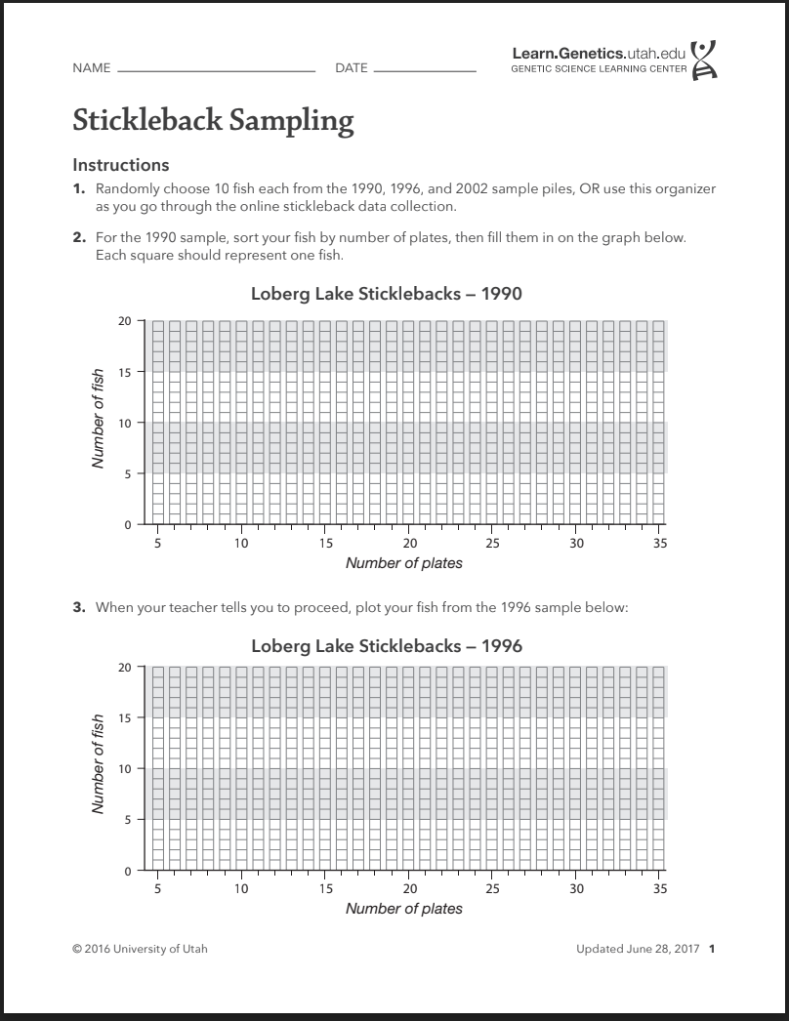

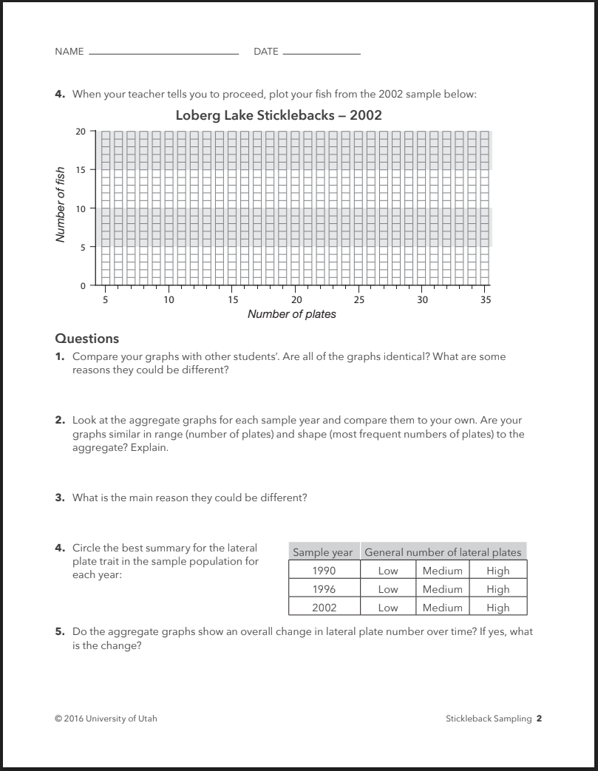

Lesson 2 Fish Cards 1 per pair of students

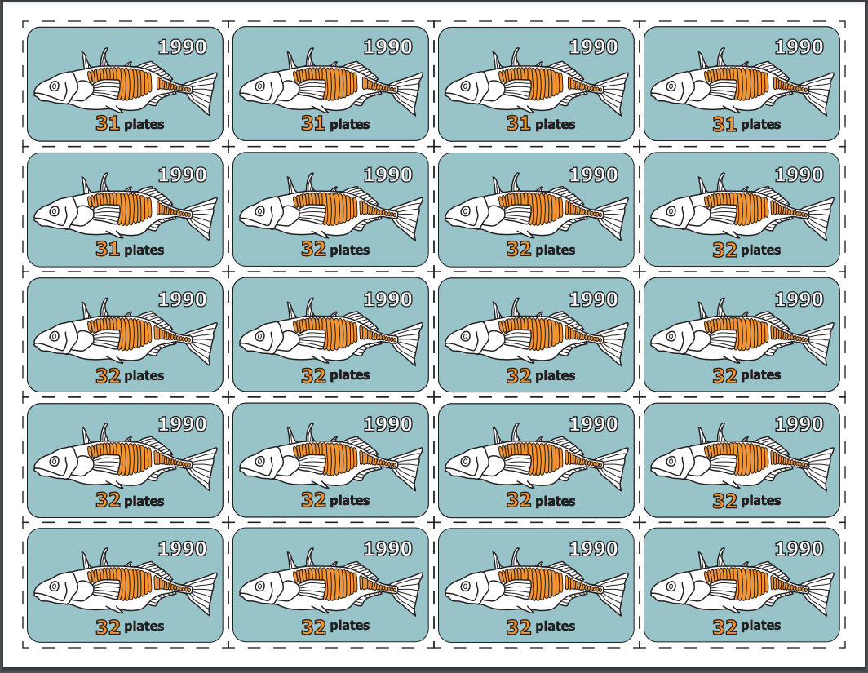

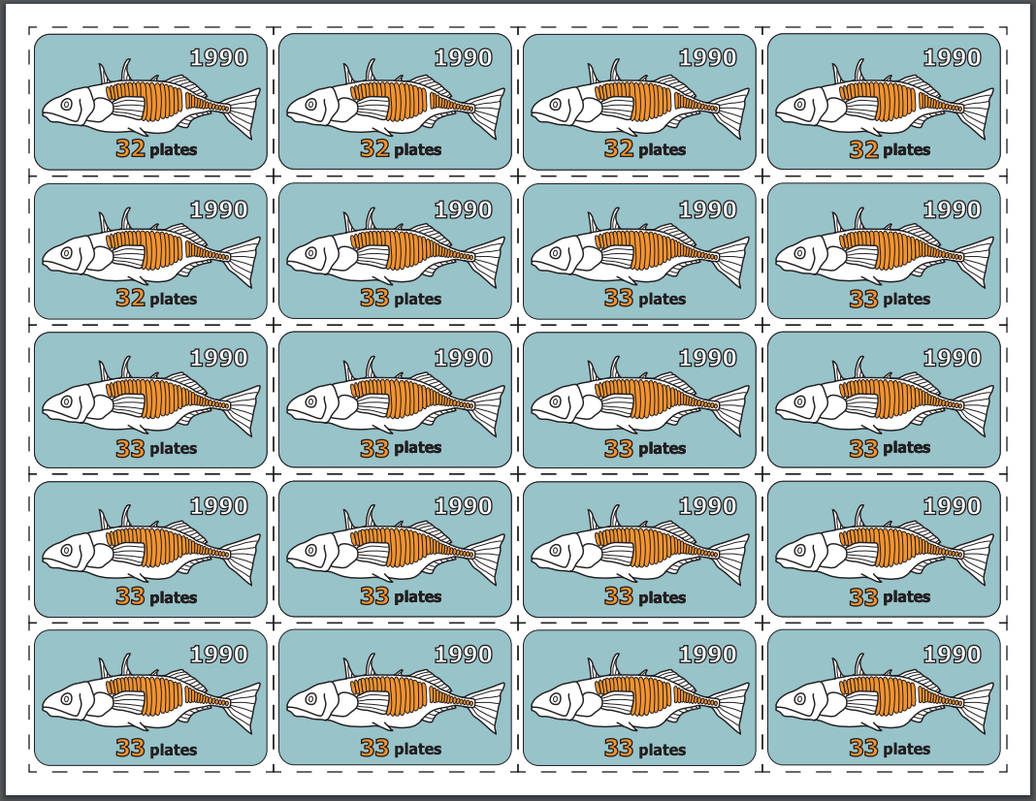

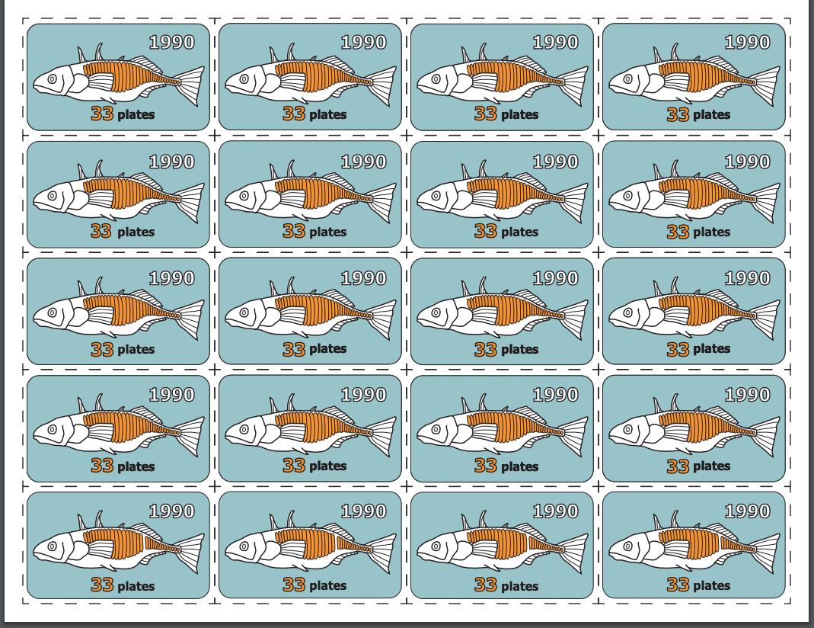

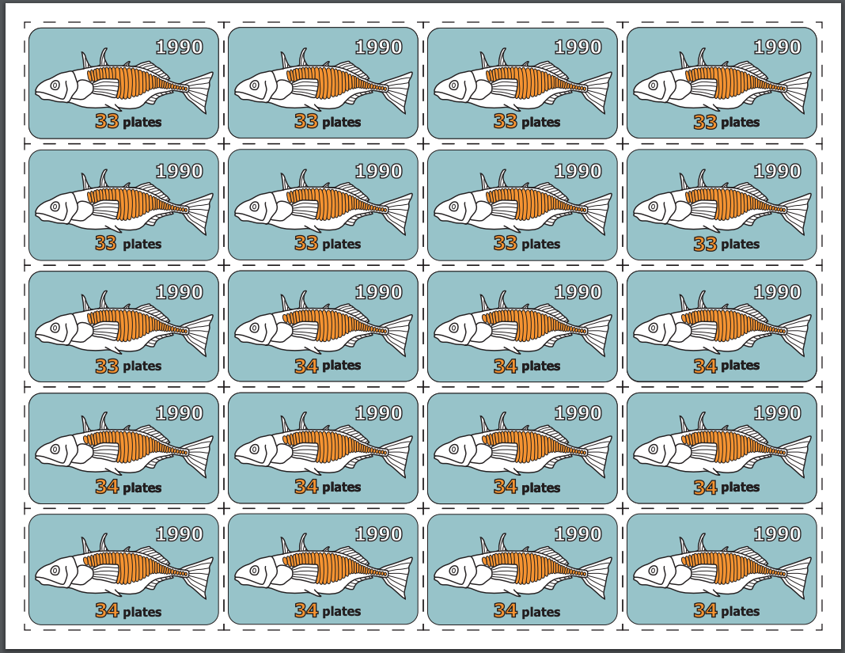

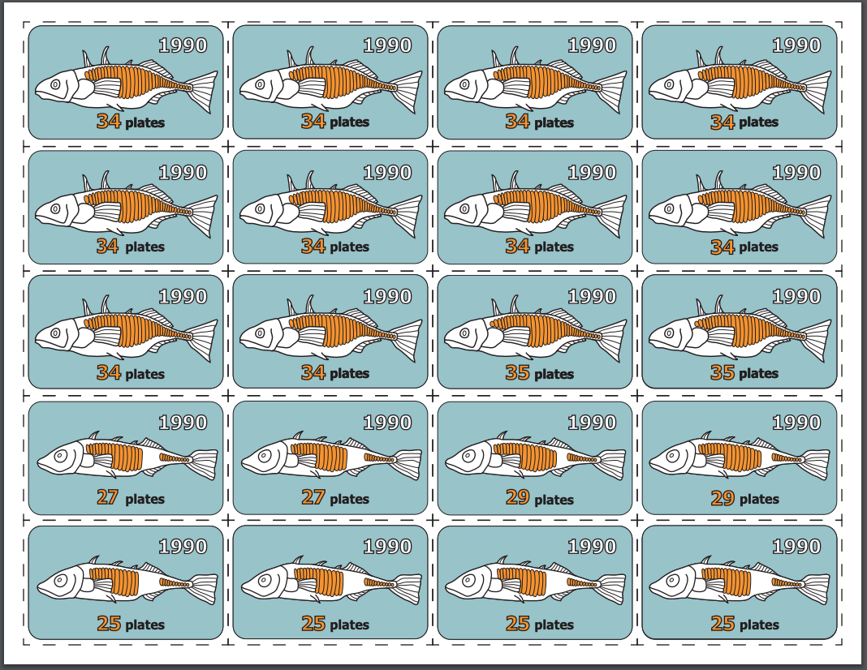

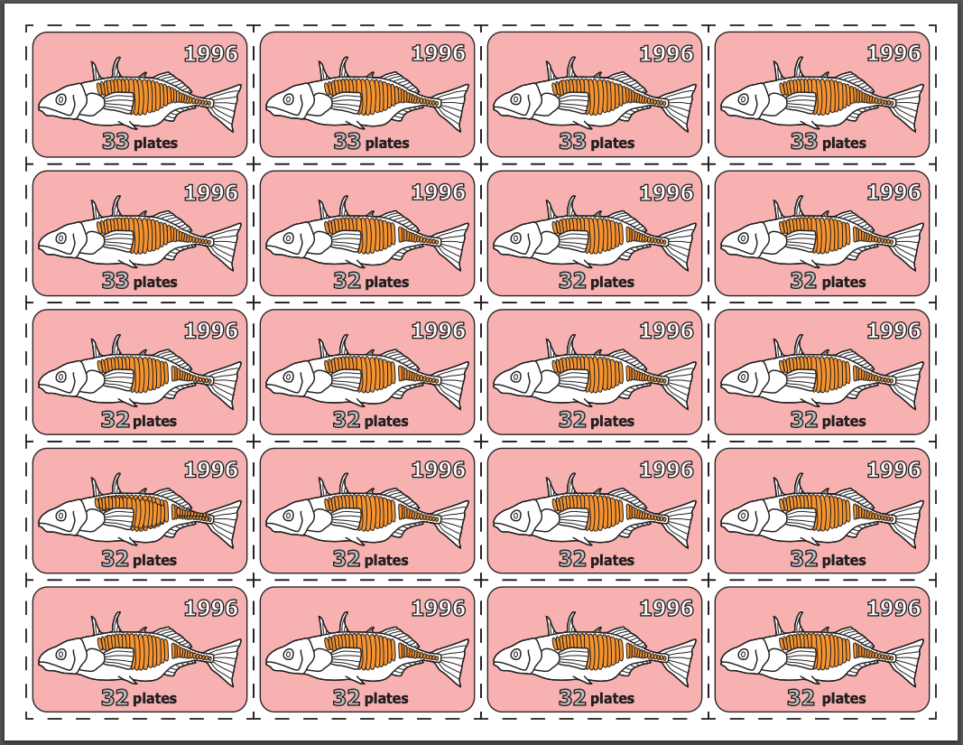

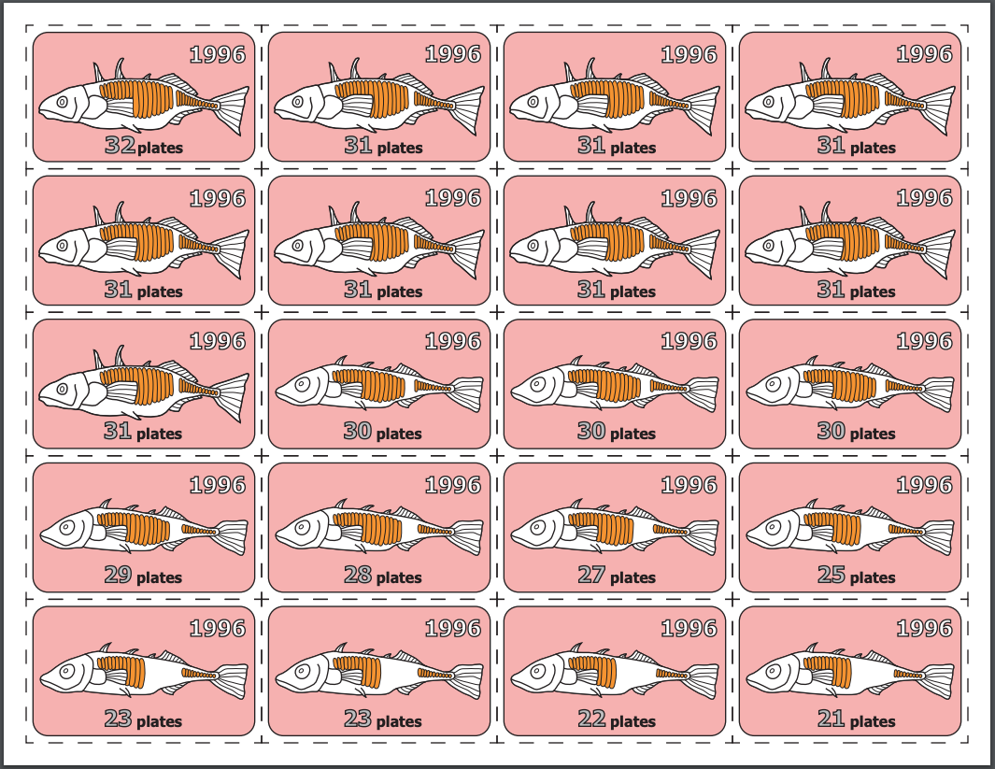

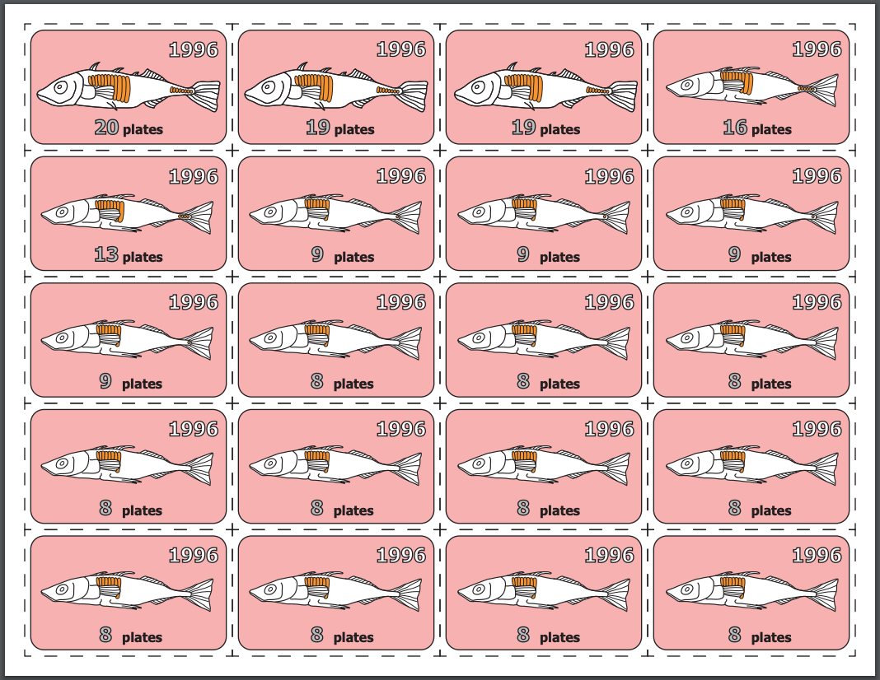

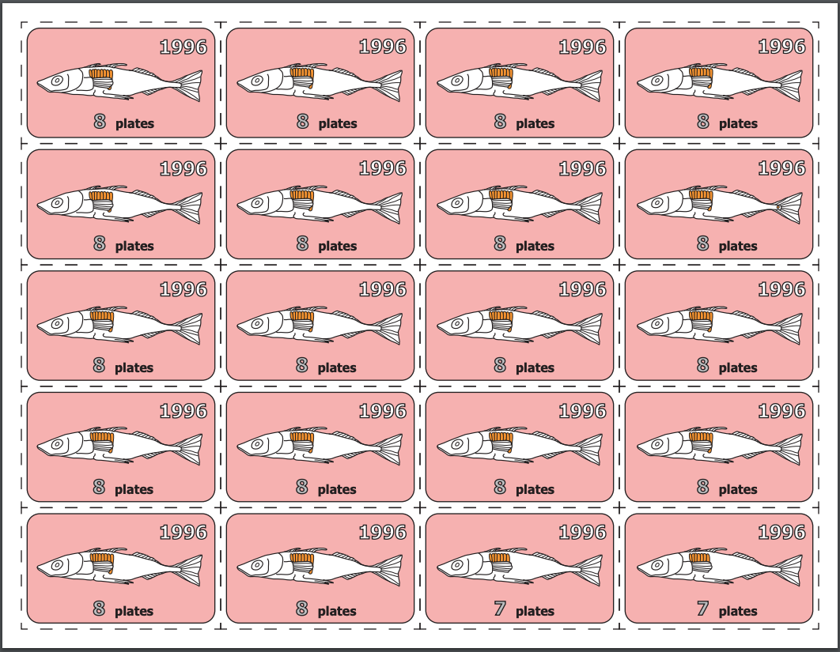

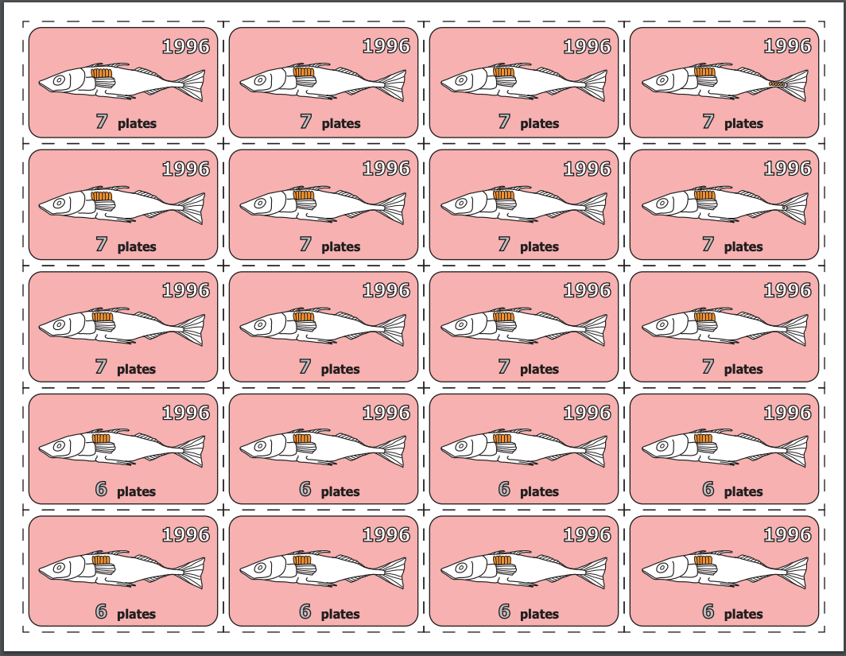

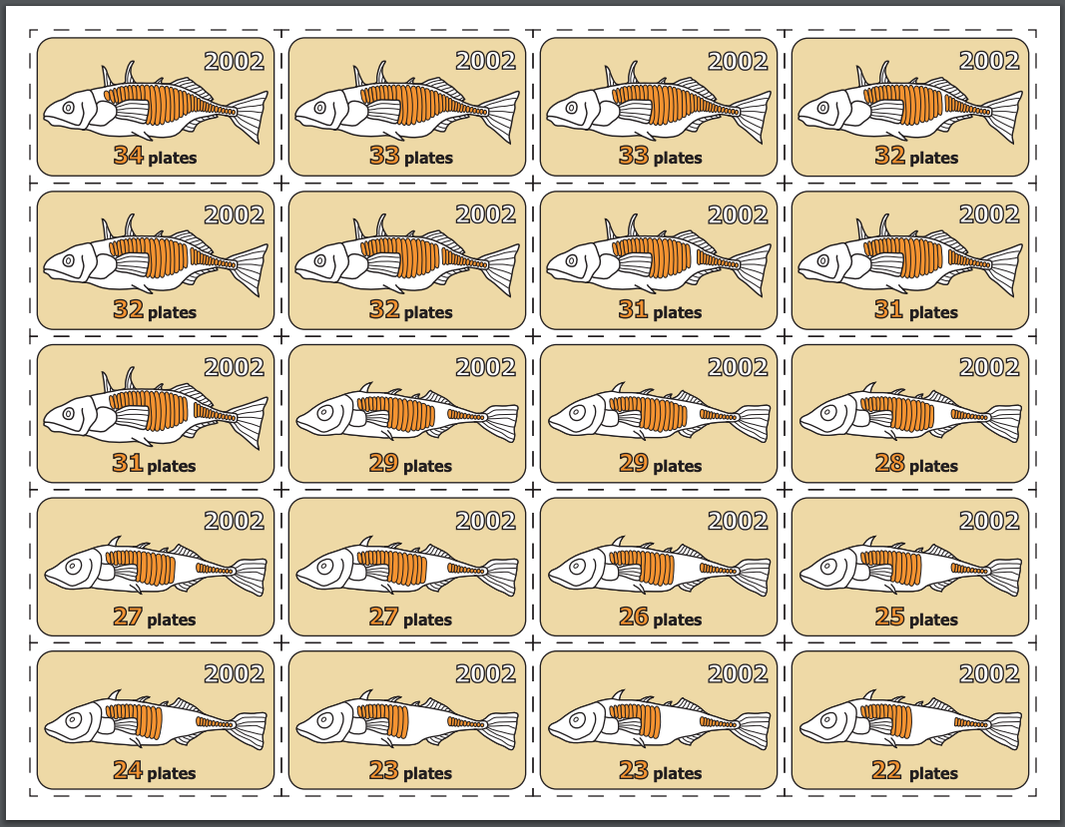

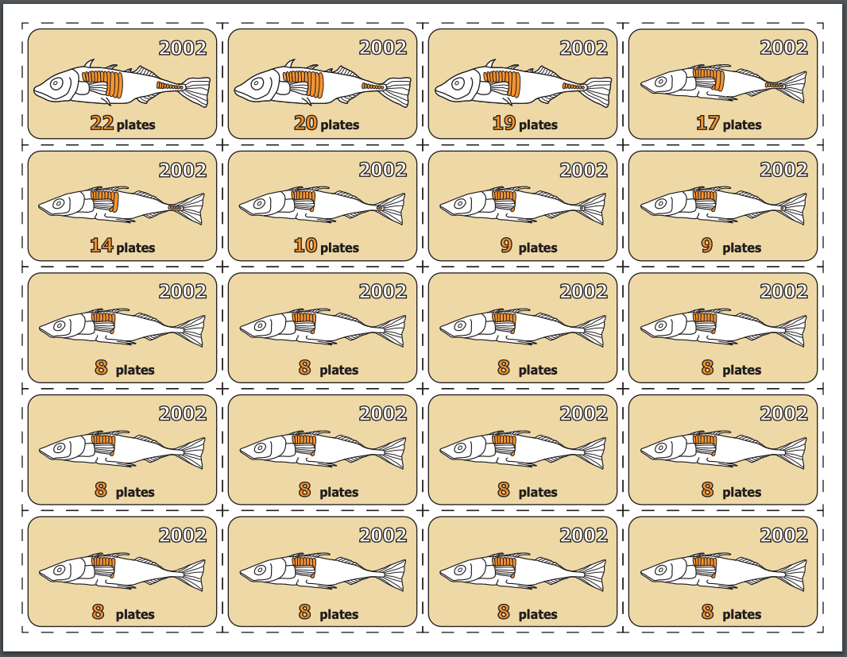

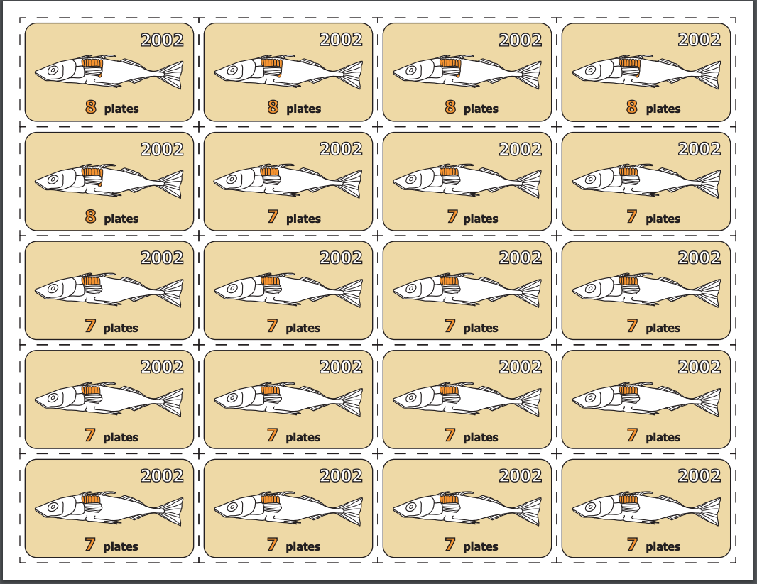

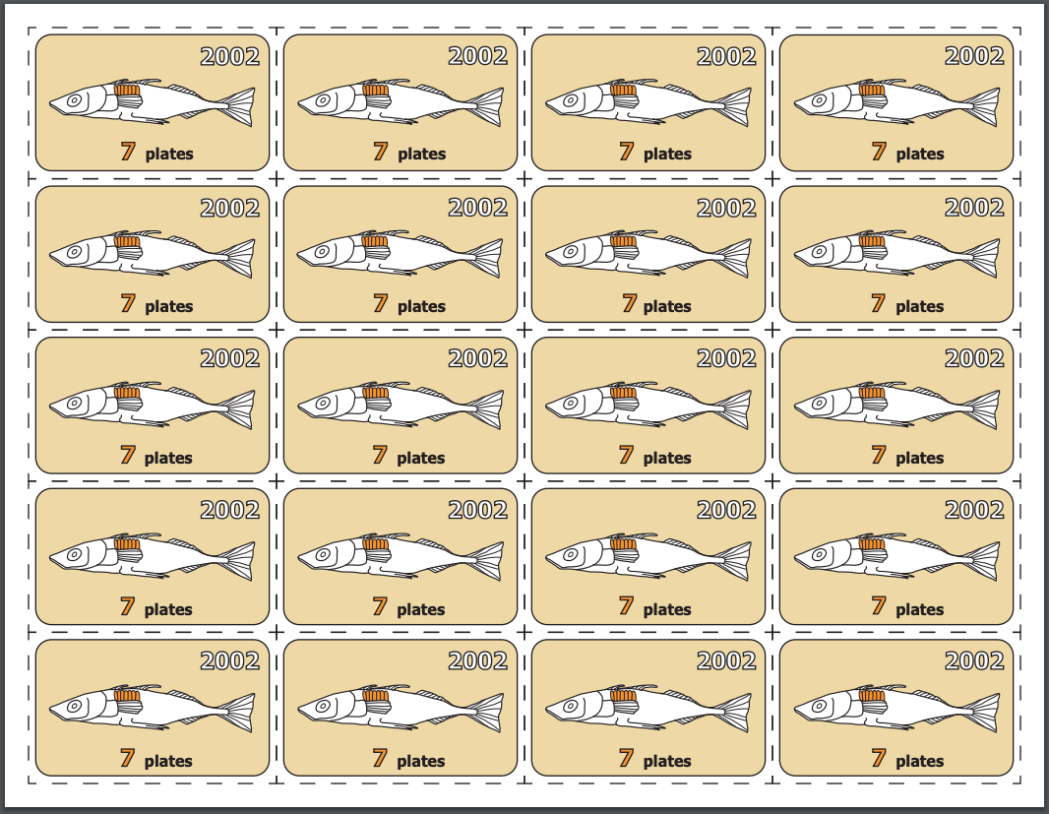

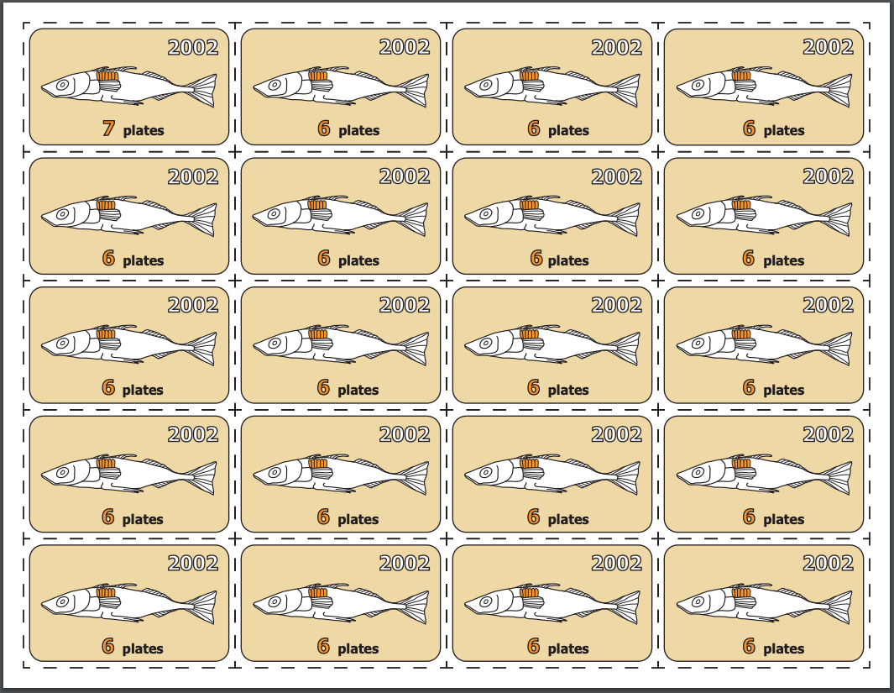

Lesson 3 Part 1 Data Cards- 1 Card per student or pair
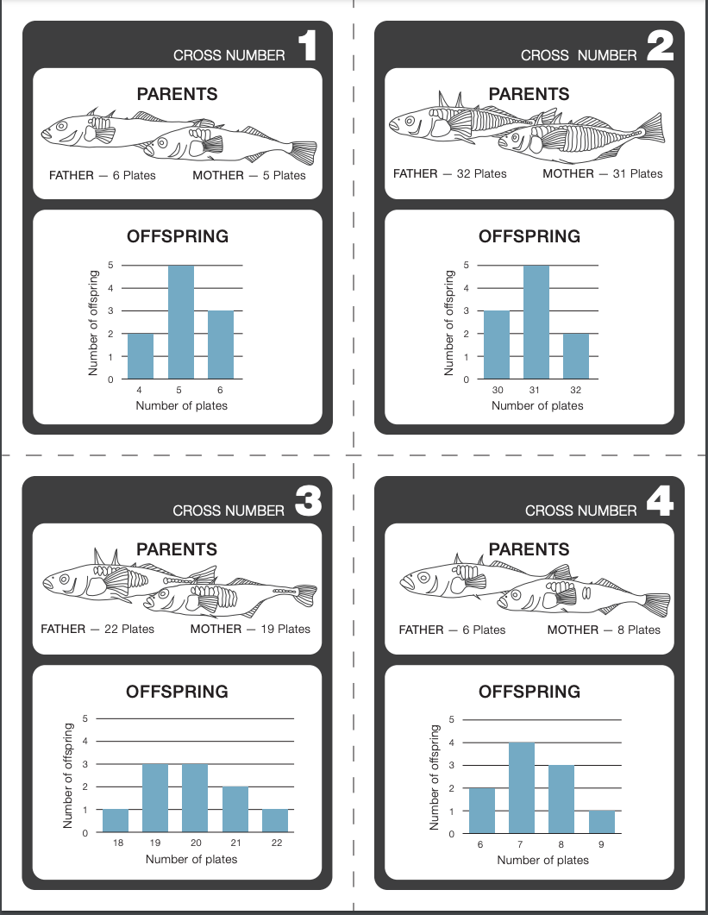
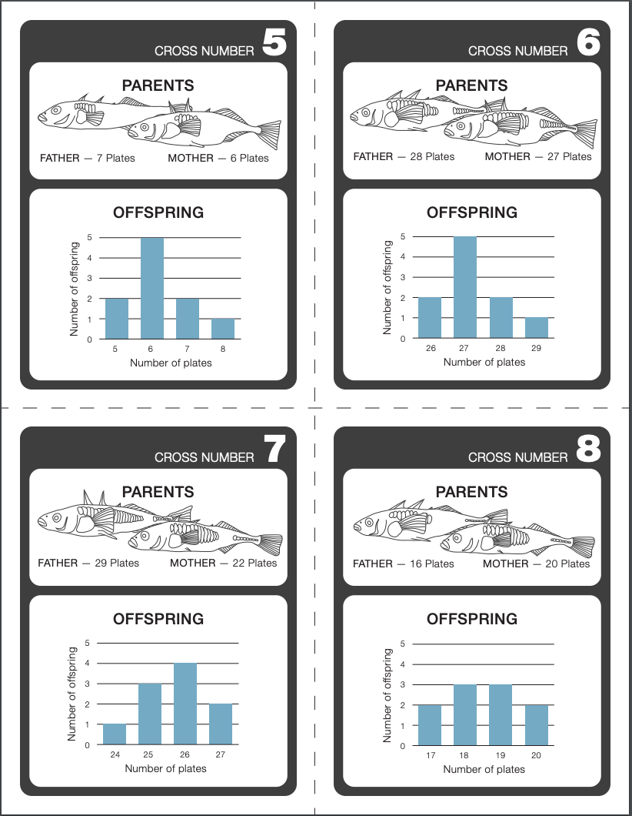

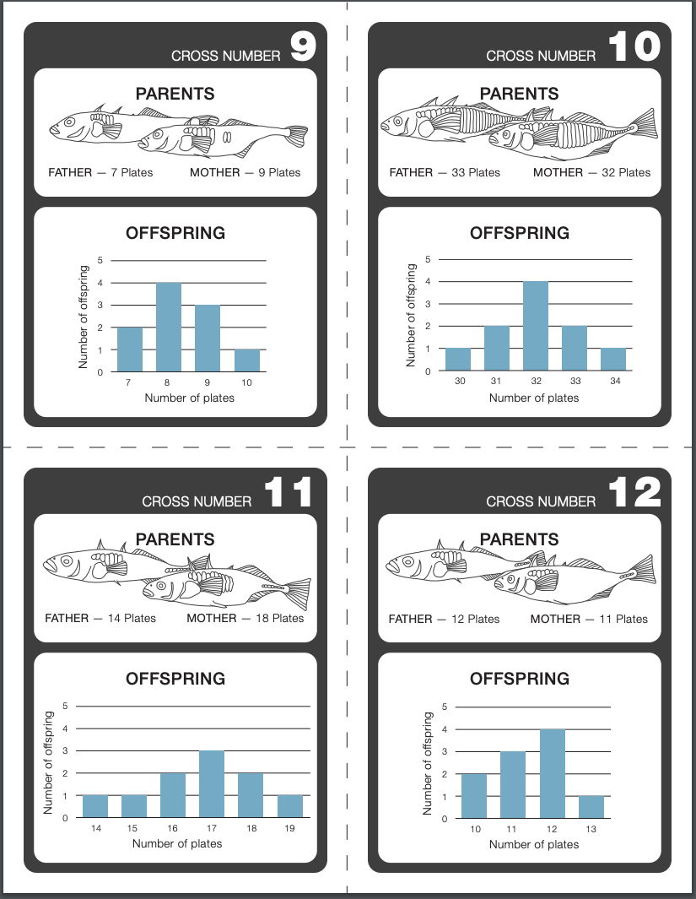

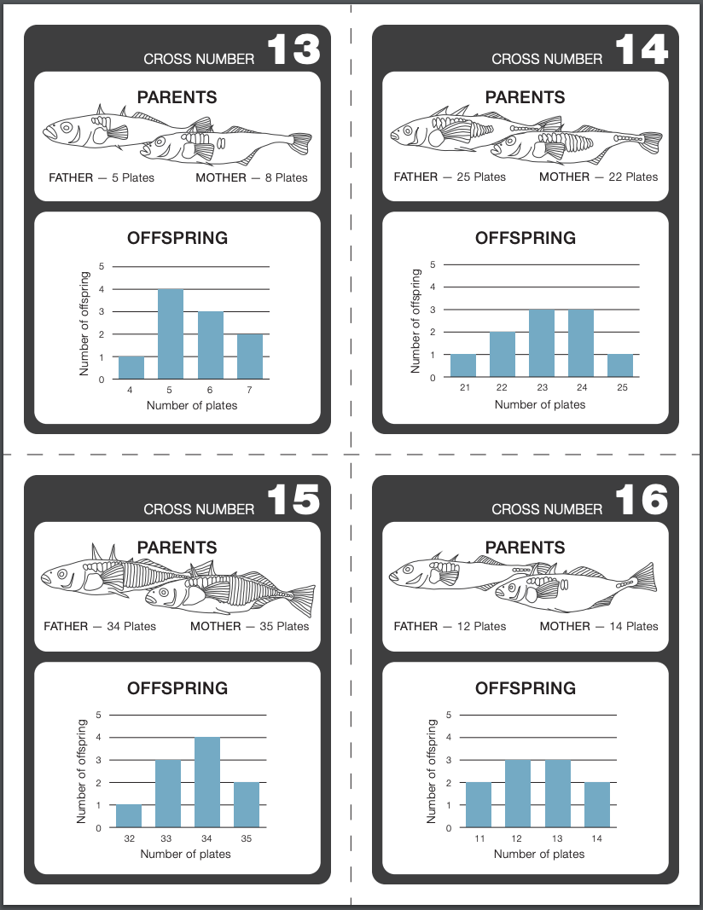

Lesson 3 Part 1 Worksheet- 1 Worksheet per student.

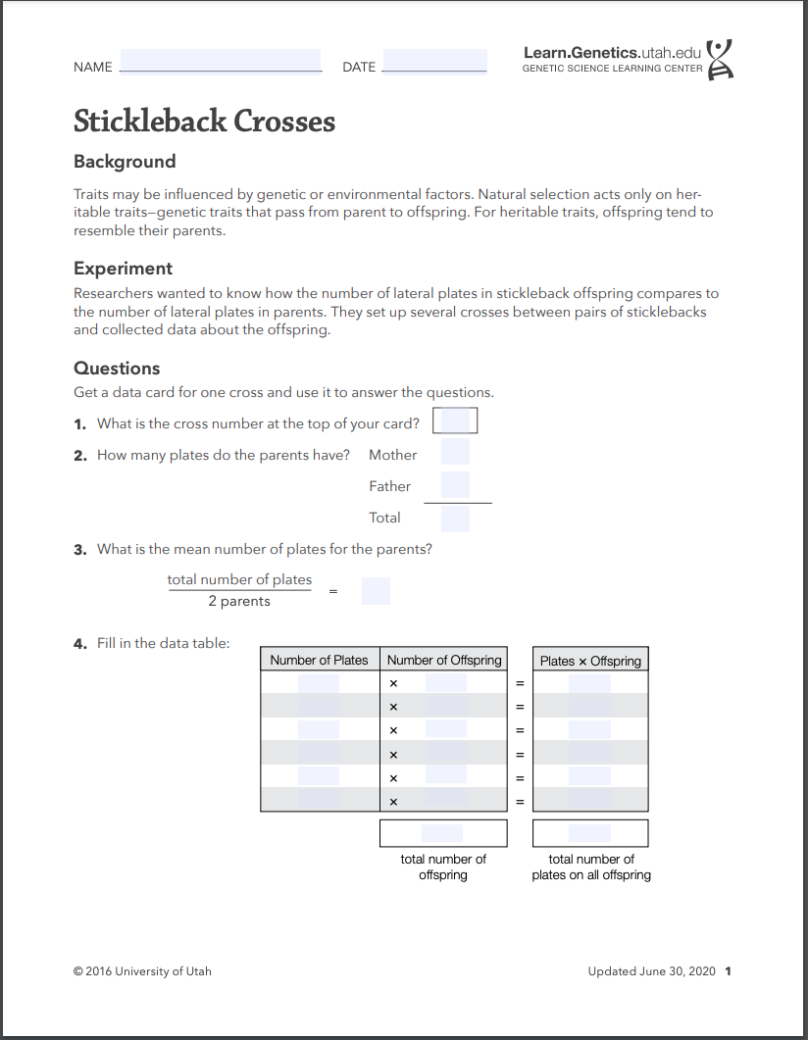

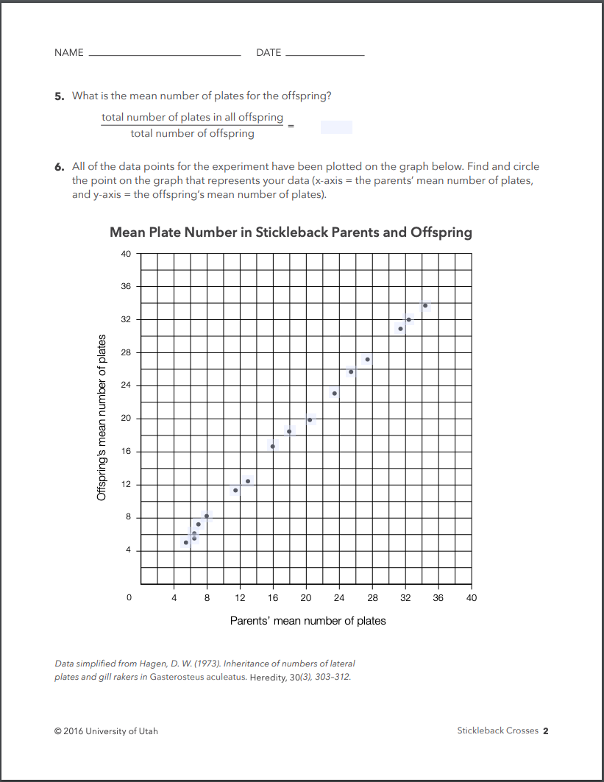
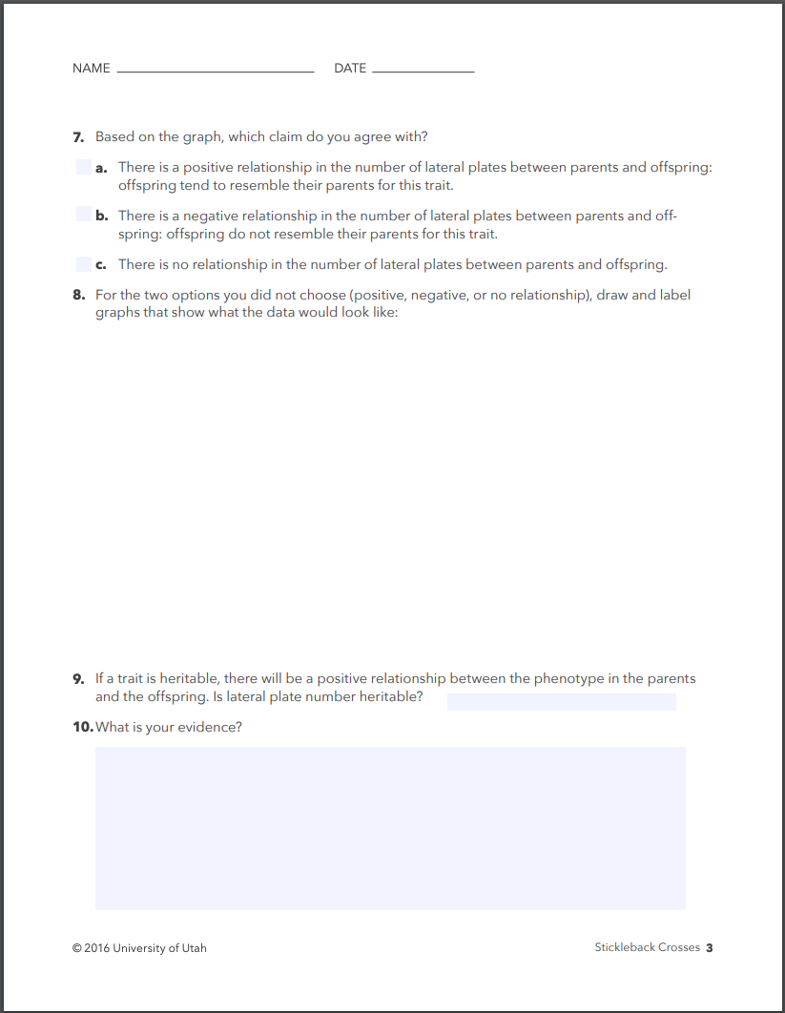

Lesson 3 Part 1 Teacher Demo Sheet (with answers)
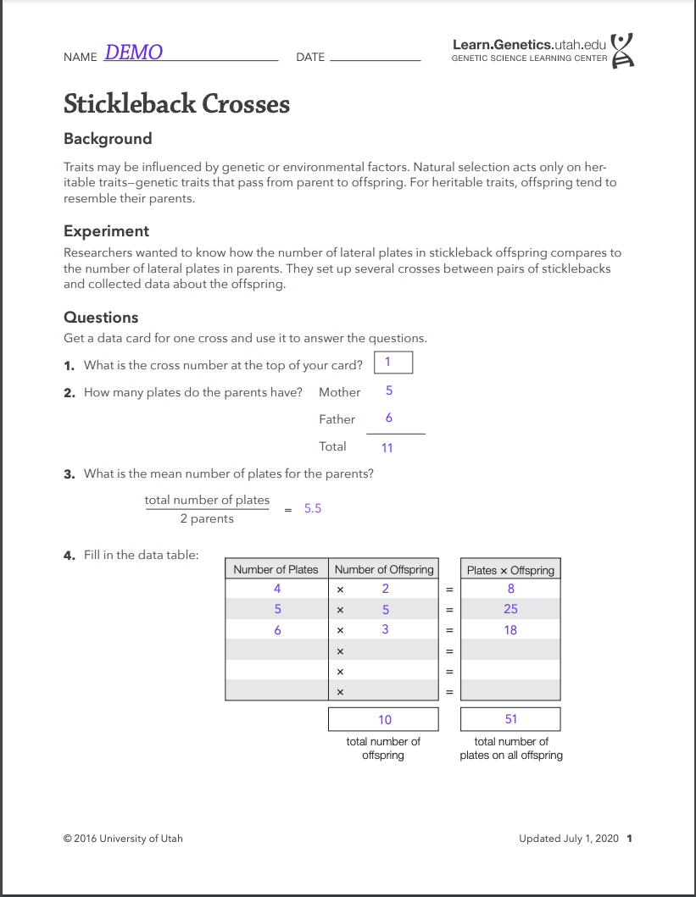
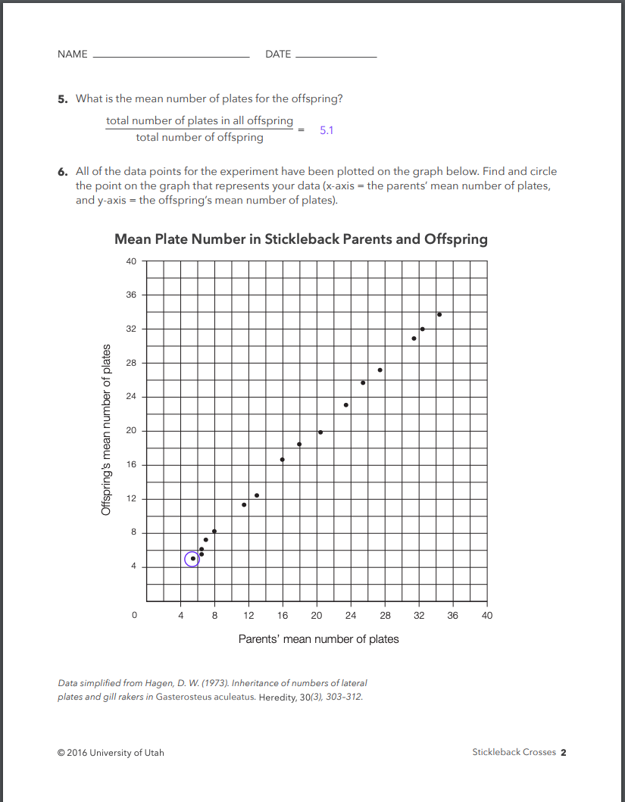

Lesson 3 Part 2 Student Worksheet Candidate Gene Approach
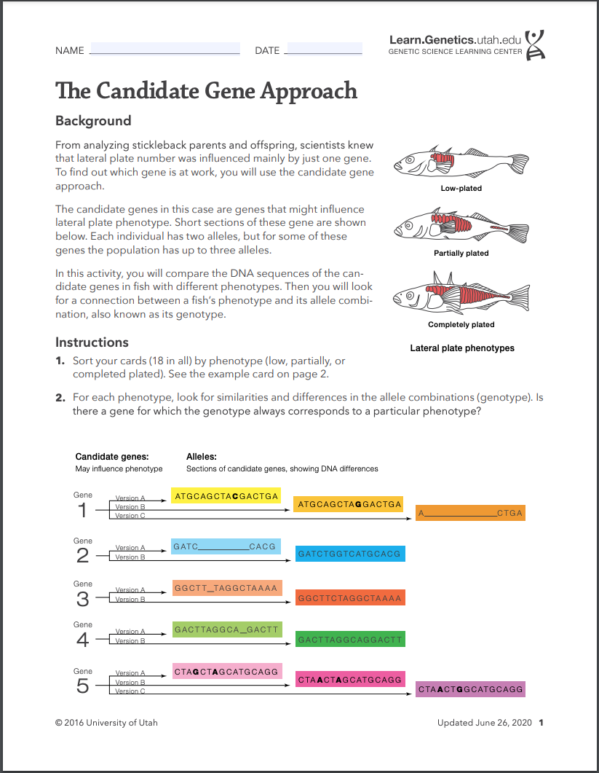
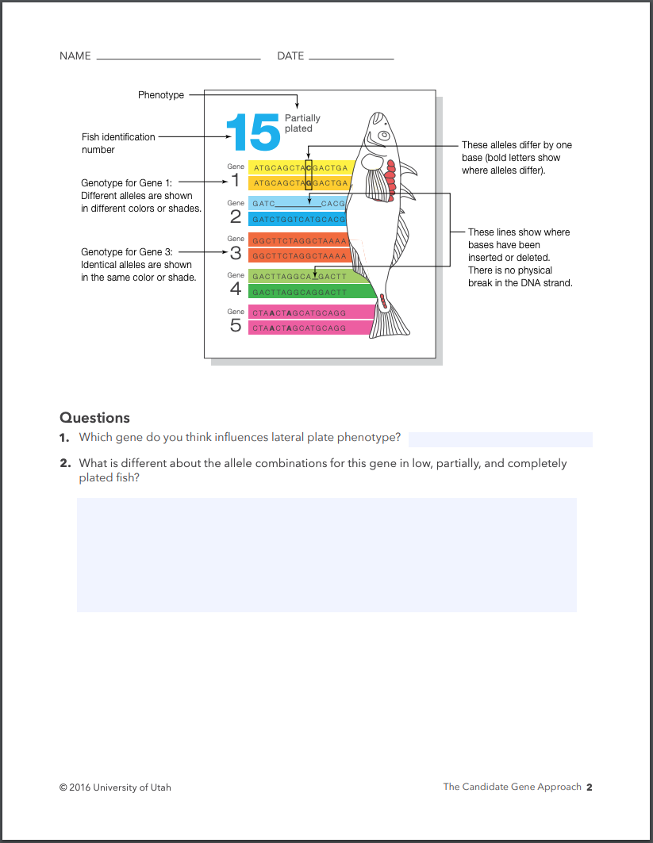

Lesson 3 Part 2 Gene Cards Candidate Gene Approach 1 copy per student or pair
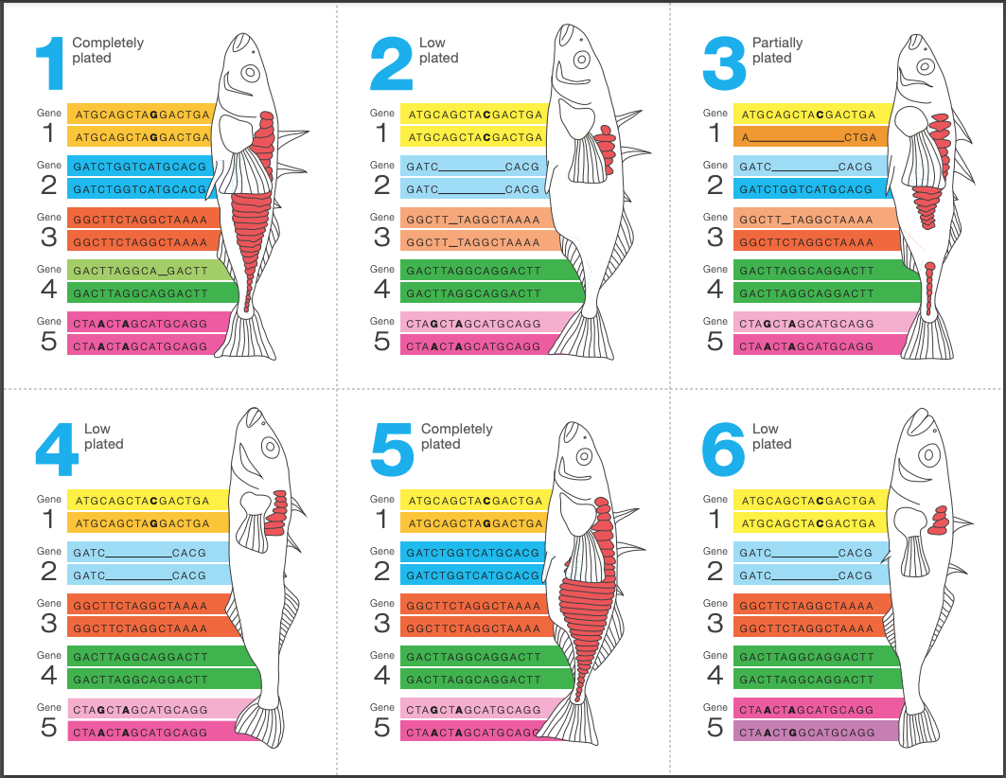

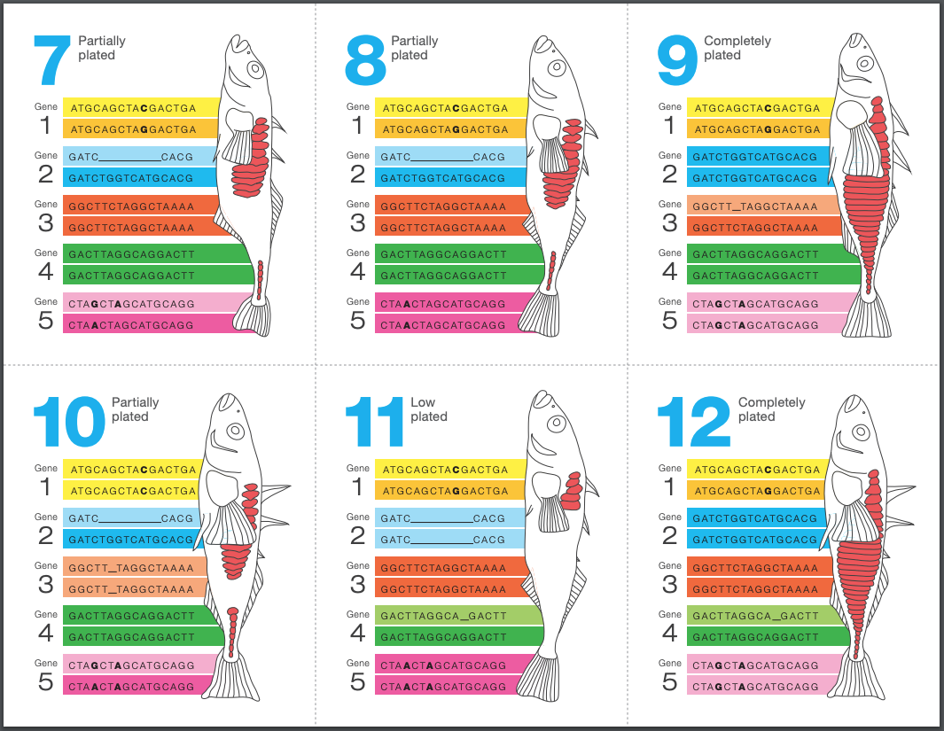

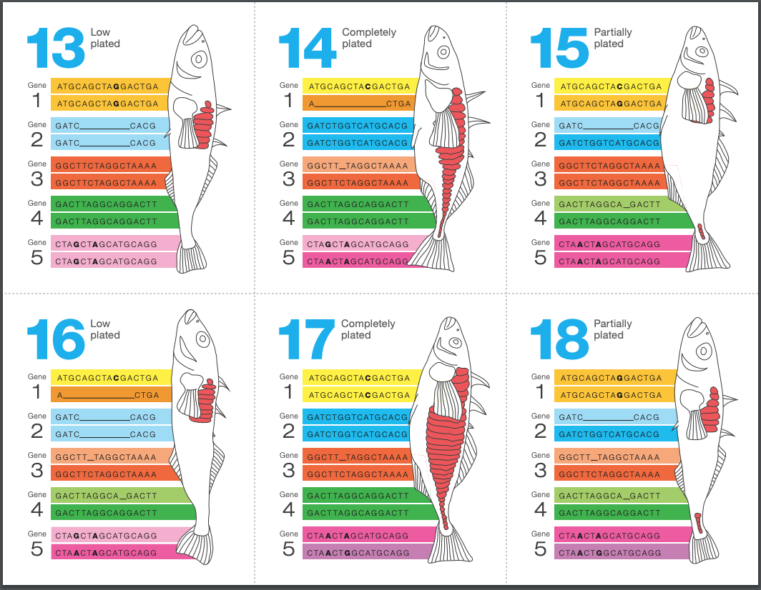

Lesson 3 Part 2 Eda Reading 1 per student
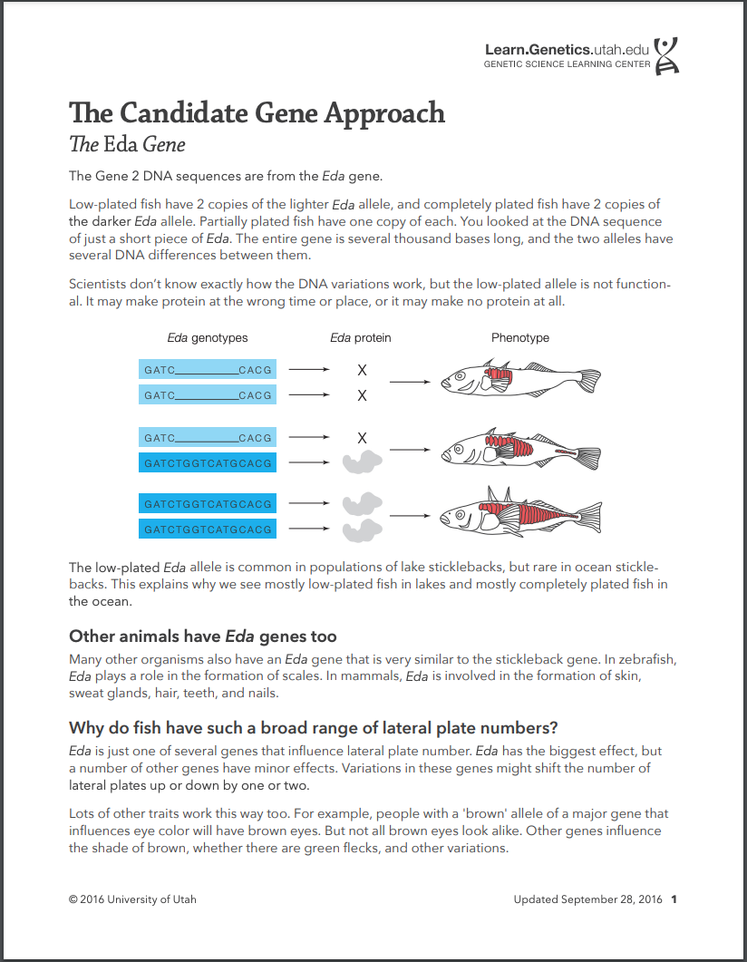

Lesson 4 Reproductive Advantage 1 per student or pair
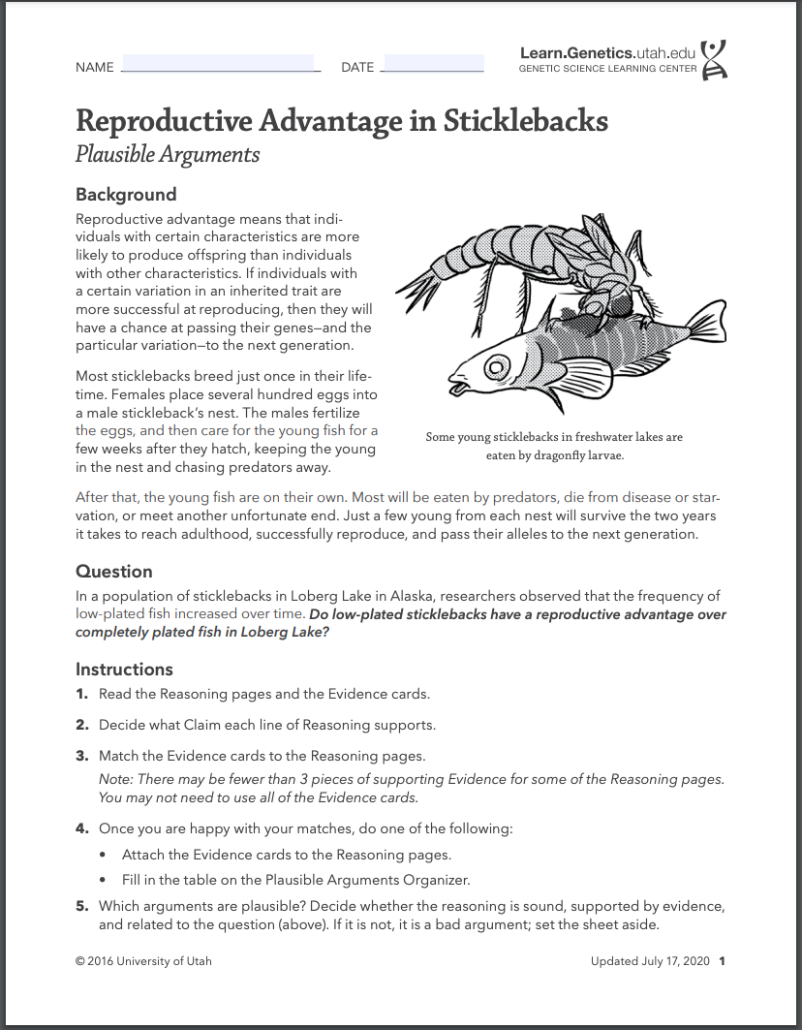
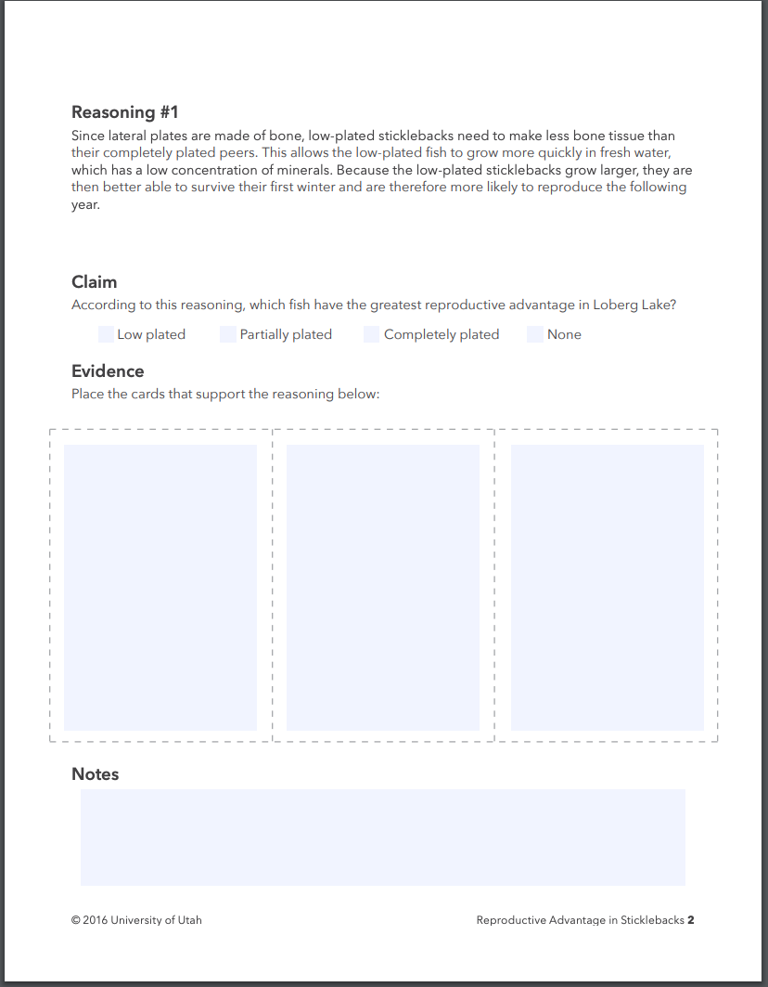

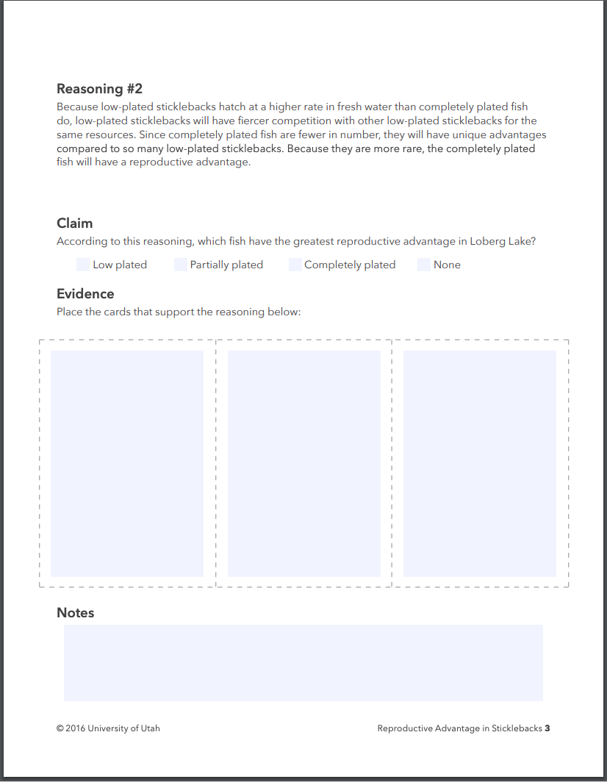

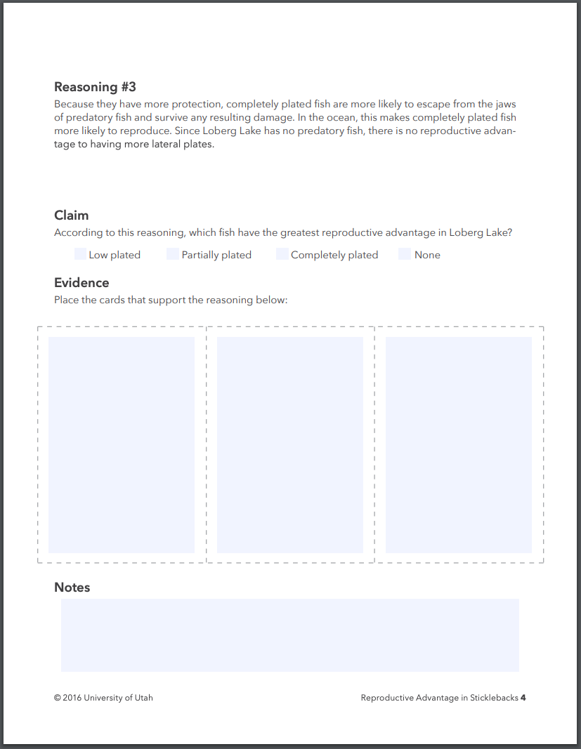

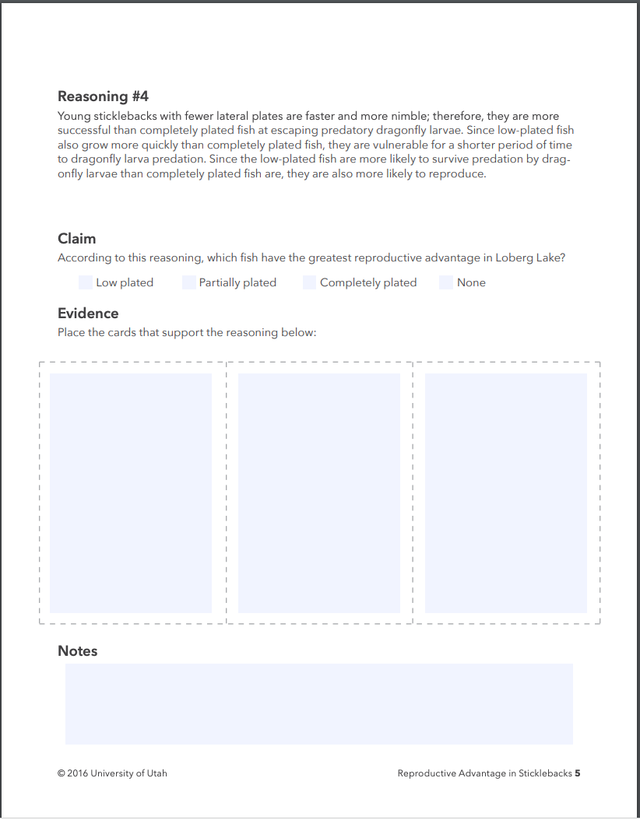

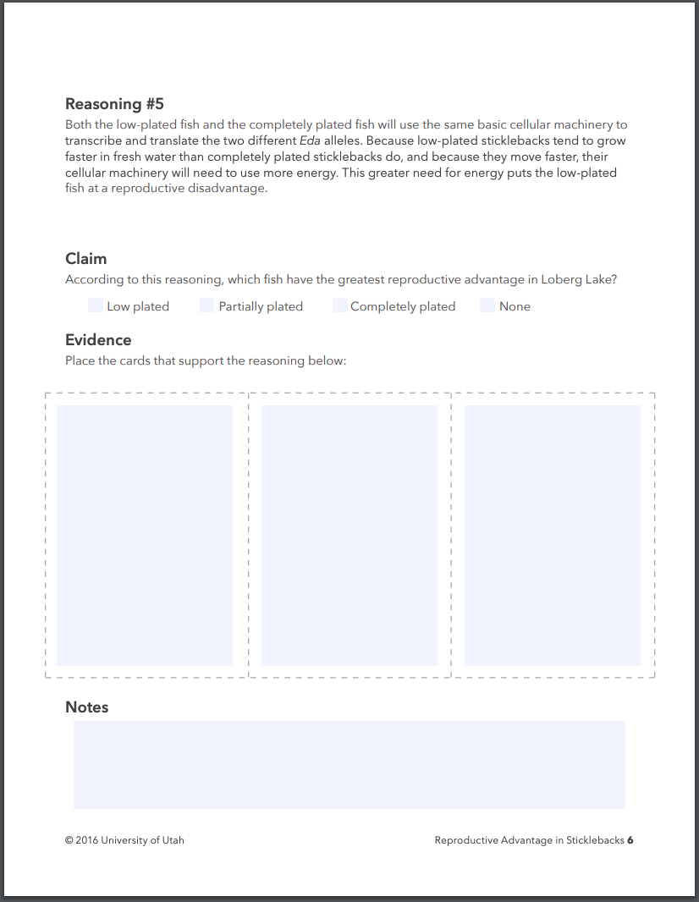

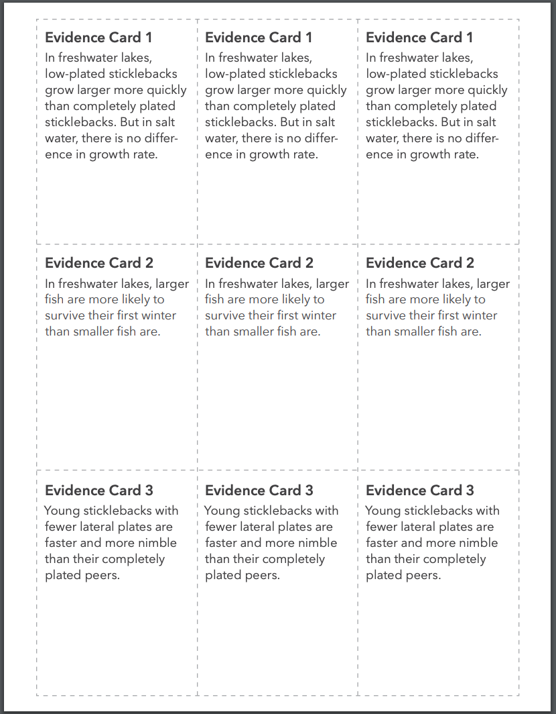

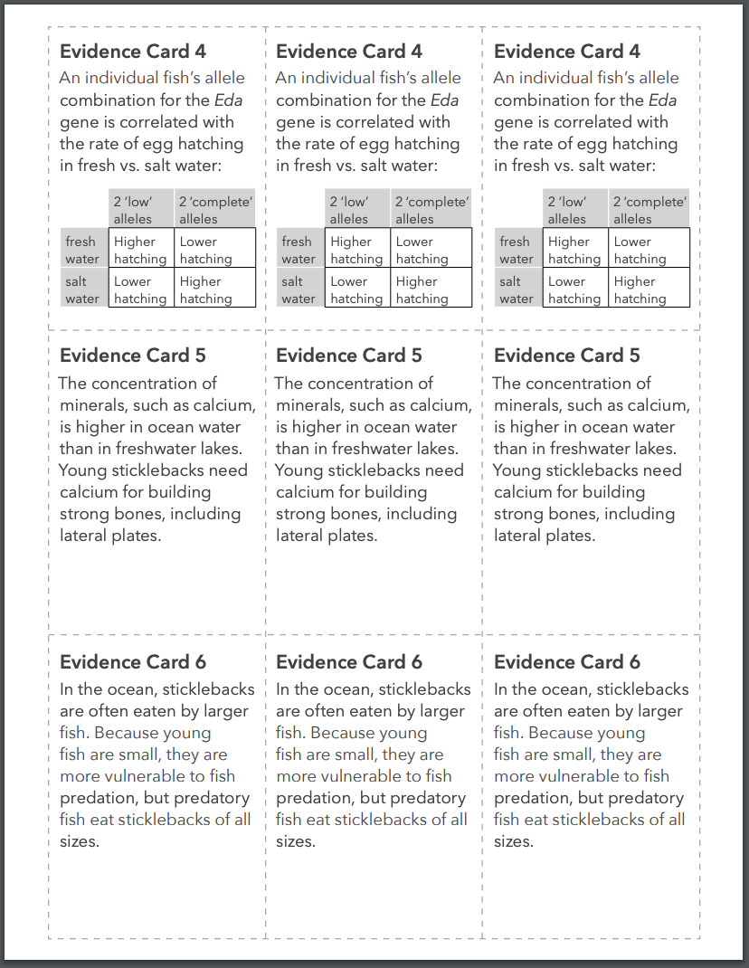

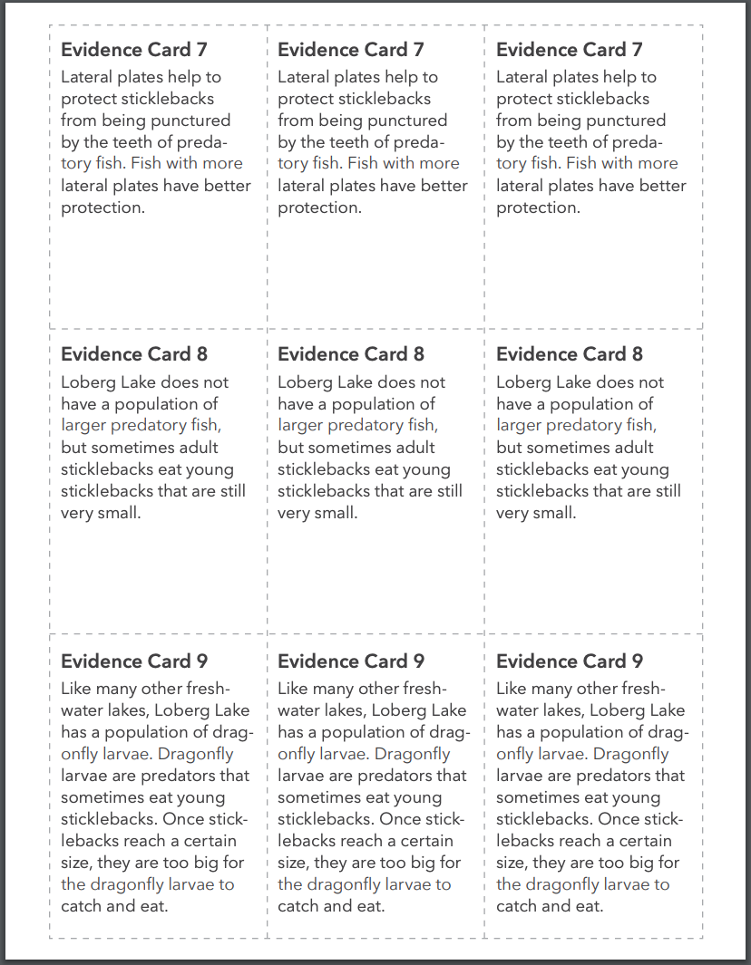

Lesson 4 Student Worksheet 1 per student
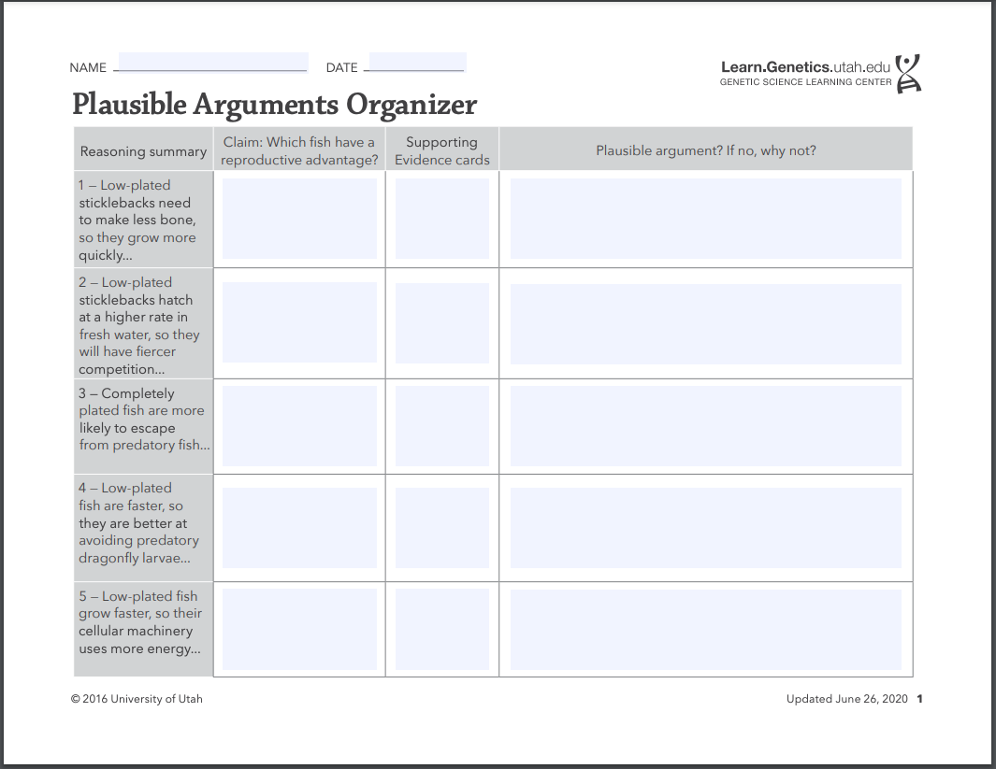
Lesson 5 - Natural Selection checklist
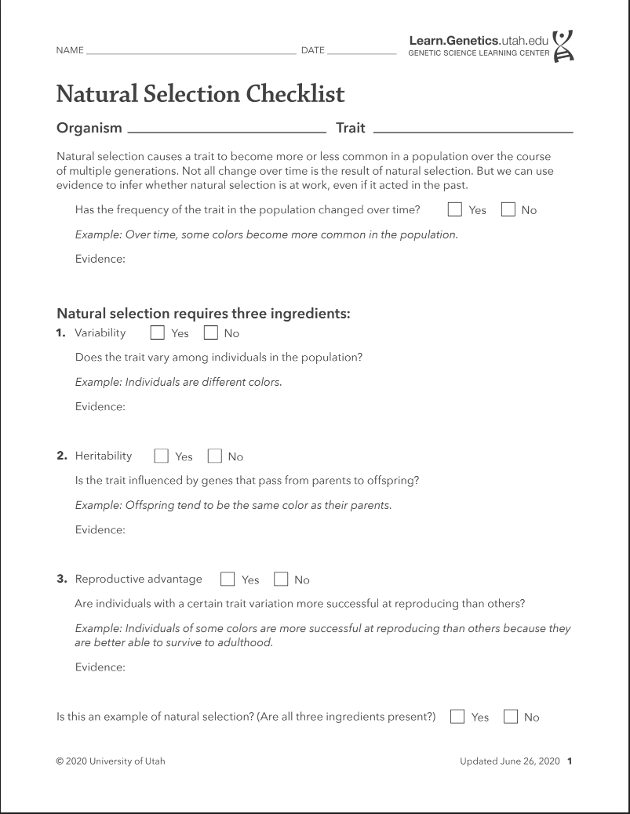

Lesson 5 - Natural Selection Argument worksheet
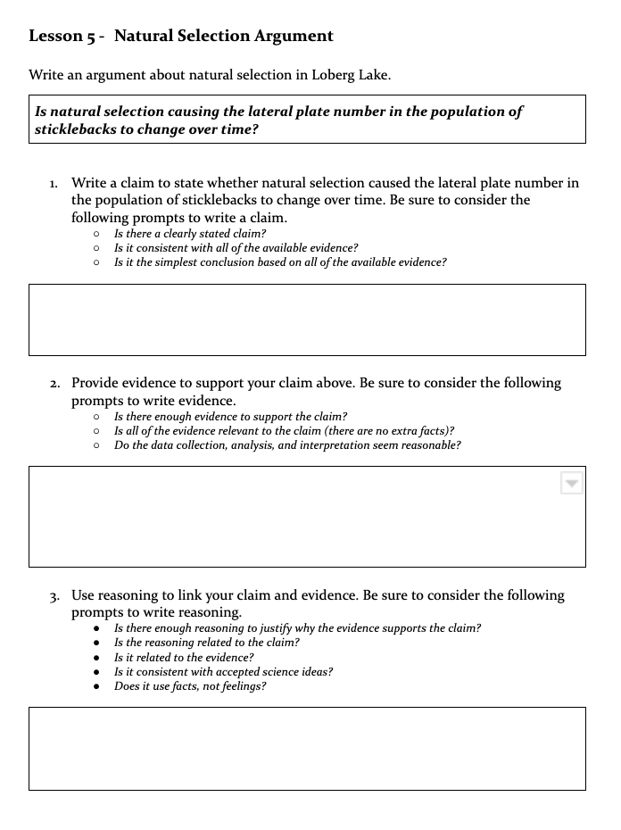

Lesson 5 Evaluating Arguments Checklist

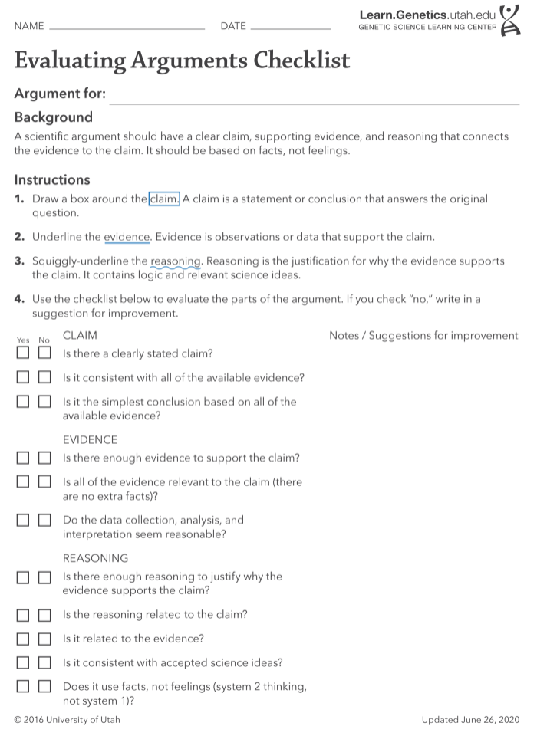

Lesson 6 - Adaptation through Natural Selection Argument Monkeyflower

Write an argument about adaptation through natural selection affects the two varieties of Monkeyflowers.
Is adaptation, through natural selection, causing the differences in the two varieties of monkeyflowers?

- Write a claim to state whether adaptation, through natural selection, caused the differences between the two varieties of monkeyflowers- one coastal and one inland. Be sure to consider the following prompts to write a claim.
  - Is there a clearly stated claim?
  - Is it consistent with all of the available evidence?
  - Is it the simplest conclusion based on all of the available evidence?

- Provide evidence to support your claim above. Be sure to consider the following prompts to write evidence.
- Is there enough evidence to support the claim?
- Is all of the evidence relevant to the claim (there are no extra facts)?
- Do the data collection, analysis, and interpretation seem reasonable?

- Use reasoning to link your claim and evidence. Be sure to consider the following prompts to write reasoning.
- Is there enough reasoning to justify why the evidence supports the claim?
- Is the reasoning related to the claim?
- Is it related to the evidence?
- Is it consistent with accepted science ideas?
- Does it use facts, not feelings?

Lesson 6 Evaluating Arguments Checklist

