|  |
| --- |
| **Learning Set 2: How Does Diabetes Affect Monique’s Body Systems?** |

|  |  |  |  |  |  |
| --- | --- | --- | --- | --- | --- |
| |  | | --- | | **Unit Driving Question:**  What controls my health?  **Sub-Driving Question:**  How does diabetes affect Monique’s body systems? | | |  | | --- | | **Materials List**   * Computer - one per pair of students * Projector - one for the class * Sticky notes * Markers * The [***Diagnosing Diabetes*** by ***Science Take Out***](http://www.sciencetakeout.com/product/diagnosing-diabetes/). * Diabetes Science Take Out kit Teacher Guide (with answers in LS 2 resource folder)   **End of Learning Set Assessment/Rubric** |   **Learning Set Level Teacher Rubric: See Assessment Folder for Assessment item and teacher rubric** | |  | | --- | | **Suggested lesson time**  4 days | |

**Student materials:**

* Intro to the Learning Set Monique Video Entry #3:

<https://youtu.be/r4ZeF54SqL8?si=BBL-e-j68ZScs6qx>

* Lesson 1 Monique Video Entry #1:

<https://youtu.be/IpdpjXLfX-w?si=E5xOKwXTxJp7kN-G>

* Lesson 1 Monique’s First Visit to the Doctor (Reading)

## Lesson 1 PART 2: Analyzing Blood Glucose Levels (handout)

## Lesson 2 PART 3: Graphing and Analyzing Blood Insulin Levels (handout)

* Lesson 3 What is Diabetes (Reading)
  + Notes for guiding questions (handout)
* Lesson 3 Juvenile Diabetes video: <https://drive.google.com/file/d/0B7HmdI-QMsuDbXdaUXJySXRMM1U/view?usp=sharing>
* Lesson 3 The Pancreas video:

<https://youtu.be/skNyttpRVpg?si=9Tgh3AqAFeFgz6fQ>

* Lesson 4 Monique’s Lab Report (Handout)

|  |
| --- |
| **Framing the Learning Set** |

**Purpose**

The purpose of this learning set is to support the students in figuring out how the functioning of body systems may result in the expression of diabetes and influence health. They will use a hands-on simulation and scientific text about diabetes in their investigation. Then, the teacher will guide students to develop a consensus model regarding Monique’s diabetes to answer the sub-driving question:How does diabetes affect Monique’s body systems?

**Learning Set Learning Goals (For instructional use)**

* The students carry out blood tests to figure out how glucose levels indicate the condition of Type 1 or Type 2 diabetes.
* The students construct a scientific explanation about the mechanisms, causes, and effects of diabetes.
* The students develop models of diabetes.
* Optional Extension Activity- The students obtain, evaluate, and communicate information about the mechanisms, causes, and effects of diabetes.

Color code: Scientific Practice, Crosscutting Concept, Disciplinary Core Idea

**Building Coherence – See the Storyline**

In this learning set, students continue to investigate Monique’s characteristics, health, and diabetes. They collect detailed information about mechanisms, causes, and effects of diabetes from a hands-on simulation and scientific text to answer some of the questions they generated in Learning Set 1. Students also develop a model with components related to diabetes and the human body.

|  |
| --- |
| **Overview of the Learning Set** |

|  |  |  |
| --- | --- | --- |
| **Instructional Sequence Overview** | **What students figure out (DCI)** | **Days** |
| **Lesson 1 - How Do You Know If You Have Diabetes?**  The students perform a glucose tolerance test on simulated blood plasma samples and analyze and interpret data to determine if the person has diabetes.  **(PART 2: Analyzing Blood Glucose Levels from Diagnosing Diabetes** **by** **Science Take Out)** | The body is a system of multiple interacting subsystems. These subsystems are groups of cells that work together to form tissues or organs that are specialized for particular body functions. | **1 day** |
| **Lesson 2 -How Do We Know If Someone Has Type 1 Diabetes or Type 2 Diabetes?**  The students perform an insulin test on simulated blood plasma samples and analyze and interpret data to determine if the person has Type 1 or Type 2 diabetes.  **(PART 3: Analyzing Blood Insulin Levels from Diagnosing Diabetes** **by** **Science Take Out)** | **1 day** |
| **Lesson 3 - What is Diabetes?**  The students read scientific texts to describe patterns in and evidence about mechanisms and cause and effect of diabetes. | **1 day** |
| **Lesson 4 - What Can You Conclude About Monique’s Health?**  The students write a scientific explanation based on the evidence in the form of a lab report to explain the results of Monique’s blood test. | **1/2 day** |
| **Lesson 5- Modeling: Why does Monique have diabetes?**  Guided by their teacher, the students build a model about the mechanism of diabetes. Then, they s discuss the components of their models, and evaluate the relationships presented. The students revisit the **Driving Question Board** **(DQB)** and reflect upon their learning. | **½ day** |
| **End of Learning Set Assessment- Google Forms** | | **½ class hour** |
| **Optional Extension Activity - How Would You Explain Diabetes to Monique?**  The students develop a visual representation (brochure, infographic or video) for the public to integrate their findings with scientific information about the mechanism of diabetes and how it affects body systems.  **(Based on PART 1: What you should know about diabetes and the glucose tolerance test from Diagnosing Diabetes** **by** **Science Take Out)** | | **1 day** |

|  |
| --- |
| **NGSS Connection to Assessment** |

|  |
| --- |
| **Target Performance Expectations**  [MS-LS1-3.](http://www.nextgenscience.org/pe/ms-ls1-3-molecules-organisms-structures-and-processes) Use arguments supported by evidence for how the body is a system of interacting subsystems composed of groups of cells. |
| **Learning Performances for Learning Set 2 to be Assessed**  Students construct a scientific explanation based on data to explain how body systems influence the growth and health/development of organisms.   |  |  |  | | --- | --- | --- | | **Disciplinary Core Idea** | **Science and Engineering Practices** | **Crosscutting Concepts** | | **LS1.A: Structure and Function**  **In multicellular organisms, the body is a system of multiple interacting subsystems. These subsystems are groups of cells that work together to form tissues and organs that are specialized for particular body functions.** | **Constructing an explanation**   * Construct an explanation using models or representations. | **System and System Models**   * Systems may have sub-systems and be a part of larger complex systems. * Systems can use models to represent systems and their interactions | |
| **How these elements are integrated and embedded in this learning set**  Students will figure out if Monique has Type 1 or Type 2 diabetes by conducting a glucose tolerance test on simulated blood plasma samples and analyzing the results. Students will integrate their findings about the blood work with scientific information obtained from reading about the mechanisms and the multiple causes and effects of diabetes. Then, students will write a scientific explanation about Monique’s diabetes. Students will also create a model to explain the biological mechanism of diabetes. As an optional extension activity, students can create a visual representation for the public about diabetes based on their findings. |

|  |
| --- |
| **Connection to Students’ Lives** |

**Link to Out-of-School Activity and Everyday Life**

* Encourage students to share their visual representation (from the Optional Extension Activity) with their peers and family at home. Discuss feedback from these audiences.
* School personnel or family members may agree to come talk with students about their experience finding out and managing their diabetes.

**Link to Career-Awareness** **in Science and STEM**

* This learning set provides an opportunity to discuss medical and public health careers related to diabetes. Students will take the role of lab technicians in the case scenario helping Monique’s doctor figure out Monique’s health issue. Students also take the role of health educators developing materials to explain diabetes to the public. One suggestion could be to contact local hospitals or health departments etc. to obtain speakers with careers related to diabetes. Family members may have jobs related to this case scenario. Local resources can be found at the American Diabetes Association website: <https://www.diabetes.org/>

|  |
| --- |
| **Instructional Sequence** |

**Introducing the Learning Set**

1. **Link to Career-Awareness** **in Science and STEM**. This learning set provides an opportunity to discuss biomedical and public health careers related to diabetes. Students will first take the role of lab technicians in the case scenario helping Monique’s doctor figure out Monique’s health issue. Students interested in a career in health care may want to know more about educational programs such as [Biological Laboratory Diagnostics Program](https://bld.natsci.msu.edu/). An optional extension activity invites students to take the role of health educators developing materials to explain diabetes to the public.
2. **Keeping coherence using the DQB**. Remind students of their questions related to Monique and diabetes on the Driving Question Board (DQB). Tell students that in this learning set they will further investigate the case study of Monique to determine how her characteristics are affecting her health. They should pay particular attention to the questions clustered around the Sub-Driving Question (SDB): **How does diabetes affect Monique’s body systems?**
3. **Introducing the learning set**. Play the [Learning diary entry #3 video clip of Monique](https://youtu.be/r4ZeF54SqL8?si=OrAvDoUu0JZeWkFo) (1:41 minutes). Discuss what students found out from the video and what they want to know. Monique talks about the importance of having a good understanding of diabetes and all the parts involved with having diabetes. Students will be exploring more about diabetes in this lesson. In this learning set, students will act as lab technicians helping Monique’s doctor figure out Monique’s health issue.

|  |
| --- |
| **Lesson 1 - How Do You Know If You Have Diabetes?** |

|  |  |
| --- | --- |
| **Learning Goal** | The students carry out blood tests to figure out how glucose levels indicate the condition of Type 1 or Type 2 diabetes. |
| **Connection to NGSS** | DCI: LS1.A: Structure and Function |
| Practice: Analyzing and interpreting data |
| CCC: System and system models |

1. **Introducing the case study.** Introduce a [video entry #1](https://youtu.be/IpdpjXLfX-w?si=xwF1_ZVc2ih2FgWh) of Monique explaining how she felt when she was first diagnosed with Type 2 diabetes.
   1. Discussion
      1. How does someone know they have diabetes?
      2. How do they know if they have Type I or Type II?
      3. Talk with your elbow partner and prepare to share out
2. **Monique’s First Visit to Her Doctor**. Ask students to read or read aloud. (Click here for the reading).
3. **Perform lab.** Students will perform a glucose tolerance test by analyzing simulated blood plasma samples. For this lesson, follow the instructions of the **PART 2 - Analyzing Blood Glucose Levels**of ***Diagnosing Diabetes by Science Take Out***. (Diabetes Science Take Out Teacher Guide (with answers in resource folder))
4. **Data analysis discussion.** Once you and your students have completed the glucose tolerance test, use the following questions as a guide for discussion. Possible answers are included.

|  |
| --- |
| ***IMPORTANT Note for the teacher***   * *Use the questions listed below instead of the questions included in the Diagnosing Diabetes by Science Take Out kit.* * *Students do not have enough information to answer some of the questions on page 7 in the ‘Diagnosing Diabetes by Science Take Out’ at this point. Those questions will actually be answered after Lesson 3.* |

1. What is the blood glucose level for the healthy person at the beginning of the glucose tolerance test?
   * Answer: Around 70mg/dL
2. What happened to the blood glucose level for the healthy person right after drinking the glucose solution?
   * Answer: The blood glucose level increases for 30 min until it reaches about 170mg/dL
3. What happens to the healthy person’s blood glucose levels after 30 minutes?
   * Answer: The blood glucose level decreases gradually and goes back to 70mg/dL after 90 to 120 min.
4. How is the patient’s blood glucose level different from the levels in a normal healthy person?
   * Answers:
     + The blood glucose level is higher in the beginning (about 150mg/dL)
     + After taking the glucose solution, the blood glucose level increases and stays higher than normal level even after 120 min.
5. Based on the information in this graph, do you think the patient has diabetes? Support your answer with evidence from the graph.
   * Answer: Yes, the patient has diabetes because their blood sugar level rose higher and remained higher than the level shown for a healthy patient.
6. Do you have enough information to determine if the patient has Type 1 or Type 2 diabetes? If not, how would you figure this out?
   * Answer: No, we would need more information. Answers may vary on how they would figure this out.

|  |
| --- |
| **Lesson 2 - How Do We Know If Someone Has**  **Type 1 or Type 2 Diabetes?** |

|  |  |
| --- | --- |
| **Learning Goal** | The students carry out blood tests to figure out how glucose levels indicate the condition of Type 1 or Type 2 diabetes. |
| **Connection to NGSS** | DCI: LS1.A: Structure and Function |
| Practice: Analyzing and interpreting data |
| CCC: System and system models |

1. **Continue case study.** Introduce the next episode of the case study describing Monique’s second visit to the doctor.

|  |
| --- |
| A week after her first visit, Monique went back to the doctor for the results of her blood test. The doctor told her that her blood sugar level was higher than normal and said “Now we need to figure out whether you have Type 1 or Type 2 diabetes. To do this, we’ll need to test the level of a special chemical in your blood called insulin.” |

1. **Perform lab.** Students will perform an insulin test by analyzing simulated blood plasma samples. For this lesson, follow the instructions of the **PART 3 - Graphing and Analyzing Blood Insulin Levels**of**Diagnosing Diabetes by Science Take Out.**
2. **Data analysis discussion.** Once you and your students have completed the insulin test, use the following questions as a guide for discussion. Possible answers are included.

|  |
| --- |
| ***IMPORTANT Note for the teacher***   * *Use the questions listed below instead of the questions included in the Diagnosing Diabetes by Science Take Out kit.* * *Students do not have enough information to answer some of the questions on page 10 in the ‘Diagnosing Diabetes by Science Take Out’ at this point. Those questions will actually be answered after Lesson 3.* |

1. Compare the insulin levels in a healthy person with the insulin levels in the patient.
   * Answer: The patient released slightly more insulin than the healthy person.
2. Based on the information in the graph, do you think the patient has Type 1 or Type 2 diabetes? Support your answer with information from the graph.
   * Answer: The patient has Type 2 diabetes because they are producing insulin (Type 1 does not produce insulin). Our graph shows XYZ to support our claim about the patient having Type 2 diabetes.
3. Do you think this patient’s diabetes should be treated with insulin injections? Why or why not?
   * Answer: No. The graph shows that the patient can produce insulin.
4. How can the patient keep the glucose levels in normal range? What do you suggest for the best treatment plan?
   * Answer: Students should recommend options for treatment that can maintain the blood glucose level in normal range, such as through healthy lifestyle choices such as by controlling intake of sugar and being physically active. Medication can also be an option.
5. What health problems may result if the patient does not follow the treatment plan suggested to keep her blood glucose levels within normal range?
   * Answer: Feeling tired, thirsty, hungry all the time (this is from the reading they have done so far, they will also read more in the following lesson to be able to add to “problems” a patient with Type 2 diabetes might have.

|  |
| --- |
| ***Lesson 3 - What is Diabetes?*** |

|  |  |
| --- | --- |
| **Learning Goal** | The students obtain, evaluate, and communicate information about the mechanisms, causes, and effects of diabetes. |
| **Connection to NGSS** | DCI: LS1.A: Structure and Function |
| Practice: Obtaining, evaluating, and communicating information |
| CCC: Cause and effect |

1. **Obtaining information about diabetes from the reading**
   1. Link to the reading ‘What is diabetes?’
2. **Discussion**: Lead a classroom discussion using the guiding questions listed in the reading.
3. **Videos:** To provide further information/support for student learning, two suggested videos could be shown:
   1. [Juvenile Diabetes video](https://drive.google.com/file/d/0B7HmdI-QMsuDbXdaUXJySXRMM1U/view?usp=sharing)
   2. [Pancreas video](https://youtu.be/skNyttpRVpg?si=118ynUhwg_ls6VVQ)

|  |
| --- |
| **Lesson 4 - What Can You Conclude About Monique’s Health?** |

|  |  |
| --- | --- |
| **Learning Goal** | The students construct a scientific explanation about Monique’s diabetes. |
| **Connection to NGSS** | DCI: LS1.A: Structure and Function |
| Practice: Constructing a Scientific Explanation |
| CCC: Cause and effect |

1. Write a lab report-**-** Tell students that in their role as a lab technician they will write a lab report for the doctor based on Monique’s test results (see the box below). The lab report needs to include answers to the following questions, in the form of **a scientific explanation**
   1. **Claim**: What do the tests show about the kind of diabetes Monique has?
   2. **Evidence**: What data do you have to support your claim?
   3. **Reasoning**: How does your data (blood test results) relate to what you have learned about Monique's diabetes (biological process and causes of diabetes)?

|  |  |
| --- | --- |
| idea.png | **What is a scientific *explanation?* How can it be used?**  Scientists try to explain how and why a natural phenomenon occurs. Scientific explanations consist of a claim, evidence, and reasoning (CER). The claim is a testable statement that expresses the answer or conclusion to a question or problem. Evidence is scientific data that supports the claim. The reasoning describes how or why the evidence can be used to support the claim by using scientific ideas and principles. |

|  |
| --- |
| **Lesson 5 - Modeling: How does diabetes affect Monique’s body systems?** |

|  |  |
| --- | --- |
| **Learning Goal** | The students develop models of the gene-environment interactions that lead to diabetes. |
| **Connection to NGSS** | DCI: LS1.A: Structure and Function |
| Practice: Developing models |
| CCC: Cause and effect |

**Developing models**

In the previous learning set, the students started developing a model of Monique’s diabetes. In this learning set, the teacher will guide students to create a model describing the biological mechanism of diabetes focusing on the sub-driving question of this learning set: **How does diabetes affect Monique’s body systems?**

**Based on their experience in this learning set, ask students to complete the Driving Question and Modeling Chart Student Version from Learning Set 1 (not filled in) - Teacher’s versio**[**n**](https://docs.google.com/document/d/1jVxSkwtTuNCUHXJqw2DTRvGoyH4ZllfwKqgZ_AWTCgE/edit) **from Learning Set 1 (filled in)**

1. **REFLECT upon learning in pairs**
   1. **Identify the sub-driving question:** What is the sub-driving question that students were asked to think about during the Learning Set?
   2. **Identify the questions**: What questions did students pose at the beginning of the Learning Set?
   3. **Identify the Main Message (**Whole group discussion): What did students figure out from the Learning Set? Use the following prompts:
      1. What do you think are the take-home messages from the learning set?
      2. What did you learn in this learning set?
2. **REFLECT upon learning as a whole group/class.** Review students’ answers for the first three sections of the table.
3. **PLAN as a whole group/class - Identify the Big Ideas/components.** Discuss with students the aspect of Monique’s diabetes that they have learned over the last couple of lessons (The mechanism of diabetes). During the discussion, write the main components of the process on the board (described below).
4. **As a whole group**
   1. **Generate different components**. Write each component on its own sticky note. Each component should be measurable and relevant.
   2. **Organize the components** - Organize the components in categories.
5. **BUILD as a whole group: Connect the components.** Connect the components in a causal relationship and apply an increase-decrease language as you connect the variables, for example:
   1. *an increase in the amount of sugary food would cause an increase in the amount of glucose in Monique’s blood*.

Students should use arrows to show the directionality of the connection. Hint: For the most part, the arrows will go towards Monique’s diabetes.

1. **TEST/REVISE as a whole group**: **Evaluate models** - Have the students evaluate their models by applying the following questions: Does your model explain and predict? Does your model make sense?

|  |  |
| --- | --- |
|  | While the students are creating their models, circle in the class, support the students, and encourage them to share their thinking and consult with their peers about their models. Students’ models can vary. However, since the models need to explain the relationships among the components, make sure the models include:  ***Components***   * Type 2 diabetes → condition of diabetes * Macro level: effects on body organs, such as kidneys, eyes, and heart * Food * Sugar / glucose * Glucose levels in the blood * Response of pancreas * Insulin secretion into blood stream   ***Relationships and labels***   * The relationships among the components * The relationship between the components and Monique’s diabetes |

1. **REVISE as a whole group**. Have the students revise their models. Once they finish, they can document (take a picture of) each group’s model and send it to their teacher. These models can be used for formative assessment, and to examine and reflect upon students’ model development process at the end of the unit.

|  |  |
| --- | --- |
| discussion.jpg | A discussion which shares insights from the various models and compares among them is extremely important as it will scaffold the students’ second revision of their models in the following step. Use questions to prompt the students to critically examine their peers’ models.  **Components:**   * Components identity: What components are included in each model? Are key components included? * Number of components: How many components are indicated in the model? Are MORE components necessarily better? * Grouping of components**:** How can we group the various components? Why should we group components? Does it improve our models? Is the grouping meaningful?   **Relationships among components:**   * Explicit relationships among the components: Are the relationships among the components indicated? Do these relationships make sense? Are the indicated relationships important?   **General features:**   * Complexity of the model: How complex is the model? * Organization: How well is the model organized? Is the organization meaningful? |

|  |
| --- |
| **Learning Set 2 Assessment** |

Students complete the End of Learning Set Assessment in Google Forms

Learning Set Level Teacher Rubric: Teacher RUBRIC LL Task 2 DIABETES

|  |
| --- |
| **Wrapping up a Learning Set 2: Revisiting the DQB** |

With the class, revisit the **Driving Question Board** **(DQB)**. Prompt the students to reflect upon their learning using the following prompts:

1. Which questions on the DQB have been answered by your models, and which remain unanswered?
   * Students should attach their answers/artifacts/model of investigation to the DQB next to the related questions.
2. After completing the activities in the learning set, does your model raise any additional questions?
   * Add new questions to the board near the related SDQ.
3. Make the transition to the next learning set. Below are some possible questions to make a transition to the next sub-driving question, How does Monique’s family affect her diabetes? (Students are **NOT** expected to come up with correct answers.)
   1. *Does your model explain how Monique got diabetes?*
   2. *Do you think Monique’s family might have something to do with her getting diabetes? If so, how?*
   3. *Why do you think she is the only one in her family with diabetes?*

|  |
| --- |
| **Family Engagement** |

If there is time and interest, students can take the role of a health educator and complete the optional extension activity below. Students can take the visual representation home and share it with family members. They can also do a short survey to see what their family members or peers think and bring results back to class.

* What did they like about the visual representation?
* What did they learn that they didn’t know?

|  |
| --- |
| **Optional Extension Activity**  **How Would You Explain Diabetes to Monique?** |

* What could be improved (to make it more understandable, useful, appealing, etc.)?

|  |  |
| --- | --- |
| **Learning Goal** | The students obtain, evaluate, and communicate information about the mechanisms, causes, and effects of diabetes. |
| **Connection to NGSS** | DCI: LS1.A: Structure and Function |
| Practice: Obtaining, evaluating, and communicating information |
| CCC: Cause and effect |

1. **Continue case study.** In this lesson, the students develop a visual representation (e.g. brochure, infographic, video), for the public, putting together all they have figured out about diabetes throughout this learning set to explain the process of diabetes and how it affects body systems.

Explain to your students that it’s not only important that Monique get her lab results, but it is also important for the doctor to talk with Monique about her diabetes diagnoses in a way that she can understand.

1. **Link to Career-Awareness** **in Science and STEM**. Students take the role of health educators developing materials to explain diabetes to the public.

One thing a health educator does is create materials to help doctors communicate with their patients. You are now going to act like a health educator and help Monique’s doctor by making something to help Monique understand diabetes. Based on what you have learned, create something for a young person to explain what diabetes is and how it affects the human body. This can be any visual representation, such as a brochure, video, poster, social media post, or PowerPoint presentation.

1. **Develop visual representation.** Students should use both a visual representation as well as some kind of explanation. Encourage students to use the readings in this learning set to guide the creation of the representation. Students can also find outside resources, online, to help them explain what diabetes is. Be sure to encourage students to only use online resources that are from reliable websites. Have a discussion about what it means to find and use [reliable online resources.](https://www.youtube.com/watch?v=q1k8rcYUmbQ)

Your visual representation must answer the question: **What does Monique need to know about diabetes?**

**What to include in the visual representation:**

* Title of your visual representation
* How does my body get energy?
* What happens in my body?
* What is diabetes?
* What is Type 1 diabetes?
* What is Type 2 diabetes?
* How does diabetes make me feel?
* How is diabetes diagnosed?
* How can I stay healthy with diabetes?

An example of a brochure - Side 1

|  |  |  |  |
| --- | --- | --- | --- |
| **Title**  **[picture]** | **How does my body get energy?**  **What happens to my body?**  **[picture]** | **What is diabetes?**   * **What is Type 1 diabetes?** * **What is Type 2 diabetes?** | **[picture]**  **[picture]** |

1. **Assess Visual Representation.**

This assignment can be used as a formative assessment to see how the individual student and the class are doing in terms of content. Teachers can have teams of students evaluate each other’s work. Using a rubric for their assessment can be useful.

1. **Evaluate Visual Representation.** Encourage students to share their visual representation with their peers and family at home. Discuss feedback from these audiences. [See the Family engagement]

**Lesson 1 Reading:** **Monique’s First Visit to Her Doctor.**

Monique has experienced strange symptoms over the last few months. She’s been feeling very tired without any reason. She’s also been feeling very hungry and thirsty even after meals and she was needing to urinate more often than normal. Monique told her mother about these symptoms and her mother took her to their doctor. The doctor told them that Monique may have diabetes, so she recommended Monique have a blood test to measure the glucose (sugar) levels in her blood.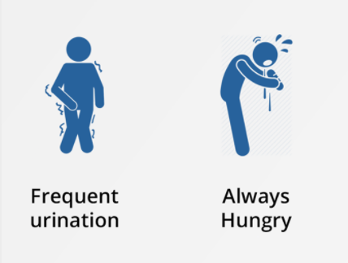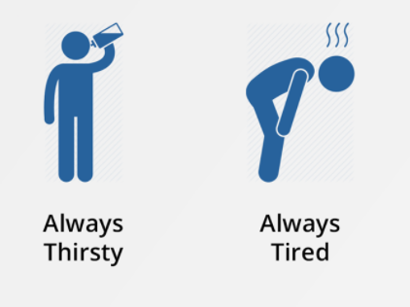

After Monique’s mother scheduled the blood tests, her doctor sent this letter about the test.

|  |
| --- |
| Here are the instructions for your upcoming lab tests.    A Glucose Tolerance Test measures the body's ability to use a type of sugar, called glucose (GLOO-kose). Glucose is the body's main source of energy. The test can be used to diagnose prediabetes and diabetes.   * To prepare for the test: The night before your test, you will need to fast overnight which means you cannot eat or drink anything after midnight.   A blood sample will be collected when you first arrive at the doctor’s office. Next, you will be asked to drink a sweet liquid containing glucose. Over the next several hours, blood samples will be collected to test the glucose levels in your blood.   * The doctor will be looking at how long it takes for the glucose in your blood to decrease down to the normal levels. |

**Diabetes LS2 Lesson 1 PART 2 (Science Take Out Kits): Analyzing Blood Glucose Levels**

To prepare for the glucose tolerance test, your patient fasted for 12 hours. To begin the test she drank a solution that contained a measured amount of glucose. Blood samples were collected immediately before she drank the glucose solution and every half hour after she drank the glucose solution. The blood sample was centrifuged to separate it into blood cells and blood plasma. You will test the concentration of glucose in the patient’s blood plasma to determine if she has diabetes.

1. Your lab kit has 5 samples of the patient’s blood plasma that were collected at various time intervals during the patient’s glucose tolerance test.

1. Use Column 1 on the “Glucose Tolerance Testing Sheet.” Place 1 drop of the appropriate plasma samples to be tested in the appropriate circles in Column 1. Save the samples of patient blood plasma for use in Part 3
2. Place a strip of glucose test paper into each of the circles in Column 1 of the “Glucose Tolerance Testing Sheet” that contain the plasma samples that you are testing. Immediately compare the color of the test paper with the color on the Glucose Test Paper Color Chart. Record the results of the glucose tests in Table 1 below.

**TABLE 1**

|  |  |
| --- | --- |
| **Time of blood collection**  **Minutes after drinking**  **Glucose solution (minutes)** | **Glucose level in blood**  **(milligrams/deciliter)** |
| **0 (after fasting)** |  |
| **30** |  |
| **60** |  |
| **90** |  |
| **120** |  |

4. The graph below shows the blood plasma glucose levels for a healthy person who does not have diabetes. Plot the data from the patient’s glucose test results (from Table 1) on the graph.

**Use the information from** **the data collected to help you interpret the results of the patient’s glucose tolerance test.**

1. What is the blood glucose level for the healthy person at the beginning of the glucose tolerance test?

|  |
| --- |
| Write your answer here: |

1. What happened to the blood glucose level for the healthy person right after drinking the glucose solution?

|  |
| --- |
| Write your answer here: |

1. What happens to the healthy person’s blood glucose levels after 30 minutes?

|  |
| --- |
| Write your answer here: |

1. How is the patient’s blood glucose level different from the levels in a normal healthy person?

|  |
| --- |
| Write your answer here: |

1. Based on the information in this graph, do you think the patient has diabetes? Support your answer with evidence from the graph.

|  |
| --- |
| Write your answer here: |

1. Do you have enough information to determine if the patient has Type 1 or Type 2 diabetes? If not, how would you figure this out?

|  |
| --- |
| Write your answer here: |

**Diabetes Lesson 2 PART 3: Graphing and Analyzing Blood Insulin Levels: PART 3 (Science Take Out Kits): Analyzing Blood Insulin Levels**

**There are two types of diabetes that result in higher-than-normal blood glucose levels - called Type 1 and Type 2 diabetes. A person with Type 1 diabetes does not produce insulin. A person with Type 2 diabetes does produce insulin but their cells are unable to respond to the insulin message.**

**To determine whether the patient has Type 1 or Type 2 diabetes, you need to test the concentration of insulin in the patient’s blood plasma.**

**1. Use Column 2 on the “Glucose Tolerance Testing Sheet.*”* Place 1 drop of the appropriate plasma samples to be tested in the appropriate circles in Column 2.**

**2. Add 1 drop of the Insulin Indicator to the plasma in each of the circles in Column 2. After 10 seconds, compare the color of the fluid in each circle with the Insulin Test Indicator Color Chart.**

**3. Record the results of the insulin tests in Table 2 on the next page.**

**4. The graph on the next page shows the blood plasma insulin levels for a healthy person who does not have diabetes. Plot the data from the patient’s insulin test results, from Table 2, on the graph.**

**TABLE 2**

|  |  |
| --- | --- |
| **Time for Blood Collection Minutes After Drinking Glucose Solution** | **Insulin Level in Blood**  **(picomole/liter)** |
| **0 (after fasting)** |  |
| **30** |  |
| **60** |  |
| **90** |  |
| **120** |  |

**Use the information from the data you just collected to help you interpret the results of the patient’s glucose tolerance test.**

**The pattern for healthy person in the graph above shows that the healthy person’s insulin starts low (time 0 minutes is 50 pmol/L) and then goes up (time 30 minutes is 375 pmol/L and at 60 minutes 380 pmol/L) after they drink the sugar water. Then, the insulin level goes down after 120 minutes (200 pmol/L).**

1. **From the graph, what pattern do you see for the patient’s insulin levels?  Hint: You can use the description above for the healthy person to guide you to write about the pattern of insulin for the patient.**

|  |
| --- |
| **Write your answer here:** |

1. **Compare the insulin levels in a healthy person with the insulin levels in the patient.**

|  |
| --- |
| **Write your answer here:** |

1. **Based on the information in the graph, do you think the patient has Type 1 or Type 2 diabetes? Support your answer with information from the graph.**

|  |
| --- |
| **Write your answer here:** |

1. **Do you think this patient’s diabetes should be treated with insulin injections? Why or why not?**

|  |
| --- |
| **Write your answer here:** |

1. **How can the patient keep the glucose levels in normal range? What do you suggest for the best treatment plan?**

|  |
| --- |
| **Write your answer here:** |

1. **What health problems may result if the patient does not follow the treatment plan suggested to keep her blood glucose levels within normal range?**

|  |
| --- |
| **Write your answer here:** |

**Lesson 3 Reading**

**What is Diabetes?**

|  |
| --- |
|  |

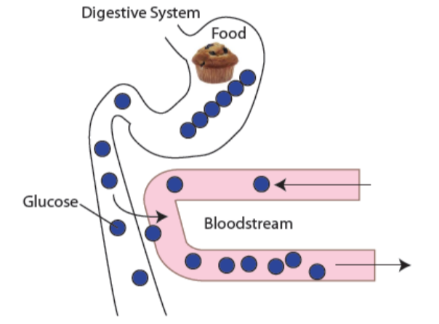

**How does your body get energy?**

The human body uses a type of sugar called **glucose** (GLOO-kose). Most of the food you eat is turned into glucose that your body can use for energy.

Your body is made of tiny building blocks called cells. Your blood carries the glucose to all the cells in your body. Your blood always has some glucose in it because your body needs glucose for energy to keep you going.

But too much glucose in the blood isn’t good for your health. It is important to have a balanced level of glucose in your blood, not too much and not too little.

*Guiding question #1: What is the role of glucose in your body?*

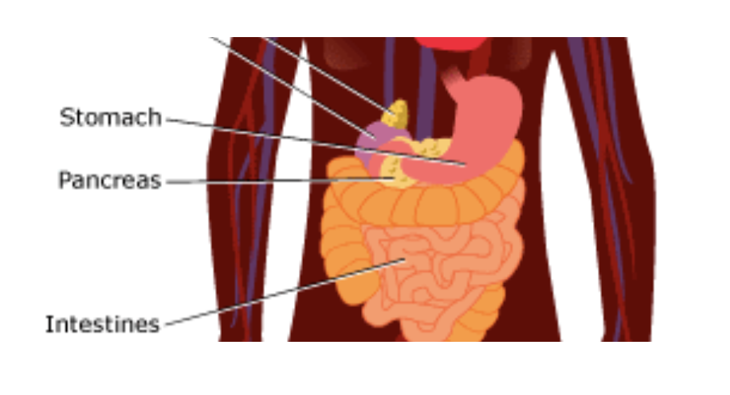

**What happens in your body?**

**Insulin** is a special chemical in your body that keeps the blood glucose levels balanced. Insulin is created in the **pancreas** which is a small organ located behind your stomach that helps you digest food. When the glucose level in the blood is high, like after eating dessert, this triggers the pancreas to release insulin into the bloodstream.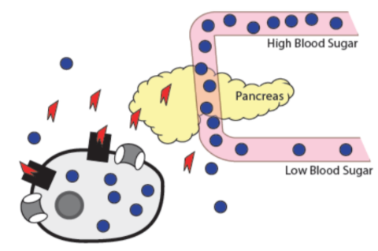

The insulin acts like a key: it opens the body cells so that glucose can enter the cells from the bloodstream. When glucose enters the cells, the sugar levels in the blood decrease.

*Guiding question #2: What is insulin? What does it do in your body?*

**How does insulin work like a key?** 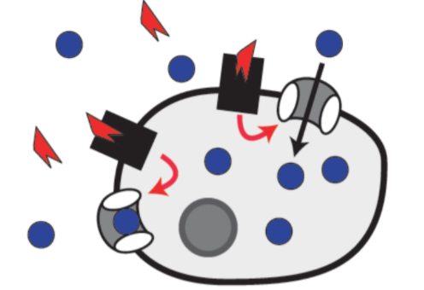

On the surface of body cells, there are **insulin receptors** which act like locks. When insulin attaches to a receptor it is like “unlocking a door” to the cell. When the cell is unlocked, special channels on the cell’s surface open up. These open channels let the glucose in from the blood. Then the cell uses glucose for energy to help you breathe and move and live.

*Guiding question #3: How does insulin help glucose move inside the cell?*

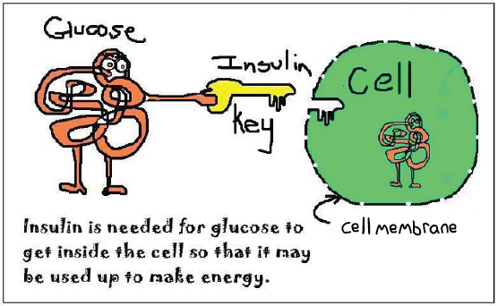

**What is Diabetes?**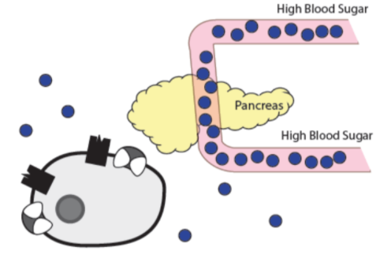

**Diabetes** is a disease. When you have diabetes your blood glucose is too high because glucose cannot get into your cells. When glucose can’t get into the cells, it stays in the bloodstream. Diabetes tends to run in families, meaning that we often see several family members with the disease.

There are two types of diabetes, Type 1 and Type 2. The pancreas of a person with **Type 1 diabetes** cannot produce enough insulin. Without insulin, glucose cannot get into the cells and builds up in the bloodstream. Usually, children have Type 1 diabetes.

**Type 2 diabetes** usually occurs in adults. However, more and more children are also being diagnosed with Type 2 diabetes. The pancreas still makes insulin if you have Type 2 diabetes. But the insulin cannot properly unlock the cell. It is like having the wrong key for the door. The glucose gets into the cell more slowly because the insulin does not work correctly.

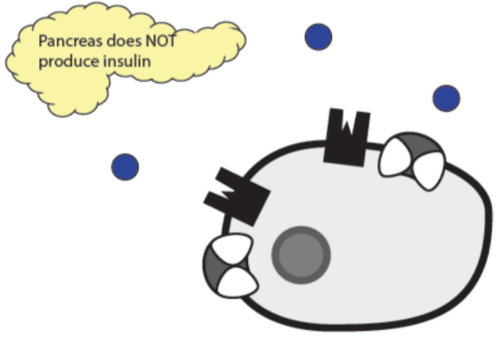 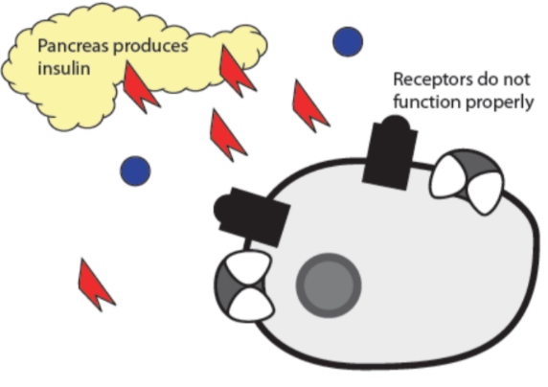

Type 1 diabetes Type 2 diabetes

*Guiding question #4: What are the two ways that glucose is prevented from getting into the cells?*

**How does it feel to have diabetes?**

In both Type 1 and Type 2 diabetes, too much glucose ends up in the blood. This is called high blood sugar. The body cells are not getting enough glucose for energy. This can cause you to feel thirsty, hungry, or tired. You might frequently pass urine. Diabetes can cause problems with your eyes, brain, heart, kidneys, feet, and nerves.

*Guiding question #5: Why do people with diabetes (Type 1 and Type2) feel tired?*

**How can you stay well with diabetes?**

Diabetes is the sixth leading cause of death in the United States, but you can stay well. People who have diabetes must work as a team with their doctor and their family to stay healthy. They also have to work with a dietician to learn about healthy eating. A diabetes educator can help people learn about how to keep from getting sick and live a healthy life.

People with diabetes have to regularly check the sugar level in their blood using a small machine that looks like a cell phone.

* **Treatment for Type 1 Diabetes**: Insulin injections
* **Treatment for Type 2 Diabetes**: Medications and/or insulin therapy to lower blood glucose levels.
* **Treatment for Type 1 and Type 2 Diabetes**:
* Make wise food choices
* Be physically active
* Control your blood pressure and cholesterol

*Guiding question #6: What are some of the things that people with diabetes need to do to keep healthy?*

**Notes for the Guiding Questions**

**Guiding Question #1**

|  |
| --- |
| Write your answer here: |

**Guiding Question #2**

|  |
| --- |
| Write your answer here: |

**Guiding Question #3**

|  |
| --- |
| Write your answer here: |

**Guiding Question #4**

|  |
| --- |
| Write your answer here: |

**Guiding Question #5**

|  |
| --- |
| Write your answer here: |

**Guiding Question #6**

|  |
| --- |
| Write your answer here: |

**Monique’s Lab Report**

Your role as a lab technician is to write a lab report for the doctor based on Monique’s test results. The lab report needs to include answers to the following questions.

**Claim**: Does Monique have diabetes or not? If so, does she have Type 1 or Type 2 diabetes?

|  |
| --- |
| Write your answer here: |

**Evidence**: What data do you have to support your claim?

|  |
| --- |
| Write your answer here: |

**Reasoning**: How does your data (blood test results) relate to what you have learned about Monique's diabetes (biological process and causes of diabetes)?

|  |
| --- |
| Write your answer here: |