|  |
| --- |
| **Learning Set 4: How Do Monique’s Characteristics and Environment Affect Her Diabetes?** |

|  |  |  |  |  |  |
| --- | --- | --- | --- | --- | --- |
| |  | | --- | | **Unit Driving Question:**  What controls my health?  **Sub-Driving Question:**  How do Monique’s characteristics and environment affect her diabetes? | | |  | | --- | | Materials List   * Computer * Projector * PPT slides: <https://hioh.education/sites/default/files/curriculum-files/unit-1/Students-Sand-Rats-simulation2.pptx> * My Diabetes Modeling Chart Student Version in Learning Set 1(not filled in) Teacher Version in Learning Set 1 (filled in)   **Links**   * Sand-rat video: <http://www.gettyimages.com/detail/video/fat-sand-rat-eating-leaves-stock-video-footage/164596805> * Sand-rat simulation: HiOH Concord Collection for Gene-Environment Interaction- How does food affect the health of sand rats? <https://learn.concord.org/health-in-our-hands> and specifically: <https://concord.org/hioh/sand-rats/> * Social Determinants of Health Infographic |  * **Learning Set Level Assessmen**t: Learning Set Level Assessment and Teacher Rubric- See Assessment Resource Folder | |  | | --- | | **Suggested lesson time**  7 days | |

**Student materials:**

* Sand-rat video: <http://www.gettyimages.com/detail/video/fat-sand-rat-eating-leaves-stock-video-footage/164596805>
* *Lesson 1: How does food affect the health of* *sand rats?* Reading: Why Do Scientists Use Animals in Research?
* Sand-rat simulation: How does food affect the health of sand rats? <https://concord.org/hioh/sand-rats/>
* For *each* inquiry (structured, guided, open), two documents are posted:
  + *Activity 1: How does food affect the health of sand rats?*
  + Sand Rats Graphing LS5 Lesson 1 Sand Rat Graph Structured Inquiry .pdf
* LS5 Lesson 4: Gene-Environment Interactions Table

|  |
| --- |
| **Framing the Learning Set** |

**Purpose**

In this learning set, students become biomedical researchers and plan and carry out a series of investigations (structured, guided, and open inquiry) using simulations of sand rats. They explore how both the environment and genetic information affect the growth of organisms and help Monique figure out the role of the environment and genes in the development of diabetes.

**Learning Set Learning Goals (For instructional use)**

* The students plan and carry out investigations to identify that both genetic factors and environmental factors affect the growth and health of organisms.
* The students revise their models to include the influence of both environmental and genetic factors on organisms’ traits.

Color code: Scientific Practice, Crosscutting Concept, Disciplinary Core Idea

**Building Coherence –** Refer to theStoryline

In Learning Sets 2 and 3, the students figured out the effects of genetic factors on an organism’s traits and connected this learning back to Monique’s diabetes. In this learning set, students figure out how gene-environment interactions affect the growth, development, and health of organisms using sand rats as an animal model.

|  |
| --- |
| **Overview of the Learning Set** |

|  |  |  |
| --- | --- | --- |
| **Instructional sequence overview** | **What students figure out (DCI)** | **Days** |
| **Lesson 1: How does food affect the health of sand rats? - Structured inquiry version**  In this structured inquiry version, students are given the question and the parameters of their experiment and carry out the same investigation. The students investigate the effect of both genetic information and environmental factors on the health of sand rats using a simulation. After being introduced to the sand rats, their natural habitat, and nutrition through a short video, the students plan and carry out an experiment using the sand rat simulation to collect and analyze data. | Genetic factors as well as local conditions affect the health and survival of the sand rats.  (LS1.B Growth and Development of organisms) | **2 days** |
| **Lesson 2: How does food affect the health of sand rats? - Guided inquiry version**  In this guided inquiry version, students are given the question and asked to identify the parameters of the inquiry. Students plan and carry out an investigation using the sand rat simulation in order to answer a given claim. In a whole class discussion, they draw evidence-based conclusions. | **1day** |
| **Lesson 4: How does Monique’s environment and her family affect her health?**  Through a class discussion, the students make the connection between the effect of the environment and genetics factors on both the simulated sand rats’ and Monique’s health. | **1 day** |
| **Lesson 5: Modeling: Why does Monique have diabetes?**  The students revise their models and link the effect of genetic and environmental factors to Monique’s diabetes. Then, they share their models with the whole class, discuss similarities and differences among the components of their models, and evaluate the relationships presented. | **1 day** |
| **Lesson 6 - Linking Ideas**  As a class, students discuss how to combine LS2 and LS3 models to further student understanding of diabetes through linking the biological mechanism of diabetes **and** the inheritance of traits within families with risk for diabetes. The students revisit the **Driving Question Board** **(DQB)** and reflect upon their learning. | Gene-environment interactions affect Monique’s and other people's health. | **1 day** |
| **End of Learning Set Assessment- Google Forms** | | **½ class hour** |
| **Optional Extension Activity: How does food affect the health of sand rats? - Open inquiry version**  Students generate their own driving questions and plan and carry out an investigation to answer their question in this open inquiry version. They share and discuss their results and draw evidence-based conclusions. | | **1 day** |

|  |
| --- |
| **NGSS Connection to Assessment** |

|  |
| --- |
| **Target Performance Expectations**  [MS-LS1-5.](http://www.nextgenscience.org/pe/ms-ls1-5-molecules-organisms-structures-and-processes) Construct a scientific explanation based on evidence for how environmental and genetic factors influence the growth of organisms.  [MS-LS2-1](https://www.nextgenscience.org/pe/ms-ls2-1-ecosystems-interactions-energy-and-dynamics). Analyze and interpret data to provide evidence for the effects of resource availability on organisms and populations of organisms in an ecosystem. |
| **Learning Performances for Learning Set 5 to be assessed**  Students analyze and interpret data on how environmental and genetic factors influence the growth and health/development of organisms.  Students plan an investigation to identify that genetic factors and environmental factors affect the growth and health/development of organisms.   |  |  |  | | --- | --- | --- | | **Disciplinary core idea** | **Science and engineering practices** | **Crosscutting concepts** | | **LS1.B: Growth and Development of Organisms**  * The growth of an animal is controlled by genetic factors, food intake, and interactions with other organisms, and each species has a typical adult size range | **Planning and carrying out investigations**  * Plan an investigation individually and collaboratively, and in the design: identify independent and dependent variables and controls, what tools are needed to do the gathering, how measurements will be recorded, and how much data are needed to support a claim.  **Analyzing and interpreting data** Analyze and interpret data to provide evidence for phenomena | **Cause and effect**   * Cause and effect relationships may be used to predict phenomena in natural systems. | |
| **How these elements are integrated and embedded in this learning set**  In this learning set, students will plan and carry out investigations using a sand rat simulation and analyze and interpret data to explain how genetic factors and environmental factors can influence the development, growth, and health of organisms. Based on the data, the students will further develop a model to explain the influence of gene-environment interaction on organisms. |

|  |
| --- |
| **Connection to Students’ Lives** |

**Link to out-of-school activity and everyday life**

* Encourage students to relate the effect of gene-environmental interactions on growth, development, and health to their own lives. Can they identify and change one factor in their everyday lives, such as the amount of sugary drinks or amount of walking in one week, and consider the effect on their well-being?

**Link to career awareness**

* Students conduct experiments using a sand rat simulation as biomedical researchers throughout this learning set. Introduce what scientists do: scientists ask questions about the natural world and try to answer their questions based on evidence. Let students know that what they will do in this learning set is very similar to what scientists do: they will plan and carry out investigations, collect and analyze data (sometimes using simulations), and draw evidence-based conclusions.

|  |
| --- |
| **Instructional Sequence** |

**Introducing the Learning Set**

1. **Keeping coherence using the DQB -** Revisit students’ questions related to Monique and diabetes on the Driving Question Board (DQB). Tell students that in this learning set they will further investigate the case of Monique to determine “How do Monique’s characteristics and environment affect her diabetes?” Tell the students that they should pay particular attention to the questions that they had clustered around that Sub-Driving Question.
2. **Introducing the learning set** 
   1. **Refer back to the previous learning sets -** Remind students about the findings from the previous learning sets.
      1. They looked at the biological mechanism of diabetes and its effects on organs.
      2. They figured out that genetic factors that affected Monique’s diabetes
3. **Link to career awareness -** Tell students that they will be biomedical researchers who study diabetes using sand rats. Students will use a simulation to help Monique further understand the various factors that affect her diabetes and health.

|  |
| --- |
| **Lesson 1 - How Does Food Affect the Health of Sand Rats?**  **Structured Inquiry** |

|  |  |
| --- | --- |
| **Learning Goal** | The students plan and carry out investigations to identify that both genetic factors and environmental factors affect the growth and health of organisms. |
| **Connection to NGSS** | DCI: LS1.B: Growth and Development of Organisms |
| Practice: Planning and Carrying out Investigations |
| CCC: Cause and effect |

In this lesson, students will use a simulation to plan and carry out investigations using a structured inquiry process to examine the effect of gene-environment interactions on the health of sand rats. The first two lessons of this learning set are designed as a process in which students progress from **structured** to **guided inquiry.**  An optional extension activity, at the end of this learning set, introduces students to **open inquiry**. Teachers can decide which type of inquiry to perform in their class based upon their classes’ abilities and experience with planning and carrying out investigations.

|  |  |
| --- | --- |
| idea.png | **Structured inquiry**  In *structured inquiry*, the students are introduced to the research process and investigate a teacher-presented question through a prescribed procedure and receive explicit step-by-step instructions at each stage, leading to a predetermined outcome. The process is similar to following a recipe.    **Guided inquiry**  In *guided inquiry*, the students investigate questions and claims that teachers present to them, but the students working collaboratively, decide the processes to be followed and the solutions to be targeted. Teachers can use guided inquiry to develop stronger science practices in their students. The amount of scaffolding needed can decrease over time, and investigations can move from teacher-driven to student-driven.  **Open inquiry (optional extension activity at the end of this learning set)**  In *open inquiry*, the students investigate questions of their choice by developing a research plan and procedures unique to their question. Open inquiry does not imply minimum guidance; in fact, this type of inquiry requires much scaffolding from the teacher in order to engage students in a productive and effective process. |

**Use the PPT presentation in the Learning Set 4 Teacher Resource folder to support teaching.**

1. **Discuss core terms of experimentation -** inquiry, inquiry question, observations *vs*. experimentation, dependent variable, independent variable, controlled variables.

**In the Learning Set 4 Teacher Resource folder (Use slides 1-6 for this part).**

|  |  |
| --- | --- |
| idea.png | When conducting experiments, the students should be familiar with the following terms:  **Independent variable** - In an experiment, it is the variable that one chooses to change or manipulate, to determine an effect on other variables.  **Dependent variable** - A variable whose value depends on another variable. In an experiment, it is the variable that changes in response to other variables being changed.  **Controlled variable** - In an experiment, this is a variable that is not changed. This enables the experimenter to fairly test the relationship between the independent and dependent variables.  **An inquiry question** - A specific type of question which supports investigation and requires the gathering and analyzing of data to propose a potential answer. |

1. **Introduce biomedical research-** Tell students that they will be biomedical researchers who study diabetes using sand rats. Students will use a simulation to help Monique further understand the various factors that affect her diabetes and health.
   1. Ask students what they know about biomedical research as a career.
      1. Has anyone heard of the term biomedical research? What do you think it means?
      2. What might a biomedical researcher do? What do they research?
   2. Make a list of students’ responses.
   3. Tell students that they will be biomedical researchers, working to better understand diabetes and how it affects living organisms. Biomedical researchers are scientists who work to gain knowledge of how the human body works and to find new ways to cure or treat disease by developing advanced diagnostic tools or new medicines.
2. **Introduce the sand rats** - As biomedical researchers who use sand rats to study diabetes, the students need to know about their research subjects.

**In the Learning Set 4 Teacher Resource folder (Use** **slide 7 for this part)**.

* 1. Show the students a video of sand rats in their natural habitat (v[ideo of sand rat](http://www.gettyimages.com/detail/video/fat-sand-rat-eating-leaves-stock-video-footage/164596805))

**In the Learning Set 4 Teacher Resource folder (Use** **slide 8 for this part**).

* 1. Discuss the reasons why scientists use sand rats to investigate diabetes using *Lesson 1: How does food affect the health of sand rats?* Reading: Why Do Scientists Use Animals in Research?

1. **Introduce the sand rats simulation**

**In the Learning Set 4 Teacher Resource folder (Use** **slide 9 for this part**).

As biomedical researchers, students will use a simulation to conduct their experiment. Introduce the students to the [sand rats simulation](https://learn.concord.org/health-in-our-hands) <https://concord.org/hioh/sand-rats/>. First, let the students play with the simulation and find out by themselves what variables they can manipulate. Then, use students’ experience to show and explain the various features of the simulation and the data it can provide.

* 1. The type of sand rats
     1. The sand rats’ health diabetes (diabetic vs. healthy)
     2. The sand rats’ risk of diabetes (high vs*.* low)
     3. The sand rats’ gender (male vs*.* female)
  2. The type of food - sugary vs. non-sugary food
  3. Measurements
     1. The sand rats’ weight (thin, heavy, obese)
     2. Number of diabetic rats

1. **Structured inquiry**

**Monique’s story.** Tell students that they will start by using the sand rat simulation to help Monique answer her question, *How does food affect her diabetes?* They will follow each step with her to figure out how food affects the health of sand rats.

Continue to use the presentation to support students’ figuring out. Have the students fill out the worksheet as you plan and carry out the investigation together: *Lesson 1: How does food affect the health of sand rats?*

1. **Plan experiments**

**In the Learning Set 4 Teacher Resource folder (Use slide 10 for this part).**

Discuss with the entire class the experimentation procedure:

1. **Brainstorm** possible independent and dependent variables for the students to test using the simulation.
2. Introduce the **inquiry question** that the students will be investigating using the simulation (as this is a **structured inquiry**, all the student teams will be conducting the same experiment).

|  |  |
| --- | --- |
| creativity.png | **Scaffolding students using *learning strategies***   1. **What are learning strategies -** Remind students what learning strategies are, and emphasize the importance of learning strategies for efficient learning. 2. **Remind students about *Brainstorming* and how it can be used** - Brainstorming is a strategy for generating ideas. It includes generating a list of spontaneous ideas which are associated with a specific topic. For effective brainstorming, (a) focus on quantity, (b) withhold criticism, (c) welcome unusual and wild ideas, and (d) combine and improve ideas. 3. **Scaffold *Brainstorming*** - Together with the entire class, use the *brainstorming* strategy to generate as many questions as possible about the effect of environmental factors on sand rats.    1. **Generating *anchors*:** Tell the students to rely on their knowledge about sand rats for their brainstorming. First, ask them to think of as many possible factors as they can that might affect the sand rats’ health; these are the independent variables. Then, ask them to think of as many factors as possible that are associated with sand rats’ health; these are the dependent variables.    2. **Examples\*** of *dependent* and *independent* variables:  * **Examples of independent variables:** The sand rats’ risk of diabetes, their gender, or types of food they eat * **Examples of dependent variables:**Weight of the sand rats, or the number of diabetic sand rats   ***\* This is not an exhaustive list*** |

1. **Conduct experiments- Use the PPT slides in the Learning Set 4 Teacher Resource folder (Use slide 13 for this part).**

In pairs or in a class discussion, the students plan and conduct their own experiments to explore the effect of food on the health of sand rats. In their teams **using the handout**, *Lesson 1: How does food affect the health of sand rats?*, the students detail the:

1. **Independent variable:** Type of food
2. **Dependent variable:** Number of diabetic sand rats
3. **Controlled variables:** Number of sand rats in the pens, risk for diabetes, gender, etc.
4. **Inquiry question:** What is the effect of *food* on *the health of sand rats*?
5. An example of the experiment design**:** 
   1. Select sand rats with the same diabetes risk and the same gender for both pens.
   2. Give sugary food to one pen and non-sugary food to the other
   3. Click the play button.
   4. Observe and record the number of diabetic sand rats.
6. **Analyzing data** - To draw conclusions from the simulation, the students follow two steps: (a) collecting data in a results table; and (b) plotting data in a graph and drawing conclusions.
7. ***Recording data in a results table*** - **in the Learning Set 4 Teacher Resource folder (Use slide 13 for this part).**
   1. Discuss with the students the use of a *results table* as a means to record their results. Then, have the students complete the following table while running their simulation.
   2. Talk about the differences between using numbers and using percentages. If needed, review converting numbers into percentages.

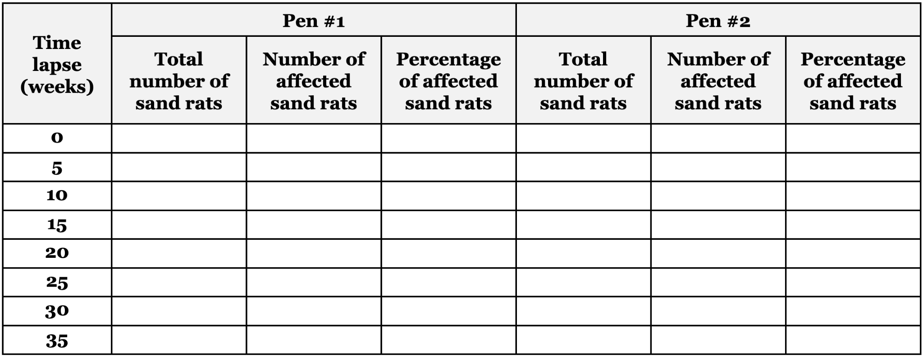

1. **Plotting data in a graph and drawing conclusions**

**In the Learning Set 4 Teacher Resource folder (Use slide 14 for this part).**

1. Have the students plot their data on a graph. Draw a conclusion about the relationship between the two variables: *type of food* and *health of sand rats*.

|  |  |
| --- | --- |
| idea.png | **Plotting graphs**  Graphs and charts are ways of visually representing the relation between the quantities of variables. They can make difficult data easier or quicker to understand. Different types of charts are used depending on the type of data. For example, data that is recorded in numbers or by word description, or data that exists in categories or is continuous.  **Emphasize: X, Y labels…**   * The **X-axis** is the horizontal axis. It is labeled with the **independent** variable. * The **Y-axis** is the vertical axis. It is labeled with the **dependent** variable.   It is very important to label each axis so that whoever is looking at your graph/chart knows what the numbers on each axis represent. |

(Students will use the following chart in their handout to plot their data. Sand Rats Graphing LS5 Lesson 1 Sand Rat Graph Structured Inquiry .pdf

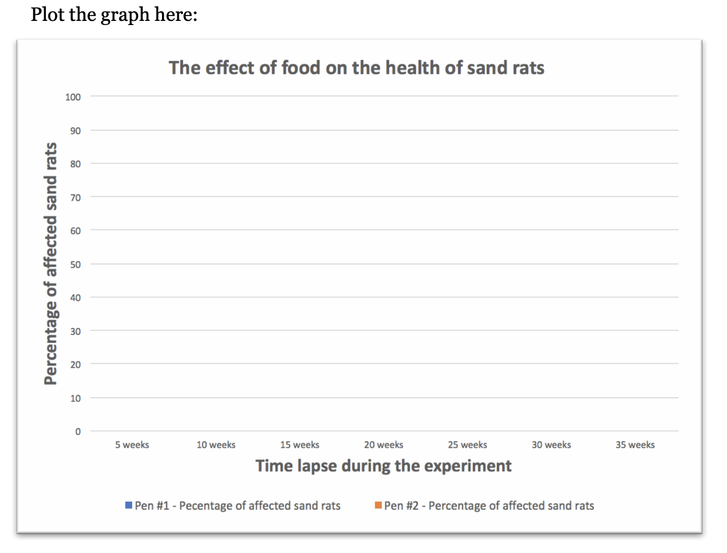

1. **Sharing and discussing-**  **in the Learning Set 4 Teacher Resource folder (Use slide 15 for this part).**

With the entire class using their handout, share and discuss the results and conclusions of the sand rat simulation by developing **scientific explanations** which include **Claim, Evidence, and Reasoning (CER)**. Use the following prompts to encourage the students to share their results and conclusions and to explain the effect of environmental factors on traits:

* 1. What pattern can you find in the data?
  2. What **claim** can you make about the effect the genetic makeup of the organism (sand rats) and the types of food on the health of sand rats? What **evidence** do you have that supports your claim? What is your **reasoning**? How does your experiment relate to what you have learned about the effects of the environment and genetics on the health of organisms? Why do some sand rats have the trait for diabetes and others do not?
  3. What are the similarities and differences between your claims and those of other teams?

|  |  |
| --- | --- |
| creativity.png | **Scaffolding students using *learning strategies***   1. **Explain what** ***scientific explanation* is and how it can be used** - Scientists try to explain how and why a natural phenomenon occurs. A scientific explanation consists of a **claim, evidence, and reasoning (CER)**. The claim is a testable statement that expresses the answer or conclusion to a question or problem. Evidence is scientific data that supports the claim. Reasoning uses scientific ideas and principles to describe how or why the evidence can be used to support the claim. 2. **Demonstrate CER** - Guide students to draw a conclusion about the relationship between genetic and environmental factors and the health of sand rats based on the data that they collected from the simulation. 3. **Instructional tips** - Ask the students to explain 1) their conclusion, 2) their evidence (data that they collected from the simulation), and 3) the scientific principle that connects the evidence and claim. Then, share them with the whole class. These can vary by student based on how he or she planned and conducted the experiment. 4. **Example CER** 5. An example of a claim: Both environmental and genetic factors affect the diabetes of sand rats. 6. An example of evidence: When the parents who had genetic risk factors (gene) for diabetes ate sugary food (environment), the number of sand rat offspring with diabetes increased. 7. An example of reasoning: Having genetic risk factors for diabetes combined with an unhealthy environment (eating too much sugary food) can cause organisms such as sand rats or humans to develop the disease of diabetes. |

|  |
| --- |
| **Lesson 2 - How Does Food Affect the Health of Sand Rats?**  **Guided Inquiry** |

|  |  |
| --- | --- |
| **Learning Goal** | The students plan and carry out investigations to identify that both genetic factors and environmental factors affect the growth and health of organisms |
| **Connection to NGSS** | DCI: LS1.B: Growth and Development of Organisms |
| Practice: Planning and Carrying out Investigations |
| CCC: Cause and effect |

1. **Guided inquiry** 
   1. Tell students that the head researcher of their lab has now given them a claim to answer, and they will now work to investigate the claim by planning and carrying out an investigation.

**In the Learning Set 4 Teacher Resource folder (Use slide 16 for this part).**

* 1. Discuss the claim on slide 16 with the students - Gender affects the health of sand rats: Female sand rats tend to develop diabetes more than male rats!
  2. Then, have the students conduct a guided inquiry in order to answer the question. In pairs, the students will plan and conduct their own experiments to answer the question using the handout again: *Lesson 1: How does food affect the health of sand rats?*

|  |  |
| --- | --- |
| idea.png | While the students work in pairs, circulate around the class and support the students, encouraging them to share their thinking and consult their peers about their plans for their experiment (especially page 2, # 1-3 in the handouts). This should be a discussion with students sharing their questions and how to test them, rather than a didactic sequential interaction with the teacher. Encourage students to ask the following questions to other groups:   * How many pens will you need to use for your investigation? Explain the reason for each pen. * What type of sand rats will you put in each pen? Explain your reasoning. * How many sand rats will you put in each pen? Explain why. * What kind of data will you collect from the simulation? * How does the data you collect help you answer your question? |

1. **Sharing and discussing**

**In the Learning Set 4 Teacher Resource folder (Use slide 17 for this part).**

With the entire class, share and discuss the students’ results. Use the following prompts:

1. About the experiment:
   1. What was the design of your experiment?
   2. How many times did you repeat the simulation and why?
   3. Did your experiment help you answer your question?
2. Results and conclusions:
   1. What pattern can you find in the data?
   2. What **claim** can you make about the effect of types of food on the health of sand rats? What **evidence** do you have that supports your claim? What is your **reasoning**? How does your experiment relate to what you have learned about the effects of the environment and genetics on the health of organisms? Why do some sand rats have the trait for diabetes and others do not?
   3. What are the similarities and differences between your claims and those of other teams?

|  |  |
| --- | --- |
| creativity.png | **Scaffolding students using *learning strategies***   1. **Explain what** ***scientific explanation* is and how it can be used** - Scientists try to explain how and why a natural phenomenon occurs. Scientific explanations consist of **claims, evidence, and reasoning (CER)**. The claim is a testable statement that expresses the answer or conclusion to a question or problem. Evidence is scientific data that supports the claim. The reasoning describes how or why the evidence can be used to support the claim using scientific ideas and principles. 2. **Model CER** - Guide students to draw a conclusion about the relationship between genetic and environmental factors and the health of sand rats based on the data that they collected from the simulation. 3. **Instructional tips** - Ask the students to explain 1) their conclusions, 2) their evidence (data that they collected from the simulation), and 3) what scientific principle connects the evidence and claim. Then, share them with the whole class. These can vary by student based on how he or she planned and conducted the experiment. 4. **Example CER**    1. An example of a claim: Gender affects the health of sand rats: Female sand rats do not tend to develop diabetes more than male rats.    2. An example of evidence: When we controlled the genetics of the sand rats and fed both groups sugary food, whether male or female, it did not make a difference in the number of sand rat offspring with diabetes.    3. An example of reasoning: Having genetic risk factors for diabetes combined with an unhealthy environment (eating too much sugary food) can cause organisms such as sand rats or humans to develop the disease of diabetes. But gender does not appear to affect diabetes. |

|  |
| --- |
| **Lesson 3 - How Does Monique’s Environment and Her Family Affect Her Health?** |

|  |  |
| --- | --- |
| **Learning Goal** | Students construct a scientific explanation that both environmental and genetic factors affect the health of organisms |
| **Connection to NGSS** | DCI: LS1.B Growth and Development of organisms |
| Practice: Constructing explanations |
| CCC: Cause and effect |

1. **Summary discussion.** All research team members share and discuss their findings and think about how their conclusions from their research can help explain Monique’s diabetes.

**In the Learning Set 4 Teacher Resource folder (Use slide 19-20 for this part**).

Have a class discussion about the interactions of genetics and environment, e.g.:

1. If two people ate different foods, would the impact on their bodies be different?
2. If the same person eats different foods, will those foods have a different impact on his or her body?
3. What would happen if two different people ate the same food? Would the foods impact their bodies the same or differently?

Discuss the limitations and nature of models and modeling.

* 1. Thinking back to Learning Set 3 when we created the model pedigree with the beads, were your findings all the same? Was the risk for diabetes the same for the kids in the pedigree as for the sand rat simulation? How were they the same? How were they different?
  2. What are the limits of using models like the beads and the sand rat simulation? What do we mean by **limits**?
  3. What are the advantages of using these kinds of models to simulate real-world scenarios?

|  |
| --- |
| **Hint**: The color of the beads and the color of the symbol for mutations in the sand rat simulation are the same. In the beads activity, the students may have found that some of the kids did not have diabetes. However, in the sand rat simulation, all the kids of parents who had a genetic risk for diabetes also show a genetic risk for diabetes. Models have limits. This helps students understand that they are **MODELS** that **SIMULATE** the real world, they are not set in stone, a yes or no, or a perfect solution. Our models can give us a more complete picture of diabetes and risk for diabetes. We can draw conclusions about what we think the models tell us, but understand they are not a perfect representation of the real-world situation. |

1. **As a class, construct an explanation**. Refer back to the data, results and analysis of the sand rats simulations. In groups, pairs or individuals, develop a **scientific explanation** which includes **Claim, Evidence, and Reasoning (CER)** about the factors that affect sand rats’ health, growth and survival.
2. What claim can you make about the effect of environmental and genetic factors on sand rats’ health, growth and survival?
3. What data do you have to support your claim?
4. What is your reasoning?
5. Exemplar explanation
   1. **Claim**: Both environment (food access) and sand rats’ genes affect their health, growth and survival.
   2. **Evidence**: The sand rats that had a low risk of diabetes and were exposed to no sugar in their diets were healthier.
   3. **Reasoning**: Some sand rats have genes that allow them to grow and survive better **in certain conditions** such as access to sugary or non-sugary foods. We see that there are both environmental and genetic factors together that affect the health, growth and survival of sand rats.
6. **Discuss gene-environment interaction.** Discuss with the students the meaning of “gene-environment interaction” i.e., that the environment acts differently on different genes. The fill in the table: LS5 Lesson 4: Gene-Environment Interactions Table

In relation to our health, this can mean that:

* 1. Under the same conditions, one person may suffer from health problems because of genetic predisposition (the person might have the risk factors) while another person might not (due to lack of the risk factors)
  2. The same person may be either healthy or sick depending on the environment. For example - access to healthy food. If a person cannot get to a store that sells fruits and vegetables, this can affect their health depending on their genetic makeup.
  3. Together with the students, come up with the following matrix that represents four different scenarios:

|  |  |  |
| --- | --- | --- |
|  | **Healthy environment** | **Unhealthy environment** |
| **Person with genetic risk factors** | No diabetes | Higher risk for diabetes |
| **Person with no genetic risk factors** | No diabetes | Lower risk for diabetes* |

(*but may be at risk for other diseases such as heart disease)

1. Make sure to explain to the students that people with genetic risk factors are at risk for diabetes. However, be sure to discuss how an unhealthy environment can put everyone at risk for other health issues, such as heart disease, stroke, and some cancers.

For example, heart disease is the number one cause of death in the US, and it is also linked to genetic risk factors and unhealthy environments, such as not eating enough fruits and vegetables.

1. **Apply the sand rat scenario to Monique’s diabetes.** Both the environment we live in and the genes we inherit can affect the development of diabetes. We can use the sand rat simulation in science class to help Monique explain all of the factors that can cause her diabetes. What we learn in science class can be used in everyday life. Support students to apply what they figured out from the sand rat simulation to Monique’s case.
2. **Discuss.** Lead a class discussion on the effects of environmental and genetic factors on health. Address the following topics:
3. The relationship between the ***sand rat simulation*** and ***human health***. Prompt students’ discussion using questions, such as:
   * 1. How is the explanation that you wrote about the sand rat simulation related to Monique’s diabetes?
     2. How is the explanation about the sand rats related to our health?
     3. How do the conclusions from the simulation help us understand diabetes? How do these conclusions advance our understanding of what affects human health?
   1. The possibility of **changing the environment**and**improving health**
4. What environmental factors impacted Monique’s health when she lived at home?
5. Why do you think Monique’s family did not react to the same environment the same way that Monique did?
   1. Use the simulation to show students that the difference in the sand rats’ health, growth and survival is affected by not only changing the kind of food sand rats were exposed to, but also by their risk for diabetes. Note: The discussion should emphasize the similarities and differences with human health and survival.
   2. Encourage students to connect what they observed to explain why other family members didn’t get diabetes.
6. Can Monique change her genetic makeup? Why or why not?
7. Why did Monique need to change her environment? What changes did she make? (walking, eating better, taking the stairs instead of the elevator) How did changing the environment affect Monique? (she lost weight, and she seemed to be happier).
8. How can where we live and what we do impact our health? What is your evidence?

|  |  |
| --- | --- |
| idea.png | It is important to emphasize that while we can’t control everything, some of our **health is in our hands**, and we can control some of the environmental factors that affect our health. However, it may take working together to affect some factors, like access to healthy food and safe places to exercise in all our neighborhoods. This issue will be further reinforced by individual actions and the community action projects in Learning Sets 6 & 7. |

|  |
| --- |
| **Lesson 4 - Modeling: Why Does Monique Have Diabetes?** |

|  |  |
| --- | --- |
| **Learning Goal** | The students will further develop their models to show the relationship between genes and environment on Monique’s health |
| **Connection to NGSS** | DCI: LS1.B Growth and Development of organisms |
| Practice: Developing models |
| CCC: Cause and Effect |

**Developing models -** In the previous learning sets, the students started to develop a model of how Monique’s family affects her diabetes as well as how her environment affects her diabetes. In this lesson, they create a model that connects the genes and environment and shows how these factors interact. In this modeling lesson, they will focus on the sub-driving question of this learning set: **How do Monique’s characteristics and environment affect her diabetes?**

**Based on their experience in this learning set, ask students to complete the Driving Question and Modeling Chart**

* My Diabetes Modeling Chart Student Version in Learning Set 1(not filled in) Teacher Version in Learning Set 1 (filled in)

1. **REFLECT upon learning in pairs**
   1. **Identify the sub-driving question.** What is the sub-driving question that students were asked to think about during the Learning Set?
   2. **Identify the questions**. What questions did students pose at the beginning of the Learning Set?
   3. **Identify the Main Message (**Whole group discussion).What did students figure out from the Learning Set? Use the following prompts:
      1. What do you think are the take-home messages from the learning set?
      2. What did you learn in this learning set?
2. **REFLECT upon learning as a whole group/class.** Review students’ answers for the first three sections of the table.
3. **PLAN as a whole group/class. Identify the components.** Discuss with students the aspect of Monique’s diabetes that they have figured out in this learning set (The combined gene-environment effect on diabetes). During the discussion, write the main components of the process on the board (described below).
4. **PLAN in small groups**
   1. **Generate different components** - Write each component on its own sticky note. Each component should be measurable and relevant.
   2. **Organize the components** - organize the components in categories.
5. **BUILD in small groups. Connect the components -** Connect the components in a causal relationship and apply an increase-decrease language as you connect the variables. For example:

An increase in the amount of sugary food would cause an increase in the amount of glucose in Monique’s blood.

Students should use arrows to show the directionality of the connection. Hint: For the most part, the arrows will go towards Monique’s diabetes.

1. **TEST/REVISE in small groups**. **Evaluate models** - Have the students evaluate their models by applying the following questions: Does your model explain and predict? Does your model make sense?

|  |  |
| --- | --- |
|  | While the students are creating their models, circle in the class, support the students, and encourage them to share their thinking and consult with their peers about their models. Students’ models can vary. However, since the models need to explain the relationships among the components, make sure the models include:  **Components**   * Genetic factors * Environmental factors   **Relationships and labels**   * The relationships among the components * The relationship between the components and Monique’s diabetes |

1. **SHARE as a whole group/class. As a whole group/class -** Collectively, share the models with the class such as a gallery walk. Throughout this exercise, the teacher will introduce: The modeling cycle and its constituent steps.
   1. When sharing models, discuss with the students:
      1. The similarities and differences between the models
      2. The models’ strengths and weaknesses
      3. Ways to improve the various models

**IMPORTANT: Realizing the relationship between gene and environment (Notice the change from previous learning sets) -** To further reinforce the idea of gene-environment interaction and its effect on diabetes, carry out with the students the following activity. Review about the ‘gene-environment interactions’

1. **REVISE in small groups**. Have the students revise their models. Once they finish, they can document (take a picture of) each group’s model and send it to their teacher. These models could be used for formative assessments, and to examine and reflect upon students’ models developing process at the end of the unit.

|  |  |
| --- | --- |
| discussion.jpg | A discussion which shares insights from the various models and compares among them is extremely important as it will scaffold the students’ second revision of their models in the following step. Use questions to prompt the students to critically examine their peers’ models.  **Components*:***   * **Components identity**: What components are included in each model? Are key components included? * **Number of components**: How many components are indicated in the model? Are MORE components necessarily better? * **Grouping of components:** How can we group the various components? Why should we group components - does it improve our models? Is the grouping meaningful?   **Relationships among components:**   * **Explicit relationships among the components**: Are the relationships among the components indicated? Do these relationships make sense? Are the indicated relationships important?   **General features:**   * **Complexity of the model**: How complex is the model? * **Organization**: How well is the model organized? Is the organization meaningful? |

|  |
| --- |
| **Learning Set 4 Assessment** |

Students complete the End of Learning Set Assessment in Google Forms

Learning Set Level Assessment and Teacher Rubric are found in the Assessment and Rubric Resource folder.

|  |
| --- |
| **Wrapping-Up the Lessons - Revisiting the Driving Question Board** |

With the class, revisit the **Driving Question Board** **(DQB)**. Prompt the students to reflect upon their learning using the following prompts, and adjust the DQB as appropriate:

1. Which questions on the DQB have we answered, and which remain open?
   1. Students should attach their answers/artifacts of investigation onto the DQB next to the questions they relate to.
2. After completing the lessons in the learning set, do you have any additional questions?
   1. Add new questions to the board near the SDQ they relate to.
3. Ask students some transitional questions that are related to the next learning set, **What can Monique do to make her environment healthier?**
   1. What would you suggest Monique do to make her environment healthier?
   2. Can what Monique eats affect her diabetes?
   3. What kind of food does she need to eat?
   4. What kind of food does she need to avoid?
   5. How do we get information about the food we eat?

|  |
| --- |
| **Optional Extension Activity - How Does Food Affect the Health of Sand Rats?**  **Open Inquiry** |

|  |  |
| --- | --- |
| **Learning Goal** | The students plan and carry out investigations to identify that both genetic factors and environmental factors affect the growth and health of organisms |
| **Connection to NGSS** | DCI: LS1.B: Growth and Development of Organisms |
| Practice: Planning and Carrying out Investigations |
| CCC: Cause and effect |

1. **Open inquiry - this extension can be used for students who have previous experience in planning and carrying out investigations and are prepared for more independent inquiry. Earlier steps (structure and guided) presented above can be skipped or done more quickly, depending on the students’ previous knowledge.**
   1. Tell students that now they will ask a question that they are interested in researching. Students will conduct an investigation as a research team to answer their own question.

**In the Learning Set 4 Teacher Resource folder (Use slide 18 for this part).**

* 1. In pairs, the students will plan and conduct their own experiments to answer their own generated question, once again using the handout: *Lesson 1: How does food affect the health of sand rats?*

|  |  |
| --- | --- |
| idea.png | While the students work in pairs, circulate around the class and support the students, encouraging them to share their thinking and consult their peers about their plans for their experiment (especially page 2, # 1-3 in the handouts). This should be a discussion, with students sharing their questions and how to test them, rather than a didactic sequential interaction with the teacher. Encourage students to ask the following questions to other groups:   * How many pens will you need to use for your investigation? Explain the reason for each pen. * What type of sand rats will you put in each pen? Explain your reasoning. * How many sand rats will you put in each pen? Explain why. * What kind of data will you collect from the simulation? * How does the data you collect help you answer your question? |

1. **Sharing and discussing** - With the entire class, share and discuss the students’ results by developing **scientific explanations** which include **Claim, Evidence and Reasoning (CER)**. **In the Learning Set 4 Teacher Resource folder (Use slide 19 for this part).**

Use the following prompts:

1. About the experiment:
   1. What was your inquiry question?
   2. What was the design of your experiment?
   3. How many times did you repeat the simulation and why?
   4. Did your experiment help you answer your question?
2. Results and conclusions:
   1. What pattern can you find in the data?
   2. What claim can you make about the effect of environmental factors on sand rats’ health? What evidence do you have that supports your claim? What is your reasoning?
   3. What are the similarities and differences between your claims and those of other teams?

|  |  |
| --- | --- |
| creativity.png | **Scaffolding students using *learning strategies***   1. **Explain what** ***scientific explanation* is and how it can be used** - Scientists try to explain how and why a natural phenomenon occurs. Scientific explanations consist of **claims, evidence, and reasoning (CER)**. The claim is a testable statement that expresses the answer or conclusion to a question or problem. Evidence is scientific data that supports the claim. The reasoning describes how or why the evidence can be used to support the claim using scientific ideas and principles. 2. **Model CER** - Guide students to draw a conclusion about the relationship between genetic and environmental factors and the health of sand rats based on the data that they collected from the simulation. 3. **Instructional tips** - Ask the students to explain 1) their conclusions, 2) their evidence (data that they collected from the simulation), and 3) what scientific principle connects the evidence and claim. Then, share them with the whole class. These can vary by student based on how he or she planned and conducted the experiment.      1. **Example CER** 2. An example of a claim: Gender affects the health of sand rats: Female sand rats do not tend to develop diabetes more than male rats 3. An example of evidence: When we controlled the genetics of the sand rats and fed both groups sugary food, whether male or female, it did not make a difference in the number of sand rat offspring with diabetes. 4. An example of reasoning: Having genetic risk factors for diabetes combined with an unhealthy environment (eating too much sugary food) can cause organisms such as sand rats or humans to develop the disease of diabetes. But gender does not appear to affect diabetes. |

**Lesson** **1: How Does Food Affect the Health of Sand Rats?**

**Reading: Why Do Scientists Use Animals in Research?**

New and better ways for treating diseases are found by using animals in scientific research. Scientists can learn more about health problems and make sure new medical treatments work safely. Many different types of animals can be used as models for studying diseases in humans. Rats, mice, rabbits, dogs, cats, frogs, and fish are some examples of animals used in research.

**Why animals?**

Scientists can only study certain health problems in living organisms. Some animals are very similar to humans. They can share many of the same health problems. Many animals have a much shorter lifespan than humans. Sand rats live about 1–1.5 years and they can reproduce at the age of 3–7 months. They are easy to study because they can be observed throughout their lifespan or for many generations. 

Scientists can also control the diet, temperature, or lighting in the animal’s environment. This would be hard to do with humans. Sand rats live in desert areas, and their main diet is a plant called the saltbush. This plant gives them food that is low in calories. When they eat regular laboratory food with higher calories, they gain too much weight. They also develop Type 2 diabetes very quickly. Scientists who want to learn about the relationships between food, weight gain, and Type 2 diabetes investigate sand rats.

**Is there any other way?**

Scientists try not to use animals for their research. Sometimes computer models can be used to develop and test new medicines. Scientists look for ways to reduce the number of animals used for research. They also try to replace animals with other research methods whenever possible.

**Names of students in this group: ______________________________________________________**

**Activity 1: How Does Food Affect the Health of Sand Rats?**

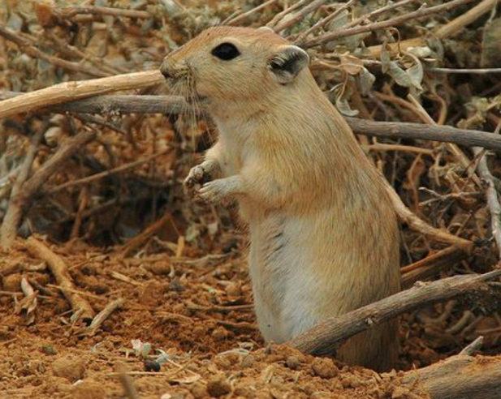

Animal research is used to study diabetes using sand rats. Even though we can’t conduct research on real sand rats, we can use a software program to simulate this research. You will use this simulation to investigate the relationship between environmental factors, inheritance, and diabetes.

**What can we manipulate in the simulation?**

* **Type of sand rats:**
  + The sand rats’ health (diabetic vs. healthy)
  + The sand rats’ risk for diabetes (high vs. low)
  + The sand rats’ gender (male vs. female)
* **Type of food:**
  + Sugary vs. non-sugary food
* **Measurements:** 
  + The sand rats’ weight (normal, heavy, obese)
  + Number of diabetic sand rats (diabetic rats, healthy rats)
  + Number of sand rats at risk of diabetes (risk, no risk)

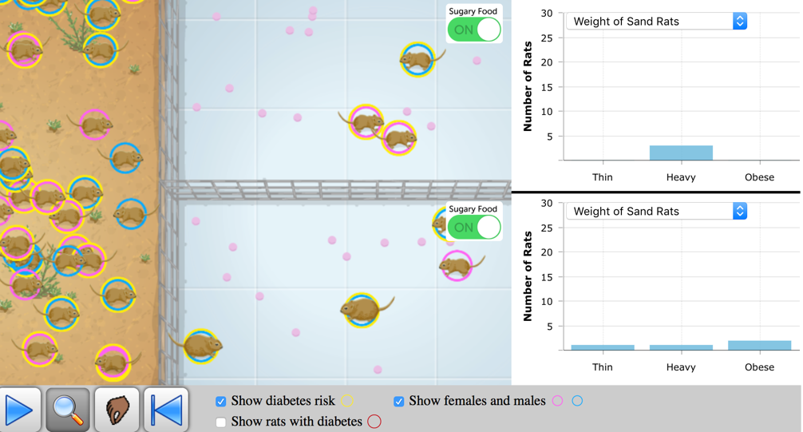

***Let’s Investigate!***

**Step 1 - Planning the inquiry question**

Discuss with your partner what question you would like to investigate. This question may change as you begin to plan your investigation. Make sure to keep track of any changes.

**Question**:

|  |
| --- |
| Write your answer here: |

**Dependent variable**: ____________________________________________

**Independent variable**: __________________________________________

**Step 2 - Planning and carrying out the experiment**

1. Which sand rats will you choose for Pen #1 and Pen #2? What are your criteria for choosing the sand rats?

|  |
| --- |
| Write your answer here: |

1. What characteristics do the sand rats have in each pen? Fill in the chart below.

|  |  |  |
| --- | --- | --- |
| **Type of sand rats:** | **Pen 1**  **# of sand rats** | **Pen 2**  **# of sand rats** |
| Male /without diabetes risk |  |  |
| Female /without diabetes risk |  |  |
| Male /with diabetes risk |  |  |
| Female / with diabetes risk |  |  |
| Total # of sand rats placed in the pen |  |  |

1. What data will you collect?

|  |
| --- |
| Write your answer here: |

**Step 3 – Analyzing data**

Run your experiment. Stop the simulation every 5 sec. At the end of each run, record the results in the *Result Table*. Run your investigation several times, until you think you have collected enough data.

|  |  |  |  |  |  |  |
| --- | --- | --- | --- | --- | --- | --- |
| **Time lapse (weeks)** | **Pen #1** | | | **Pen #2** | | |
| **Total number of sand rats** | **Number of affected sand rats** | **Percentage of affected sand rats** | **Total number of sand rats** | **Number of affected sand rats** | **Percentage of affected sand rats** |
| **0** |  |  |  |  |  |  |
| **5** |  |  |  |  |  |  |
| **10** |  |  |  |  |  |  |
| **15** |  |  |  |  |  |  |
| **20** |  |  |  |  |  |  |
| **25** |  |  |  |  |  |  |
| **30** |  |  |  |  |  |  |
| **35** |  |  |  |  |  |  |

**Step 4 – Interpreting data and communicating information**

1. What **pattern** can you find in the data? Discuss with your partner the trends and record them here.

|  |
| --- |
| Write your answer here: |

1. What **claim** can you make about the effect of environmental factors on sand rats’ health? What evidence do you have that supports your claim? What is your reasoning?

|  |
| --- |
| Write your answer here: |

1. How does your investigation help explain **Monique’s diabetes**?

|  |
| --- |
| Write your answer here: |

1. How can your investigation help answer the driving question: **What controls my health**?

|  |
| --- |
| Write your answer here: |

1. What are the possible limitations of the data collected from the sand rat simulation?

|  |
| --- |
| Write your answer here: |

1. What could you do to decrease possible errors in data collection and/or improve the data collected?

|  |
| --- |
| Write your answer here: |

Gene-Environment Interactions Table

