|  |
| --- |
| **Learning Set 3: Why do we all look for thrills?** |

|  |  |  |  |
| --- | --- | --- | --- |
| **Driving Question**  **for the unit:**  How can looking for thrills make me miserable?  **Driving Question**  **for the learning set:**  Why do we all look for thrills?   |  | | --- | |  | | **Materials**  **Supplies**   * Big post-it   **Background information**   * [Additional info on peppered moths](https://askabiologist.asu.edu/activities/peppered-moth)   **Handouts**   * How do adaptive traits come about in a population * Peppered Moth Data Collection Worksheet * Offline moth simulation * Reading: Darwin’s Finches [and Natural Selection](https://docs.google.com/document/d/1huzU4ItudiltD0rTaTvYByPyimLweoU8wgXjTCEDGvg/edit?usp=sharing) * Scientific Explanation: Moth Lab Report   **Simulations**   * [*Peppered moths simulation*](https://askabiologist.asu.edu/peppered-moths-game/)   **Links to videos**   * Natural selection - <https://www.youtube.com/watch?v=GhHOjC4oxh8> * Natural selection - <https://www.youtube.com/watch?v=0SCjhI86grU>   **For the Optional Extension Activity**  My SUD Modeling Chart: Teacher Version | **Suggested learning set time**  4 days |

Student materials:

* [peppered moth simulation](https://askabiologist.asu.edu/peppered-moths-game/)
* <https://askabiologist.asu.edu/peppered-moths-game>/
* [Peppered Moth Data Collection Worksheet](https://docs.google.com/document/d/1PXx2TLTWBX1YI0lJolVAlycyllXBn0y9bDQUIa6T1lo/edit?usp=sharing)
* [Offline moth simulation](https://docs.google.com/document/d/1SNaBBDJZbOFLFFf6Ye3bTNHEn9Ai-82_iK9GWzBYHLk/edit?usp=sharing)
* [*How do adaptive traits come about in a population?*](https://docs.google.com/document/d/1DbrwMmZtY6TPV_2n8B-ZkW2eMYGuDW4Y4ZltQTu9PEk/edit?usp=sharing)
* Reading: [Darwin’s Finches and Natural Selection](https://docs.google.com/document/d/1huzU4ItudiltD0rTaTvYByPyimLweoU8wgXjTCEDGvg/edit?usp=sharing)
* Scientific Explanation: [Moth Lab Report](https://docs.google.com/document/d/1k9-VP6pNMqyJR3Pa0WhXU5uM901J0nZVEiHhw0JKEQM/edit?usp=sharing)
* **For the Optional Extension Activity**
  + My SUD Modeling Chart
  + Integrated Models

|  |
| --- |
| **Building Coherence** |

This unit guides students through a journey to figure out the sub-driving question, “Why do we all look for thrills?” by investigating how thrill seeking evolved as a survival mechanism. Because of environmental changes and modern lifestyle, thrill seeking can sometimes lead to addiction, misery and even death. Throughout the unit, students investigate several sub-driving questions to support them to gradually answer the bigdriving question, “How can looking for thrills make me miserable?” which encompasses these scientific ideas.

Guided by the sub-driving question, the journey unfolds as students figure out:

* In **LS1** - What gets us excited by examining the sub-driving question, “What do you do for thrills?”
* In **LS2** - The basic mechanism of the brain’s reward pathway which is responsible for the feeling of excitement through the sub-driving question, “Why do thrills make us feel excited and happy?”
* In **LS3** - The importance of thrill seeking to our survival and how the reward pathway evolved through the process of natural selection. Students investigate the sub-driving question, “Why do we all look for thrills?”
* In **LS4** - The risk for substance use disorders and behavioral addictions is caused, in part, by their environment. Students focus on both national and global trends related to SUD and behavioral addictions to understand the contribution of various environmental factors. and answer the sub-driving question, “What puts us at risk for substance use disorder (SUD) and behavioral addictions?”
* In **LS5** - Some genes might cause us to be at risk for substance use disorder (SUD), while others might protect us against. Alcohol flush is a genetic mutation that causes discomfort following alcohol consumption. Alcohol use disorder is caused by the interaction of an individual’s genes and the environment. Taken together, with Learning Set 5, this information helps students answer the sub-driving question, “What are the environmental and genetic factors that put us at risk or protect us from SUD?”
* In **LS6** - What they can do to reduce the risk of addiction by designing and conducting a community action project focused on making a change in their environment. Students address the sub-driving question, “Can we make a change? What can we do to reduce the risk of substance use disorder and behavioral addictions for ourselves and our community?”

To see more details, refer to the **Storyline**.

**In this learning set**, the students will investigate the reward pathway that they learned about in the previous learning set from an evolutionary perspective to understand how the reward system evolved in organisms.

|  |
| --- |
| **Framing the Learning Set** |

**Purpose**

In this learning set, students will focus on the sub-driving question of this learning set, **“Why do we all look for thrills?”** They will figure out why the reward system evolved from an evolutionary perspective. The students will be introduced to concepts of adaptation and natural selection, and then apply these concepts to the reward pathway. Students will continue to develop their models to demonstrate their understanding.

**Learning Set Learning Goals (For instructional use)**

* The students will plan and carry out investigations to explain how variation of traits and natural selection affect survival of a population over time.
* The students will develop a model to show how natural selection affects the development of the reward pathway.

|  |
| --- |
| **Overview of the Learning Set** |

|  |  |  |
| --- | --- | --- |
| **Instructional sequence overview** | **What students figure out**  **(DCI)** | **Instruction days** |
| **Lesson 1 - How do traits evolve in populations?**  Using online simulations, the students will learn about the principles of natural selection and adaptation. | Adaptation by natural selection acting over generations is one important process by which species change over time in response to changes in environmental conditions. Traits that support successful survival and reproduction in the new environment become more common; those that do not, become less common. Thus, the distribution of traits in a population changes. | 3 days |
| **Wrap up - Revisiting the Driving Question Board**  The students will revisit the Driving Question Board (DQB**)** and reflect upon their learning. | 1/2 day |
| **Optional Extension Activity-**  The students will revise their models to answer the question, **“Why do we all look for thrills?”** | Natural selection plays a role in why we look for thrills. | 1 day |
| **Optional Extension Activity -**  Constructing a scientific explanation to answer the sub- Driving Question  Students will construct scientific explanations using integrated models to explain the phenomenon of SUDs and behavioral addictions by answering the sub-Driving Question of the learning set. | SUDs and behavioral addictions are caused by the interaction of genes and the environment. | 2 days |

|  |
| --- |
| **NGSS connection to assessment** |

|  |
| --- |
| **Target Performance Expectations**  [**MS-LS1-5**](http://www.nextgenscience.org/pe/ms-ls1-5-molecules-organisms-structures-and-processes)**.** Construct a scientific explanation based on evidence for how environmental and genetic factors influence the growth of organisms.  [**MS-LS4-4**](https://www.nextgenscience.org/pe/ms-ls4-4-biological-evolution-unity-and-diversity)**.** Construct an explanation based on evidence that describes how genetic variation of traits in a population increases some individuals’ probability of surviving and reproducing in a specific environment.  [**MS-LS4-6**](https://www.nextgenscience.org/pe/ms-ls4-6-biological-evolution-unity-and-diversity)**.** Use mathematical representations to support explanations of how natural selection may lead to increases and decreases of specific traits in populations over time. |
| **Learning performance to be assessed**  Students analyze and interpret data to identify that variation in traits give some organisms an advantage in surviving.  Students construct a scientific explanation to explain how variation in traits give some organisms an advantage in surviving in their environment within a population.     |  |  |  | | --- | --- | --- | | **Disciplinary core idea** | **Science and engineering practices** | **Crosscutting concepts** | | **LS4.B: Natural Selection**Natural selection leads to the predominance of certain traits in a population, and the suppression of others.**LS4.C: Adaptation**Adaptation by natural selection acting over generations is one important process by which species change over time in response to changes in environmental conditions. Traits that support successful survival and reproduction in the new environment become more common; those that do not become less common. Thus, the distribution of traits in a population changes**.** | **Analyzing and interpreting data**   * Use graphical displays (e.g., maps, charts, graphs, and/or tables) of large data sets to identify temporal and spatial relationships. * Analyze and interpret data to provide evidence for phenomena   **Constructing scientific explanation**   * Students use models to construct a scientific explanation that explains why we look for thrill and why looking for thrills can make me miserable. | **Patterns**   * Patterns can be used to identify cause and effect relationships.   **Cause and effect**   * Cause and effect relationships may be used to predict phenomena in natural systems. * Phenomena may have more than one cause, and some cause-and-effect relationships in systems can only be described using probability. | |
| **How these elements are integrated and embedded in this learning set**  In this learning set, students will plan and carry out an experiment using simulations about natural selection and analyze and interpret data to identify and explain how natural selection leads to the predominance of certain traits in a population, and the suppression of others and can influence the survival of organisms with different traits. |

|  |
| --- |
| **Connection to Students’ Lives** |

**Link to out-of-school activity and everyday life**

The natural world is all around us and through keen observation we can even learn about ourselves. Encourage students to identify animals in their local environment, including mammals, birds, and insects, and make observations of their appearance and behavior. Biologists are scientists who study the natural world.

**Link to career-awareness**

Dr. Kettlewell was an entomologist, a biologist who studied insects. Through careful observations and experiments, he tested ideas about natural selection in animals that help us explain human behavior. Here is more about Dr. Kettlewell:

<https://askabiologist.asu.edu/peppered-moths-game/kettlewell.html>.

Here is some more about biologists today:

* This researcher is studying the brain and gene-environment interactions: <https://askabiologist.asu.edu/meet-our-biologists/learning-remember>
* This website has nice descriptions of biology research and biographies of researchers: <https://askabiologist.asu.edu/explore/biologists>
* History Makers is an incredible website with biographies of many biologists including Tyrone Hayes: <https://www.thehistorymakers.org/biography/tyrone-hayes-41>

|  |
| --- |
| **Instructional Sequence** |

**Introducing the Learning Set**

1. **Link to career-awareness**- Dr. Kettlewell was an entomologist, a biologist who studied insects. Through careful observations and experiments, he tested ideas about natural selection in animals that help us explain human behavior. Here is more about Dr. Kettlewell:

<https://askabiologist.asu.edu/peppered-moths-game/kettlewell.html>.

1. **Keeping coherence using the DQB** - Remind students of the driving question of the unit (How can looking for thrills make us miserable?) and the additional questions on the Driving Question Board (DQB). Tell students that in this learning set, we will investigate the sub-driving question, “Why do we all look for thrills?” Building on students’ questions from the sub-driving question, “Why do we all look for thrills?” have students brainstorm and discuss their ideas:
   1. What might be the benefit or good about looking for thrills?
   2. What might happen if we don’t look for thrills?
   3. Why do you think the reward pathway system exists?
2. **Using historical studies in science -** In a scientific setting, scientists can’t always use humans in experiments to answer their questions. Why do you think that might not be appropriate? Instead, scientists can study conditions and conduct experiments in the natural world to understand scientific concepts. In this learning set, the students will use a simulation to be scientists and follow the historical events that were studied by previous scientists. In this case, students will look at Dr. Kettlewell’s work with the peppered moths to help them explain natural selection and relate the principles of natural selection to thrill seeking.

|  |
| --- |
| **Lesson 1 – How do Traits Evolve in Populations?** |

|  |  |
| --- | --- |
| **Learning Goal** | The students will plan and carry out investigations to explain how variation of traits and natural selection affect survival of a population over time. |
| **Connection to NGSS** | DCI: LS1.B: Growth and Development of Organisms |
| Practice: Planning and carrying out a scientific investigation |
| CCC: Patterns |

1. **Introduce the simulation** 
   1. Introduce the peppered moths on the homepage of the [peppered moth simulation](https://askabiologist.asu.edu/peppered-moths-game/)
      1. [Peppered moths](https://askabiologist.asu.edu/peppered-moths-game/peppered-moth.html) are small insects with light wings peppered with small dark spots. Some have dark, almost black bodies.
      2. They are common in Europe and North America.
      3. Their predators are flycatchers, nuthatches, and European robins.
   2. Tell the students that they will be using a simulation to explore the question: Why do different moth populations survive in different environments?
   3. Provide the link to the simulation: [peppered moth simulation](https://askabiologist.asu.edu/peppered-moths-game/)
   4. Students should select “How to play” to read about the game. Next, have students select “Play” to begin.
   5. Have the students play with the simulation by themselves, then discuss their experience. Some discussion questions:
      1. What did you notice when playing the game?
         1. Why do you think that is?
      2. Which forest did you try?
      3. Which moths survived?
         1. Why do you think that is?

|  |  |
| --- | --- |
| **Note to the teacher** | **Figuring out vs. Learning about**  It is important for students to identify patterns themselves using the simulation before they are introduced to scientific content knowledge or background information.  After exploring the simulation, collecting data, and constructing their own explanation about the phenomenon, the students will read the background and connect it back to what they did with the simulation. |

1. **Structured inquiry - Playing *light forest* version** 
   1. **Planning -** Discuss the variables and the inquiry question for the simulation with the entire class:
      1. Generating the inquiry question -
         1. Guide students to come up with the inquiry question, based on their observations from playing the game at the beginning.
         2. For example: “Let’s think about the light forest. Which moths seemed to be the easiest prey? Why do you think so?”
         3. As a scientist, we can’t just guess based on our observations, scientists like to collect data to back up their “hunches.” What is a scientific question we could ask so that we could use the simulation to collect data?
         4. Introduce the *inquiry question:* How does the color of the peppered moth affect their survival?
      2. Explain independent and dependent variables:
         1. **Independent variable**: color of the moths
         2. **Dependent variable**: surviving moths in each population
         3. With the entire class, run and watch the *light forest* simulation for a few seconds.

|  |  |
| --- | --- |
| idea.png | When conducting experiments, the students should be familiar with the following terms:  **Variable -** A variable is any factor that can change or be changed in an experiment.  **Independent variable** - a variable whose variation does not depend on another variable. In an experiment, it is the variable one chooses to change or manipulate, to determine an effect on other variables.  **Dependent variable** - a variable whose value depends on another variable. In an experiment, it is the variable that changes in response to other variables being changed.  **Controlled variable** - In an experiment, this is a variable that is not changed. This enables the experimenter to fairly test the relationship between the independent and dependent variables.  **Inquiry question** - An inquiry question defines the relationship between two variables. |

* 1. **Conducting experiments -** Individually, or in pairs, students play the role of the predator: Use the Peppered Moth Data Collection Worksheet
     1. Control the bird using keypad/mouse
     2. Click on the moth to eat
     3. Check the graph of each moth population in the bottom and record the data in the following table
     4. Run it again and record the second data. Have students run the game and collect data at least 4 times. Have students record the strategy they used in the table.

|  |  |
| --- | --- |
| **Note to the teacher** | Depending on the strategy students use as “predators,” results of which moths survive may vary. For example, if students don’t move the predator, but simply click, the moths eaten will be those that happen to fly by the predator. In this case, it may be that there is no pattern. The “ideal” predator is one that will focus on those moths that it can readily see and “eat.” |

|  |  |  |  |
| --- | --- | --- | --- |
| **Light Forest**  All games start with a population of 50% dark moths and 50% light moths | | | |
| Game # | % light colored moths  at the end of the game | % dark colored moths  at the end of the game | Strategy used |
| Game 1 |  |  |  |
| Game 2 |  |  |  |
| Game 3 |  |  |  |
| Game 4 |  |  |  |

1. **Sharing and discussing -** Have each team of students report their findings and conclusions to the class:
   1. **Discussing the results -**
      1. What pattern can you find from the data?
         1. Did you get similar or different results as your partner?
         2. Did you get similar or different results as other teams?
      2. What conclusion can you make about the effect of the color of the moths on their survival?
      3. What is the evidence to support your claim
   2. **Discussing fitness and adaptation** 
      1. Which moth seemed to survive better? Why?
         1. [Because the birds couldn’t see them - they have a trait (color) that makes them *better fit* to their environment. In science we would say that the light-colored moth was *better adapted* or *better fit* to their environment. The light color is an *adaptation* to the specific characteristic of the forest, in this case - the light forest.]
      2. According to this simulation, how do organisms acquire traits that are *adaptive* to the environment?
         1. Include the terms, parents, inherit and offspring in your answers.
      3. Can you think of other examples of animals/plants with adaptive or non-adaptive traits?

|  |  |
| --- | --- |
| **Scientific background** | **Darwin's theory of natural selection**  Within a population, individuals have different traits. The different traits cause some individuals to be better adapted/fit to their environment than others.  These individuals have higher chances of survival and reproduction. Their offspring, which inherit these traits, also have higher chances of survival and reproduction. Over time, the number of individuals with these traits will increase, and the number of individuals without these traits will decrease. After many generations, all the population will have these traits, and the population as a whole will be better adapted to the environment.  A common misconception about Darwin’s theory is that only the “fittest” survive suggesting only the “strongest” survive. However, in Darwin’s theory, “fittest” means those individuals that are most fit are the ones best able to survive and reproduce, irrespective of their strength, and that differences in the survival and reproduction among individuals occurs because they have the specific adaptive traits that make them the most successful in that environment. Being the strongest doesn’t always give an individual the advantage. Think of the dinosaurs. They were the biggest and strongest, but they did not survive their environment. |

1. **Guided inquiry - Playing *dark forest* version**
   1. If the light moths in the light forest survive, what do you think will happen to that population of moths? What will eventually happen to the dark colored moths? Why?
   2. Discuss the claim below with the students. *Pollution will result in an increase in the number of dark moths in the population.* 
      1. Do you think that is a true or false statement?
         1. Why?

|  |
| --- |
| ***Inquiry question:*** *How will pollution affect the survival of moths?*  ***Claim:*** *Pollution will lead to an increase in the number of black moths in the population.* |

* 1. Next, individually or in pairs, have the students plan and carry out their investigation, and use the simulation to answer the inquiry question- this time with the dark forest. Have the students prepare their data collection chart on page 2 of Peppered Moth Data Collection Worksheet.

Proposed chart:

|  |  |  |  |
| --- | --- | --- | --- |
| **Dark Forest**  All games start with a population of 50% dark moths and 50% light moths | | | |
| Game # | % light colored moths  at the end of the game | % dark colored moths  at the end of the game | Strategy used |
| Game 1 |  |  |  |
| Game 2 |  |  |  |
| Game 3 |  |  |  |
| Game 4 |  |  |  |

1. **Sharing and discussing** - With the entire class, share and discuss the students’ results. Use the following prompts:
   1. What was the design of your experiment? Explain why.
   2. How many times did you repeat the simulation? Explain why.
   3. How did your experiment help you answer your question?
   4. What pattern can you find from the data?
   5. Does the data support or oppose the claim?
   6. What evidence do you have?
   7. What are the similarities and differences between your results and those of other teams?
   8. What conclusion can you make about the effect of the color of the moths on their survival?
   9. What is the evidence to support your claim?
   10. Based on your results from this simulation, how do organisms develop traits that are adaptive to the environment?
2. **Review the data from the simulation -** With the students, review the data about dark and light moths from both rounds of simulation.
3. **Figure out the principles of natural selection –** Use the **offline moth simulation worksheet**. Here is the teacher version. For each scenario:
   1. Read and discuss the environment
   2. Read and discuss the rules for reproduction
   3. Discuss the assumption. This is important as this varies between the scenarios.
   4. Review the table and focus on the process by which one population becomes predominant in the environment. **See Note to teacher below**
   5. For the graphing part of this lesson, students can use a linear graph or bar graph for this activity.
   6. If students choose to use a bar graph, it might be good to discuss the kind of data the graph is representing
      1. With a linear graph you are representing the population of moths over time along a continuum,
      2. The bar graph examines the number of moths at one specific point in time. If students use a bar graph they should connect all the dots to get an estimate of the growth of the population.
   7. This might be a great point to talk with students about the differences between a bar graph and a linear graph and discuss which kind of graph better represents this set of data.

|  |  |
| --- | --- |
| **Note to the teacher** | In scenarios (1+2) the trait of color is inherited, therefore, natural selection can occur (this is a principle that drives natural selection).  In this scenario (3) the trait of color is NOT inherited, and there is NO pattern in the colors of the offspring.  Students can randomly assign some of them to be dark and some of them to be light.  Discuss with students - What happens then if it is totally random? What does random mean (No pattern like they saw in the other scenarios driven by Natural Selection)? Kids will not see the pattern they saw before which drove natural selection, and the increase in one population versus the decrease in the other. |

|  |  |
| --- | --- |
| **Note to the teacher** | The goal of this activity is to support students in figuring out the principles of natural selection without giving them the answer first. In this activity, students focus on the process by which the number of individuals carrying a more adaptive trait increases over time in a population, only if the principles of natural selection are met: 1) variation, 2) heredity, 3) selection. |

1. **Discuss the three principles of Natural Selection:** Lead a class discussion to support students to figure out the three principles of natural selection, and answer the question “what principles drive natural selection?”
2. **Guide to the *principle of variation*** - Thinking about the moth simulations, were the two populations the same? How are they similar and/or different? What would have happened if they were the same?
3. **Guide to the *principle of heredity* -** Is the color of the moths inherited? When the trait “color of the moths” was inherited, were we able to identify a pattern? When the “color of the moths” was not inherited, were we able to identify a pattern?
4. **Guide to the *principle of selection* -** The environment plays a role in determining which individuals survive and reproduce based on their traits.
   1. In the simulation, which offspring were more likely to survive in the dark forest? Light or Dark? Why?
   2. Based on the moth simulation, under which conditions did we see natural selection occurring? Which were more likely to have their population grow?

|  |  |
| --- | --- |
| **Scientific background** | **The principles of natural selection**  We can summarize Darwin’s theory of evolution through natural selection in three principles:   1. **Principle of variation.** Among individuals within any population, there is variation in morphology, physiology, and behavior. 2. **Principle of heredity.** Offspring resembles their parents more than they resemble unrelated individuals. 3. **Principle of selection.** Some forms are more successful at surviving and reproducing than other forms in a given environment. |

1. **Implement the principles of natural selection** - Have each student complete the flowchart/worksheet, **How do adaptive traits come about in a population?** The goal of the worksheets is to further support students in figuring out how traits evolve in populations and the principles of natural selection through visual scaffolds. The worksheets include three examples:
   1. In the first activity, students are required to figure out why **dark moths** are found in a **dark forest** if a **predator eats light moths.** Students need to choose one of the two terms written between the blank boxes, and fill them in. Once they finish, the flowchart should describe the process of natural selection by which the population of dark moths becomes predominant in the dark forest.
   2. In the second activity, students are required to figure out why **light moths** are found in a **light forest** if a **predator eats dark moths**. In this activity, students need to choose the appropriate term from a word bank located at the bottom of the page. Once they finish, the flowchart should describe the process of natural selection by which the population of light moths becomes predominant in the light forest.
   3. **Optional Extension Activity**- In the third activity, students have a chance to ask a question of their own which would involve the process of natural selection, For example: Why do we find white bears in the arctic? Why do we find brown rabbits in the woods? Why do we find squirrels in trees? Students need to fill in the blank boxes based on their understanding of the process of natural selection. Once they finish, the flowchart should answer their question based on the process of natural selection.
2. **Summarize the concept of natural selection**
   1. **Reading -** Darwin’s Finches and Natural Selection
   2. **Video** - With the students, watch the video, start the video at 4:50 minutes. The video summarizes natural selection and adaptation. Discuss the relation between this video and the students’ experiments with the simulations: <https://www.youtube.com/watch?v=0SCjhI86grU>
3. Through a class discussion, guide students to use the principles of natural selection to answer the questions:
   1. How do farmers use the principles of natural selection to create new and better varieties of foods?
   2. How does the video use the example of the iguana, eating the bugs on the leaf, to demonstrate the three principles of Natural Selection?
      1. **Principle of variation**. Among individuals within any population, there is variation in physical and behavioral traits.
      2. **Principle of heredity.** Offspring resembles their parents more than they resemble unrelated individuals.
      3. **Principle of selection**. Some forms are more successful at surviving and reproducing than other forms in a given environment.
4. **Connect the scientific background to the simulation**
   1. **Read the background history and discuss:** 
      1. In the online simulation, have the students find the tab and read ‘[Natural Selection](https://askabiologist.asu.edu/peppered-moths-game/natural-selection.html)’ and ‘[Dr. Kettlewell](https://askabiologist.asu.edu/peppered-moths-game/kettlewell.html)’ section
      2. Facilitate a classroom discussion by using the prompts below:
         1. By 1990, how did the moth population change?
         2. What are some influences of the Industrial Revolution on the environment?
         3. How can the idea of natural selection explain the change of moth population?
         4. What was Dr. Kettlewell’s claim?
         5. What evidence did he have to support his claim?
5. **Constructing a scientific explanation student worksheet- moth lab report** Tell students that in their role as a scientist, they will write a lab report to share with colleagues on their findings from the moth simulation. The lab report will be in the form of a scientific explanation (see the box below). The lab report will include answers to the following questions.
   * 1. **Claim**: What does the moth simulation show about how the color of moths and their environment affect their survival?
     2. **Evidence**: What data do you have to support your claim?
     3. **Reasoning**: How can we use scientific ideas and concepts we have studied (Natural Selection) to show that the color of moths and their environment affected moth survival? Use the principles of Natural Selection in your answer.
        1. **Principle of variation**. Among individuals within any population, there is variation in physical and behavioral traits.
        2. **Principle of heredity.** Offspring resembles their parents more than they resemble unrelated individuals.
        3. **Principle of selection**. Some forms are more successful at surviving and reproducing than other forms in a given environment.

|  |  |
| --- | --- |
| idea.png | **What is a *scientific explanation?* How can it be used?**  Scientists try to explain how and why a natural phenomenon occurs. A scientific explanation consists of a claim, evidence, and reasoning (CER). The claim is a testable statement that expresses the answer or conclusion to a question or problem. Evidence is scientific data that supports the claim. The reasoning describes how or why the evidence can be used to support the claim by using scientific ideas and principles. |

1. **Connect the simulation of moths to thrill seeking -** Engage students to make the link between what they know about natural selection and why people look for thrills.
   1. Help students think about what thrill-seeking has to do with our survival. Ask some questions about our ancestors long ago and the environments they lived in.
      1. How can we apply the moth’s survival to explain people seeking thrills? What does thrill-seeking have to do with our survival?
      2. What do you think our early ancestors’ everyday life looked like? What did they have to do to survive? Our early ancestors survived on hunting and food gathering in the wild.
      3. Did the activities involve high risks? Hunting was one of the early expressions of thrill-seeking, particularly when they began to hunt large mammals where there's a high risk involved. Many people enjoy hunting even today.
      4. Do all people find the same activities “thrilling?” Remind students of the results of their survey of family members in Learning Set 1. There is a difference among people and their thrill-seeking tendencies.
         1. Discuss with students the advantage of having a continuum in thrill seeking behaviors in a population. Under certain circumstances or certain environments, it might be better to be more cautious or more adventurous. There is an advantage to having all types of thrill-seeking individuals within a population.
      5. Do you think people still use thrill seeking as a way to survive? Is it really necessary to look for thrills to survive? Why? What are things we enjoy today that help us survive?
      6. Are there things we enjoy today that don’t help us survive? If we don’t really need to look for thrills to survive, why do you think we still look for thrills? It’s part of our human nature.
   2. Have a discussion about people’s thrill seeking in our modern life.
      1. How can we compare riding roller coasters today to fighting a wild animal long ago? What’s the similarity and what’s the difference? They cause the brain to produce the same chemical. Back then it was a matter of survival. In today's far safer world, it's a matter of pleasure.
      2. How about smaller thrills? Can students give examples from their own lives? School accomplishments, sports and other after school activities? How do these work in our reward system?

|  |
| --- |
| **Wrapping-up the Learning Set - Revisiting the Driving Question Board** |

With the class, revisit the **Driving Question Board** **(DQB)**. Prompt the students to reflect upon their learning using the following prompts, and adjust the DQB as appropriate:

1. Which questions on the DQB have we answered, and which remain open?
   1. Students should attach their answers/artifacts of investigation onto the DQB next to the questions they relate to.
2. After completing the lessons in the learning set, do you have any additional questions?
   1. Add new questions to the board near the SDQ they relate to.
3. Ask students some transitional questions that are related to the next learning set. **How can looking for thrills hijack our brains?**
   1. Based on what we learned in this Learning Set, Why do you think people vape?
      1. What do you think are the consequences of vaping?
      2. Some young people say they know it’s bad and want to stop. Why do they continue vaping?
   2. How do you think some thrill seeking activities become dangerous to our brains and bodies?

|  |
| --- |
| **Family Engagement** |

Bring in arts and design to reinforce the ideas of natural selection and adaptation. Here's an optional maker space idea that can be done at home with family members: The students imagine and create their own organisms that they, as researchers, found on an isolated island. The creature can be made from anything found at home. Then students explain how the traits of this creature are adaptive to the environment and increase its fitness and survival. They would also need to create their island landscape. Students bring their creatures, island drawing or landscape, and written descriptions to share with their classmates. Be sure to use the principles of natural selection in discussions to reinforce their understanding. Have students use the handouts as scaffolds to support their explanations of their creatures.

|  |
| --- |
| **Optional Extension Activity – Developing Models** |

|  |  |
| --- | --- |
| **Learning Goal** | The student will develop a model to connect their understanding of natural selection to the development of the reward pathway system. |
| **Connection to NGSS** | DCI: LS1.B: Growth and Development of Organisms |
| Practice: Developing models |
| CCC: Cause and Effect |

**Developing models for the unit -** How can looking for thrills make me miserable?

In this lesson, students develop one part of the model that will focus on the sub-driving question of this learning set **“Why do we all look for thrills?”**

**Based on their experience in this learning set, ask students to complete the students to fill out My SUD Modeling Chart Student Version (not filled in) / Teacher’s version**

1. **REFLECT upon learning in pairs**
   1. **Identify the sub-driving question -** What is the sub-driving question that students were asked to think about during the Learning Set?
   2. **Identify the questions** - What questions did students pose at the beginning of the Learning Set?
   3. **Identify the Main Message (**Whole group discussion) - **What** did students figure out from the Learning Set? Use the following prompts:
      1. What do you think are the take-home messages from the learning set?
      2. What did you learn in this learning set?
2. **REFLECT upon learning as a whole group/class.** Review students’ answers for the first three sections of the table.
3. **PLAN as a whole group/class.** 
   1. **Identify the components** - Start with a class discussion to remind the students of the different components to explain people’s thrill seeking behavior using the concept of natural selection as they discussed. For example: Adaptive traits (Thrill seeking), Variation, Selection, Inheritance, Survival rates, Number of individuals carrying the trait, Natural selection, Adaptation.
   2. Be sure to use My SUD Modeling Chart (teacher version) for the Learning Set to support the discussion about components. These are just suggestions, students will likely come up with many more on their own and through the discussion.
4. **PLAN in small groups.**
   1. **Generate different components** - Write each component on its own sticky note. Each component should be relevant. (At this point, components in a student's model may not be measurable. It is fine even if they cannot come up with the components that are measurable.)
   2. **Organize the components** - organize the components, such as adaptive and non-adaptive traits, principles of natural selection, etc.
5. **BUILD in small groups: Connect the components (demonstrate to the class before students go into small groups)** - Connect the components in a **causal relationship** from the cause to the effect. Students should use arrows to show the directionality of the connection. (Hint: For the most part, the arrows will go from thrill seeking.)
6. **TEST/REVISE in small groups**: **Evaluate models** - Instruct students to switch off in the roles of presenter and listener. Explain the phenomenon by explaining why we all look for thrills. Have the students test their models by applying the following questions:
   1. Does your model explain and predict?
   2. Does your model make sense? Does it make sense when you use increase-decrease language?
   3. Are the components in your model relevant to activities for thrill-seeking?
   4. Does your model show cause-effect relationships?

Together, make any changes needed to make their models more clear and complete.

1. **SHARE as a whole group/class -** Collectively, share the models with the class such as a gallery walk. Use the questions above, e.g one per small group, to have students present to the large group.
   1. When sharing models, discuss with the students:
      1. The similarities and differences between the models
      2. The models’ strengths and weaknesses
      3. Ways to improve the various models
2. **REVISE in small groups** - Based on feedback and observing other models, have the students revise their models. Once they finish, they can document (e.g take a picture of) their group’s model and send it to their teacher. These models can be used for formative assessment, and for students’ to examine and reflect upon their model development process at the end of the unit.

|  |  |
| --- | --- |
|  | While the students develop their models, circle in the class, support the students, and encourage them to share their thinking and consult with their peers about their models. Students’ models can vary. However, since the models need to explain the relationships among the components, make sure the models include:  **Components**   * Thrill seeking (Adaptive traits) * Variation * Inheritance * Survival rates * Number of individuals carrying the thrill seeking behaviors through natural selection overtime   **Relationships and labels**   * The relationships among the components * The relationship between the components and natural selection |

|  |  |
| --- | --- |
| discussion.jpg | A discussion which shares insights from the various models and compares among them is extremely important as it will scaffold the students’ second revision of their models in the following step. Use questions to prompt the students to critically examine their peers’ models.  **Components**   * **Components identity**- What components are included in each model? Are key components included? * **Number of components** - How many components are indicated in the model? Are MORE components necessarily better? * **Grouping of components** - How can we group the various components? Why should we group components—does it improve our models? Is the grouping meaningful?   **Relationships among components**   * **Explicit relationships among the components** - Are the relationships among the components indicated? Do these relationships make sense? Are the indicated relationships important?   **General features**   * **Complexity of the model** *-* How complex is the model? * **Organization**- How well is the model organized? Is the organization meaningful? |

|  |
| --- |
| **Optional Extension Activity – Constructing a Scientific Explanation to Answer the Unit Driving Question**  **End of Learning Set Assessment** |

|  |  |
| --- | --- |
| **Learning Goal** | Students develop (evaluate and revise) a model to explain how looking for thrills can make us miserable.  The students construct a scientific explanation that explains why looking for thrills can make me miserable. |
| **Connection to NGSS** | DCI: LS1.B: Growth and Development of Organisms |
| Practice: Developing a scientific model  Constructing a scientific explanation |
| CCC: Cause and effect |

Through class discussion, the students, guided by the teacher, will develop integrated models which connect consensus models from different learning sets to construct scientific explanations (CER) to explain the phenomenon of SUD / behavioral addiction and gene-environment interaction by answering the Driving Question of the unit, “How can looking for thrills make me miserable?”

1. **Teacher and students complete this model link together (**integrated models teacher version is found below and integrated models student worksheet**).** The following list of questions and My SUD Modeling chart (teacher version / student version) can guide connecting the two models and coming up with a CER.
   1. To support linking two different models to make a claim:
2. What are the common components between the two learning sets?
3. Where do the two models link together?
4. What are the main ideas of each learning set? How can they be linked?
5. How does one model help explain, expand, and elaborate another?
   1. To support the evidence:
6. What activities did we do in each learning set?
7. What videos did we watch?
8. What experiment did we conduct?
9. What data (i.e. from maps, charts, simulation, interview) did we collect or use?
10. What are some specific examples, shown in your models, that can be used as evidence to support your claim?
    1. To support the reasoning:
11. What are the underlying scientific ideas shown in your models and in the unit that can explain how your claim and evidence are connected?

**2. Integrated model for LS1 and LS3**

**Main idea to include Linking various thrill-seeking activities to natural selection**

Links can be made from “thrill seeking” in the LS1 model to the LS3 model where it describes thrill seeking traits which can vary among individuals.

Links can be made between the outcomes of various thrill-seeking activities in LS1 model and increase/decrease of survival rate in LS3 model.

Exemplar model

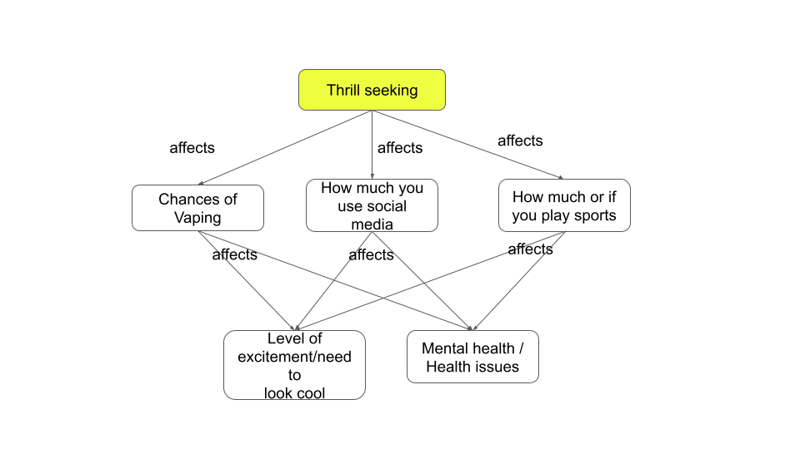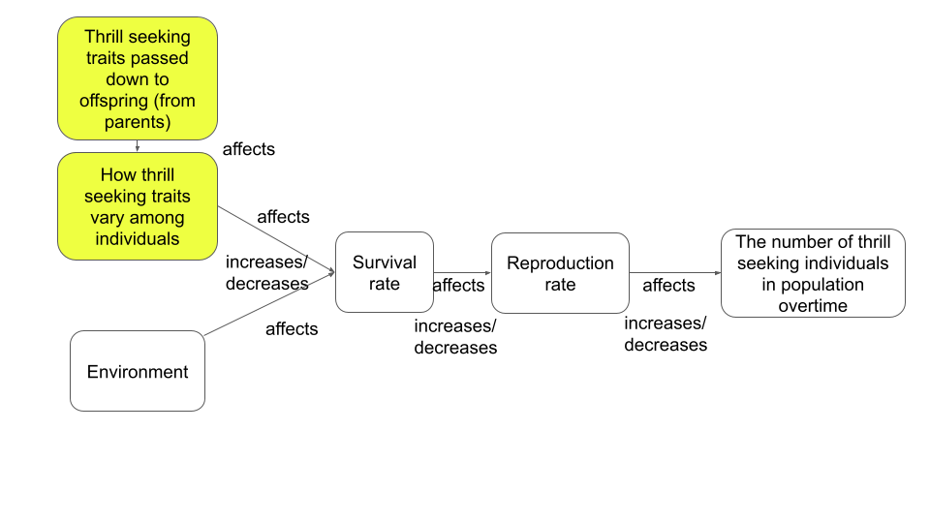

|  |  |
| --- | --- |
| **Sub-Driving Question: Why do we look for thrills?** | |
| **Claim** | Thrill-seeking behaviors are part of our nature and people participate in different thrill-seeking behaviors, those behaviors can sometimes make us miserable. |
| **Evidence** | We learned through our investigations of the moth simulation that some traits, in nature, make it more likely that the individuals will survive and pass those traits on to their offspring and those offspring will have that trait as well. |
| **Reasoning** | The thrill-seeking variation has been passed along over generations. The theory of natural selection explains why some traits have a higher chance of being passed on through generations. Some of those thrill-seeking behaviors can be healthy and promote survival of the individuals and some thrill-seeking behaviors are not healthy and can lead to death and those individuals will not reproduce. |

**Discussion:** Help students make the generalization from ***the peppered moth*** to ***our/my traits***, and from ***thrill seeking*** to ***health***, for example:

* + 1. Ask students “Do the peppered moth traits apply only to ***moths***, or can they be generalized to ***other organisms*** as well?”
    2. Original: Why do we all look for the thrills?
       1. How can this sub-driving question apply to our own thrill-seeking and our health?

**Lesson 1 Worksheet:**

**Peppered Moth Simulation Data Collection Worksheet**

Directions: As you use the [peppered moth simulation](https://askabiologist.asu.edu/peppered-moths-game/) you will collect data to analyze and compare with your classmates.

**Conducting experiments -** Individually, or in pairs, students play the role of the predator:

* + Control the bird using keypad/mouse
  + Click on the moth to eat
  + Check the graph of each moth population in the bottom and record the data in the following table
  + Run it again and record the second data.
  + Run the game and collect at least 4 times.
  + Record the strategy you used in the table. Strategy means- How did you choose which moths to eat? Did you move around? Stay in one place? Briefly explain your method for eating birds.

**Playing *light forest* version**

|  |  |  |  |
| --- | --- | --- | --- |
| **Light Forest**  All games start with a population of 50% dark moths and 50% light moths | | | |
| Game # | % light colored moths  at the end of the game | % dark colored moths  at the end of the game | Strategy used/Method used to hunt birds |
| Game 1 |  |  |  |
| Game 2 |  |  |  |
| Game 3 |  |  |  |
| Game 4 |  |  |  |

**Playing *dark forest* version**

* + Discuss the claim - *Pollution will cause the population of dark moths to increase.* 
    - Do you think that is a true or false statement? Why?

|  |
| --- |
| **The statement is (circle one): True or False**  **Explain:** |

|  |
| --- |
| ***Inquiry question:*** *How will pollution affect the survival of moths in the dark forest?*  ***Claim:*** *Pollution will cause the population of dark moths to increase.* |

* + Using the simulation, plan and carry out an investigation to answer the inquiry question, this time with the dark forest. Prepare your data collection chart.

|  |  |  |  |
| --- | --- | --- | --- |
| **Dark Forest**  All games start with a population of 50% dark moths and 50% light moths | | | |
| Game # | % light colored moths  at the end of the game | % dark colored moths  at the end of the game | Strategy used |
| Game 1 |  |  |  |
| Game 2 |  |  |  |
| Game 3 |  |  |  |
| Game 4 |  |  |  |

**Lesson 1 Worksheet:**

**Offline Moth Simulation**

**Scenario #1**

**Environment: Dark forest**. In the dark forest, the dark color is an adaptive trait since it enables the moths to hide from their predators. The light color is the non-adaptive trait, since the moth’s predators can spot them easily. Therefore, in the dark forest, the dark moths are better fitted to the environment than the light moths.

**The game rules for reproduction and death of moths:**

1. A pair of moths are needed to reproduce. To calculate the number of pairs, divide the total number of moths by 2.
2. Each pair of moths have 4 offspring. To calculate the number of offspring, multiply the number of pairs by 4.
3. Half of the “less fit” individuals (light moths) die. To calculate the number of surviving moths, divide the number of light offspring by 2.

**Assumption:** The color of the moth **is an inherited trait**. Dark colored parents always have dark offspring. Light colored parents always have light offspring.

|  |  |  |  |  |
| --- | --- | --- | --- | --- |
| **Generations** | **Population 1** | **Population 2** | **Total dark-light** | |
| **Dark** | **Light** |
| Initial population | **20 dark moths** | **20 light moths** | **20** | **20** |
| 1st generation | 20/2*4=40 | 20/2*4=40 half die = 20 |  |  |
| 2nd generation | 40/2*4=80 | 20/2*4=40 half die = 20 |  |  |
| 3rd generation | 80/2*4=160 | 20/2*4=40 half die = 20 |  |  |
| 4th generation | 160/2*4=320 | 20/2*4=40 half die = 20 |  |  |
| 5th generation | 320/2*4=640 | 20/2*4=40 half die = 20 |  |  |

**Draw a graph**

Get ready for some graphs!

1. Using the data in the two columns at the right of the table above, draw a linear graph of the dark and light moths’ populations over 5 generations.
2. What do you think will happen in the 6th and 7th generations? Continue the graph for these generations.

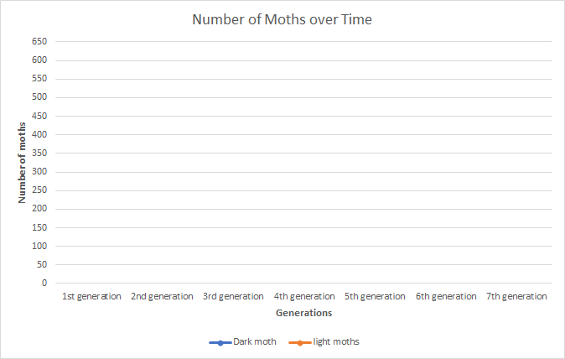

**Teacher Version**

|  |  |  |  |  |
| --- | --- | --- | --- | --- |
| **Generations** | **Population 1** | **Population 2** | **Total dark-light** | |
| **Dark** | **Light** |
| Initial population | **20 dark moths** | **20 light moths** | **20** | **20** |
| 1st generation | 20/2*4=40 | 20/2*4=40 half die = 20 | 40 | 20 |
| 2nd generation | 40/2*4=80 | 20/2*4=40 half die = 20 | 80 | 20 |
| 3rd generation | 80/2*4=160 | 20/2*4=40 half die = 20 | 160 | 20 |
| 4th generation | 160/2*4=320 | 20/2*4=40 half die = 20 | 320 | 20 |
| 5th generation | 320/2*4=640 | 20/2*4=40 half die = 20 | 640 | 20 |

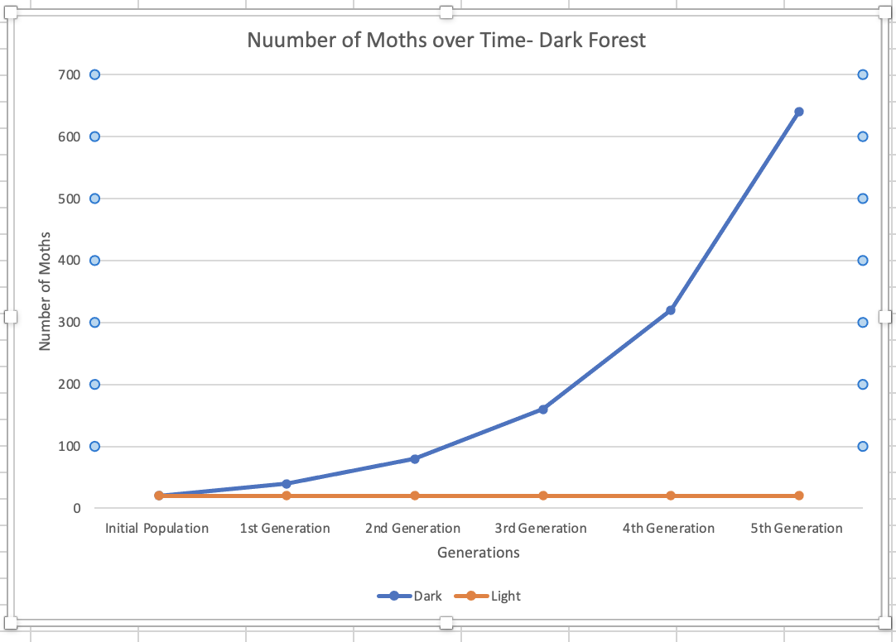

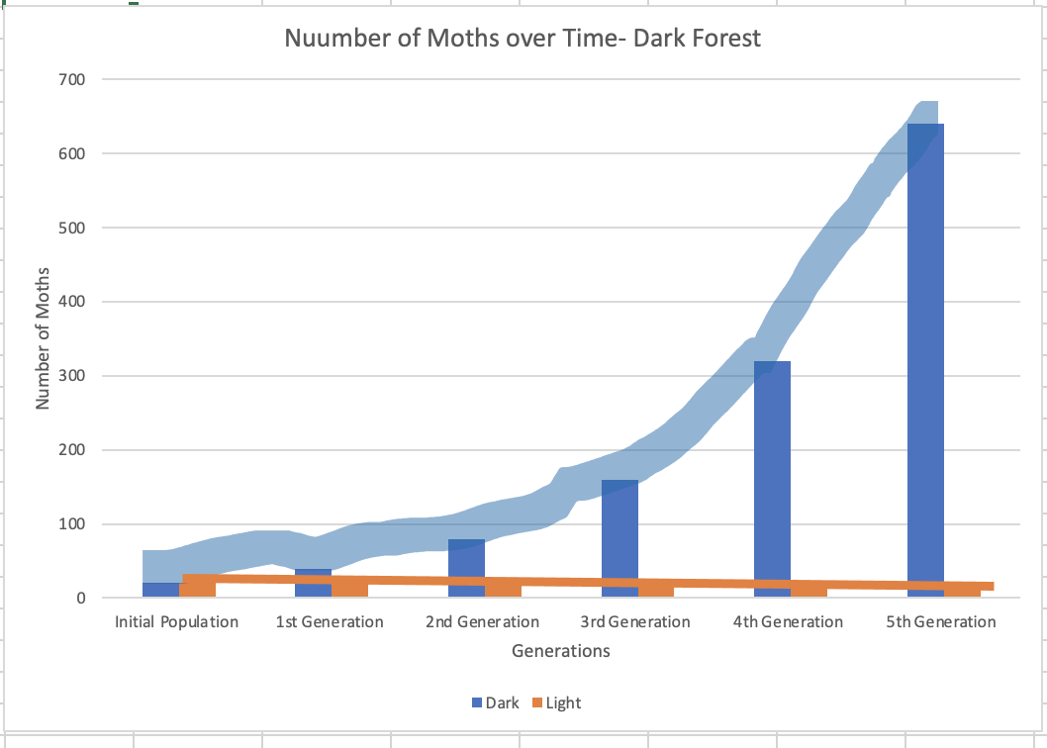

**Scenario #2**

**Environment: Light forest.** In the light forest, the light color is an adaptive trait since it enables the moths to hide from their predators. The dark color is the non-adaptive trait, since the moth’s predators can spot them easily. Therefore, in the light forest, the light moths are more fitted to the environment than the dark moths.

**The rules for reproduction and death of moths:**

1. A pair of moths are needed to reproduce. To calculate the number of pairs, divide the total number of moths in 2.
2. Each pair of moths have 4 offspring. To calculate the number of offspring, multiply the number of pairs by 4.
3. Half of the less fitted individuals (dark moths) die. To calculate the number of surviving moths, divide the number of light offspring by 2.

**Assumption:** The color of the moth **is an inherited trait**. Dark colored parents always have dark offspring. Light colored parents always have light offspring.

|  |  |  |  |  |
| --- | --- | --- | --- | --- |
| **Generations** | **Population 1** | **Population 2** | **Total dark-light** | |
| **Dark** | **Light** |
| Initial population | **20 dark moths** | **20 light moths** | **20** | **20** |
| 1st generation | 20/2*4=40 half die = 20 | 20/2*4=40 |  |  |
| 2nd generation | 20/2*4=40 half die = 20 | 40/2*4=80 |  |  |
| 3rd generation | 20/2*4=40 half die = 20 | 80/2*4=160 |  |  |
| 4th generation | 20/2*4=40 half die = 20 | 160/2*4=320 |  |  |
| 5th generation | 20/2*4=40 half die = 20 | 320/2*4=640 |  |  |

**Draw a graph**

Get ready for some graphs!

1. Using the data in the two columns at the right of the table above, draw a linear graph of the dark and light moths’ populations over 5 generations.
2. What do you think will happen in the 6th and 7th generations? Continue the graph for these generations.

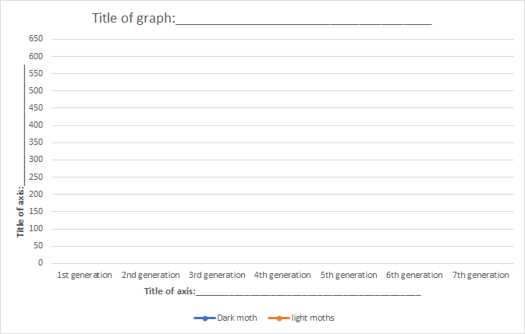

**Teacher Version**

|  |  |  |  |  |
| --- | --- | --- | --- | --- |
| **Generations** | **Population 1** | **Population 2** | **Total dark-light** | |
| **Dark** | **Light** |
| Initial population | **20 dark moths** | **20 light moths** | **20** | **20** |
| 1st generation | 20/2*4=40 half die = 20 | 20/2*4=40 | 20 | 40 |
| 2nd generation | 20/2*4=40 half die = 20 | 40/2*4=80 | 20 | 80 |
| 3rd generation | 20/2*4=40 half die = 20 | 80/2*4=160 | 20 | 160 |
| 4th generation | 20/2*4=40 half die = 20 | 160/2*4=320 | 20 | 320 |
| 5th generation | 20/2*4=40 half die = 20 | 320/2*4=640 | 20 | 640 |

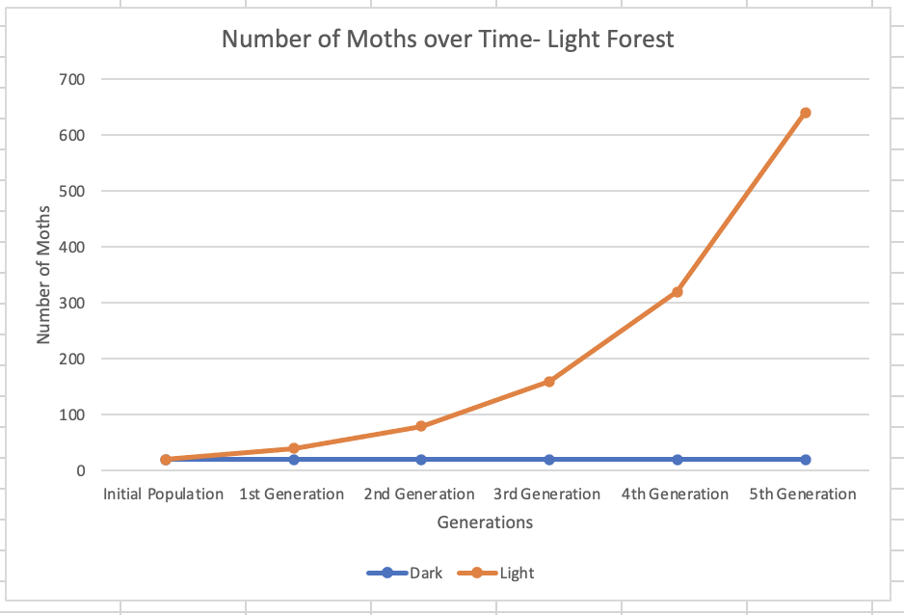

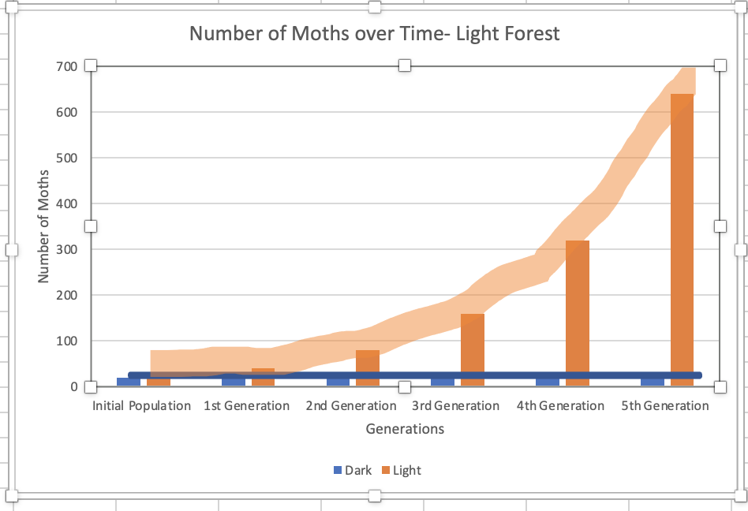

**Optional Extension Activity Scenario #3**

**Environment: Dark forest**. In the dark forest, the dark color is an adaptive trait since it enables the moths to hide from their predators. The light color is the non-adaptive trait, since the moth’s predators can spot them easily. Therefore, in the dark forest, the dark moths are more fitted to the environment than the light moths.

**The rules for reproduction and death of moths:**

1. A pair of moths are needed to reproduce. To calculate the number of pairs, divide the total number of moths in 2.
2. Each pair of moths have 4 offspring. To calculate the number of offspring, multiply the number of pairs by 4.
3. Half of the less fitted individuals (light moths) die. To calculate the number of surviving moths, divide the number of light offspring by 2.

**Assumption:** The color of the moth **is** **NOT an inherited trait**. Dark colored parents do not always have dark offspring. Light colored parents do not always have light offspring.

|  |  |  |  |  |
| --- | --- | --- | --- | --- |
| **Generations** | **Population 1** | **Population 2** | **Total dark-light** | |
| **Dark** | **Light** |
| Initial population | **20 dark moths** | **20 light moths** | **20** | **20** |
| 1st generation | 20/2*4=40  BUT – 10 are dark and 30 are light  Surviving:  10 dark 15 lights = total: 25 | 20/2*4=40  BUT – 20 are dark and 20 are light  Surviving:  20 dark 10 light = total: 30 |  |  |
| 2nd generation | 25/2*4=48  BUT – 30 are dark and 10 are light  Surviving:  30 dark and 5 light | 30/2*4=60  But – 2 are dark and 58 are light  Surviving:  2 dark and 29 light |  |  |
| 3rd generation | 35/2*4=68  BUT – 32 are dark and 36 are light  Surviving:  32 dark and 18 light | 60/2*4=120  But – 70 are dark and 50 are light  Surviving:  70 dark and 25 light |  |  |
| 4th generation | 68/2*4=136  But – 46 are dark and 90 are light  Surviving:  46 dark and 45 light | 95/2*4=94  BUT – 20 are dark and 74 are light  Surviving:  20 dark and 37 light |  |  |
| 5th generation |  |  |  |  |

**Draw a graph**

Get ready for some graphs!

1. Using the data in the two columns at the right of the table above, draw a linear graph of the dark and light moths’ populations over 5 generations.
2. What do you think will happen in the 6th and 7th generations? Continue the graph for these generations.

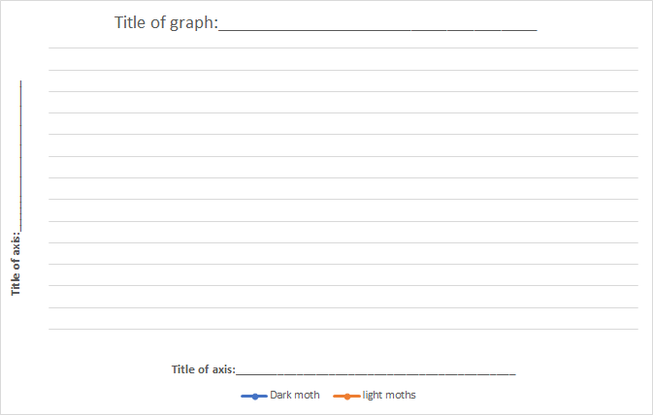

**Teacher Version**

|  |  |  |  |  |
| --- | --- | --- | --- | --- |
| **Generations** | **Population 1** | **Population 2** | **Total dark-light** | |
| **Dark** | **Light** |
| Initial population | **20 dark moths** | **20 light moths** | **20** | **20** |
| 1st generation | 20/2*4=40  BUT – 10 are dark and 30 are light  Surviving:  10 dark 15 lights = total: 25 | 20/2*4=40  BUT – 20 are dark and 20 are light  Surviving:  20 dark 10 light = total: 30 | 30 | 25 |
| 2nd generation | 25/2*4=48  BUT – 30 are dark and 10 are light  Surviving:  30 dark and 5 light | 30/2*4=60  But – 2 are dark and 58 are light  Surviving:  2 dark and 29 light | 32 | 34 |
| 3rd generation | 35/2*4=68  BUT – 32 are dark and 36 are light  Surviving:  32 dark and 18 light | 60/2*4=120  But – 70 are dark and 50 are light  Surviving:  70 dark and 25 light | 102 | 43 |
| 4th generation | 68/2*4=136  But – 46 are dark and 90 are light  Surviving:  46 dark and 45 light | 95/2*4=94  But – 20 are dark and 74 are light  Surviving:  20 dark and 37 light | 66 | 82 |
| 5th generation | 66/2*4= 132  But 1oo are dark and 32 are light  **Random numbers**  100 dark and 32 light | 82/2*4= 164  But 60 are dark and 104 are light  **Random numbers**  60 dark and 104 light | 160 | 136 |

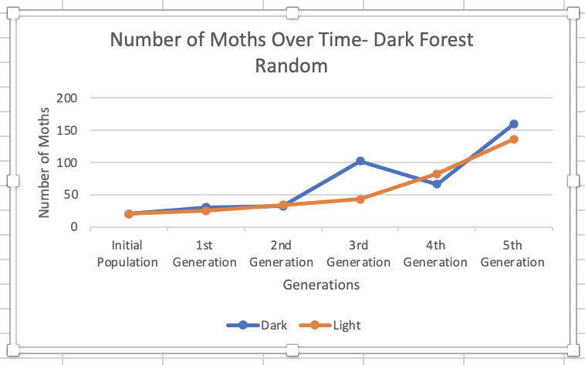

**Lesson 1: How do adaptive traits come about in a population?**

1. Why do we find **dark moths** in a **dark forest** if a **predator eats light moths**?

For each box in the flowchart:

1. Choose one of the terms written between the boxes, and write it in the appropriate box, on the left or on the right.
2. Circle the term “Increase” or “Decrease” depending on whether the population of moths will increase or decrease.



2. Why do we find **light moths** in a **light forest** if a **predator eats dark moths**?

For each box in the flow chart:

1. At the bottom of the page is a Word Bank. Choose terms from the Word Bank to fill in the boxes in the flowchart.
2. Circle the term “Increase” or “Decrease” depending on whether the population of moths will increase or decrease.

**Word bank for Question #2**

Number of dark offspring, Number of light offspring, Population of dark moths over time, Population of light moths over time, Light moths, Dark moths, Survival of dark moths, Survival of light moths

**Optional Extension Activity**

**Now - your turn! Think of your own question:**

3. Why do we find **____________________** in ________________________?

Fill in the empty boxes of the flowchart with the appropriate terms based on your understanding of how traits evolve in a population. Also circle the term increase or decrease depending on whether the population of moths will increase or decrease.



**Moth Simulation Lab Report**

Your role as a scientist is to write a lab report sharing the findings of your research from the moth simulation. The lab report needs to include answers to the following questions.

**Claim:** What does the moth simulation show about how the color of moths and their environment affect their survival?

|  |
| --- |
| Write your answer here: |

**Evidence** : What data do you have to support your claim?

|  |
| --- |
| Write your answer here: |

**Reasoning** : How can we use scientific ideas and concepts we have studied (Natural Selection) to show that the color of moths and their environment affected moth survival? Use the principles of Natural Selection in your answer.

* + - 1. **Principle of variation**. Among individuals within any population, there is variation in physical and behavioral traits.
      2. **Principle of heredity.** Offspring resembles their parents more than they resemble unrelated individuals.
      3. **Principle of selection**. Some forms are more successful at surviving and reproducing than other forms in a given environment.

|  |
| --- |
| Write your answer here: |

**Lesson 1: Darwin’s Finches and Natural Selection**

How can we explain the change in the color of the moths in our peppered moth experiment? Maybe Charles Darwin’s story can help.

Charles Darwin lived from 1809 to 1882. When he was young, he thought he wanted to be a doctor. But when he went to study medicine, he found the classes very boring. His interest in nature kept taking him away from his studies and eventually he began to study natural science instead. Later he was invited to go on a scientific expedition as a geologist and naturalist and he sailed around the world for 5 years on a ship named the HMS Beagle.

**Darwin’s Finches**

Darwin was a keen observer of similarities and differences between organisms of the same or similar species. On the Galapagos Islands, he saw giant tortoises and many birds such as finches and mockingbirds.

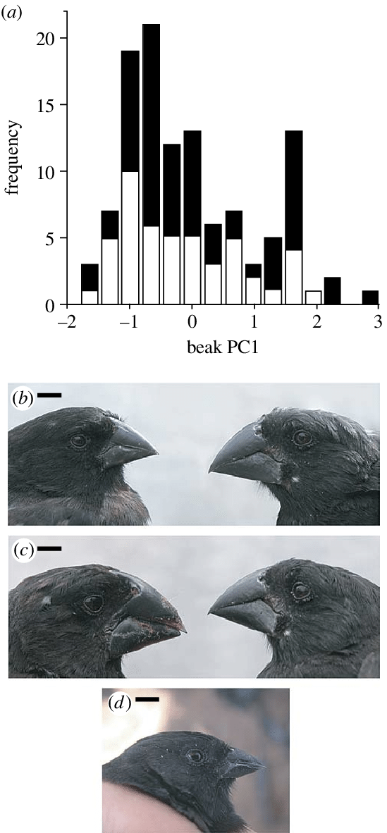

But something that puzzled him was all the variation he observed between different individuals of the same species. Look carefully at the beak sizes of these two Medium Ground Finches who live on an island in the Galapagos. Can you see the variation in the beaks that Darwin saw?

**Artificial Selection**

These differences between similar animals led Darwin to ask many questions. He began to question some of the ideas he learned in class. He thought about people who breed animals or plants. They select parents for traits that they want passed on to offspring. This is called “artificial selection.”

Think about dog breeds. What traits in Golden Retriever parents do breeders select to be passed on to their offspring? How about Toy Poodle’s traits? Do dog breeders choose physical traits, behavioral traits, or both?

Golden Retriever Toy Poodle

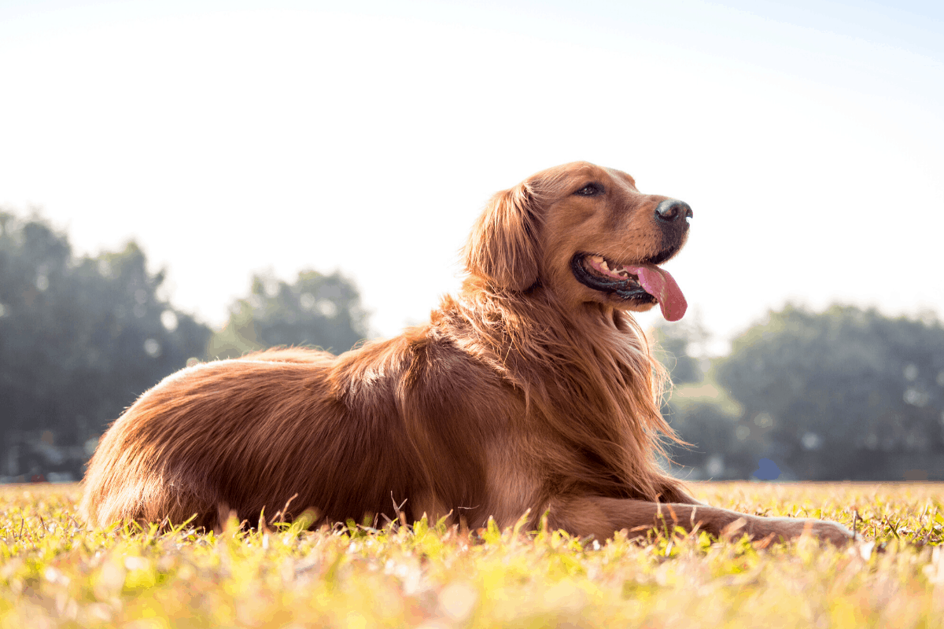 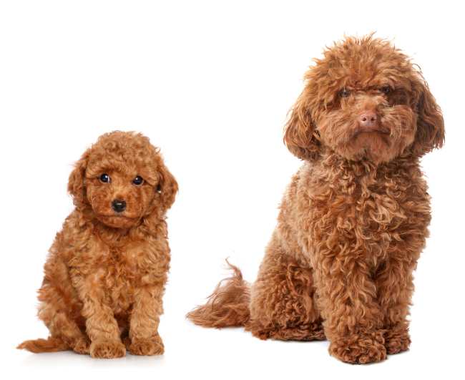

**Natural Selection**

Darwin proposed a new explanation for variation within a species called “**natural selection”** to help explain how species change.

He argued that in nature, the population of a given species at a given time includes individuals of varying traits. The population of the next generation will contain more of those types that most successfully survive and reproduce under the existing environmental conditions. Thus, the appearance of various types within the species will change over time to best adapt to the environmental conditions.

**Principles of Natural Selection**

Through his many years of observations, Darwin proposed that there are 3 **principles of natural selection**:

1. **Variation** - Within any population of a species, there are physical differences (inside and outside of the body) and behavioral differences.
2. **Heredity** - Offspring (babies) look more like their parents than others who are not related.
3. **Selection** - In a certain environment, some variants of a species are better at surviving and reproducing.

How can we use the idea of natural selection to explain what happened with the peppered moths? They were the same species, but dark moths and light moths survived and reproduced at different rates depending on their environment. 

Use the **principles of natural selection** to explain the results of your peppered moth experiment:

1. **Variation** - what physical or behavioral differences are there in a population of peppered moths that we studied?
2. **Heredity** - how did the differences in the peppered moth offspring come about?
3. **Selection** - in which environment do dark peppered moths survive and reproduce most successfully? In which environment do light peppered moths survive and reproduce most successfully?