Learning Set 4: What Puts Us at Risk for Substance Use Disorder (SUD) and Behavioral Addictions?

Driving Question  for the unit:  How can looking for thrills make us miserable?  Driving Question  for the learning set:  What puts us at risk for substance use disorder (SUD) and behavioral addictions? (Part 1) | Materials  - Computer  - Handouts (link or printed)  - A video about how to find reliable source  - Lesson 2 PPT: What patterns can we find for alcohol use around the world?  - Optional Extension Activities  - My SUD Modeling chart - Teacher Version; Student Version  - Integrated models (student version)  Resources  How to talk to youth about Cannabis  https://www.thenationalcouncil.org/program/getting-candid/cannabis-resource-center/?mkt_tok=NzczLU1KRi0zNzkAAAGIpg0Un7fVnkeWn_39yfReMPZPT9leKBjbwkYoTjwIxSU32PNopsMjvEF6kSHtCZHhQhDOlYlCmMCUDrDPj7LveBiE9Ri4sP3Rev3BPGDIfg | Suggested learning set time  7 Days

Student materials:
Lesson 2
- Link to the student worksheet for whole group/class activity

Lesson 3
- Links to the student worksheet for small group activity
  - Alcohol disorders deaths
  - Alcohol disorders
  - Summary table
  - Alcohol Lab Report- worksheet for the scientific explanation

Optional Extension Activities
- My SUD Modeling Chart
- Integrated models
- Opioid
- Cell Phone addiction
- Gaming addiction
- Addiction Gallery Walk Notes
- Share of population that never drank alcohol 2010 - link to the student worksheet
- Alcohol consumption per person 2016 - link to the student worksheet
- Alcohol attributed deaths 2012 - link to the student worksheet
- Burden for alcohol use disorder 2017 - link to the student worksheet
- Alcohol summary table

Building Coherence

This unit guides students through a journey to figure out thrill seeking, and how thrill seeking evolved as a survival mechanism. Because of environmental changes and modern lifestyle, thrill seeking can sometimes lead to substance use disorder (SUD) or behavioral addiction, misery and even death. Throughout the unit, students will investigate several sub-driving questions to support them to gradually answer the big driving question, “How can looking for thrills make me miserable?” which encompasses these scientific ideas.

Guided by the sub-driving question, the journey unfolds as students figure out:
- In LS1 - What gets us excited by examining the sub-driving question, “What do you do for thrills?”
- In LS2 - The basic mechanism of the brain’s reward pathway which is responsible for the feeling of excitement through the sub-driving question, “Why do thrills make us feel excited and happy?”
- In LS3 - The importance of thrill seeking to our survival and how the reward pathway evolved through the process of natural selection. Students investigate the sub-driving question, “Why do we all look for thrills?”
- In LS4 - The risk for substance use disorders and behavioral addictions is caused, in part, by their environment. Students focus on both national and global trends related to SUD and behavioral addictions to understand the contribution of various environmental factors. and answer the sub-driving question, “What puts us at risk for substance use disorder (SUD) and behavioral addictions?”
- In LS5 - Some genes might cause us to be at risk for substance use disorder (SUD), while others might protect us against. Alcohol flush is a genetic mutation that causes discomfort following alcohol consumption. Alcohol use disorder is caused by the interaction of an individual’s genes and the environment. Taken together, with Learning Set 5, this information helps students answer the sub-driving question, “What are the environmental and genetic factors that put us at risk or protect us from SUD?”
- In LS6 - What they can do to reduce the risk of addiction by designing and conducting a community action project focused on making a change in their environment. Students address the sub-driving question, “Can we make a change? What can we do to reduce the risk of substance use disorder and behavioral addictions for ourselves and our community?”

To see more details, refer to the Storyline.

In the previous learning sets the students studied what can happen to the reward pathway if the environmental conditions to which it has been adapted undergo changes. They also learned how the brain can be hijacked by “modern” thrill stimulators, such as: drugs, social media, video games, exercise, food, sugar (glucose), etc. In this learning set, students continue to investigate the effect of environmental conditions on the risk for SUD and behavioral addictions. Students look at national and global trends related to environmental factors that might affect SUD and behavioral addictions.

Framing the Lesson

Purpose
In this learning set, the students will continue to examine how some environments might cause us to be at risk for SUDs, while others might protect us against it. Students will analyze various data sets (maps, graphs, infographics) to identify patterns related to various addictive behaviors and then explain patterns they identify in those sources of data. Students discuss what is valid and reliable data and data sources as well as the difference between causation and correlation related to environmental factors that affect addictive behaviors. This learning set begins to help them answer the sub-driving question, “What puts us at risk for substance use disorder (SUD) and behavioral addictions?”

Learning Set Learning Goals (For instructional use)
- The students obtain, evaluate, and communicate information about the pattern of SUD and behavioral addictions in various populations.
- The students analyze and interpret data to explain potential factors that might affect SUD and behavioral addiction trends.
- The students obtain, evaluate, and communicate information about the pattern of alcohol consumption and alcohol use disorder.
- The students analyze and interpret data to explain potential factors that might affect alcohol consumption and alcohol use disorder.

Overview of the Learning Set

Instructional sequence overview | Figuring out | Instruction days
Lesson 1 - How can thrill seeking become dangerous to our brains and bodies?  Students will rewatch the first vaping and Cedar Point videos and review what they found out about thrill seeking and about Floratryp using the physical models. They will then discuss how looking for thrills can become a negative behavior and lead to SUD and other behavioral addictions. |  | 1 day
Lesson 2 - How are substance use disorders (SUD) and behavioral addictions the same or different across the United States?  Students examine national data about SUD and behavioral addictions and consider some potential external factors explaining these trends. This prepares students for the following lesson about a global view of SUD from environmental perspectives. | There are various types of SUD and behavioral addiction and different patterns describe their use. | 2 days
Lesson 3 - What patterns can we find in alcohol use around the world?  Students look at different maps from across the world about consumption and SUD related to alcohol. | Some countries show higher rates of alcohol consumption and alcohol use disorder than others affected by various environmental factors. | 2 days
Wrap up - Revisiting the Driving Question Board  The students will revisit the Driving Question Board (DQB) and reflect upon their learning. | Environmental factors affect SUD. | 1 day
Optional Extension Activity- Developing models  The students will revise their models to answer the question, “What puts us at risk for substance use disorder (SUD) and behavioral addictions?” | Environmental factors affect SUD. | 1 day
Optional Extension Activity- Constructing a scientific explanation to answer the Sub-Driving Question  Students will construct scientific explanations using integrated models to explain the phenomenon of SUDs and behavioral addictions by answering the Driving Question of the Unit. | SUDs and behavioral addictions are caused by the interaction of genes and the environment. | 2 days

NGSS Connection to Assessment

Target Performance Expectations
MS-LS1-5. Construct a scientific explanation based on evidence for how environmental and genetic factors influence the growth of organisms.

Learning performance to be assessed
Students analyze and interpret data to identify the patterns of SUD and behavioral addictions and identify possible environmental factors that might affect SUD and behavioral addictions.
Disciplinary core idea | Science and engineering practices | Crosscutting concepts
LS1.B Growth and Development of Organisms  - The growth of an animal is controlled by genetic factors, food intake, and interactions with other organisms, and each species has a typical adult size range (MS-LS-1 and Framework page 146). | Analyze and interpret data  - Use graphical displays (e.g., maps, charts, graphs, and/or tables) of large data sets to identify temporal and spatial relationships.  - Distinguish between causal and correlational relationships in data.  - Analyze and interpret data to provide evidence for phenomena.  - Analyze and interpret data to determine similarities and differences in findings.  Constructing scientific explanation  - Students use models to construct a scientific explanation that explains why we look for thrill and why looking for thrills can make me miserable. | Pattern  - Graphs, charts, and images can be used to identify patterns in data.

How these elements are integrated and embedded in this learning set
The students will use different types of representation (maps, graphs, and charts) about SUDs and behavioral addictions to identify various patterns across the nation and the world affected by environmental factors.

Connection to Students’ Lives

Link to career-awareness
Epidemiologists are disease detectives. They study patterns of disease in people in hospitals and local communities, the United States and around the world to reduce and prevent disease. For example epidemiologists at University of Michigan found out that teenagers are smoking a lot less but the rates of vaping among teens are climbing. Here’s their report, which students could read and discuss how what they are studying in the classroom is related to this career: https://sph.umich.edu/news/2020posts/smoking-tobacco-use-among-teens-drops-e-cig-use-grows.html.
Learn more about epidemiology: https://sph.umich.edu/epid/index.html

Instructional Sequence

Introducing the Learning Set

Keeping coherence using the DQB - Remind students of their questions related to looking for thrills and excitement on the Driving Question Board (DQB). Tell students that in this learning set they will further investigate thrill seeking and that they should pay particular attention to the questions that they had clustered around that Sub-Driving Question, “What puts us at risk for substance use disorder (SUD) and behavioral addictions?”

Link to career-awareness
Epidemiologists are disease detectives. They study patterns of disease in people in hospitals and local communities, the United States and around the world to reduce and prevent disease. For example epidemiologists at University of Michigan found out that teenagers are smoking a lot less but the rates of vaping among teens are climbing. (See description above for more resources on epidemiologists).
- Discuss with students: What questions could you ask them?

Introducing the Learning Set - Start with the transition questions that they raised at the end of the previous learning set.
- We learned that thrill seeking can lead to behaviors that lead to SUD and affect survival. Are we all at the same risk for SUD? Why or why not?
  - If family members share the same lifestyle, will they all have the same risk for SUD?
  - Do behaviors such as vaping, smoking, or drinking alcohol lead to SUD for everyone, all the time?
- What are factors that affect people’s SUD?
  - What triggers or prevents people from SUD?
  - Are these factors something that we can always change?
- Do we have new questions about, “What puts us at risk for SUD and behavioral addictions?”

Lesson 1 – How Can Thrill-Seeking Become Dangerous to Our Brains and Bodies?

Learning Goal | The students obtain, evaluate, and communicate information to identify and determine that thrill seeking can become non-adaptive and lead to SUD.
Connection to NGSS | DCI: LS1.D: Natural selection
 | Practice: Obtain, evaluate, and communicate information
 | CCC: Cause and Effect

  Note to the teacher | At this point, students have obtained a considerable amount of information about thrill seeking and the mechanism of the reward pathway. In this lesson, students, like researchers, critically discuss the pieces of data that they have accumulated throughout the unit, and try to identify and determine the main scientific ideas behind thrill seeking and SUD.

Summarize - Facilitate a discussion that recaps the ideas presented in Learning Sets 1, 2 and 3, the main ideas being:
- We all look for thrills, but each individual looks for thrills in different ways. Have students refer to their family interview results from Learning Set 1.
  - What were some of the things you said you did for thrills?
  - What did you learn about thrill seeking from your interviews with family members? Were all thrills the same for everyone?

- Thrill seeking stems from our brain reward pathway:
  - Have students bring out the physical models they created in Learning Set 2 to guide them to answer the following questions:
    - What is the function of the reward pathway of the brain?
    - Use your model to explain how the reward pathway works.
    - What causes people to repeat behaviors that stimulate the brain reward region?
    - Have students review how Floratryp worked, using their physical models to explain.
    - How was it affecting Ray’s life?
  - If needed, you and students can return to the reading from LS2 to review the Reward Pathway (Copy found in LS4 Resource folder).

- Thrill seeking evolved through natural selection because of its importance to our survival. Have students refer to their artifacts and resources from LS3, especially the findings from the moth simulation and natural selection as they discuss the following questions:
  - Why was it helpful for early human beings to look for thrills?
  - Remember the moth simulation. How can we apply the moth’s survival to explain people’s seeking thrills? What does thrill-seeking have to do with our survival?
  - In modern times, what are ways that thrill seeking has changed?
    - Technology is one kind of modern convenience that has significantly changed our environment. How are we adapting to it? In what ways do we use it to seek thrills?
    - Is technology as a thrill-seeking mechanism, helpful or harmful?
  - Can you think of any examples of behavioral traits?

- How does our environment influence thrill-seeking behaviors in humans?
  - When early humans hunted, the reward pathway was directly linked to their survival. Through time, the ways in which we seek thrills continually changes. What humans did for thrill-seeking thousands of years ago, hundreds of years ago, and even 50 and 25 years ago was different from today. (Refer back to their interviews with family members from LS1.) We seek thrills in different ways. What are those ways now?
- What types of “new thrills” can you think of? - Students will rewatch the Cedar Point and vaping videos and discuss how looking for thrills can lead to both positive and negative consequences.
- Cedar Point Video (found in LS1 Resource folder)
- Vaping video (found in LS1 Resource folder)

- Do we still need to seek thrills in our modern environment? Why? What thrills do we seek? (Discussion might include Thrills are good because they can be a means to challenge ourselves, such as rock climbing, hiking in the wilderness, entering a dance contest or science fair, trying out for a part in a play, etc. This challenges us mentally and physically and develops drive and fortitude. We seek thrills big and small every day. It's built into our psyche and is an adaptive trait. Modern life (drugs, video games, social media) can hijack our adaptive mechanism.

Making a transition to thrill seeking as a mechanism that is dangerous and harmful to our bodies, our brains and our health and can lead to substance use disorder (SUD) or behavioral addictions. [Hint, encourage students to refer back to their models and explanations from previous learning sets to explain their ideas and predict outcomes.]

- When does “helpful/positive thrill seeking” become “harmful/negative thrill seeking”? [Focus on, 1) the reasons for the thrill-seeking behavior now (to escape, forget, etc.) and 2) the frequency (looking for that thrill every day, multiple times a day)]
  - Is going to “Cedar point” a positive or a negative way to get thrilled? Explain.
  - Is vaping a helpful or a harmful way to get thrilled? Explain.
  - What about posting on social media and getting “likes”? Is that a helpful/positive or a harmful/negative way to get thrilled? Explain.
    - Students might bring up - But thrill-seeking can be hijacked. Getting likes on social media is thrilling until it is not. For example: When you are only seeking the likes and not caring about real affection.
  - What about playing video games? Is that a helpful/positive or a harmful/negative way to get thrilled. Explain.
    - Thrill-seeking can be hijacked. For example, playing video games is thrilling until it is not: it can cause poor mental, health and/or emotional problems, social disconnection, and poor academic performance.
  - Wanting to do well in school? Is that a helpful/positive or a harmful/negative way to get thrilled. Explain.
    - Thrill-seeking can be hijacked. For example, wanting to do well in school has many benefits until it is not: too much stress can cause some health and mental issues or intense competition can cause issues with social skills.
  - When do these thrills go from being helpful/positive to becoming harmful/negative? Explain.

- When thrill seeking becomes a negative behavior, how can it affect us?
  - What did the young people in the video say about how vaping was negatively affecting them? Describe.
  - Why do you think people continue to engage in thrill seeking behaviors even though they feel the harmful/negative effects on their brains and bodies?

Lesson 2 – How Are Behaviors Like Substance Use Disorder (SUD) and Behavioral Addictions the Same or Different Across the United States?

Learning Goal | The students obtain, evaluate, and communicate information about the pattern of substance use disorder (SUD) and behavioral addictions in various populations.  The students analyze and interpret data to explain potential factors that might affect substance use disorder (SUD) and behavioral addiction trends.
Connection to NGSS | DCI: LS1.B: Growth and Development of Organisms
Practice: Obtain, evaluate, and communicate information
Analyze and interpret data
CCC: Patterns
Cause and effect

- Looking at representations (maps, graphs, and infographics) showing national trends and identifying patterns in various types of SUDs and behavioral addictions. As a whole class look at different maps on smoking to identify trends and patterns in smoking. Optional Extension Activities at the end of the lesson offer a look at more national trends on different kinds of SUDs and behavioral addictions.
  - Smoking

Note to the teacher | Correlation is not causation.  Correlation is a relationship or connection between two variables where whenever one changes, the other is likely to also change. But a change in one variable doesn’t necessarily cause the other to change. Causation means that there is evidence that one event causes another event to occur. Once scientists identify a pattern, then the cause can be researched. Causation can only be determined from an appropriately designed experiment.  Even if there is correlation between two variables, we cannot conclude that one variable causes a change in the other. A third variable may be causing both variables to change or the relation could be coincidental. For example, a community with lower economic status may show a higher rate of SUDs. However, poverty doesn’t necessarily cause SUD. SUD afflicts many wealthy people. Other factors, such as poorer access to health care and increased stressors overly affect people of lower income affecting access to mental health services which can lead to SUDs.  See NGSS Middle School cause and effect pg. 5 as well and in the Middle School NGSS practice of analyzing data pg. 9 for more on causation).

Note to the teacher | How to evaluate sources for reliability  For the practice, “Obtaining, evaluating, and communicating information”, middle school students need to learn how to track down information using a variety of sources, determine their significance and credibility, and summarize the information accurately. From Common Sense Media, here are some ways you can help your students find reliable sources for researching and reporting.  - Know your domains. Every website has to register a domain that indicates what kind of agency it is. For example, ".com" (businesses that profit from their sites), ".net" (networks that are often private), ".org" (nonprofits that don't profit from their sites), ".gov" (government sites that are obligated to publish public information), and ".edu" (university sites that publish peer-reviewed studies). All of these can provide information for research reports, but in general, ".gov" and ".edu" sites will offer objective data based on research. Taken from Common Sense Media https://www.commonsensemedia.org/news-and-media-literacy/how-can-my-kid-find-reliable-sources-for-school-reports  - Google and Wikipedia. These aren't necessarily poor sources, but they need to be cross-referenced. And they're not enough to support an entire school research report. Google Scholar (a free search engine that indexes scholarly literature such as academic papers) offers a large range of topics for print and web articles, academic papers.  Common Sense Media https://www.commonsensemedia.org/news-and-media-literacy/how-can-my-kid-find-reliable-sources-for-school-reports  Another resource for teachers - From EdSurge

Note to the teacher | The link between smoking and taxes on cigarettes is a well studied and documented public health issue. Higher cigarette taxes reduce teen smoking. Students may bring up this connection. Here are some useful links that provide more information about this link: https://www.ncbi.nlm.nih.gov/pmc/articles/PMC4937114/  https://www.ncbi.nlm.nih.gov/pmc/articles/PMC5583019/  https://truthinitiative.org/research-resources/smoking-region/tobacco-use-utah-2019  Truth Initiative by region: https://truthinitiative.org/research-resources/topic/smoking-region

- Discussion: How to evaluate sources for reliability and bias
  - Ask students, “How can you tell if this is accurate and reliable data? Just because I gave this data to you, is that enough evidence? What if you want more information about your topic? How would you go about finding reliable information?”
  - Show students a video about how to find and use reliable and biased sources. Cover these points in discussion:
    - When you looked at your data, how do you think that data were collected? (i.e. interviews, surveys, collecting data from a government website)
    - Could the data presented be biased (remember from the video they talked about bias)? Explain. Students could argue that any of the data collected are biased in some way. For example, for a long time only white men were used in studies looking at the effects of different drugs, which leaves out large portions of the population who might respond differently than white men.
- Discussion: Support students in understanding that patterns indicate correlations which may or may not indicate a cause (see above).
  - Does the pattern you identified ALWAYS happen? Or are there exceptions that you can identify from the maps? If there are exceptions, can we say that X causes Y or can we say that there might be a relationship (aka correlation)?
  - What do you think we would need in order to be able to say X causes Y?
    - We don't have enough evidence to say there is causation. To prove that, you need to do more carefully designed research (see the teacher box above for more guidance).
  - What does it mean to say there is a relationship between X and Y?
    - X may just be one factor that is affecting Y, but we cannot say it is the only thing. There must be other factors affecting Y.
- As a whole class, discuss the following:
  - What kind of SUD or behavioral addiction does our map (or graph/infographic) represent? Smoking
  - What data does each map show?
  - What are our hypotheses about the relationship between the two maps that we analyzed? Why is the risk for smoking so high?
    - What’s the evidence? What information from representations help you support your hypothesis?
    - What is your reasoning? Why/how does evidence help you explain the relationship?
- For the Optional Extension Activity- Students pick or are assigned one SUD and after analyzing the data they generate hypotheses and argue from evidence through a gallery walk. Have each team create posters (or some other type of presentation) for the classroom gallery walk based on the SUD they were assigned.
  - SUD
    - Opioid
    - Cell Phone addiction
    - Gaming addiction
  - In the poster make sure students include:
    - What kind of SUD or behavioral addiction does our map (or graph/infographic) represent?
    - What data does each map, graph, or infographic show?
    - What are our hypotheses about the relationship between the two maps, graphs, or infographics that we analyzed? Why is the risk for SUD or behavioral addiction so high?
      - What’s the evidence? What information from representations help you support your hypothesis?
      - What is your reasoning? Why/how does evidence help you explain the relationship?

Lesson 3 – What Patterns Can We Find in Alcohol Use Around the World?

Learning Goal | The students obtain, evaluate, and communicate information about the pattern of alcohol consumption and alcohol use disorder.  The students analyze and interpret data to explain potential factors that might affect alcohol consumption and alcohol use disorder.
Connection to NGSS | DCI: LS1.B: Growth and Development of Organisms
Practice: Obtain, evaluate, and communicate information
Analyze and interpret data
CCC: Pattern
Cause and effect

- Introduce the lesson - Students began the learning set by looking at some interesting national trends related to various SUD and behavioral addictions. In this lesson, the class will participate in an activity to look at global level maps from across the world specifically about alcohol consumption and alcohol use disorder. The PowerPoint, “What patterns can we find for alcohol use around the world?”, contains all the different maps with questions and a summary table. Note: create a new PPT for each class. After assigning maps to groups (Step 1 below), students can find their map and questions in the PPT and fill in their information.

- Step 1 - Investigating different maps
- First divide students into different two groups and assign each group a different map.
- Alcohol use disorder 2017 - link to the student worksheet
- Alcohol use disorder deaths 2017 - link to the student worksheet
b. Note: For background information or to find more maps about alcohol consumption and alcohol use disorder, go to: https://ourworldindata.org/alcohol-consumption#alcohol-use-disorders

- Step 2 - Filling out the information in the worksheet - Study the map and fill out the student worksheet.

- Step 3- Sharing the information
  - Together they draw a general conclusion by completing the summary table. They will figure out that there are differences in different countries with alcohol consumption and alcohol use disorder, which can be affected by various environmental factors. The emphasis is on different environmental factors by different countries.
  - Students are not expected to identify those exact environmental factors. However, classroom discussions might lead them to bring up that different regions around the world have different religions, politics and laws, cultures, economics, history, weather, etc. Also emphasize that any environmental factors they bring up would be factors that are correlated with alcohol consumption, not causes for the rates.

- Step 4 - Debriefing as a class
  - As a class, each jigsaw group shares their final conclusion with other groups.
    - Is your conclusion the same or different from the other group? How is it similar or different?
    - Do you agree or disagree with conclusions from other groups? What is your evidence for agreement/disagreement?
    - Does this global view add to our ideas about social determinants of health?
  - Tell students to keep their summary table at hand. They will use this work in the next learning set.

- Constructing a scientific explanation - Alcohol Lab Report (handout).
  - Tell students that in their role as a scientist, they will write a lab report to share with colleagues on their findings from the global maps on alcohol use and deaths.
  - The lab report will be in the form of a scientific explanation (see the box below). The lab report will include answers to the following questions.
    - Claim: What patterns can we find in alcohol use and deaths around the world?
    - Evidence: What data do you have to support your claim?
    - Reasoning: How can we use ideas and concepts we have studied in this learning set to show that alcohol use and deaths differ globally?

 | What is a scientific explanation? How can it be used?  Scientists try to explain how and why a natural phenomenon occurs. A scientific explanation consists of a claim, evidence, and reasoning (CER). The claim is a testable statement that expresses the answer or conclusion to a question or problem. Evidence is scientific data that supports the claim. The reasoning describes how or why the evidence can be used to support the claim by using scientific ideas and principles.

Optional Extension Activity for Lesson 2
- Jigsaw activity step 1 - Investigating different maps
- First divide students into different jigsaw groups (3 OR 6 students per group) and assign each student within each group a different map (one or two depending on group size). The PowerPoint Presentation, “What patterns can we find for alcohol use around the world?”, contains all the different maps with questions and a summary table. Note: create a new PPT for each class. After assigning maps to groups (Step 1 below), students can find their map and questions in the PPT and fill in their information.
- Share of population that never drank alcohol 2010 - link to the student worksheet
- Alcohol consumption per person 2016 - link to the student worksheet
- Alcohol attributed deaths 2012 - link to the student worksheet
- Burden for alcohol use disorder 2017 - link to the student worksheet
- Each student goes to the station of each different map where they are assigned to fill out the student worksheet.
- Jigsaw activity step 2 - Sharing the results about different maps
  - The members come back to their jigsaw group and take turns presenting their findings.
  - Together they draw a general conclusion by completing the summary table. They will figure out that there are differences in different countries with alcohol consumption and alcohol use disorder, which can be affected by various environmental factors. The emphasis is on different environmental factors by different countries. Students are not expected to identify those exact environmental factors. However, classroom discussions might lead them to bring up that different regions around the world have different religions, politics and laws, cultures, economics, history, weather, etc.. Also emphasize that any environmental factors they bring up would be factors that are correlated with alcohol consumption, not causes for the rates.
- Jigsaw activity step 3 - Debriefing as a class
  - As a class, each jigsaw group shares their final conclusion with other groups.
    - Is your conclusion the same or different from other groups? How is it similar or different?
    - Do you agree or disagree with conclusions from other groups? What is your evidence for agreement/disagreement?

Wrapping-up the Learning Set - Revisiting the Driving Question Board

With the class, revisit the Driving Question Board (DQB). Prompt the students to reflect upon their learning using the following prompts, and adjust the DQB as appropriate:
- Which questions on the DQB have we answered, and which remain open? Students should attach their answers/artifacts of investigation onto the DQB next to the questions they relate to.
- After completing the lessons in the learning set, do you have any additional questions? Add new questions to the board near the SDQ they relate to.

- Ask students some transitional questions that are related to the next learning set. What puts us at risk for substance use disorder (SUD) and behavioral addictions?
  - Based on what we learned in this Learning Set,
    - Why do you think people use alcohol?
    - What do you think are the consequences of drinking alcohol ?
  - Some people say they know it’s bad and want to stop. Why do they continue drinking alcohol?

Optional Extension Activity – Revisiting the Driving Question Board and Developing Individual Models

Learning Goal | The students develop models about SUD affected by environmental factors.
Connection to NGSS | DCI: LS1.B: Growth and Development of Organisms
 | Practice: Developing models
 | CCC: Cause and Effect

Developing models for the Unit - How can looking for thrills make me miserable?
In this lesson, students develop one part of the model that will focus on the sub-driving question of this learning set: What puts us at risk for substance use disorder or behavioral addictions?

Based on their experience in this learning set, ask students to fill out the My SUD Modeling Chart Student Version (not filled in) - Teacher’s version.

- REFLECT upon learning in pairs
  - Identify the sub-driving question - What is the sub-driving question that students were asked to think about during the Learning Set?
  - Identify the questions - What questions did students pose at the beginning of the Learning Set?
  - Identify the Main Message (Whole group discussion) - What did students learn from the Learning Set? Use the following prompts:
    - What do you think are the take-home messages from the learning set?
    - What did you learn in this learning set?

- REFLECT upon learning as a whole group/class. Review students’ answers for the first three sections of the table.

- PLAN as a whole group/class.
  - Identify the components - Start with a class discussion to remind the students of the different components of activities that people do for thrills as they discussed when creating the Driving Question Board. For example: playing sports, getting good grades, using social media, gaming, drugs, vaping, gambling etc.
  - Identify the components - Also ask students to find consequences of each activity (can be either positive or negative). For example: looking cool, getting better, feeling excited, addiction, illness etc. (Be sure to use the teacher version of My SUD Modeling Chart for the Learning Set to support the discussion about components). These are just suggestions; students will likely come up with many more on their own and through the discussion.

- PLAN in small groups.
  - Generate different components - Write each component on its own sticky note. Each component should be relevant. (At this point, components in a student's model may not be measurable. It is fine even if they cannot come up with the components that are measurable.)
  - Organize the components - Organize the components in categories, such as: positive consequences, negative consequences, and etc...

- BUILD in small groups: Connect the components (demonstrate to the class before students go into small groups)- Connect the components in a causal relationship from the cause to the effect. Students should use arrows to show the directionality of the connection. (Hint: For the most part, the arrows will go from thrill seeking.)

- TEST/REVISE in small groups: Evaluate models - Instruct students to switch off in the roles of presenter and listener. Explain the phenomenon by explaining how the components may lead to thrills. Have the students test their models by applying the following questions:
  - Does your model explain and predict?
  - Does your model make sense? Does it make sense when you use increase-decrease language?
  - Are the components in your model relevant to activities that can create thrills?
  - Does your model show cause-effect relationships?
Together, make any changes needed to make their models more clear and complete.

- SHARE as a whole group/class - Collectively, share the models with the class such as a gallery walk. Use the questions above, e.g one per small group, to have students present to the large group.
  - When sharing models, discuss with the students:
    - The similarities and differences between the models
    - The models’ strengths and weaknesses
    - Ways to improve the various models

REVISE in small groups - Based on feedback and observing other models, have the students revise their models. Once they finish, they can document (e.g take a picture of) their group’s model and send it to their teacher. These models can be used for formative assessment, and for students’ to examine and reflect upon their model development process at the end of the unit.

 | While the students model, move around the class, support the students, and encourage them to share their thinking and consult with their peers about their models. Students’ models can vary. However, since the models need to explain the relationships among the components, make sure the models include:  Components  - Environment factors  - Family lifestyle  - Peer pressure  - School environment  - Community (where you live for example)  - Policies and laws  Relationships and labels  - The relationships among each factor.  - The relationship showing if each factor can increase or decrease one’s risk of Substance Use Disorder (SUD) or behavioral addictions.

 | A discussion which shares insights from the various models and compares among them is extremely important as it will scaffold the students’ second revision of their models in the following step. Use questions to prompt the students to critically examine their peers’ models.  Components  - Components identity: What components are included in each model? Are key components included?  - Number of components: How many components are indicated in the model? Are MORE components necessarily better?  - Grouping of components: How can we group the various components? Why should we group components? Does it improve our models? Is the grouping meaningful?  Relationships among components  - Explicit relationships among the components: Are the relationships among the components indicated? Do these relationships make sense? Are the indicated relationships important?  General features  - Complexity of the model: How complex is the model?  - Organization: How well is the model organized? Is the organization meaningful?

Optional Extension Activity- Constructing a Scientific Explanation to Answer the Unit Driving Question
End of Learning Set Assessment

Learning Goal | Students develop (evaluate and revise) a model to explain how looking for thrills can make us miserable.  The students construct a scientific explanation that explains why looking for thrills can make me miserable.
Connection to NGSS | DCI: LS1.B: Growth and Development of Organisms
Practice: Developing a scientific model
Constructing a scientific explanation
 | CCC: Cause and effect

Through class discussion, the students, guided by the teacher, will develop integrated models which connect consensus models from different learning sets to construct scientific explanations (CER) to explain the phenomenon of SUD / behavioral addiction and gene-environment interaction by answering the Driving Question of the unit, “How can looking for thrills make me miserable?”

- Teacher and students complete this model link together (integrated models teacher version is found below and integrated models student worksheet). The following list of questions and My SUD Modeling chart (teacher version / student version) can guide connecting the two models and coming up with a CER.
  - To support linking two different models to make a claim:
- What are the common components between the two learning sets?
- Where do the two models link together?
- What are the main ideas of each learning set? How can they be linked?
- How does one model help explain, expand, and elaborate another?
  - To support the evidence:
- What activities did we do in each learning set?
- What videos did we watch?
- What experiment did we conduct?
- What data (i.e. from maps, charts, simulation, interview) did we collect or use?
- What are some specific examples, shown in your models, that can be used as evidence to support your claim?
  - To support the reasoning:
What are the underlying scientific ideas shown in your models and in the unit that can explain how your claim and evidence are connected?

- Integrated model for LS1 and LS4
- Main idea to include Linking lifestyle of individuals regarding thrill seeking behaviors to environmental factors
  - The LS1 model of thrill-seeking behaviors can be linked to an SUD or behavioral addiction to the LS4 model. And the environmental factors in both LS1 and LS4 can be connected.
  - Exemplar model

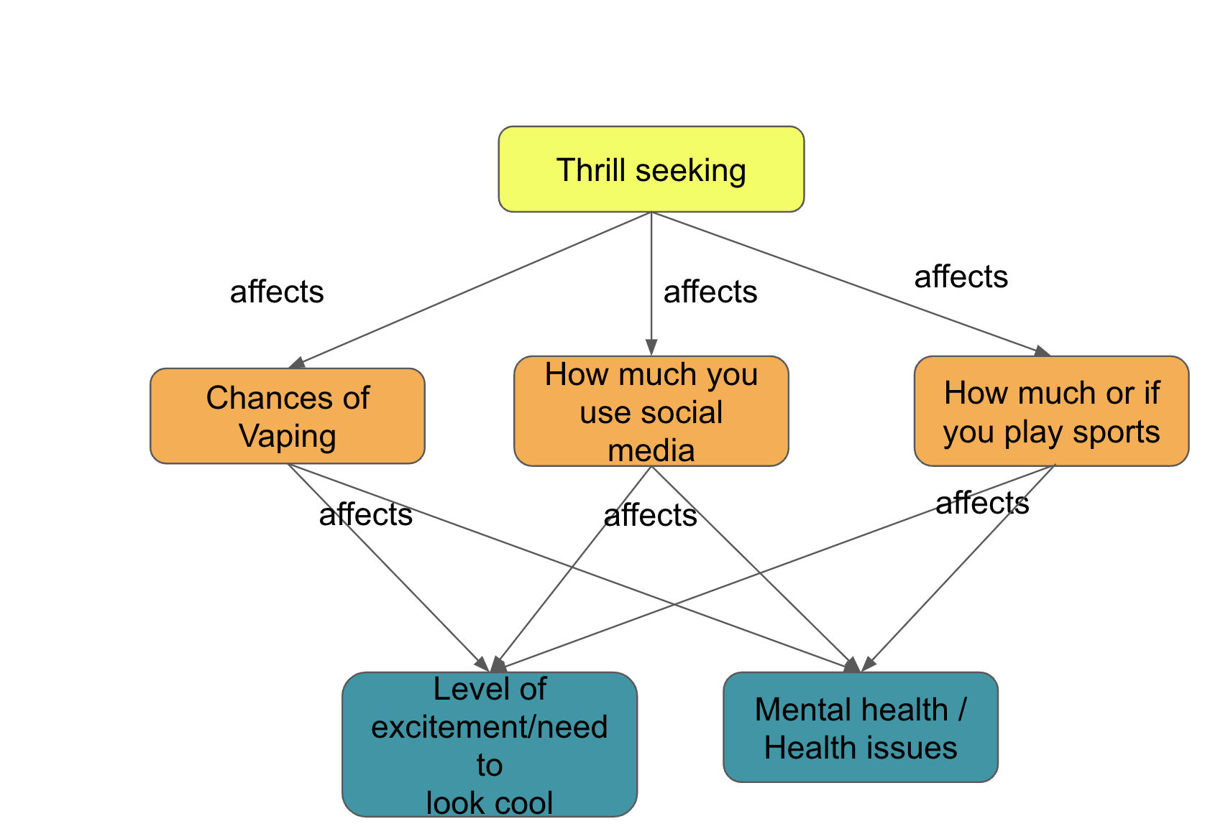
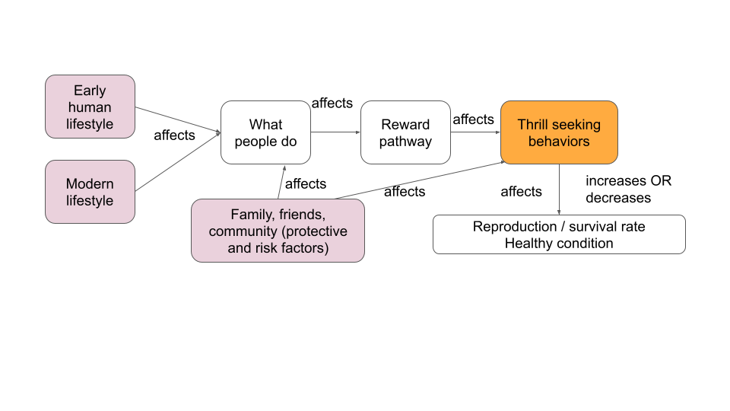

Sub-Driving question: What puts us at risk for substance use disorder (SUD) and behavioral addictions?
Claim | Some thrill-seeking behaviors can make some people miserable because of different genetic and environmental factors that each person has.
Evidence | In Learning Set 4 we discussed how thrill seeking has been a mechanism used since the beginning of mankind to help us survive. However, in modern times thrill seeking can have negative consequences as we saw in the interviews. From our interviews, we learned that family history affects one’s risk for SUD. The interviewee also stated that peer pressure affects one’s risk for SUD (environmental).  We also studied different maps and charts that showed the distribution of SUD and behavioral addictions by state and nation. We learned that there are some genes that can protect us from SUD (alcohol flush variant) and there are some genes that can put us at risk for SUD.
Reasoning | The risk for SUD is caused by gene-environment interaction (interaction of our genetic makeup with our environment).  *Students may want to use the table from LS5 that describes the link between gene-environment interactions

3. Discussion: Help students make the generalization about the environment to our/my environment, and from thrill seeking to health, for example:
    - Ask students “Do the different environments in the data apply to us, or can they be generalized to other people as well?”
    - Original: What puts us at risk for substance use disorder and behavioral addictions?
    - How can this sub-driving question apply to our own thrill-seeking and our health?

Lesson 2 - What’s going on in the world?
Looking at national trends (Smoking)

Map 1
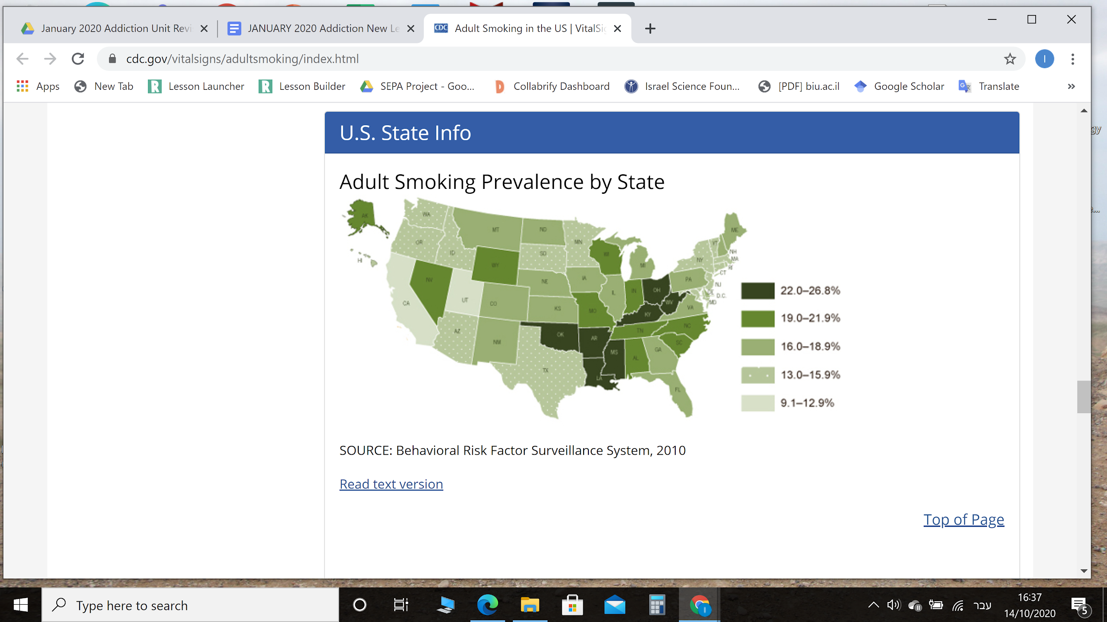
From: https://www.cdc.gov/vitalsigns/adultsmoking/index.html

Getting to know your map
- Look at the title of the map:
  - What type of substance use disorder (SUD) is the map describing?

  - Use your class definition of addiction to define the smoking addiction. Conduct an internet search to compare. Write 2-3 sentences. Be sure to use a reliable source for your definition.

- Look at the legend/key:
  - Describe the legend
    - What is the legend measuring?

    - What is the gradient of colors describing?

Evaluating the source of data
- What is the source of the data? Is it reliable? How do you know?

- How do you think the data were collected?

- Can this data collection method cause the data to be biased?

Making sense of data
- The highest percentage of adult smokers is in which state(s)? (name the states) ________________
- Why do you think that is? Give one possible explanation for the pattern.

- The lowest percentage of adult smokers is in which state(s)? (name the states) ________________
- Why do you think that is? Give one possible explanation for the pattern.

Examining more data: Look at the following map

Map 2
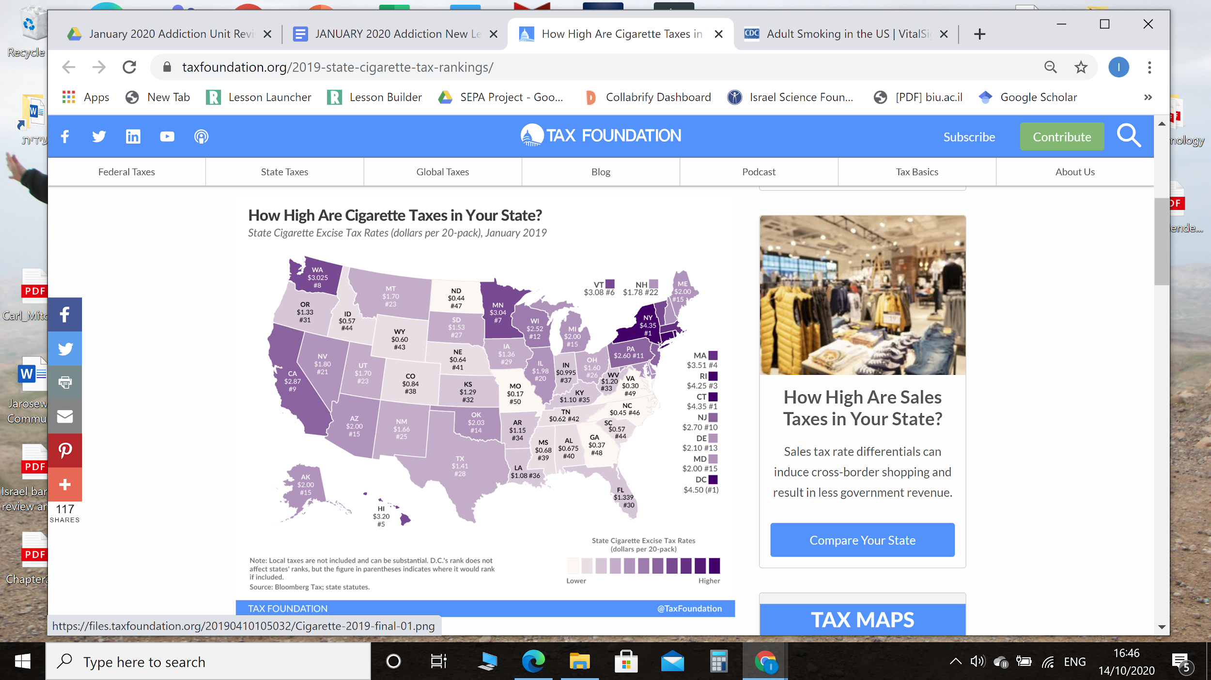

From: https://taxfoundation.org/2019-state-cigarette-tax-rankings/

Getting to know your map
- Look at the title of the map:
  - What is the map describing?

- Look at the legend/key:
  - Describe the legend
    - What is the legend measuring?

    - What is the gradient of colors describing?

Making sense of data
How does this map help you make sense of the phenomenon of smoking? Explain how the maps are related.
- Map 1: Choose a state with a high percentage of adult smokers. Name of the state:

_________________________
- Map 2: What are the taxes on cigarettes in that state? ___________
- Map 1: Choose a state with a low percentage of adult smokers. Name of the state:

_________________________
- Map 2: What are the taxes on cigarettes in that state? ___________
- Do you see a pattern between the taxes and the percentage of adult smokers? What is the pattern have you identified?

- Is this pattern always true?
  - Can you find additional cases in which your pattern is true?

  - Can you find cases in which your pattern is not true? Describe.

  - Does the pattern that you found show correlation or causation? Why do you think so?

Correlation vs Causation
Correlation is a relationship or connection between two variables where whenever one changes, the other is likely to also change.
Causation means that there is evidence that one event causes another event to occur.

*BONUS ROUND* (Optional extension activity)
Supporting or refuting my explanation:
- Conduct an online search for a map, graph, or infograph that can help you support or refute (reject) your explanation for the pattern. Make sure to use a reliable source.
- Paste your map, graph, or infograph on this worksheet.

- How does this map, graph or infograph support or refute your explanation for the pattern you identified? Explain.

Lesson 3 - What’s going on in the world?
Looking at global trends for death rate from alcohol use disorder
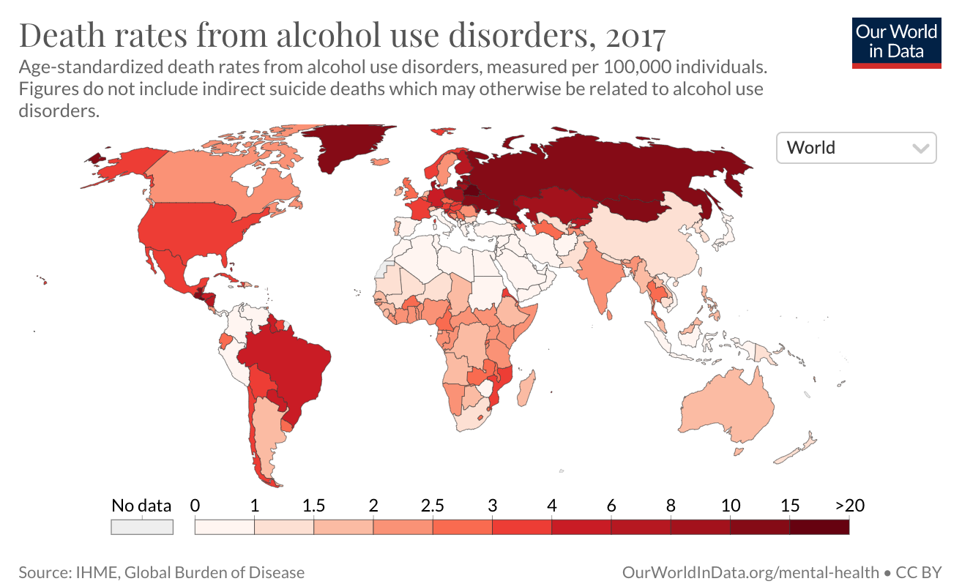
From: https://ourworldindata.org/grapher/death-rates-from-alcohol-use-disorders?time=2017

Getting to know your map
- Look at the title of the map:
  - What type of substance use disorder (SUD) is the map describing?

  - What kind of data is the map showing? What does the data represent?

- Look at the legend/key:
  - What is the legend measuring?

  - What is the gradient of colors describing?

Evaluating the data
- What is the source of the data? How reliable do you think this source is? (Highly reliable, Not reliable, Somewhere in between) Why do you think so?

- How do you think the data were collected?

Making sense of data
- Name three countries with the highest death rate from alcohol use disorder:
  - Can you identify any pattern in these countries? Give one possible reason for the pattern.

- Name three countries with the lowest death rate from alcohol use disorder:
  - Can you identify any pattern in these countries? Give one possible reason for the pattern.

*BONUS ROUND* (Optional extension activity)
Supporting or refuting my explanation
- Conduct an online search for a map, graph, or infograph that can help you support or refute your explanation for gaming. Make sure to use a reliable source.
- Paste your graph here:

- How does this map, graph, or infograph support or refute your explanation for the pattern you identified? Explain.

Lesson 3 - What’s going on in the world?
Looking at global trends for alcohol use disorder
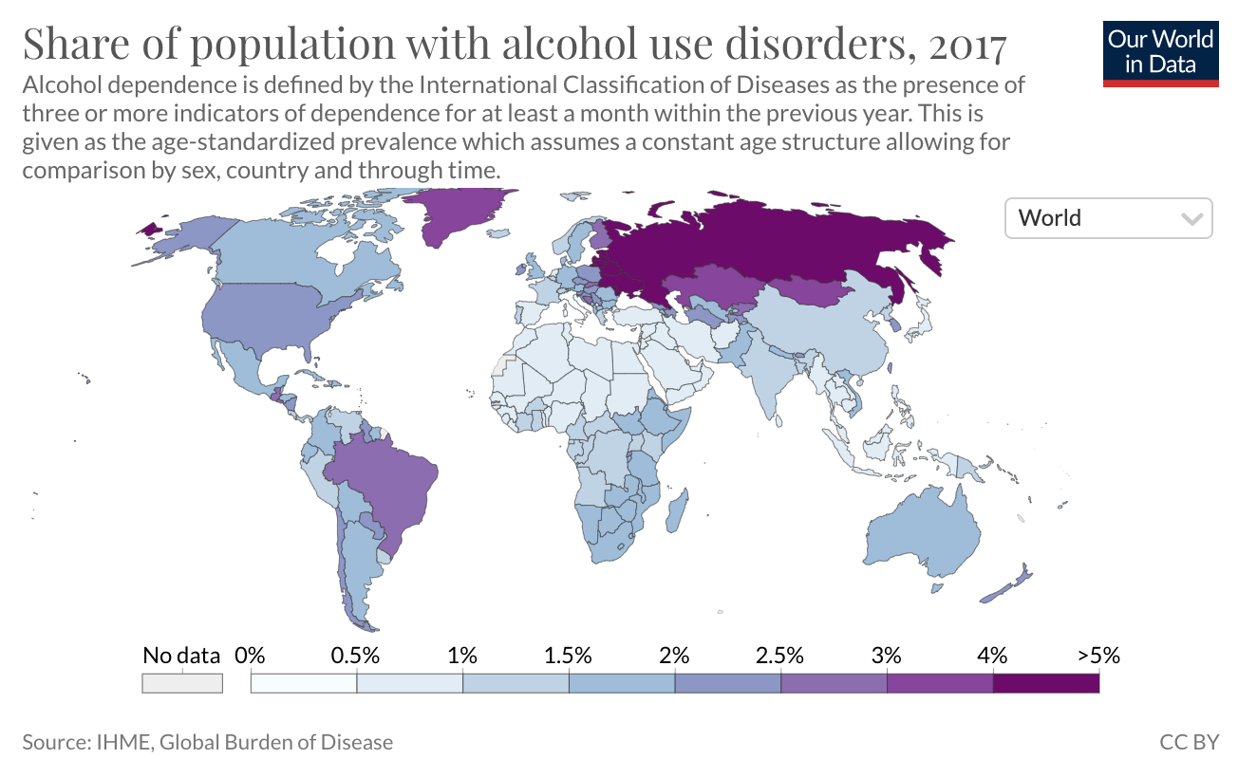
From: https://ourworldindata.org/grapher/share-with-alcohol-use-disorders?time=2017

Getting to know your map
- Look at the title of the map:
  - What type of substance use disorder (SUD) is the map describing?

  - What kind of data is the map showing? What does the data represent?

- Look at the legend/key:
  - What is the legend measuring?

  - What is the gradient of colors describing?

Evaluating the data
- What is the source of the data? How reliable do you think this source is? (Highly reliable? Not reliable? Somewhere in between?) Why do you think so?

- How do you think the data were collected?

Making sense of data
- Name three countries with the highest death rate from alcohol use disorder:
  - Can you identify any pattern in these countries? Give one possible reason for the pattern.

- Name three countries with the lowest death rate from alcohol use disorder:
  - Can you identify any pattern in these countries? Give one possible reason for the pattern.

*BONUS ROUND* (Optional extension activity)
Supporting or refuting my explanation
- Conduct an online search for a map, graph, or infograph that can help you support or refute your explanation for gaming. Make sure to use a reliable source.
- Paste your graph here:

- How does this map, graph, or infograph support or refute your explanation for the pattern you identified? Explain.

Lesson 3 - Summary Table
(Link to teacher answer key)

As a class share and discuss findings and completes the chart below.

Type of data showing | Pattern identified  What are the similarities and differences? | Factors that could cause the pattern  How does each map help explain the other? What is the evidence? | Relationship/  correlation between alcohol use disorder and deaths from alcohol use disorder
Alcohol use disorder | Between maps about alcohol use disorder  Example: Countries in Northeast Europe tend to show higher rates of alcohol use disorder issues. | Between maps about alcohol use disorder  Example: These countries share common cultural and historical backgrounds. | Example: Countries with more alcohol tend to show more alcohol use disorder.
Alcohol use disorder death

What is your conclusion about worldwide alcohol use disorder? Make sure to include 1) patterns about alcohol use disorder identified, 2) factors that can affect alcohol use disorder, and 3) evidence supporting your conclusion.

Optional Extension Activity for
Lesson 2 - What’s going on in the world?
Looking at national trends (Opioid)
Map 1
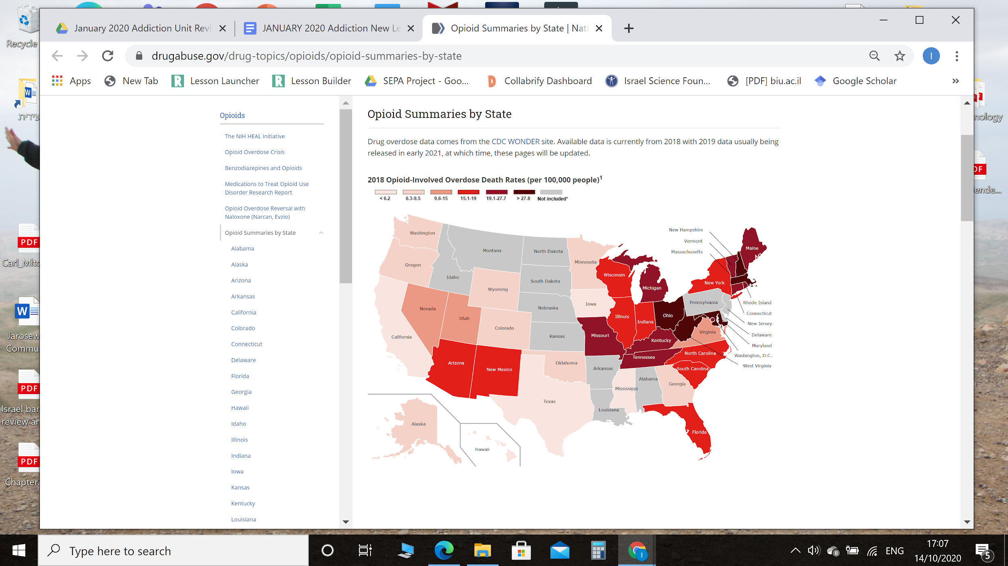

From: https://www.drugabuse.gov/drug-topics/opioids/opioid-summaries-by-state

Getting to know your map
- Look at the title of the map:
  - What type of substance use disorder (SUD) is the map describing?

  - Use your class definition of addiction to define opioid addiction. Conduct an internet search to compare. Write 2-3 sentences. Be sure to use a reliable source for your definition.

- Look at the legend/key
  - Describe the legend
    - What is the legend measuring?

    - What is the gradient of colors describing?

Evaluating the data
- What is the source of the data? Is it reliable? How do you know?

- How do you think the data were collected?

- Can this data collection method cause the data to be biased?

Making sense of data
- The highest rates of opioid overdose are in which state(s)? (Name the states)
_________________________________________________________________

- Why do you think that is? Give one possible explanation for the pattern.

- The lowest rates of opioid overdose are in which state(s)? (Name the states)
_________________________________________________________________

- Why do you think that is? Give one possible explanation for the pattern.

Examining more data: Look at the following map:

Map 2
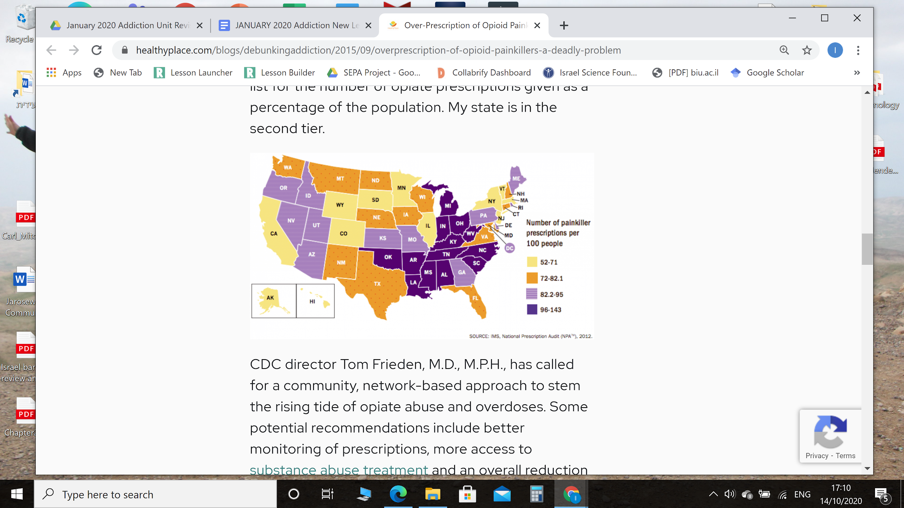

From: https://www.healthyplace.com/blogs/debunkingaddiction/2015/09/overprescription-of-opioid-painkillers-a-deadly-problem

Getting to know your map
- Look at the title of the map:
  - What is the map describing?

- Look at the legend/key:
  - Describe the legend
    - What is the legend measuring?

    - What is the gradient of colors describing?

Making sense of data
How does this map help you make sense of the phenomenon of opioid addiction? Explain how the maps are related.
- Map 1: Choose a state with a high rate of opioid overdose. Name the state:

_________________________
- Map 2: What are the rates of painkiller prescriptions in that state? ___________
- Map 1: Choose a state with a low rate of opioid overdose. Name the state:

________________________

- Map 2: What are the rates of painkiller prescriptions in that state?

___________
- Do you see a pattern between the rate of opioid overdose and the rates of painkiller prescriptions? What is the pattern have you identified?

- Is this pattern always true?
  - Can you find additional cases in which your pattern is true? Describe.

  - Can you find cases in which your pattern is not true? Describe.

  - Does the pattern that you found show correlation or causation? Why do you think so?

Correlation vs Causation
Correlation is a relationship or connection between two variables where whenever one changes, the other is likely to also change.
Causation means that there is evidence that one event causes another event to occur.

*BONUS ROUND* (Optional extension activity)
Supporting or refuting my explanation:
- Conduct an online search for a map, graph, or infograph that can help you support or refute (reject) your explanation for the pattern. Make sure to use a reliable source.
- Paste your map, graph or infograph on this worksheet.

- How does this map, graph, or infograph support or refute your explanation for the pattern you identified? Explain.

Optional Extension Activity for
Lesson 2 - What’s going on in the world?
Looking at national trends (Cell Phone addiction)
Graph 1

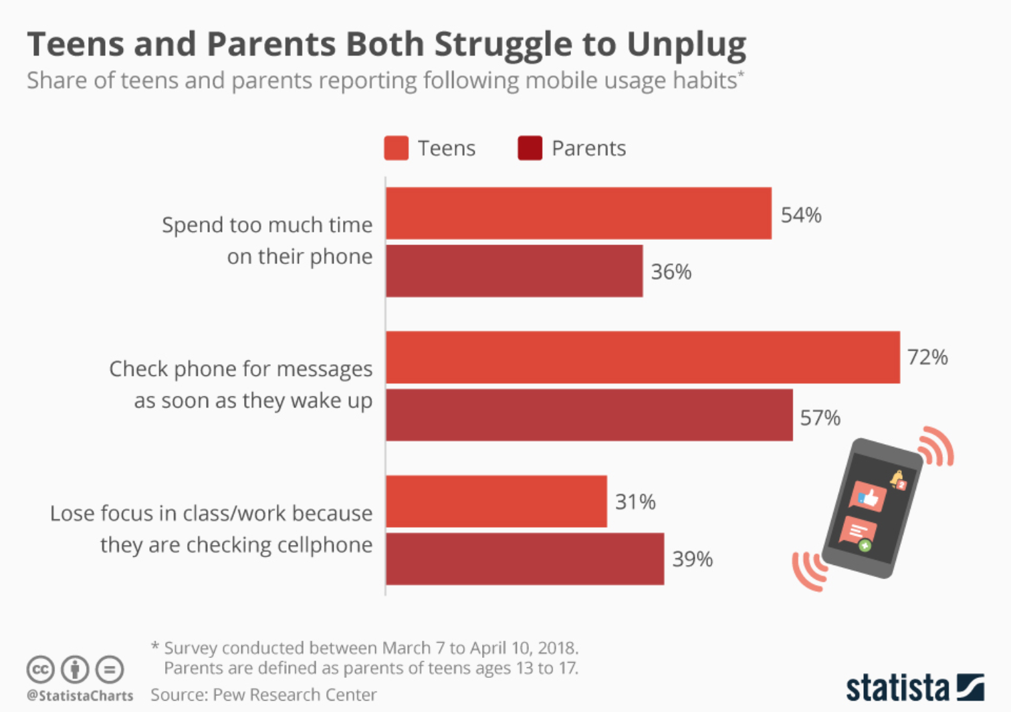
From : https://www.statista.com/chart/16505/teen-parent-mobiles/

Getting to know your graph
- Look at the title of the graph:
  - What type of behavioral addiction is the graph describing?

  - Use your class definition of behavioral addiction to define the cell phone addiction. Conduct an internet search to compare. Write 2-3 sentences. Be sure to use a reliable source for your definition.

- Describe the graph:
    - What do the colors represent?

    - What do the graphs represent?

Evaluating the data:
- What is the source of the data? Is it reliable? How do you know?

- How do you think the data were collected?

- Can this data collection method cause the data to be biased?

Making sense of data
- What do students and parents think about their phone use? How often do they check their phones? What are the consequences of their phone use?

- Why do you think that is? Give one possible explanation for the pattern.

Examining more data: Look at the following graph:

Graph 2
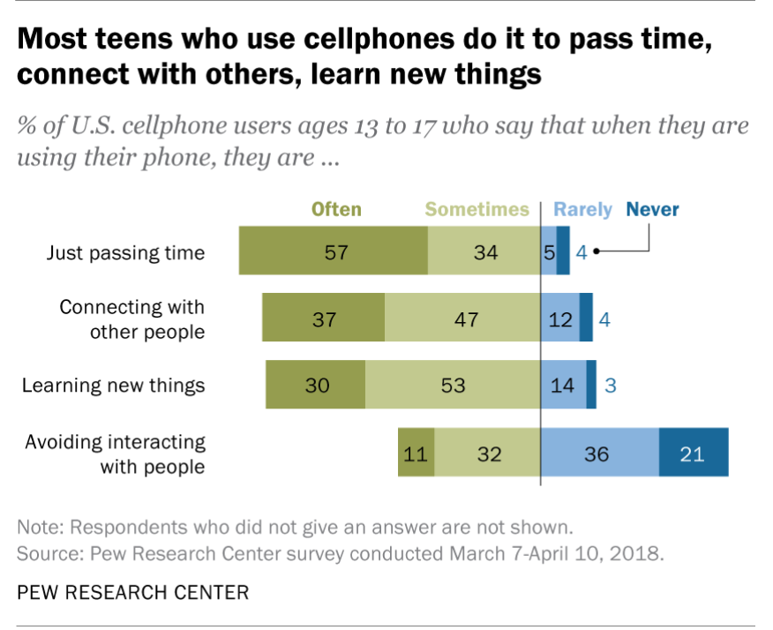

From: https://www.pewresearch.org/fact-tank/2019/08/23/most-u-s-teens-who-use-cellphones-do-it-to-pass-time-connect-with-others-learn-new-things/

Getting to know your graph
- Look at the title of the graph:
  - What is the graph describing?

- Describe the graph:
    - What do the colors represent?

    - What do the graphs represent?

Making sense of data
How does this graph help you make sense of the phenomenon of phone-use? Explain how the graphs are related.
- Graph 1: What conclusion can you draw from the different graphs?

- Graph 2: What conclusion can you draw from Graph 2?

- How can the information provided in graph 2 explain your conclusion from Graph 1?

- Are there patterns in Graph 1 and Graph 2 that can show any correlation or causation related to teens and phone use? Why do you think so?

Correlation vs Causation
Correlation is a relationship or connection between two variables where whenever one changes, the other is likely to also change.
Causation means that there is evidence that one event causes another event to occur.

- Read the following claim: Phone-use is always negative.
  - Use the information presented in graph 2 to support this claim.

  - Use the information presented in graph 2 to refute (reject) this claim.

*BONUS ROUND* (Optional extension activity)
Supporting or refuting my explanation
- Conduct an online search for a map, graph, or infograph that can help you support or refute your explanation for the over-use of phones. Make sure to use a reliable source.
- Paste your graph here:

- How does this map, graph, or infograph support or refute your explanation for the pattern you identified? Explain.

Optional Extension Activity for
Lesson 2 - What’s going on in the world?
Looking at national trends (Gaming addiction)
Graph 1
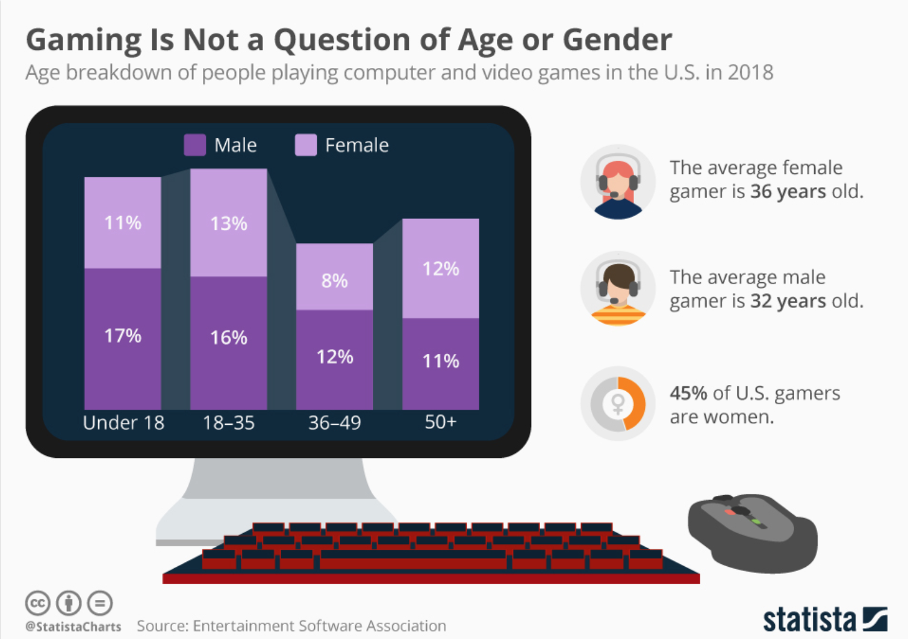

From: https://www.psychiatry.org/patients-families/internet-gaming

Getting to know your graph
- Look at the title of the graph:
  - What type of behavioral addiction is the graph describing?

  - Use your class definition of substance use disorder (SUD) to define the gaming addiction. Conduct an internet search to compare. Write 2-3 sentences. Be sure to use a reliable source for your definition.

- Describe the graph:
    - What do the colors represent?

    - What do the graphs represent?

Evaluating the data
- What is the source of the data? Is it reliable? How do you know?

- How do you think the data were collected?

- Can this data collection method cause the data to be biased?

Making sense of data
- Is there a difference between male gamers and female gamers? Describe.

- The highest percentage of gamers is in which age group? ______________

- Why do you think that is? Give one possible explanation for the pattern.

- The lowest percentage of gamers is in which age group? ______________

- Why do you think that is? Give one possible explanation for the pattern.

Examining more data: Look at the following infographics:

Infographics
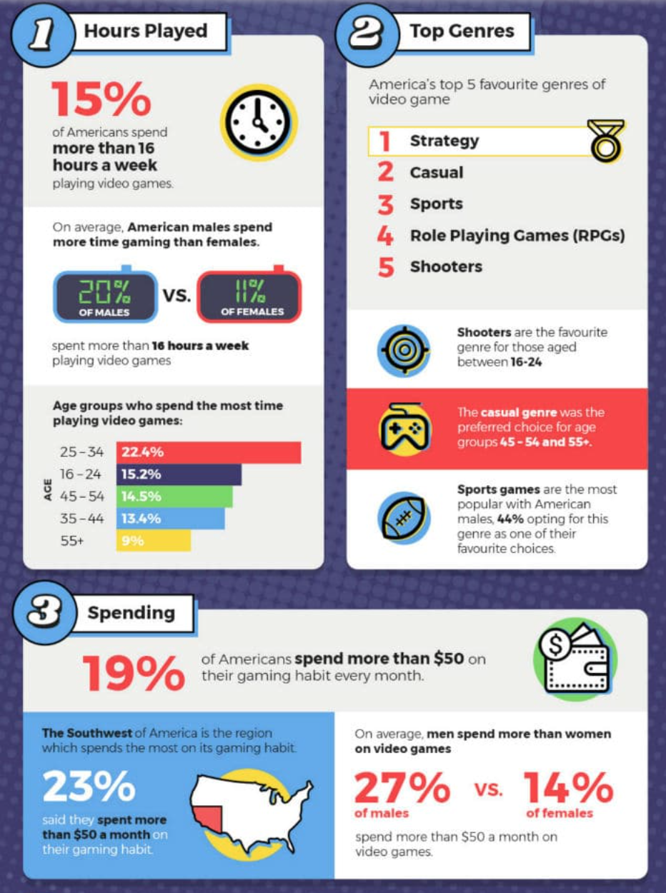

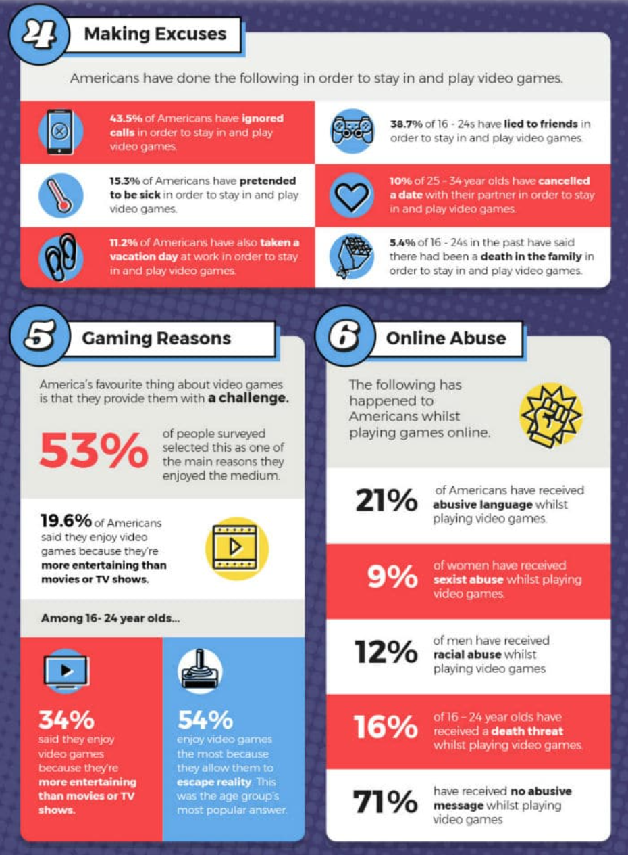

From: https://bitrebels.com/entertainment/us-addicted-gaming-infographic/

Getting to know your graph
- Look at the titles of the different sections of the infographics:
  - What is the infographic describing?

- Describe the infographic:
    - What are the takeaway messages of the infographic?

Making sense of data
How does this infographic help you make sense of the phenomenon of gaming? Explain how the graph and infographic are related.
- From Graph 1: What conclusion can you draw from the graphs?

- From the infographic: What conclusion can you draw from the infographic?

- How can the information provided in the infographic explain your conclusion from Graph 1?

- Do the data sources show correlation or causation related to gaming and age or gender? Why do you think so?

Correlation vs Causation
Correlation is a relationship or connection between two variables where whenever one changes, the other is likely to also change.
Causation means that there is evidence that one event causes another event to occur.

- Read the following claim: Gaming is always negative.
  - Use the information presented in the infographic to support this claim.

  - Use the information presented in the infographic to refute (reject) this claim.

*BONUS ROUND* (Optional extension activity)
Supporting or refuting my explanation
- Conduct an online search for a map, graph, or infograph that can help you support or refute your explanation for gaming. Make sure to use a reliable source.
- Paste your graph here:

- How does this map, graph, or infograph support or refute your explanation for the pattern you identified? Explain.

Optional Extension Activity for
Lesson 2-
SUD Gallery Walk Notes
Complete the chart for each team.

Type of substance use disorder (SUD) or behavioral addiction
Information about the visual displays | What data does the first visual display represent?
 | What data does the second visual display represent?
Their hypotheses | What factors do they claim are influencing the phenomenon? What conclusion did they draw?
 | What’s their evidence? What pattern did they find between the two visual displays?
 | Did the group say the pattern was caused by causation or correlation? Why?
My thoughts | Do I agree or disagree? What is the evidence that supports my argument?

Optional Extension Activity for
Lesson 3 - What’s going on in the world?
Looking at global trends for population who never drink alcohol
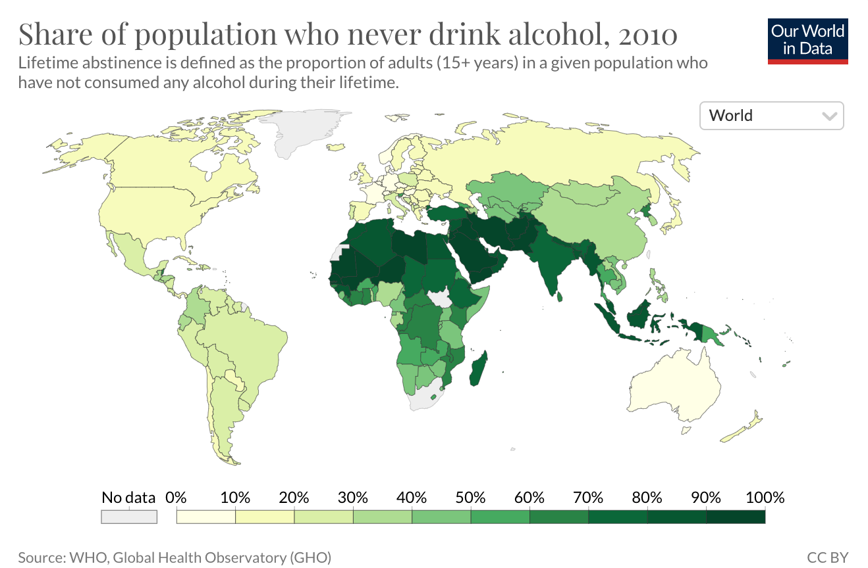
From: https://ourworldindata.org/grapher/share-of-population-who-never-drink-alcohol?time=2010

Getting to know your map
- Look at the title of the map:
  - What type of substance use disorder (SUD) is the map describing?

  - What kind of data is the map showing? What does the data represent?

- Look at the legend/key:
  - What is the legend measuring?

  - What is the gradient of colors describing?

Evaluating the data
- What is the source of the data? How reliable do you think this source is? (Highly reliable, Not reliable, Somewhere in between) Why do you think so?

- How do you think the data were collected?

Making sense of data
- Name 3 countries with the lowest percentage of people who never drink alcohol.
  - Can you identify any pattern in these countries? Give one possible reason for the pattern.

- Name 3 countries with the highest percentage of people who never drink alcohol.
  - Can you identify any pattern in these countries? Give one possible reason for the pattern.

*BONUS ROUND* (Optional extension activity)
Supporting or refuting my explanation
- Conduct an online search for a map, graph, or infograph that can help you support or refute your explanation for gaming. Make sure to use a reliable source.
- Paste your graph here:

- How does this map, graph, or infograph support or refute your explanation for the pattern you identified? Explain.

Optional Extension Activity for
Lesson 3 - What’s going on in the world?
Looking at global trends for alcohol consumption
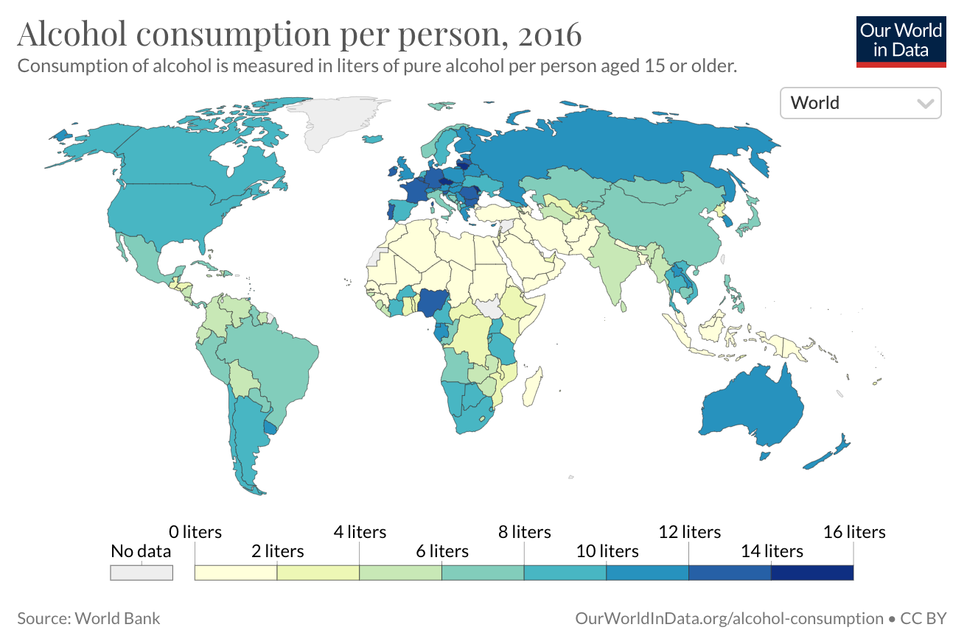
From: https://ourworldindata.org/grapher/total-alcohol-consumption-per-capita-litres-of-pure-alcohol?time=2016
Getting to know your map
- Look at the title of the map:
  - What type of substance use disorder (SUD) is the map describing?

  - What kind of data is the map showing? What does the data represent?

- Look at the legend/key:
  - What is the legend measuring?

  - What is the gradient of colors describing?

Evaluating the data
- What is the source of the data? How reliable do you think this source is? (Highly reliable? Not reliable? Somewhere in between?) Why do you think so?

- How do you think the data were collected?

Making sense of data
- Name three countries with the highest alcohol consumption:
  - Can you identify any pattern in these countries? Give one possible reason for the pattern.

- Name three countries with the lowest alcohol consumption:
  - Can you identify any pattern in these countries? Give one possible reason for the pattern.

*BONUS ROUND* (Optional extension activity)
Supporting or refuting my explanation
- Conduct an online search for a map, graph, or infograph that can help you support or refute your explanation for gaming. Make sure to use a reliable source.
- Paste your graph here:

- How does this map, graph, or infograph support or refute your explanation for the pattern you identified? Explain.

Optional Extension Activity for
Lesson 3 - What’s going on in the world?
Looking at global trends for alcohol attributed death
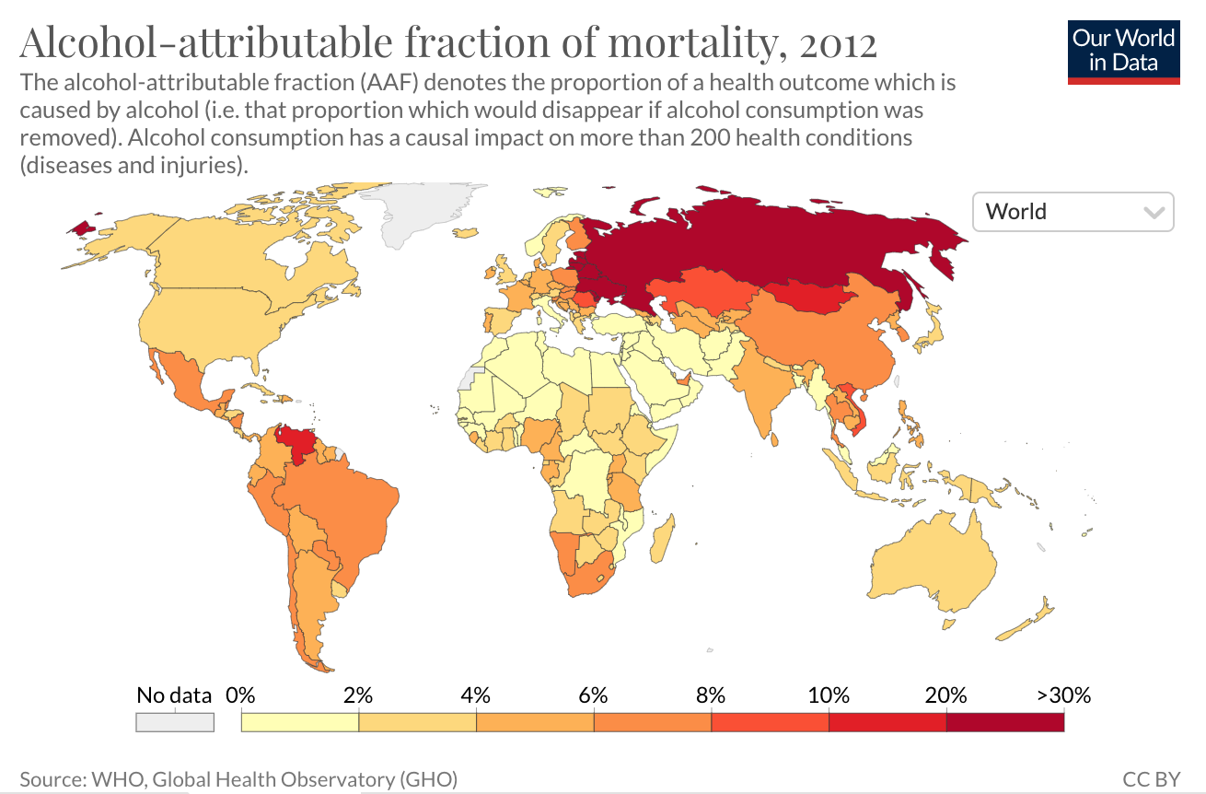
From:
https://ourworldindata.org/grapher/alcohol-attributable-fraction-of-mortality?time=2012
Getting to know your map
- Look at the title of the map:
  - What type of substance use disorder (SUD) is the map describing?

  - What kind of data is the map showing? What does the data represent?

- Look at the legend/key:
  - What is the legend measuring?

  - What is the gradient of colors describing?

Evaluating the data
- What is the source of the data? How reliable do you think this source is? (Highly reliable? Not reliable? Somewhere in between?) Why do you think so?

- How do you think the data were collected?

Making sense of data
- Name three countries with the highest rate of death caused by alcohol:
  - Can you identify any pattern in these countries? Give one possible reason for the pattern.

- Name three countries with the lowest rate of death caused by alcohol:
  - Can you identify any pattern in these countries? Give one possible reason for the pattern.

*BONUS ROUND* (Optional extension activity)
Supporting or refuting my explanation
- Conduct an online search for a map, graph, or infograph that can help you support or refute your explanation for gaming. Make sure to use a reliable source.
- Paste your graph here:

- How does this map, graph, or infograph support or refute your explanation for the pattern you identified? Explain.

Optional Extension Activity for
Lesson 3 - What’s going on in the world?
Looking at global trends for disease burden from alcohol use disorder
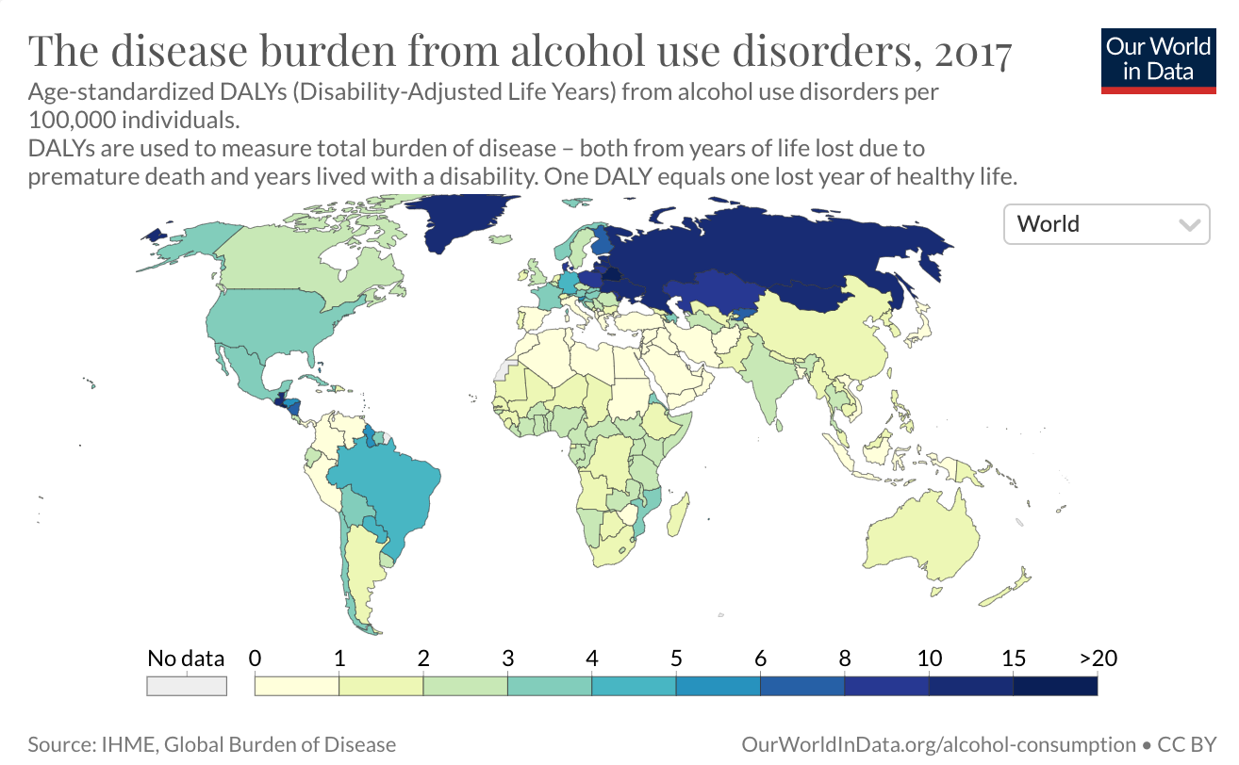
From: https://ourworldindata.org/grapher/alcohol-disorders-dalys-age-standardized-rate?time=2017

*Disease burden: How much death and loss of health there is to people due to factors such as disease or injury.

Getting to know your map
- Look at the title of the map:
  - What type of substance use disorder (SUD) is the map describing?

  - What kind of data is the map showing? What does the data represent?

- Look at the legend/key:
  - What is the legend measuring?

  - What is the gradient of colors describing?

Evaluating the data
- What is the source of the data? How reliable do you think this source is? (Highly reliable? Not reliable? Somewhere in between?) Why do you think so?

- How do you think the data were collected?

Making sense of data
- Name three countries with the highest death rate from alcohol use disorder.
  - Can you identify any pattern in these countries? Give one possible reason for the pattern.

- Name three countries with the lowest death rate from alcohol use disorder.
  - Can you identify any pattern in these countries? Give one possible reason for the pattern.

*BONUS ROUND* (Optional extension activity)
Supporting or refuting my explanation
- Conduct an online search for a map, graph, or infograph that can help you support or refute your explanation for gaming. Make sure to use a reliable source.
- Paste your graph here:

- How does this map, graph, or infograph support or refute your explanation for the pattern you identified? Explain.

Optional Extension Activity for
Lesson 3 - Summary Table
(Link to teacher answer key)

Each member representing a different home team shares their findings and completes the chart below together with their expert group members.

Type of data showing | Pattern identified  What are the similarities and differences? | Factors that could cause the pattern  How does each map help explain the other? What is the evidence? | Relationship/  correlation between alcohol consumption and alcohol use disorder
People never drank alcohol | Between maps about drinking alcohol  Example: Countries in north Africa tend to use less alcohol. | Between maps about drinking alcohol  Example: Islam is the dominant religion in North Africa. So this may affect this pattern. | Example: Countries with more alcohol tend to show more alcohol use disorder.
Alcohol consumption

Alcohol attributed deaths
Alcohol use disorder | Between maps about alcohol use disorder  Example: Countries in Northeast Europe tend to show higher rates of alcohol use disorder issues. | Between maps about alcohol use disorder  Example: These countries share common cultural and historical backgrounds.
Alcohol use disorder death

Disease burden for alcohol use disorder

What is your conclusion about worldwide alcohol use disorder? Make sure to include 1) patterns about alcohol use disorder identified, 2) factors that can affect alcohol use disorder, and 3) evidence supporting your conclusion.

