|  |
| --- |
| **Learning Set 5: What are the Environmental and Genetic Risks that Put Us at Risk for Substance Use Disorder (SUD) and Behavioral Addictions?** |

|  |  |  |
| --- | --- | --- |
| **Driving Question**  **for the unit:**  How can looking for thrills make us miserable?  **Driving Question**  **for the learning set:**  What puts us at risk for substance use disorder (SUD) and behavioral addictions? (Part 2) | **Materials**   * Computer * Handouts (link or printed) * **Optional Extension Activities**   + My SUD Modeling chart   + Teacher Version   + Student Version | **Suggested learning set time**  4 Days |

**Student materials:**

**Lesson 1**

* Link to student worksheet for small group activity
* [A video about alcohol flush](https://www.youtube.com/watch?v=MXjvx5Eq_PI)
* Reading
* SUD Matrix
* Alcohol Flush- Scientific Explanation (handout)

**Optional Extension Activities**

* My SUD Modeling Chart
* **Integrated Models**

|  |
| --- |
| **Building Coherence** |

This unit guides students through a journey to figure out thrill seeking, and how thrill seeking evolved as a survival mechanism. Because of environmental changes and modern lifestyle, thrill seeking can sometimes lead to substance use disorder (SUD) or behavioral addiction, misery and even death. Throughout the unit, students investigate several sub-driving questions to support them to gradually answer the bigdriving question, “How can looking for thrills make me miserable?” which encompasses these scientific ideas.

Guided by the sub-driving question, the journey unfolds as students figure out:

* In **LS1** - What gets us excited by examining the sub-driving question, “What do you do for thrills?”
* In **LS2** - The basic mechanism of the brain’s reward pathway which is responsible for the feeling of excitement through the sub-driving question, “Why do thrills make us feel excited and happy?”
* In **LS3** - The importance of thrill seeking to our survival and how the reward pathway evolved through the process of natural selection. Students investigate the sub-driving question, “Why do we all look for thrills?”
* In **LS4** - The risk for substance use disorders and behavioral addictions is caused, in part, by their environment. Students focus on both national and global trends related to SUD and behavioral addictions to understand the contribution of various environmental factors. and answer the sub-driving question, “What puts us at risk for substance use disorder (SUD) and behavioral addictions?”
* In **LS5** - Some genes might cause us to be at risk for substance use disorder (SUD), while others might protect us against. Alcohol flush is a genetic mutation that causes discomfort following alcohol consumption. Alcohol use disorder is caused by the interaction of an individual’s genes and the environment. Taken together, with Learning Set 5, this information helps students answer the sub-driving question, “What are the environmental and genetic factors that put us at risk or protect us from SUD?”
* In **LS6** - What they can do to reduce the risk of addiction by designing and conducting a community action project focused on making a change in their environment. Students address the sub-driving question, “Can we make a change? What can we do to reduce the risk of substance use disorder and behavioral addictions for ourselves and our community?”

To see more details, refer to the **Storyline**.

In the previous learning sets the students studied what can happen to the reward pathway if the environmental conditions to which it has been adapted undergo changes. They also learned how the brain can be hijacked by “modern” thrill stimulators, such as: drugs, social media, video games, exercise, food, glucose, and etc. In this learning set, students investigate the effect of gene-environment interactions on risk for SUDs and behavioral addictions. They figure out more about the biological mechanism by which genes affect traits.

|  |
| --- |
| **Framing the Lesson** |

**Purpose**

In this learning set, the students will examine how some genes might cause us to be at risk for SUDs, while others might protect us against it. This learning set will focus on one phenomenon associated with addictive behavior called alcohol flush, a mutation that causes discomfort following alcohol consumption, thereby reducing the risk for alcohol addiction. Students will analyze various data sets to identify patterns related to alcohol use and then explain that alcohol addiction can be caused by the interaction of their genes and the environment, i.e. the environment has a different effect on individuals based on their genetic makeup. This helps them answer the sub-driving question, “What puts us at risk for substance use disorder (SUD) and behavioral addictions?”

**Learning Set Learning Goals (For instructional use)**

* The students obtain, evaluate, and communicate information to explain the cause and effects of alcohol flush.
* The students analyze and interpret data to explain the cause and effects of alcohol flush.
* The students develop models of the effect of gene-environment interactions in risk for SUDs and behavioral addictions.

|  |
| --- |
| **Overview of the Learning Set** |

|  |  |  |
| --- | --- | --- |
| **Instructional sequence overview** | **Figuring out** | **Instruction days** |
| **Lesson 1 - What is alcohol flush and how does it affect alcohol use and substance use disorder (SUD)?**  The lesson starts by analyzing the map of occurrences of alcohol flush in various global populations. Students identify a pattern between alcohol flush and alcohol consumption and SUD. This will help them understand and explain that gene-environment interaction affects risk for SUD. | Genes (mutation) affect traits for SUD. The interaction of our genes with our environment affects our risk for SUD. | 3 days |
| **Wrap up- Revisiting the Driving Question Board**  The students will revisit the *Driving Question Board* *(DQB****)*** and reflect upon their learning. | SUD is caused by the interaction of genes and the environment. | 1 day |
| **Optional Extension Activity- Developing models**  The students will develop models. | SUD is caused by the interaction of genes and the environment. | 1 day |
| **Optional Extension Activity - Constructing a scientific explanation to answer Learning Set 3 sub- Driving Question**  **\*Learning Set Assessment**  Students use their integrated models to construct scientific explanations to explain why looking for thrills can make me miserable. | Genes (mutation) affect traits for SUD. The interaction of our genes with our environment affects our risk for SUD. | 2 day |

|  |
| --- |
| **NGSS Connection to Assessment** |

|  |
| --- |
| **Target Performance Expectations**  [**MS-LS1-5**](http://www.nextgenscience.org/pe/ms-ls1-5-molecules-organisms-structures-and-processes)**.** Construct a scientific explanation based on evidence for how environmental and genetic factors influence the growth of organisms.  [**MS-LS3-1**](http://www.nextgenscience.org/dci-arrangement/ms-ls3-heredity-inheritance-and-variation-traits)**.** Develop and use a model to describe why structural changes to genes (mutations) located on chromosomes may affect proteins and may result in harmful, beneficial, or neutral effects to the structure and function of the organism. |
| **Learning performance to be assessed**  Students develop and use a model to explain how genetic factors affect SUD.   |  |  |  | | --- | --- | --- | | **Disciplinary core idea** | **Science and engineering practices** | **Crosscutting concepts** | | **LS3.A Inheritance of Traits** Changes (mutations) to genes can result in changes to proteins, which can affect the structures and functions of the organism and thereby change traits. | **Analyze and interpret data**   * Use graphical displays (e.g., maps,charts, graphs, and/or tables) of large data sets to identify temporal and spatial relationships. * Distinguish between causal and correlational relationships in data. * Analyze and interpret data to provide evidence for phenomena. * Analyze and interpret data to determine similarities and differences in findings.   **Constructing scientific explanation**   * Students use models to construct a scientific explanation that explains why we look for thrill and why looking for thrills can make me miserable. | **Cause and effect**   * Cause and effect relationships may be used to predict phenomena in natural systems. | |
| **How these elements are integrated and embedded in this learning set**  They will use a map of alcohol flush and ALDH2 enzyme to develop a deeper understanding about genetics (traits, genes, chromosomes, mutations, proteins) and link gene and environment interactions as factors that affect SUDs. At the end of the unit, they will develop a model to explain our risk for SUDs and behavioral addictions. |

|  |
| --- |
| **Connection to Students’ Lives** |

**Link to career-awareness**

Epidemiologists are disease detectives. They study patterns of disease in people in hospitals and local communities, the United States and around the world to reduce and prevent disease. For example, epidemiologists at University of Michigan found out that teenagers are smoking a lot less but the rates of vaping among teens are climbing. Here’s their report: <https://sph.umich.edu/news/2020posts/smoking-tobacco-use-among-teens-drops-e-cig-use-grows.html>.

|  |
| --- |
| **Instructional Sequence** |

**Introducing the Learning Set**

1. **Keeping coherence using the DQB** - Remind students that they investigated alcohol use and alcohol use disorder around the world in the previous learning set to answer the sub-driving question, “What puts us at risk for substance use disorder (SUD) and behavioral addictions?” Tell them they will keep investigating other factors that affect SUD and behavioral addictions in this learning set using alcohol as an example.
2. **Link to career-awareness**- Epidemiologists are disease detectives. They study patterns of disease in people in hospitals and local communities, the United States and around the world to reduce and prevent disease. For example epidemiologists at University of Michigan found out that teenagers are smoking a lot less but the rates of vaping among teens are climbing.
3. **Introducing the Learning Set** - Start with some questions that link LS4 and 5.

* What did you figure out in the previous learning set? What affects SUD and behavioral addictions?
* What affects alcohol use disorder? How are alcohol use and alcohol use disorder related?
* What does alcohol actually do in our body?
* Do you think all people react to alcohol the same? Why or why not?

|  |
| --- |
| **Lesson 1 – What Is Alcohol Flush and How Might It Affect Alcohol Use and Substance Use Disorder (SUD)?** |

|  |  |
| --- | --- |
| **Learning Goal** | The students obtain, evaluate, and communicate information to explain the cause and effects of alcohol flush.  The students analyze and interpret data to explain the causes and effects of alcohol flush. |
| **Connection to NGSS** | DCI: Variation of traits |
| Practice: Obtaining, evaluating, and communicating information  Analyzing Data |
| CCC: Pattern  Cause and effect |

**Part 1. - What happens in our body after drinking alcohol? (Introducing the phenomenon)**

1. **What is alcohol flush?** - **Watch first 20 seconds of the** [**video about alcohol flush**](https://www.youtube.com/watch?v=MXjvx5Eq_PI) 
   1. Ask students what they think might be happening when a person turns red when they drink. What questions does this bring up?
   2. Returning to the DQB might identify questions that students brought up about things like: How does alcohol affect the body? This is the key question that leads to the next piece of information for students.
2. **How does alcohol affect our body** - The class watches a video about what happens in our body when we drink alcohol. [Video](https://www.youtube.com/watch?v=-oN2emCHMIg) of how alcohol affects our body. Discuss what they have figured out from the video?
   1. Alcohol is poisonous to our bodies and is expelled or broken down into non-poisonous chemicals.
   2. Most alcohol ends up in the liver whose job it is to break down alcohol into non-poisonous chemicals.
   3. A healthy liver can only break down about a drink an hour. If we drink more, it accumulates in our body and can affect many organs including our brain.
3. **How does alcohol flush work?** - Students watch the second part of the alcohol flush video (<https://www.youtube.com/watch?v=MXjvx5Eq_PI>). (Make sure to watch the video from 0:00 - 1:00. STOP at exactly 1:00 minute. Also see the worksheet below to reinforce these messages.
   1. How does our body control alcohol?
      1. First, our liver breaks down alcohol into a substance called acetaldehyde. But this is still a poison.
      2. Then, another chemical in the liver called ALDH2 breaks down acetaldehyde into non-poisonous components.
      3. ALDH2 is a type of enzyme in our body. Enzymes are proteins that are coded in our genes and then produced by our cells to do a job. The job of ALDH2 is to break down toxic acetaldehyde in our body.
   2. What happens to a person’s body with an alcohol flush trait after drinking alcohol?
      1. When the enzyme ALDH2 doesn’t work properly, more acetaldehyde accumulates in your body causing a red face and other symptoms (rapid heartbeat, headache, nausea, or vomiting).

**Part 2 - How might alcohol flush affect alcohol use and alcohol use disorder? (Looking for worldwide patterns)**

1. Students use Map 1 showing distribution of alcohol flush reaction around the world. Introduce alcohol flush as a genetic trait and that there is variation in the trait in humans. Complete the worksheet (Map 1 only) and share with peers. (**Note:** Make sure students complete only Map 1 and stop before Map 2. They will come back to this worksheet.)
2. Discuss the effect of alcohol flush and how it can be connected to alcohol use disorder.
   * 1. What are the symptoms of alcohol flush?
     2. Do you think these symptoms increase or decrease the chance of one’s consumption of alcohol? Why?
     3. Do you think these symptoms increase or decrease one’s chances of alcohol use disorder? Why? (Help students link back to the reward pathway.)
     4. Note - This gene mutation does not cause people to be affected by alcohol use disorder. Other genetic changes may affect other SUD.
3. Revisit LS4 Lesson 2 and our conclusions about Alcohol Use Disorder. Find the relationship between alcohol flush and the worldwide trend of alcohol use and alcohol use disorder using the summary table in LS4 Lesson 2.
   1. Which regions or countries have more people with the alcohol flush trait?
   2. Do those regions or countries show higher or lower rates of alcohol use? Support your answer using what you found in Lesson 2.
   3. Do those regions or countries show higher or lower rates of alcohol addiction? Support your answer using what you found in lesson 2.
   4. Look at the United States. What population has a higher number of an alcohol flush trait?

**Part 3 - What is the genetic cause of the alcohol flush reaction? (Understanding genetics)**

* 1. Ask students to think about why the ALDH2 doesn't work properly for people with an alcohol flush trait.
  2. Help students to link genetic aspects by referring to the risk for diabetes or color of moths as traits determined by genes.
     + - 1. Discuss prior knowledge.

What do you know about genes?

What do you know about chromosomes?

1. Use the reading to understand that genetic change (for example a mutation in the ALDH2 gene) affects the function of this enzyme coded for by the gene.
   1. There is a pair of alleles of a gene located on a pair of chromosomes (one allele of a gene on each chromosome). Genetic information that produces ALDH2 enzymes can be changed. The combination of the pair can determine the traits.
      1. If both alleles are non-mutated: Normal ALDH2 activity
      2. If one allele is mutated: Reduced ALDH2 activity
      3. If both alleles are mutated: Zero ALDH2 activity

3. Have students finish seeing the **LAST 30 seconds** of the alcohol flush video to help them visualize the phenomenon and discuss and to tie it all together. (<https://www.youtube.com/watch?v=MXjvx5Eq_PI>).

**Part 4 - How does this genetic factor help us explain the relationship between alcohol flush and alcohol use and overuse? (Linking genetics to explain worldwide phenomenon)**

1. Use Map 2 of the worksheet. Students tie the genetic and cellular levels, the alcohol flush trait, and worldwide patterns of alcohol consumption and overuse.
   1. Have a class discussion - Relate Map 1 and Map 2 to explain alcohol flush trends around the world using genetic aspects.
      1. What is the pattern that you find?
      2. Is this pattern always true?
         1. What are some countries in which your pattern is true?
         2. What are some countries in which your pattern is not true?
      3. Do you think genetic make-up is the only factor that affects alcohol use or addiction? Why or why not?
         1. Support your answer using what you found in lesson 2.

|  |  |
| --- | --- |
| **Scientific background** | **Alcohol Flush Reaction**  **ALDH2 is an enzyme that breaks down acetaldehyde -** acetaldehyde is a toxic substance produced as the body breaks down the alcohol. Alcohol flush symptoms caused by gene make-up mutation.  **For people with an alcohol flush trait,** either one allele or both alleles of the ALDH2 gene can be mutated**. acetaldehyde accumulates in the body of people who have an alcohol flush trait leading to negative symptoms.** Drinking can be unpleasant even when moderate amounts are consumed. This can prevent people from drinking too much alcohol and becoming addicted.  **Worldwide patterns are associated with alcohol flush mutation occurrence.**   * Make sure that students see that the **key** in Map 2 is the **same** as the **key** in the reading. This is important for students to understand genes, alleles, and mutations. * In areas where there is a high occurrence of the alcohol flush mutation, there are lower rates of alcohol addiction. Genetic differences in the enzymes may help to explain why some ethnic groups have higher or lower rates of alcohol-related problems. For example, Asian populations show higher rates of the trait ALDH2 mutation which can lead to lower rates of alcohol consumption and addiction. (Note: To avoid stereotyping, make sure that students recognize that NOT ALL Asian populations experience alcohol flush reaction. Only ⅓ of Asian people carry this allele.) |

**Part 5 - What are other factors that affect alcohol use and addiction? (environmental factors or other genetic factors)**

1. Refer back to the [alcohol use disorder map](https://ourworldindata.org/grapher/share-with-alcohol-use-disorders?time=2017) and summary table.
   1. Does the alcohol flush trait explain ALL the alcohol consumption in the world?
      1. There are certain factors that may be **correlated** with alcohol consumption rates, but that does **not** mean they cause alcohol consumption rates.
   2. Are there other places that show lower rates of alcohol consumption?
2. Have a whole class discussion about other possible factors that can affect alcohol addiction.

Possible factors:

1. Other genetic factors (e.g. other mutations)
2. Environmental factors: cultural differences, religious norms, economic status, local policies (e.g. taxes on alcohol, restrictions on stores, laws prohibiting drinking), and even weather.

Reinforce causation (cause-effect relationships which have been researched) vs. correlation (relationships that we see as a pattern but don’t have enough evidence to prove causation).

1. Be sure to discuss that we know that having the genes for alcohol flush (1 or 2 alleles) causes people to turn red when they consume alcohol. This phenomenon has been studied and researched extensively.
2. On the other hand, environmental factors may only be **correlated** with things like alcohol consumption, we cannot say they are the cause. The environmental factors may **influence** and be **related to** alcohol consumption. Further study to prove causation may be required.

**Part 6- Discuss gene-environment interaction.** Discuss with the students the meaning of the “gene-environment interaction” - i.e., that the environment acts differently on different genetic makeups (the specific set of instructions genes carry around in the organism’s cells). In relation to our health, this can mean that:

* In the previous lesson, we discussed the genetic protective factor, alcohol flush reaction. There are also genetic risk factors that put us at risk of SUD and behavioral addictions.
* Review some of the environmental risk factors and environmental protective factors students identified in the post interview discussion (friends could have been in both risk and protective, school could have been a protective factor, students should have identified others in the interview).
* Under the same conditions, one person may suffer from health problems because of their genetic makeup (the person might have the risk factors) while another person might not (due to lack of the risk factors - environmental and genetic)
* The same person may either have a SUD or a behavioral addiction, not depending on the environment (whether they are in a safe environment or not). Make sure to discuss how an unhealthy environment can put everyone at risk for SUD or behavioral addictions..
* Together with the students, come up with the following matrix that represents four different scenarios: Support students to fill out the following matrix:

|  |  |  |
| --- | --- | --- |
|  | **Environmental Protective factors (Healthy and safe)** | **Environmental Risk factors (Unhealthy and unsafe)** |
| **Person with genetic risk factors** | Low risk for SUD or behavioral addictions | High risk for SUD or behavioral addictions |
| **Person with no genetic risk factors** | Lower risk for SUD or behavioral addictions | At risk for SUD or behavioral addictions- risk lower than with genetic risk factors |

|  |  |
| --- | --- |
| idea.png | It is important to emphasize that while we can’t control everything, some of our *health is in our hands*, and we can control some of the environmental factors that affect our health. This is a bridge to Learning Set 7 where this will be further reinforced through individual and collective action.  Here is an example of another matrix like the one above to help students see how gene environment interactions play out in our health. <https://www.reddit.com/r/Mcat/comments/ehfhlp/miledown_anki_card_question_geneenvironment/> ; [Gene-environment Interaction example](https://docs.google.com/document/d/1d_GPUP8AumSKsHjG-dn6BQ1fTuBWRpMncTOb-6AivKY/edit?usp=sharing) |

**Generalize their findings**

* Both the environment and the genes we inherit can affect the development of SUD. Various data in lesson 2 and 3 helps students to understand how environmental and genetic factors can cause alcohol use disorder and behavioral addictions. Support students to apply what they figured out from alcohol use disorder to generalize factors that affect SUDs and behavioral addictions.
  + Are we all at the same risk for SUDs or behavioral addiction? Why or why not?
  + What makes some people vulnerable to SUDs and behavioral addictions around certain activities?

Part 7- Construct a Scientific Explanation using the Alcohol flush handout. Tell students that in their role as a scientist, they will write an explanation to share with colleagues about what they have discovered about alcohol flush. The scientific explanation (see the box below). The lab report will include answers to the following questions.

* + 1. **Claim**: How might alcohol flush affect alcohol use disorder in a person?
    2. **Evidence**: What data do you have to support your claim?
    3. **Reasoning**: How can we use ideas and concepts we have studied in this learning set to show that there are genetic and environmental factors that can affect alcohol use disorder? Try to use as many of the following terms as you can in your response: **Gene, Chromosomes, Protein, Mutation, Variation, Environment, Risk factors, Protective factors**

|  |  |
| --- | --- |
| idea.png | **What is a *scientific explanation?* How can it be used?**  Scientists try to explain how and why a natural phenomenon occurs. A scientific explanation consists of a claim, evidence, and reasoning (CER). The claim is a testable statement that expresses the answer or conclusion to a question or problem. Evidence is scientific data that supports the claim. The reasoning describes how or why the evidence can be used to support the claim by using scientific ideas and principles. |

|  |
| --- |
| **Wrapping-up the Learning Set - Revisiting the Driving Question Board** |

Use some questions below to make a transition to the next sub-driving question: **What Can We Do to Reduce the Risk of Substance Use Disorders (SUD) for Ourselves and Our Community? (Community action projects)**

(Students NOT expected to come up with the correct answer.)

* Does your model can help you understand not only SUD and behavioral addictions but also other health issues? If so, how?
* Does your model can help you think about what YOU can do to make YOUR environment healthier? If so, how?
* What are some things that YOU and other people in your community need to do together to make the community healthier and reduce the risk of SUD and behavioral addictions?

|  |
| --- |
| **Optional Extension Activity – Revisiting the Driving Question Board and Developing Individual Models** |

|  |  |
| --- | --- |
| **Learning Goal** | The students develop models of the effect of gene-environment interactions in risk for addiction. |
| **Connection to NGSS** | DCI: LS4.B: Natural Selection |
| Practice: Developing models |
| CCC: Cause and Effect |

**Review the discussion about gene-environment interaction.**

|  |  |  |
| --- | --- | --- |
|  | **Environmental Protective factors (Healthy and safe)** | **Environmental Risk factors (Unhealthy and unsafe)** |
| **Person with genetic risk factors** | Low risk for SUD or behavioral addictions | High risk for SUD or behavioral addictions |
| **Person with no genetic risk factors** | Lower risk for SUD or behavioral addictions | At risk for SUD or behavioral addictions- risk lower than with genetic risk factors |

|  |  |
| --- | --- |
| idea.png | It is important to emphasize that while we can’t control everything, some of our *health is in our hands*, and we can control some of the environmental factors that affect our health. This is a bridge to Learning Set 8 where this will be further reinforced through individual and collective action.  Here is an example of another matrix like the one above to help students see how gene environment interactions play out in our health. <https://www.reddit.com/r/Mcat/comments/ehfhlp/miledown_anki_card_question_geneenvironment/> |

**Review**

* Both the environment and the genes we inherit can affect the development of SUD. Various data in lesson 2 and 3 helps students to understand how environmental and genetic factors can cause alcohol use disorder and behavioral addictions. Support students to apply what they figured out from alcohol use disorder to generalize factors that affect SUDs and behavioral addictions.
  + Are we all at the same risk for SUDs or behavioral addiction? Why or why not?
  + What makes some people vulnerable to SUDs and behavioral addictions around certain activities?

**Developing models for the Unit -** How can looking for thrills make me miserable?

In this lesson, students develop one part of the model that will focus on the sub-driving question of this learning set, “**What puts us at risk for substance use disorder or behavioral addictions?”**

**Based on their experience in this learning set, ask students to complete the My SUD Modeling Chart Student Version (not filled in) (Teacher’s version).**

* **REFLECT upon learning in pairs**
  + **Identify the sub-driving question -** What is the sub-driving question that students were asked to think about during the Learning Set?
  + **Identify the questions**- What questions did students pose at the beginning of the Learning Set?
  + **Identify the Main Message (**Whole group discussion) - **What** did students figure out from the Learning Set? Use the following prompts:
    - What do you think are the take-home messages from the learning set?
    - What did you learn in this learning set?
* **REFLECT upon learning as a whole group/class.** Review students’ answers for the first three sections of the table.
* **PLAN as a whole group/class.** 
  + **Identify the components** - Start with a class discussion to remind the students of the different components of **activities that they (people) do for thrills** as they discussed when creating the Driving Question Board, for example: Playing sports, getting good grades, using social media, gaming, drugs, vaping, gambling etc.
  + **Identify the components** - Also ask students to find **consequences of each activity** (can be either positive or negative), for example: looking cool, getting better, feeling excited, addiction, illness etc. Be sure to use the teacher version of MY SUD Modeling Chart for the Learning Set to support the discussion about components. These are just suggestions, students will likely come up with many more on their own and through the discussion.
* **PLAN in small groups.**
  + **Generate different components** - Write each component on its own sticky note. Each component should be relevant. (At this point, components in a student's model may not be measurable. It is fine even if they cannot come up with the components that are measurable.)
  + **Organize the components** - organize the components in categories, such as: positive consequences, negative consequences, and etc..
* **BUILD in small groups: Connect the components (demonstrate to the class before students go into small groups)**. Connect the components in a **causal relationship** from the cause to the effect. Students should use arrows to show the directionality of the connection. (Hint: For the most part, the arrows will go from thrill seeking.)
* **TEST/REVISE in small groups**: **Evaluate models** - Instruct students to switch off in the roles of presenter and listener. Explain the phenomenon by explaining how the components thrill people. Have the students test their models by applying the following questions:
  + Does your model explain and predict?
  + Does your model make sense? Does it make sense when you use increase-decrease language?
  + Are the components in your model relevant to activities for thrill?
  + Does your model show cause-effect relationships?

Together, make any changes needed to make their models more clear and complete.

* **SHARE as a whole group/class -** Collectively, share the models with the class such as a gallery walk. Use the questions above, e.g one per small group, to have students present to the large group.
  + When sharing models, discuss with the students:
    - The similarities and differences between the models
    - The models’ strengths and weaknesses
    - Ways to improve the various models
* **REVISE in small groups** - Based on feedback and observing other models, have the students revise their models. Once they finish, they can document (e.g take a picture of) their group’s model and send it to their teacher. These models can be used for formative assessment, and for students’ to examine and reflect upon their model development process at the end of the unit.

|  |  |
| --- | --- |
|  | While the students model, move around the class, support the students, and encourage them to share their thinking and consult with their peers about their models. Students’ models can vary. However, since the models need to explain the relationships among the components, make sure the models include:  **Components**   * **Genetic factors**    + Gene   + Chromosomes   + Allele   + Proteins   + Mutation   + Variation   + (optional) components to explain specific addictions such as (for alcohol addiction) Alcohol, ALDH2, Acetaldehyde, Alcohol flush reaction   **Relationships and labels**   * The relationships among each factor. * The relationship showing if each factor can increase or decrease one’s risk of SUDs or behavioral addictions. |

|  |  |
| --- | --- |
| discussion.jpg | A discussion which shares insights from the various models and compares among them is extremely important as it will scaffold the students’ second revision of their models in the following step. Use questions to prompt the students to critically examine their peers’ models.  **Components**   * **Components identity**- What components are included in each model? Are key components included? * **Number of components** - How many components are indicated in the model? Are MORE components necessarily better? * **Grouping of components** - How can we group the various components? Why should we group components - does it improve our models? Is the grouping meaningful?   **Relationships among components**   * **Explicit relationships among the components** - Are the relationships among the components indicated? Do these relationships make sense? Are the indicated relationships important?   **General features**   * **Complexity of the model** *-* How complex is the model? * **Organization** - How well is the model organized? Is the organization meaningful? |

|  |
| --- |
| **Optional Extension Activity – Constructing a Scientific Explanation to Answer the Unit Driving Question**  **End of Learning Set Assessment** |

|  |  |
| --- | --- |
| **Learning Goal** | Students develop (evaluate and revise) a model to explain how looking for thrills can make us miserable.  The students construct a scientific explanation that explains why looking for thrills can make me miserable. |
| **Connection to NGSS** | DCI: LS1.B: Growth and Development of Organisms |
| Practice: Developing a scientific model  Constructing a scientific explanation |
| CCC: Cause and effect |

Through class discussion, the students, guided by the teacher, will develop integrated models which connect consensus models from different learning sets to construct scientific explanations (CER) to explain the phenomenon of SUD / behavioral addiction and gene-environment interaction by answering the Driving Question of the unit, “How can looking for thrills make me miserable?”

1. **Teacher and students complete this model link together (**integrated models teacher version is found below and integrated models student worksheet**).** The following list of questions and My SUD Modeling chart (teacher version / student version) can guide connecting the two models and coming up with a CER.
   1. To support linking two different models to make a claim:
2. What are the common components between the two learning sets?
3. Where do the two models link together?
4. What are the main ideas of each learning set? How can they be linked?
5. How does one model help explain, expand, and elaborate another?
   1. To support the evidence:
6. What activities did we do in each learning set?
7. What videos did we watch?
8. What experiment did we conduct?
9. What data (i.e. from maps, charts, simulation, interview) did we collect or use?
10. What are some specific examples, shown in your models, that can be used as evidence to support your claim?
    1. To support the reasoning:
11. What are the underlying scientific ideas shown in your models and in the unit that can explain how your claim and evidence are connected?

**2. Integrated model for LS3 and LS5**

1. **Main idea to include Linking natural selection and genetic factors**
   * 1. Links can be made from the LS3 model that begins with the thrill-seeking adaptive trait to the LS5 model
   1. Exemplar model

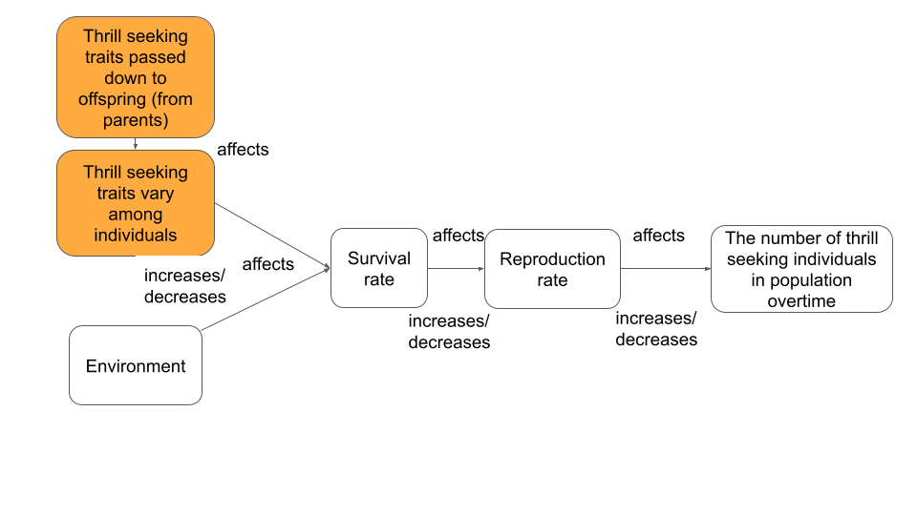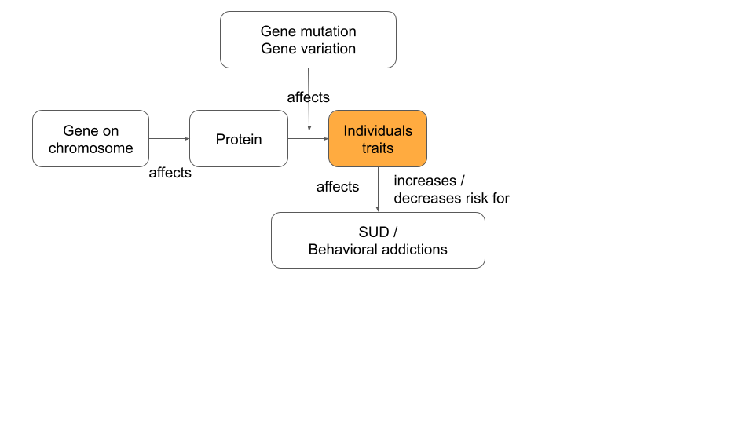

|  |  |
| --- | --- |
| **Sub-Driving question: What puts us at risk for substance use disorder (SUD) and behavioral addictions?** | |
| **Claim** | Thrill-seeking behaviors are part of our nature and those behaviors can sometimes make us miserable as a result of both gene-environment interactions. |
| **Evidence** | We learned through our investigations of the moth simulation that some traits, in nature, make it more likely that the individuals will survive and pass those traits on to their offspring and those offspring will have that trait as well.  We also learned that some genetic mutations can put people at risk for a SUD and some genetic mutations can be protective against SUD. |
| **Reasoning** | The thrill-seeking variation has been passed along over generations. The theory of natural selection explains why some traits have a higher chance of being passed on through generations. Natural Selection has three principles: principle of variation (having or not having the thrill-seeking trait, principle of heredity (those traits get passed onto offspring-their children), and principle of selection (those traits that are better fit to the environment will survive and reproduce and pass on that trait). Some of those thrill-seeking behaviors can be healthy and promote survival of the individuals and some thrill-seeking behaviors are not healthy and can lead to death and those individuals will not reproduce. There are genetic mutations that can protect against SUD and there are genetic mutations that put us at risk for SUD. There are gene-environment interactions that can put us at risk or protect us from SUD. |

**Discussion:** Help students make the generalization to ***us/my environment***, and from ***thrill seeking*** to ***health***, for example:

* + 1. Ask students “How does gene and environment interaction can be applied to ***us***? Can they be generalized to ***other people*** as well?”
    2. Original: What puts us at risk of substance use disorder and behavioral addiction?
       1. How can this sub-driving question apply to our own thrill-seeking and our health?

**Lesson 1 - What is alcohol flush and how might it affect alcohol use and alcohol use disorder?**

Use this information in the box to help you understand Map 1 and answer the questions below:

|  |
| --- |
| When a person drinks alcohol, the body breaks it down in the liver and produces a toxic substance called **acetaldehyde**. Then, an enzyme called ALDH2 breaks down acetaldehyde into non-poisonous pieces. Therefore, when ALDH2 doesn’t work properly, more acetaldehyde accumulates in the body. This causes a red face and other symptoms such as rapid heartbeat, headache, nausea, and vomiting. This phenomenon is called ‘alcohol flush’. |

**Map 1. Distribution of alcohol flush reaction**

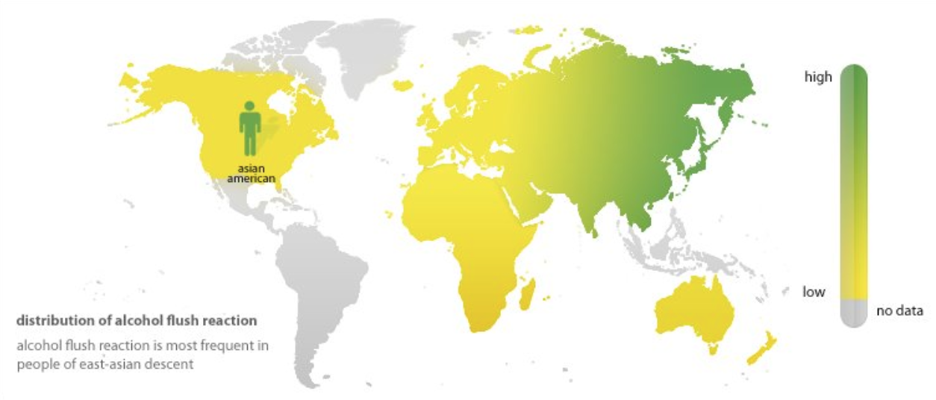

From: <https://www.slideserve.com/giona/breaking-down-the-structure-of-the-enzyme-aldh2-1-tequila-2-tequila-asian-flush>

**Getting to know your map**

* Look at the title of the map:
  + What is alcohol flush? Use the information above to answer.
  + What kind of data is the map showing? What does the data represent?
* Look at the legend/key:
  + What is the slider measuring?
  + What is the shading of colors describing?

**Making sense of data**

* Where in the world is the alcohol flush reaction most frequently found?
* Does any group of people in the United States have alcohol flush more frequently?
* Why do you think we see this pattern? Use the information about the alcohol flush from the internet to explain what causes it.

Use this information in the box to help you understand Map 2 and answer the questions.

|  |
| --- |
| Alcohol flush reaction is a trait **caused** by genetic factors that tends to run in families. Genes are the code that contains information for cells to build different proteins.  Proteins are needed to do different work inside our bodies. Genetic information can be changed and that affects how the proteins are built. This is called a **gene mutation**.  For people with an alcohol flush trait,either one allele or both alleles of the ALDH2 gene can be mutated**.** This causes acetaldehyde to be accumulated in the body leading to negative symptoms.  In the previous maps we looked at factors that may *influence* drinking alcohol. Those are not necessarily the causes of drinking or not drinking alcohol, but they are factors that may be *correlated or influence* alcohol drinking. More research may be necessary to prove causation.  But scientists have identified a gene that does *cause* the face to get red in some people. They know that having one or two alleles causes people’s faces to get red, which is called alcohol flush. |

**Map 2. Distribution of ALDH2 genetic variants**

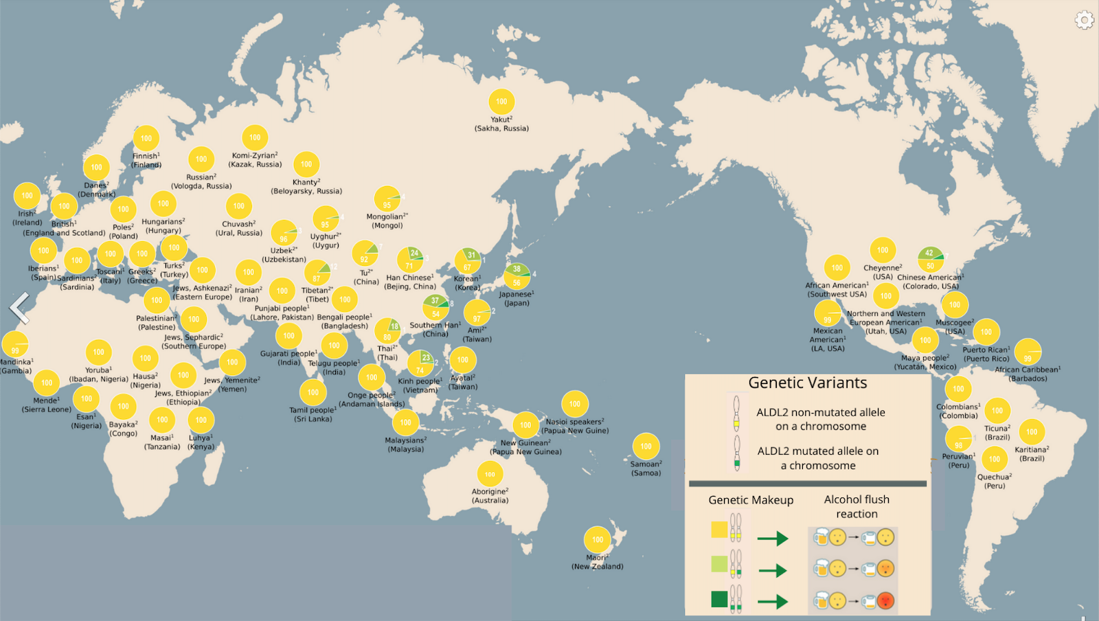

Revised from: <https://en.wikipedia.org/wiki/Alcohol_flush_reaction#/media/File:ALDH2_rs671_genotype_frequency.png>

**Getting to know your map**

* Look at the title of the map:
  + What is ALDH 2? What does it do in our body? Use the information above to answer.
  + What kind of data is the map showing? What does the data represent?
* Look at the legend/key:
  + What are the different colors describing? Make sure to include:
    - Which color(s) represents the traits with mutation
    - How each color represents different facial redness after drinking

**Making sense of data**

* Which population in the world shows more of the ALDH2 mutation?
  + Why do you think that is? Give one possible explanation for the pattern.
* Putting Map 1 and Map 2 together: What pattern can you find between people with alcohol flush distribution and genetic make-up for ALDH2?
* What is your conclusion about the relationship between alcohol flush and genetic make-up for ALDH2? What causes the alcohol flush?

**Lesson 1 Reading: How can a tiny gene prevent substance use disorder (SUD) around alcohol?** 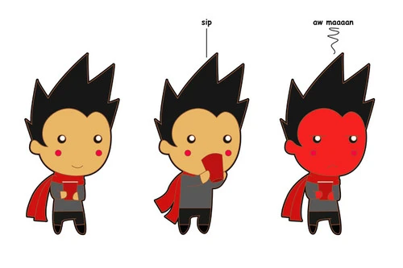

For some people, their faces turn red after a couple glasses of wine or beer. Why does this happen to some people? That is because they have trouble breaking down alcohol completely in their bodies and that causes their faces to turn very red. This phenomenon is called “alcohol flush reaction.”

Alcohol is actually poisonous to our bodies. When a person drinks alcohol, the body breaks down alcohol in the liver first by breaking it down into a toxic substance called *acetaldehyde*. Then the liver uses an **enzyme** called “aldehyde dehydrogenase 2” (or ALDH2, for short) to further break the acetaldehyde down chemically. 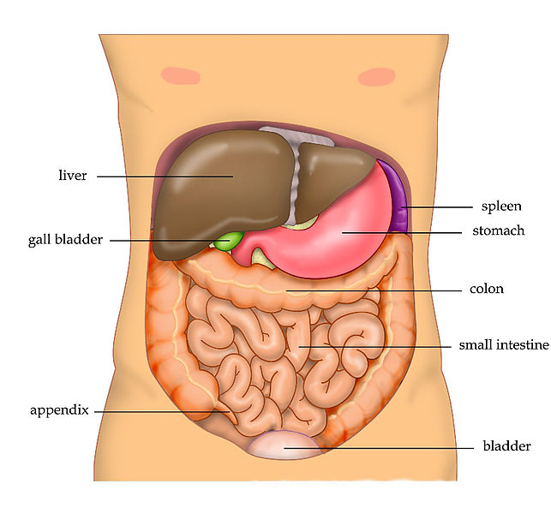

The ALDH means ‘breaking down acetaldehyde’. ALDH2 is one of many chemicals made in our cells called **enzymes**.

Enzymes are one kind of **protein** in your body that help perform important tasks such as building muscles, digesting food, and breaking apart poisons (like ALDH2).

**Proteins** are important for living things because they do most of the work in the body. Proteins can:

* Build something in the body such as bones and internal organs,
* Direct the body to do something such as flex muscles and grow hair, and
* Support bodily functions such as enzymes controlling chemical reactions in the body or insulin controlling the amount of sugar in the blood. 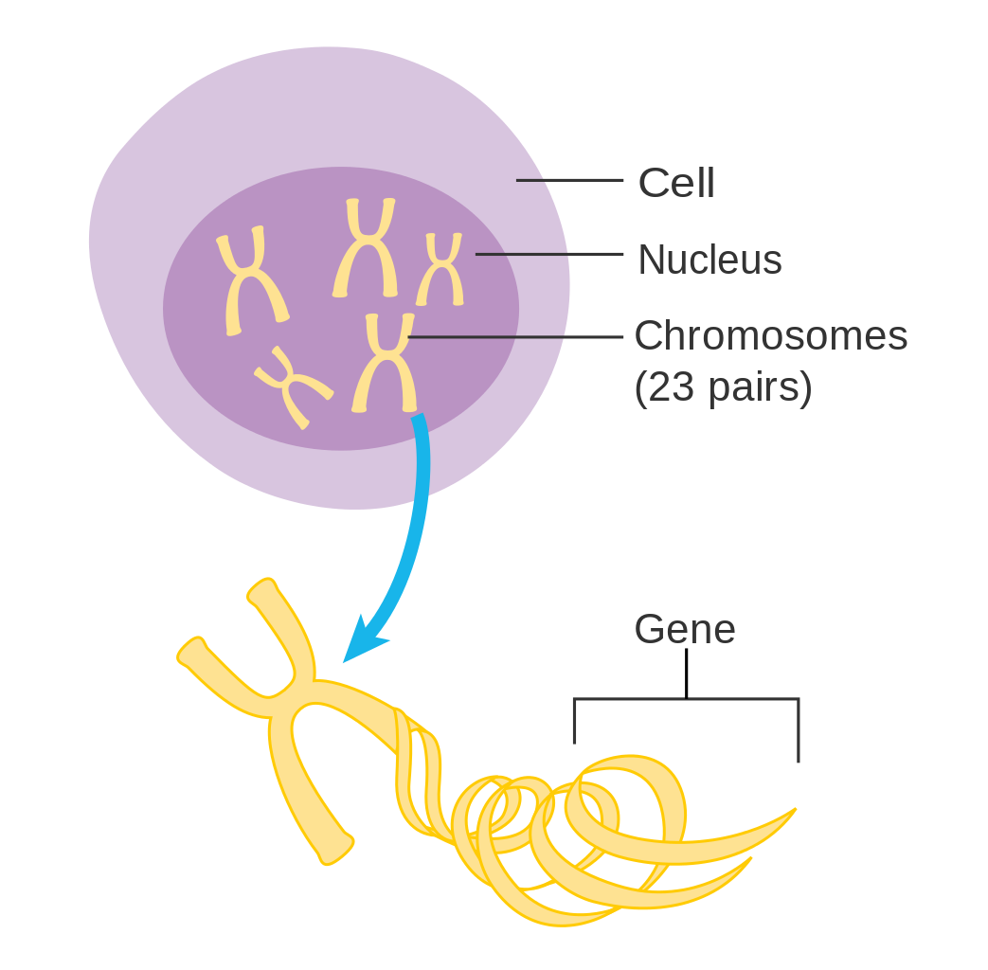

Your cells build proteins using information contained in your **genes.** Genes are found on **chromosomes** and each chromosome can contain hundreds, even thousands, of genes. Chromosomes come in matching sets of two (or pairs), one from each parent.

Genes are written in a chemical code along the chromosomes called the **genetic code.** Unique combinations of genes in each individual’s genetic code are responsible for everything in our body. This genetic code can be changed, such as the order of the code can be switched or parts of the code can go missing. A change in the genetic code is called a **gene mutation**.

A **gene mutation** can cause a change in the production of proteins which may affect an organism’s traits. A gene mutation can be harmful, helpful, or neutral (have no effect) to the survival of an organism. For example, the alcohol flush trait is caused by a mutation in the gene that codes for the ALDH2 enzyme (a type of protein), which prevents ALDH2 from breaking down acetaldehyde (a chemical in alcohol) properly. The mutation results in the accumulation of acetaldehyde in the body that leads to a red face and other symptoms such as rapid heartbeat, headache, nausea, or vomiting.

**Think of it like this:**

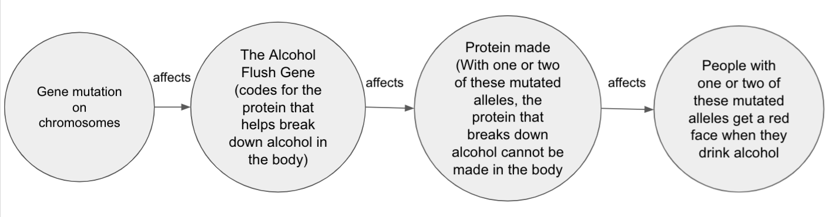

Humans have 23 sets of chromosomes in every cell in the body. Genes come in pairs, too. One copy of a gene is called an **allele** and each gene has two alleles, one comes from each of your parents. 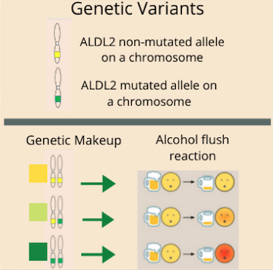

The effect of alcohol flush mutation depends on a person’s genetic make-up (see Figure 1.). If a person’s genetic code contains two alleles with no mutations, then no alcohol flush is experienced. If a person has one allele with a mutation, then some symptoms of alcohol flushing are experienced. If a person has two mutated alleles with mutations, then more severe alcohol flush symptoms are experienced.

Figure 1. Genetic Make-up and Alcohol Flush

**Question for discussion**:

How can a gene mutation affect how much alcohol someone drinks? Do you think the alcohol flush mutation might be harmful, neutral, or helpful to a person’s survival? Why?

Imagine a gene mutation that causes a person to drink more alcohol than is healthy for them. Would this mutation be harmful, neutral, or helpful to a person’s survival? Why?

Image source: <https://getsunset.com/blogs/news/the-ultimate-guide-to-asian-flush-and-asian-glow>; Image source: <https://en.wikipedia.org/wiki/Liver>

Image source: copyright CancerHelp UK; <https://estephaniebioclass.weebly.com/central-dogma.html> ; Image source copyright Michigan State University

**Lesson 2 - Summary Table**

**(Link to teacher answer key)**

Each member representing a different home team shares their findings and completes the chart below together with their expert group members.

|  |  |  |  |
| --- | --- | --- | --- |
| **Type of data showing** | **Pattern identified**  What are the similarities and differences? | **Factors that could cause the pattern**  How does each map help explain the other? What is the evidence? | **Relationship/**  **correlation between alcohol consumption and alcohol use disorder** |
| **People never drank alcohol** | Between maps about drinking alcohol  Example: Countries in north Africa tend to use less alcohol. | Between maps about drinking alcohol  Example: Islam is the dominant religion in North Africa. So this may affect this pattern. | Example: Countries with more alcohol tend to show more alcohol use disorder. |
| **Alcohol consumption** |
| **Alcohol attributed deaths** |
| **Alcohol use disorder** | Between maps about alcohol use disorder  Example: Countries in Northeast Europe tend to show higher rates of alcohol use disorder issues. | Between maps about alcohol use disorder  Example: These countries share common cultural and historical backgrounds. |
| **Alcohol use disorder death** |
| **Disease burden for alcohol use disorder** |

What is your conclusion about worldwide alcohol use disorder? Make sure to include 1) patterns about alcohol use disorder identified, 2) factors that can affect alcohol use disorder, and 3) evidence supporting your conclusion.

**Lesson 2 : SUD Matrix**

**Student Version:**

|  |  |  |
| --- | --- | --- |
|  | **Environmental Protective factors (Healthy and safe)** | **Environmental Risk factors (Unhealthy and unsafe)** |
| **Person with genetic risk factors** |  |  |
| **Person with no genetic risk factors** |  |  |

**Teacher Version:**

|  |  |  |
| --- | --- | --- |
|  | **Environmental Protective factors (Healthy and safe)** | **Environmental Risk factors (Unhealthy and unsafe)** |
| **Person with genetic risk factors** | low risk for SUD | High risk for SUD |
| **Person with no genetic risk factors** | lower risk for SUD | At risk for SUD- risk lower than with genetic risk factors |

**Alcohol Flush**

Your role as a scientist is to write an explanation sharing the findings of your research about alcohol flush. The explanation needs to include answers to the following questions.

**Claim:** How might alcohol flush affect alcohol use disorder in a person?

|  |
| --- |
| Write your answer here: |

**Evidence:** What data do you have to support your claim?

|  |
| --- |
| Write your answer here: |

**Reasoning:** How can we use ideas and concepts we have studied in this learning set to show that there are genetic and environmental factors that can affect alcohol use disorder? Try to use as many of the following terms as you can in your response: **Gene, Chromosomes, Protein, Mutation, Variation, Environment, Risk factors, Protective factors**

|  |
| --- |
| Write your answer here: |